MARYLAND = 9

1 BLACKWELL LIBRARY – (Salisbury, Maryland, Usa)
http://salisbury.worldcat.org/search?ai=wclocal_salisbury&qt=affiliate_wcl_all&fq=&search_category=journals&search_type=journals&search_field=title&search_relation=starts_with&func=find-db-1-title&mode=title&search_type=contains&q=dislessia+e+riabilitazione&quick-search-submit=Search%21&scope=0

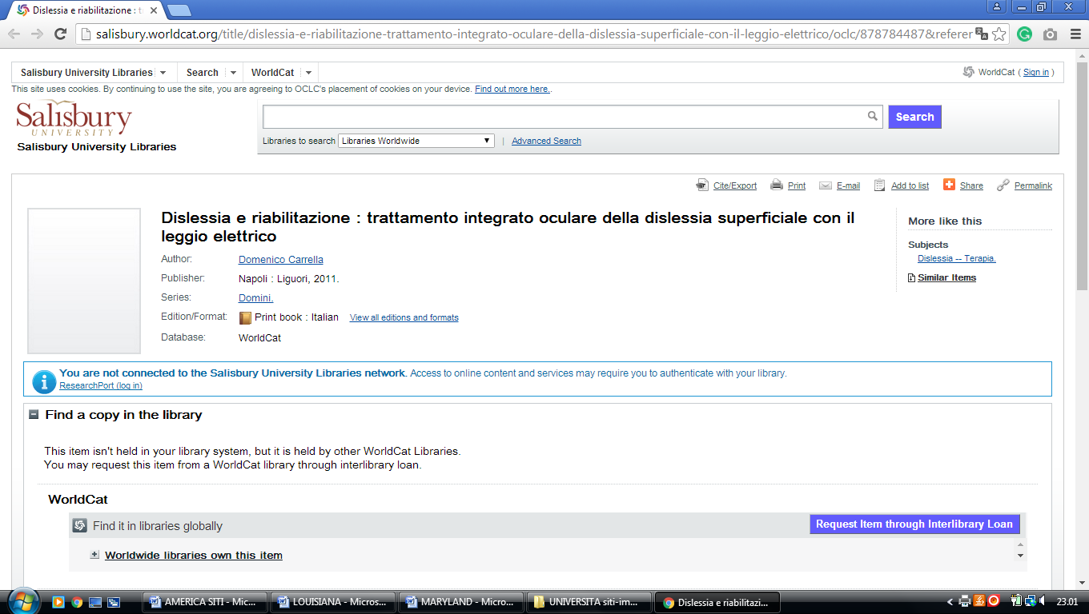

2 FREDERICK DOUGLASS LIBRARY – (Princess Anne, Maryland, Usa)
http://eds.b.ebscohost.com/eds/results?vid=3&sid=8c3e7e0d-c7b5-4394-8dbb-8a3d2ab23709%40sessionmgr101&bquery=(dislessia+AND+e+AND+riabilitazione)&bdata=JnR5cGU9MCZzaXRlPWVkcy1saXZl
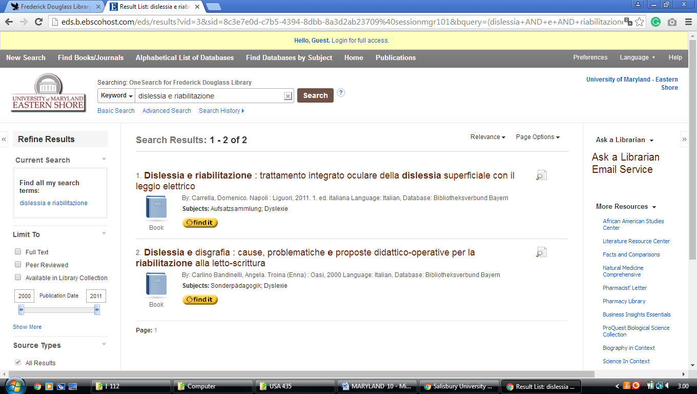

3 LANGSDALE LIBRARY – (Baltimore, Maryland, Usa)
http://ubalt.worldcat.org/search?qt=afiliate&ai=wclocal_ubalt&q=dislessia+e+riabilitazione&wcsbtn2w=Go

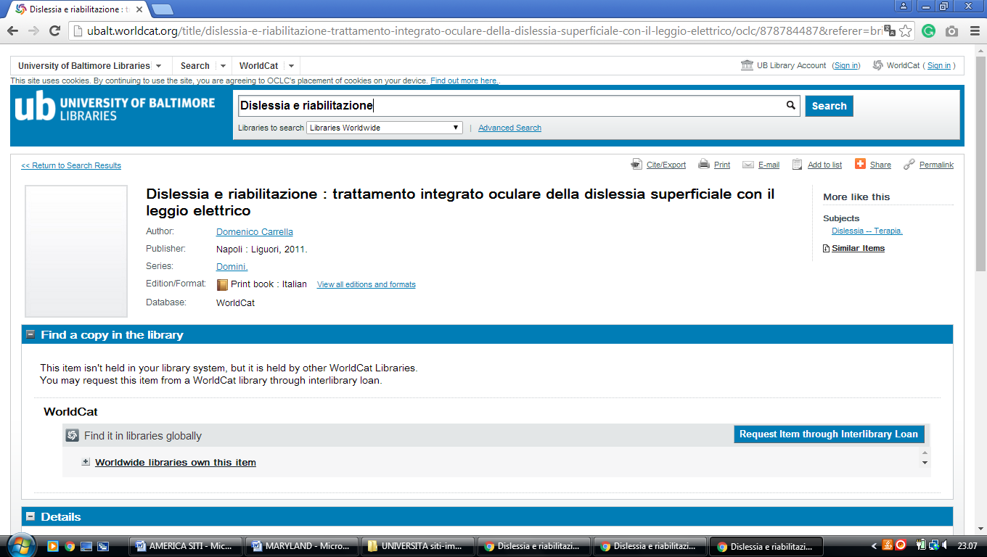

4 LEWIS J. ORT LIBRARY – (Frostburg, Maryland, Usa)
http://eds.a.ebscohost.com/eds/results?vid=0&sid=8f6fca4a-e989-4492-b96a-79f1a391a2fa%40sessionmgr4008&bquery=dislessia+e+riabilitazione&bdata=JnR5cGU9MCZzaXRlPWVkcy1saXZlJnNjb3BlPXNpdGU%3d

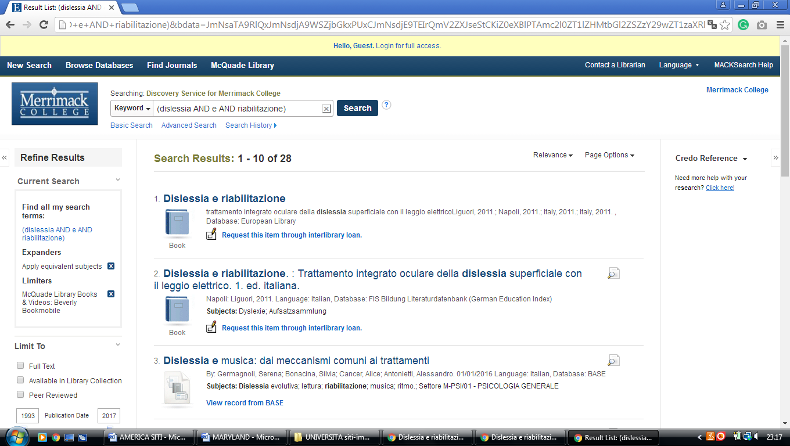

5 MOUNT ST. MARY'S SEMINARY AND COLLEGE: HUGH J. PHILLIPS LIBRARY ...– (Emmitsburg, MD, Usa)
https://msm.on.worldcat.org/search?sortKey=LIBRARY&databaseList=&queryString=dislessia+e+riabilitazione&changedFacet=author&scope=&format=all&database=all&author=Carrella%2C+Domenico&year=all&yearFrom=&yearTo=&language=all&topic=all

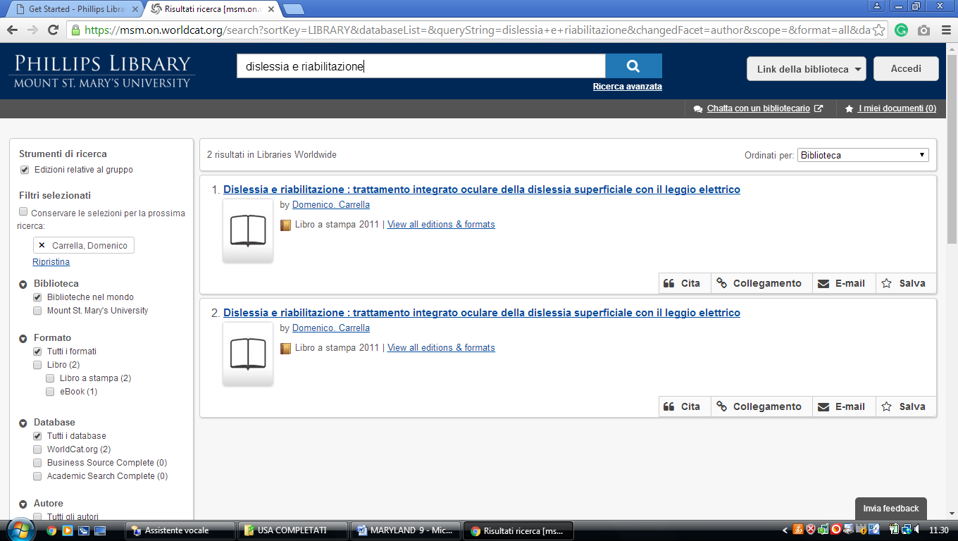

6 NIMITZ LIBRARY – (Annapolis, Maryland, Usa)
https://usna.summon.serialssolutions.com/?#!/search?ho=f&fvf=ContentType,Book%20Review,t&l=en&q=dislessia%20e%20riabilitazione

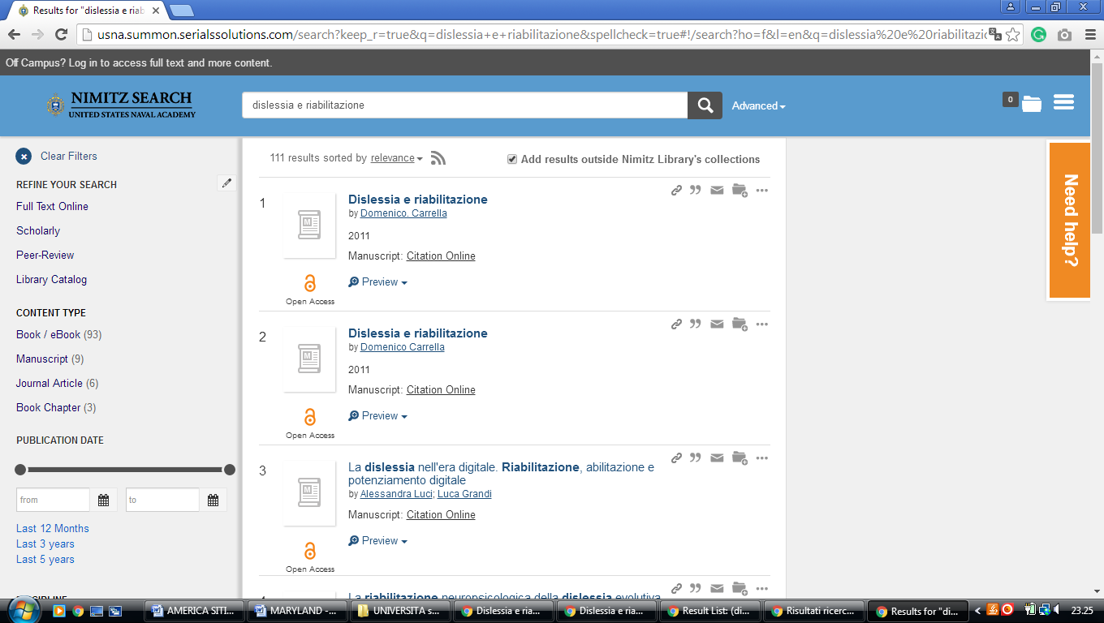

7 PRINCE GEORGE’S COMMUNITY COLLEGE LIBRARY – (Largo, Maryland, Usa)
http://pgcc.summon.serialssolutions.com/search?s.q=dislessia+e+riabilitazione&spellcheck=true&keep_r=true#!/search?ho=f&l=en&q=dislessia%20e%20riabilitazione

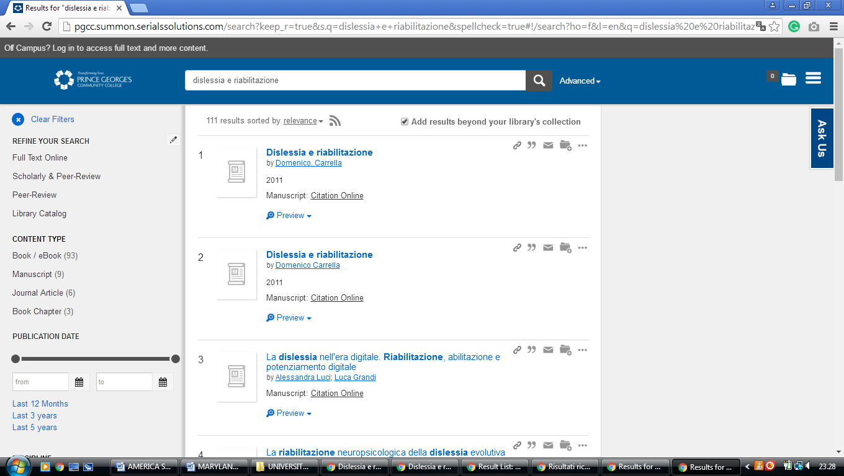

8 UNIVERSITY OF MARYLAND LIBRARIES – (College Park, Maryland, Usa)
https://umaryland.on.worldcat.org/search?sortKey=LIBRARY&databaseList=&queryString=dislessia+e+riabilitazione&changedFacet=author&scope=&format=all&database=all&author=Carrella%2C+Domenico&year=all&yearFrom=&yearTo=&language=all&topic=all

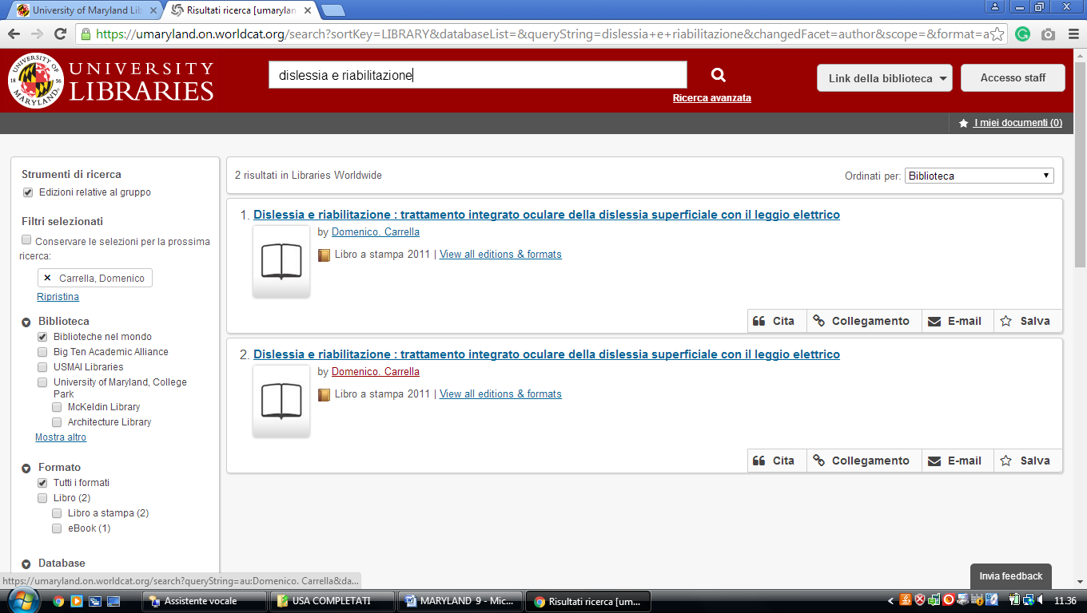

9 LANGSDALE LIBRARY - UNIVERSITY OF BALTIMORE - (Maryland, Usa)
http://ubalt.worldcat.org/title/dislessia-e-riabilitazione-trattamento-integrato-oculare-della-dislessia-superficiale-con-il-leggio-elettrico/oclc/878784487&referer=brief_results
