MASSACHUSSETES = 20

1 AMELIA V. GALLUCCI-CIRIO LIBRARY – (Fitchburg, Massachusetts, USA)
https://fitchburgstate.summon.serialssolutions.com/search?utf8=%E2%9C%93&s.q=dislessia+e+riabilitazione#!/search?ho=f&l=en&q=dislessia%20e%20riabilitazione

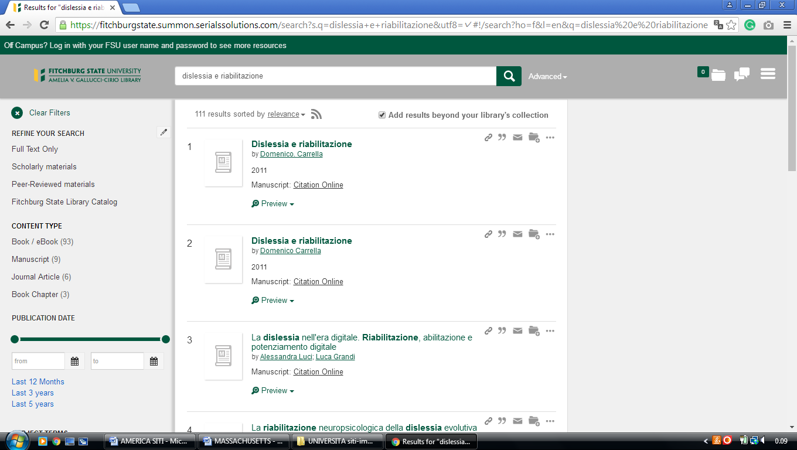

2 BOSTON COLLEGE UNIVERSITY LIBRARIES – (Chestnut Hill, MA, Usa)
https://bc.on.worldcat.org/search?databaseList=&queryString=dislessia+riabilitazione

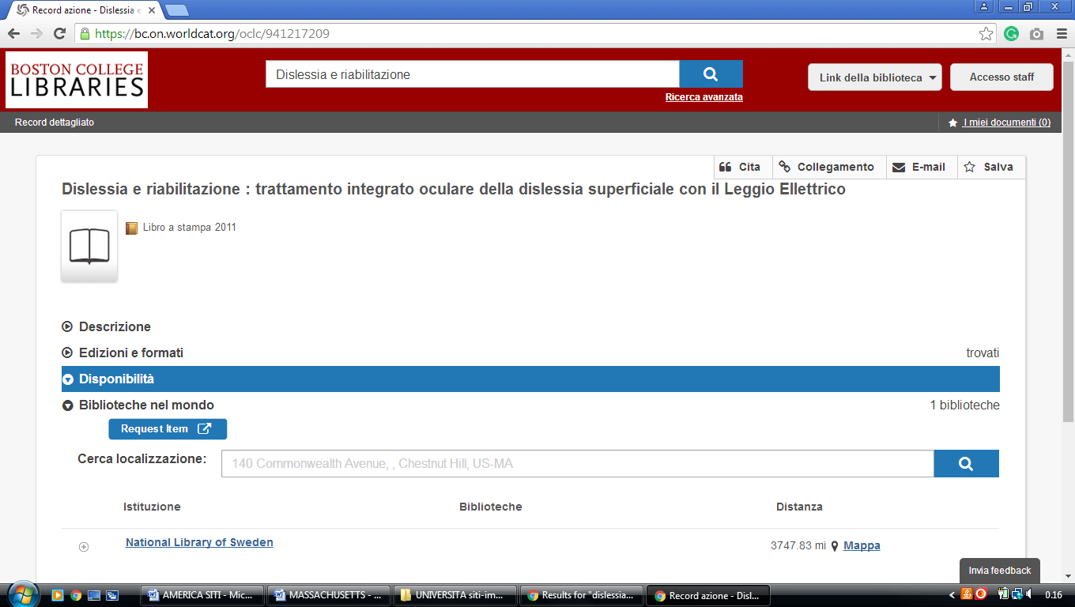

3 UMASS BOSTON LIBRARY – (Boston, Massachusetts, Usa)
https://umbrella.lib.umb.edu/primo-explore/search?query=any,contains,dislessia%20e%20riabilitazione&tab=default_tab&vid=01MA_UMB&mode=Basic&sortby=rank&lang=en_US
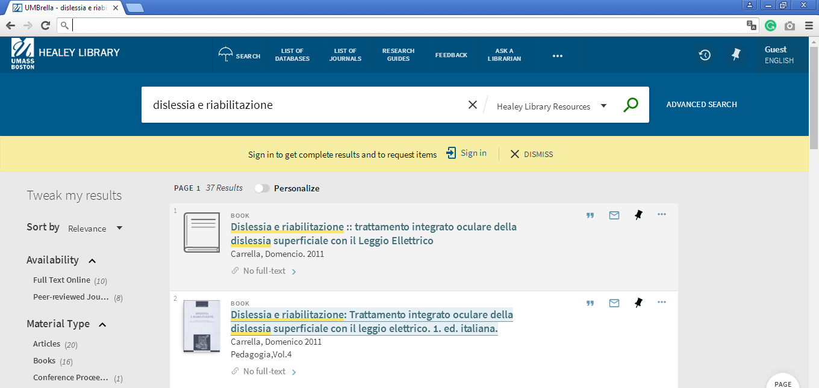

4 HEALEY LIBRARY | HOURS - UNIVERSITY OF MASSACHUSETTS BOSTON (Dorchester, Boston, Massachusetts, Usa)
http://umassboston.worldcat.org/search?qt=wc_org_umassboston&q=dislessia+e+riabilitazione&scope=0&oldscope=&wcsbtn2w=Search&fq=

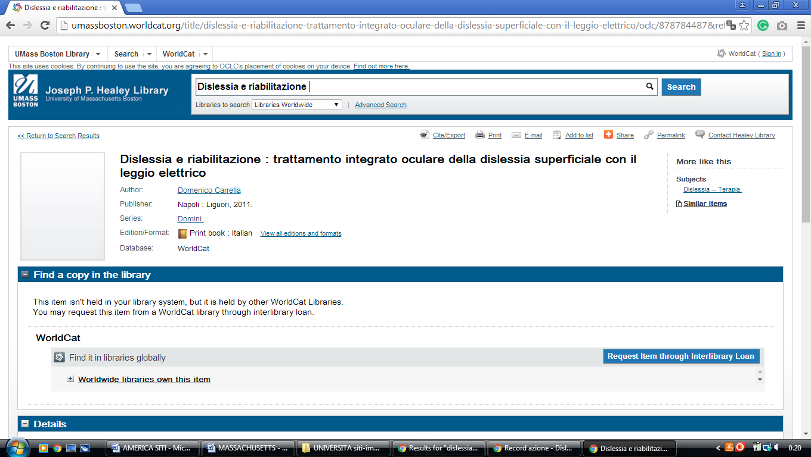

5 BRIDGEWATER STATE COLLEGE LIBRARY – (Bridgewater, MS, Usa)
https://bridgew.on.worldcat.org/search?queryString=dislessia+e+riabilitazione

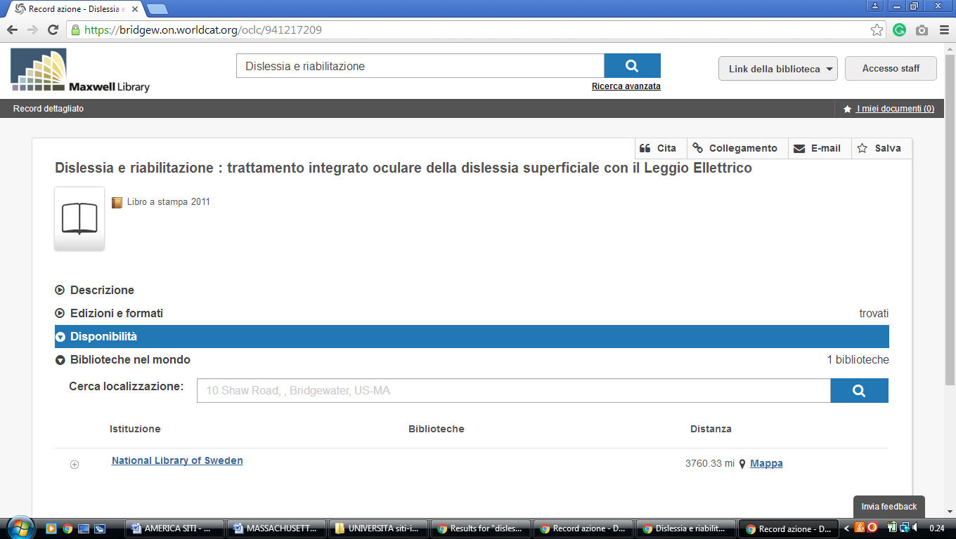

6 EMMANUEL D'ALZON LIBRARY WORCESTER – (Massachusetts, Usa)
https://assumption.on.worldcat.org/search?sortKey=BEST_MATCH&databaseList=&queryString=dislessia+e+riabilitazione&changedFacet=scope&clusterResults=on&scope=&scope=wz%3A324&format=
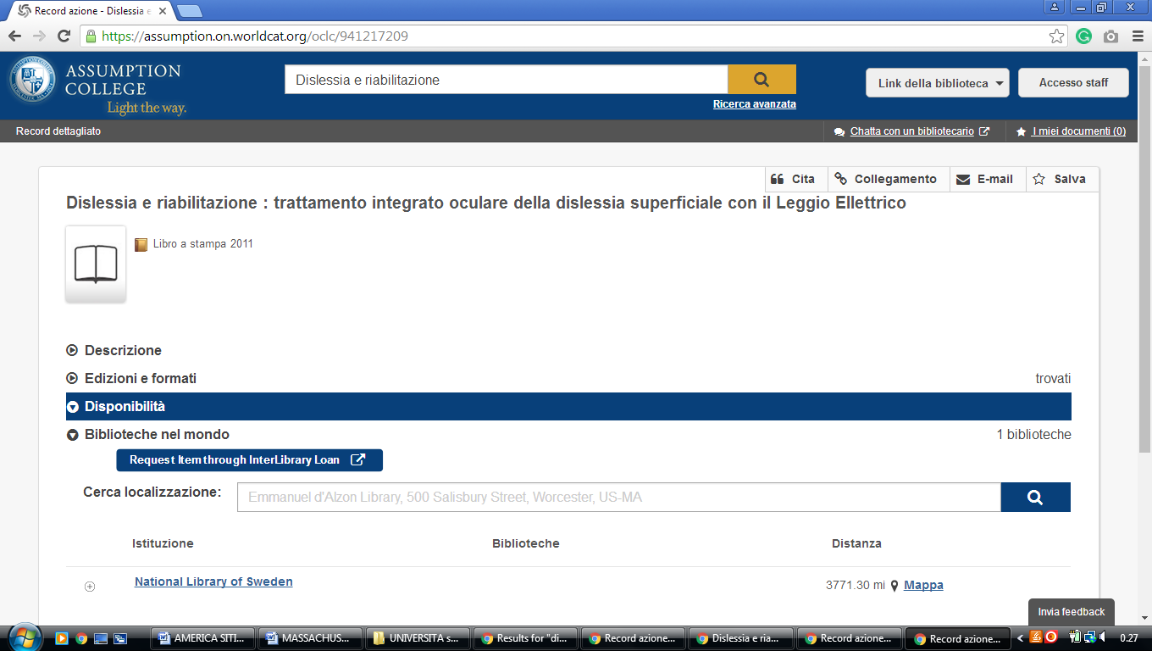

7 GEORGE C. GORDON LIBRARY | | WPI - WORCESTER POLYTECHNIC INSTITUTE – (Worcester, Massachusetts, Usa)
http://wpi.summon.serialssolutions.com/#!/search?ho=f&fvf=ContentType,Newspaper%20Article,t&l=en&q=dislessia%20e%20riabilitazione

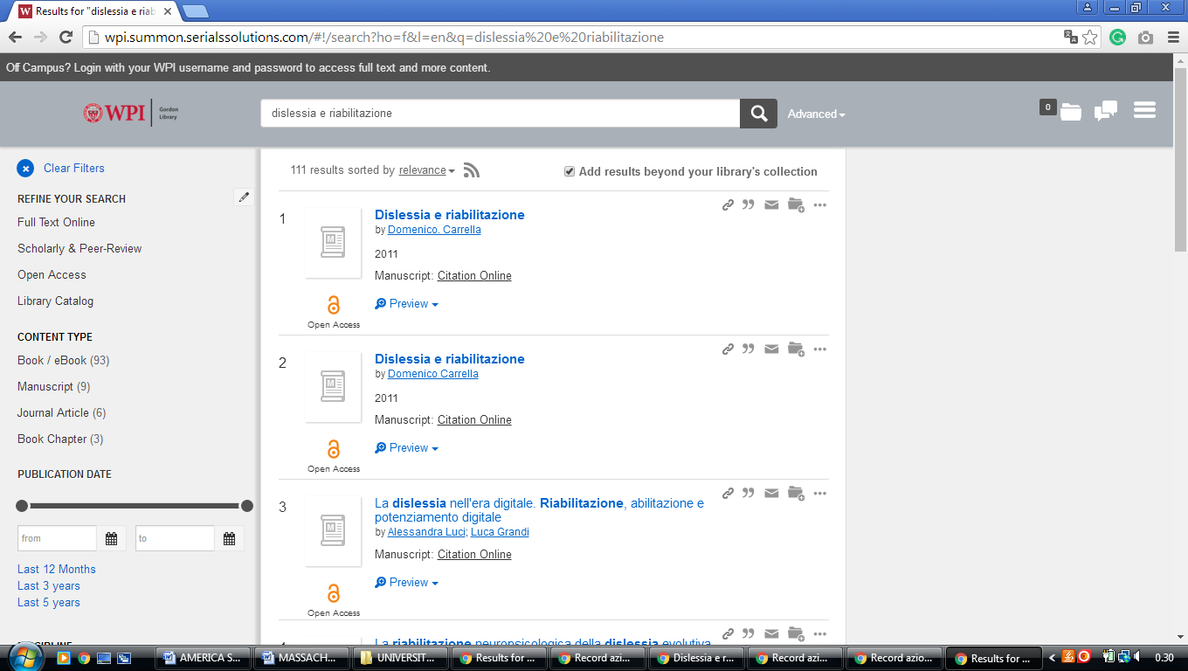

8 HARVARD LIBRARY - (Cambridge, Massachusetts, Usa)
https://hollis.harvard.edu/primo-explore/search?vid=HVD2&tab=everything&search_scope=everything&query=any,contains,dislessia%20e%20riabilitazione

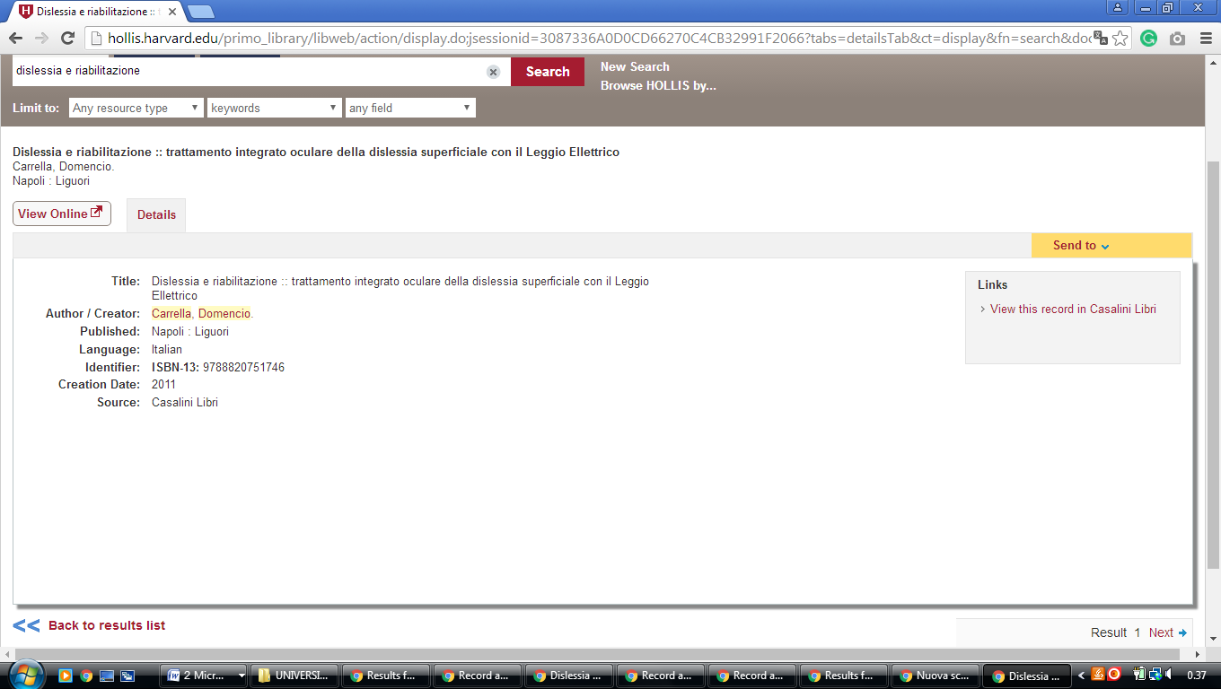

9 HORN LIBRARY – (Babson Park, Massachusetts, Usa)
https://babson.summon.serialssolutions.com/?#!/search?ho=f&l=en&q=dislessia%20e%20riabilitazione

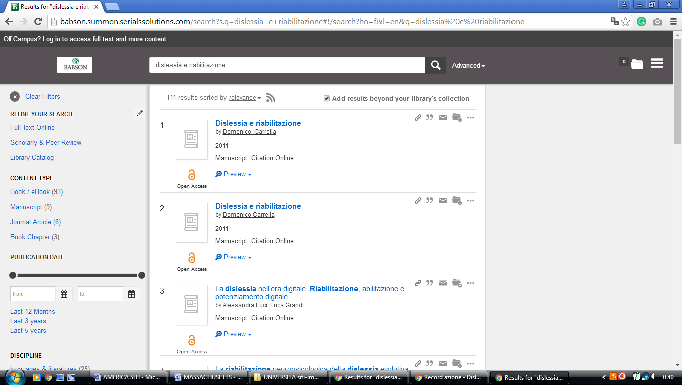

10 LAMAR SOUTTER LIBRARY – (Worcester, Massachusetts, Usa)
http://umassmed.worldcat.org/search?qt=affiliate_wcl_all&ai=wclocal_umassmed&fq=&q=dislessia+e+riabilitazione&oldscope=&wcsbtn2w=Search+Print+Materials

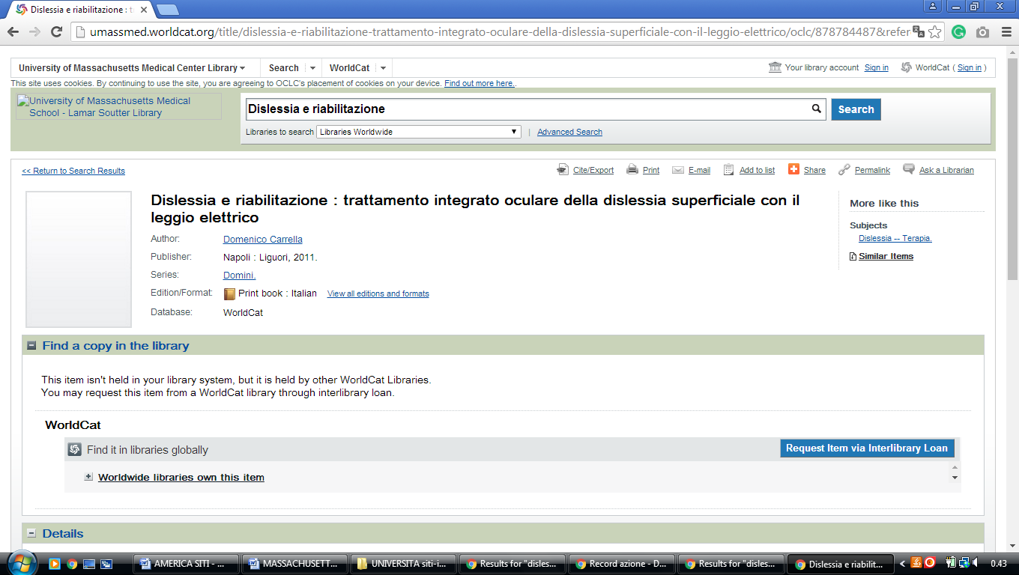

11 SEARCH | MIT LIBRARIES – (Mass. Institute of Technology Libraries

Cambridge, Usa)
http://mit.worldcat.org/search?q=dislessia%20e%20riabilitazione

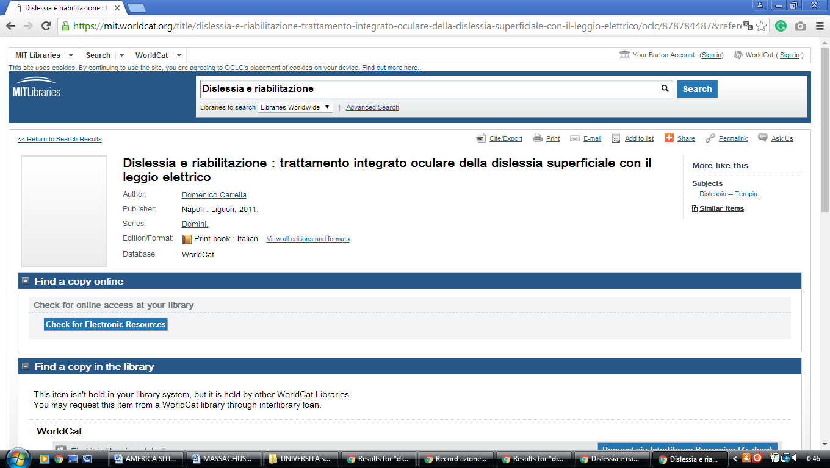

12 MCQUADE LIBRARY – (North Andover, Massachusetts, Usa)
http://eds.b.ebscohost.com/eds/resultsadvanced?vid=1&sid=8198958f-e6c2-43af-8d9c-7e0cb885061e%40sessionmgr120&bquery=(dislessia+AND+e+AND+riabilitazione)&bdata=JnR5cGU9MSZzaXRlPWVkcy1saXZlJnNjb3BlPXNpdGU%3d

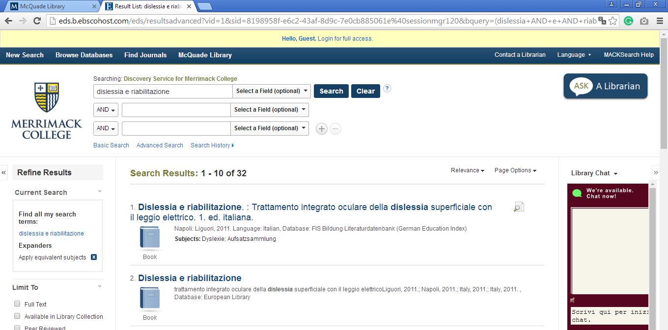

13 TUFTS UNIVERSITY LIBRARIES – (Medford, Massachusetts, Usa)
https://tufts-primo.hosted.exlibrisgroup.com/primo-explore/search?query=any,contains,dislessia%20e%20riabilitazione&tab=everything&search_scope=EVERYTHING&sortby=rank&vid=01TUN&lang=en_US&offset=0&pcAvailability=true
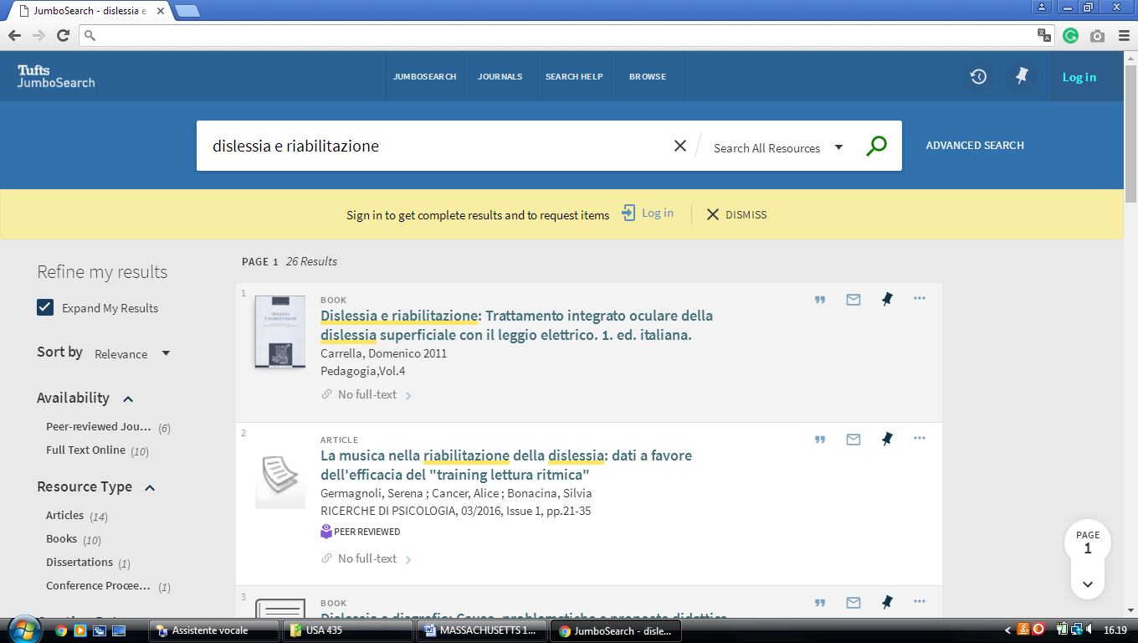

14 TUFTS UNIVERSITY LIBRARIES – (Medford, Massachusetts, Usa)
https://tufts.on.worldcat.org/search?databaseList=&queryString=dislessia+e+riabilitazione
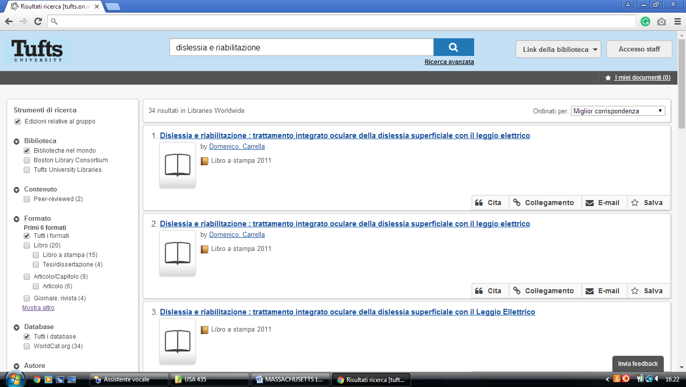

15 UNIVERSITY OF MASS LOWELL LIBRARIES – (Lowell, Massachusetts, Usa)
http://uml.worldcat.org/search?q=kw%3Adislessia+e+riabilitazione&qt=advanced&dblist=2513%2C283

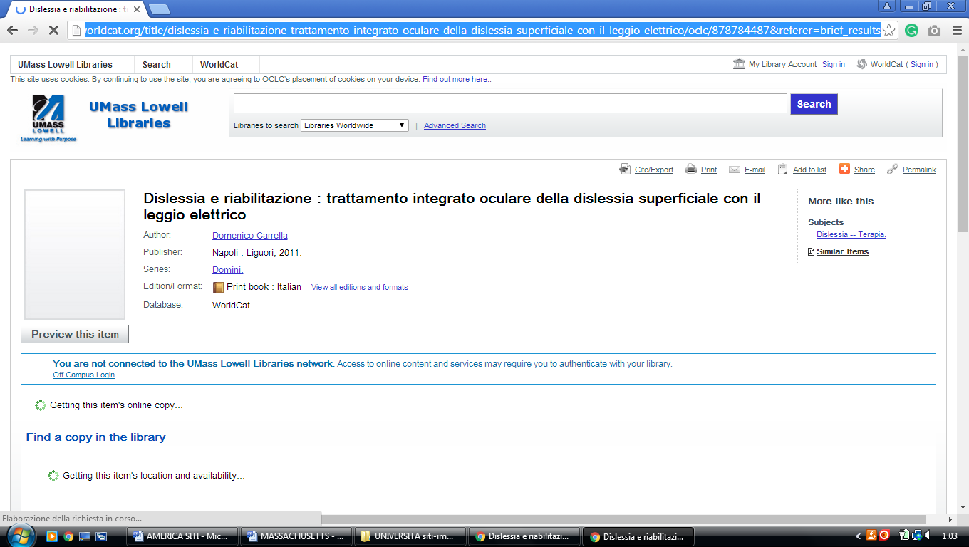

16 WALLACE LIBRARY – (Norton, Massachusetts, Usa)
https://wheatoncollege.on.worldcat.org/search?sortKey=RELEVANCE&databaseList=283&queryString=dislessia+e+riabilitazione&changedFacet=scope&clusterResults=on&stickyFacetsChecked=on&scope=&scope=wz%3A191

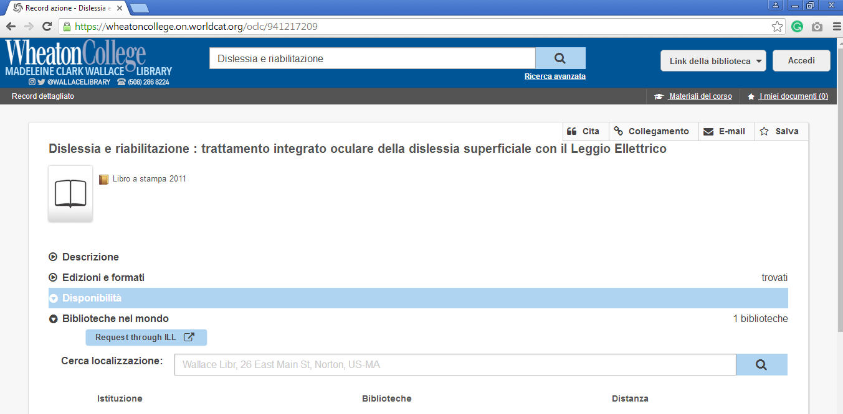

17 WESTFIELD STATE UNIVERSITY ELY LIBRARY – (Westfield, Mass., Usa)
https://westfield.on.worldcat.org/search?queryString=dislessia+e+riabilitazione&format=&scope=

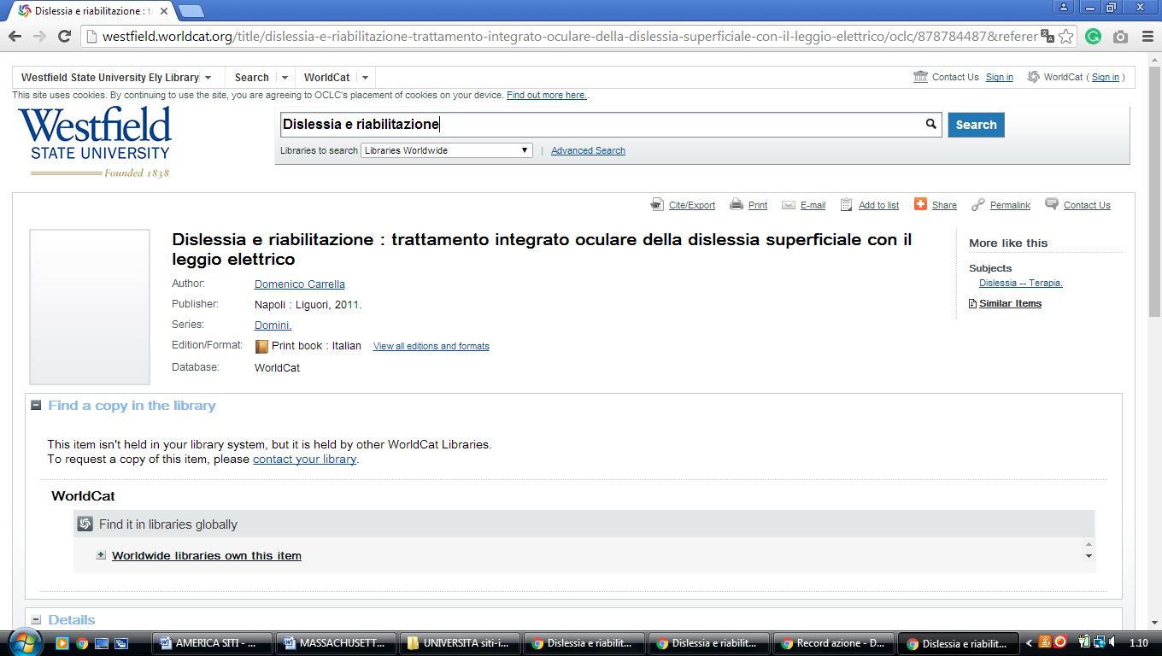

18 BU LIBRARIES | BOSTON UNIVERSITY - (Boston, Usa)
https://buprimo.hosted.exlibrisgroup.com/primo-explore/search?query=any,contains,dislessia%20e%20riabilitazione&tab=worldcat&search_scope=WorldCat&vid=BU&lang=en_US&offset=0

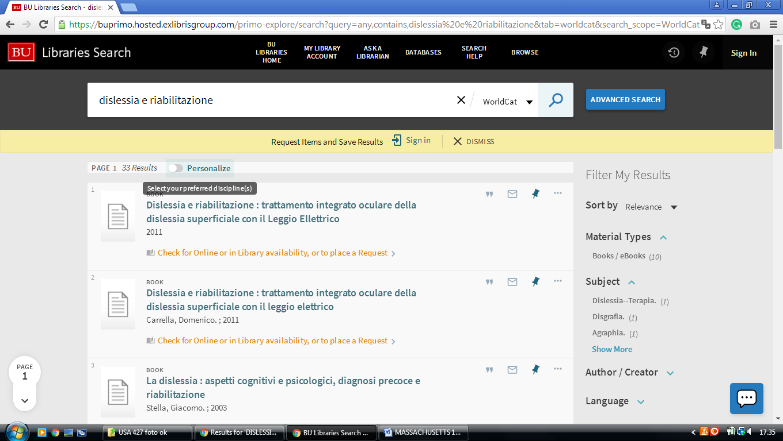

19 FITCHBURG STATE UNIVERSITY LIBRARY - (Fitchburg, Massachusetts, Usa)
https://fitchburgstate.summon.serialssolutions.com/search?utf8=%E2%9C%93&s.q=dislessia+e+riabilitazione#!/search?ho=f&l=en&q=dislessia%20e%20riabilitazione
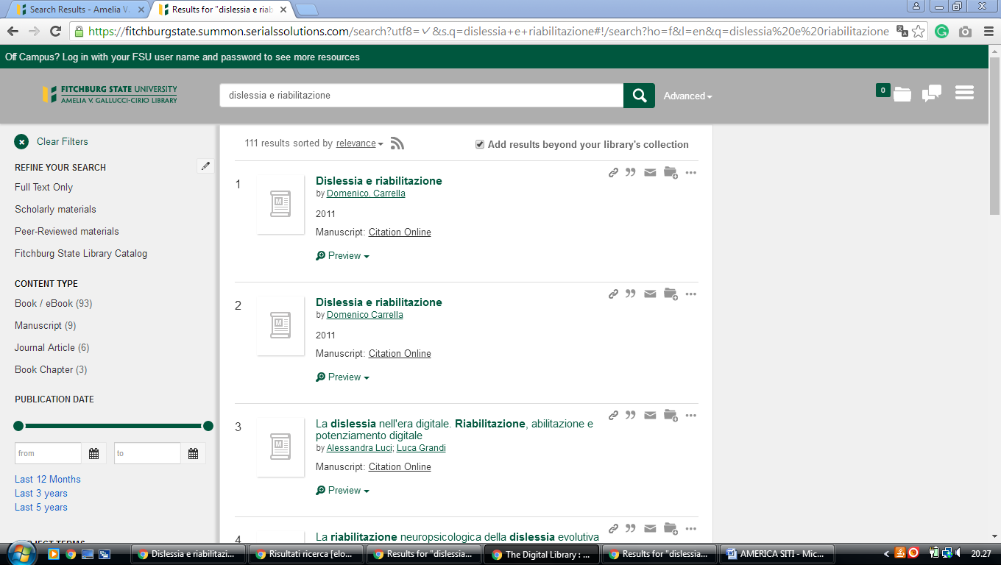

20 JUMBOSEARCH - TISCH LIBRARY - TUFTS UNIVERSITY -
https://tufts-primo.hosted.exlibrisgroup.com/primo-explore/search?query=any,contains,dislessia%20e%20riabilitazione&tab=everything&search_scope=EVERYTHING&sortby=rank&vid=01TUN&lang=en_US&offset=0&pcAvailability=true

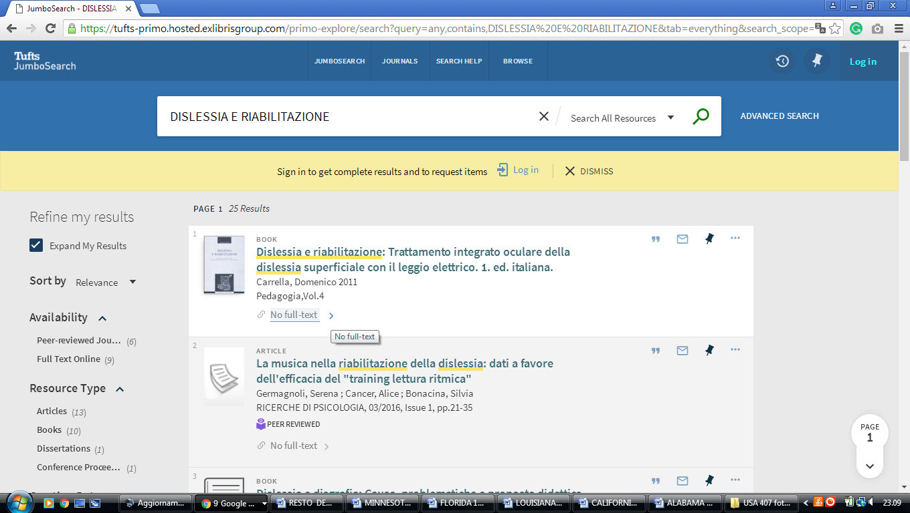

Boston usa
https://buprimo.hosted.exlibrisgroup.com/primo-explore/search?query=any,contains,dislessia%20e%20riabilitazione&tab=worldcat&search_scope=WorldCat&vid=BU&lang=en_US&offset=0
