MICHIGAN = 14

1 OU LIBRARIES - OAKLAND UNIVERSITY - (Rochester, Michigan, Usa)
https://oakland.summon.serialssolutions.com/search?s.q=dislessia+e+riabilitazione#!/search?ho=f&l=en&q=dislessia%20e%20riabilitazione

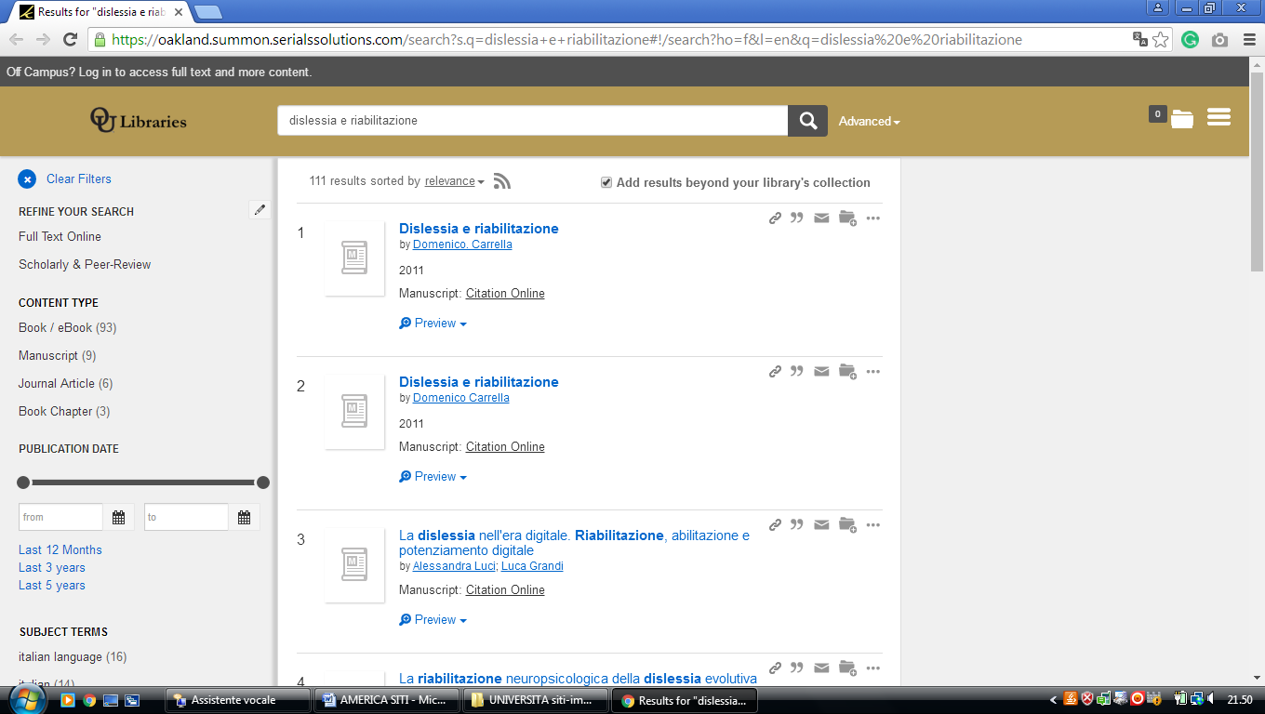

2 MARDIGIAN LIBRARY - (Dearborn, Michigan, Usa)
https://umdearborn.summon.serialssolutions.com/search/results?q=dislessia+e+riabilitazione&spellcheck=true#!/search?ho=f&l=en&q=dislessia%20e%20riabilitazione

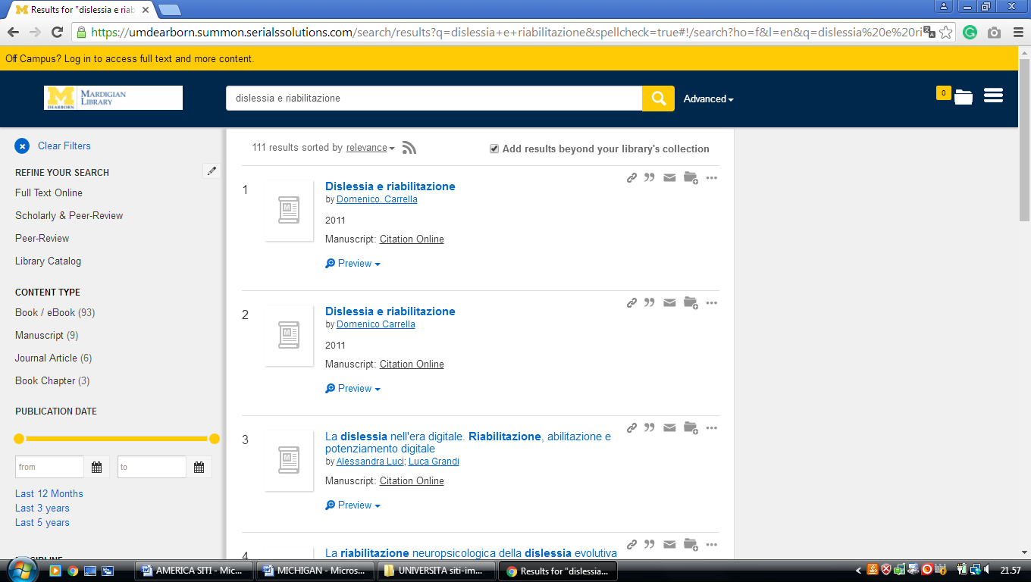

3 MILLER IBRARY - (Grand Rapids, Michigan, Usa)
https://cornerstone.summon.serialssolutions.com/?#!/search?ho=f&fvf=ContentType,Newspaper%20Article,t%7CContentType,Book%20Review,t%7CContentType,Newpaper%20Article,t%7CContentType,Newsletter,t&l=en&q=dislessia%20e%20riabilitazione

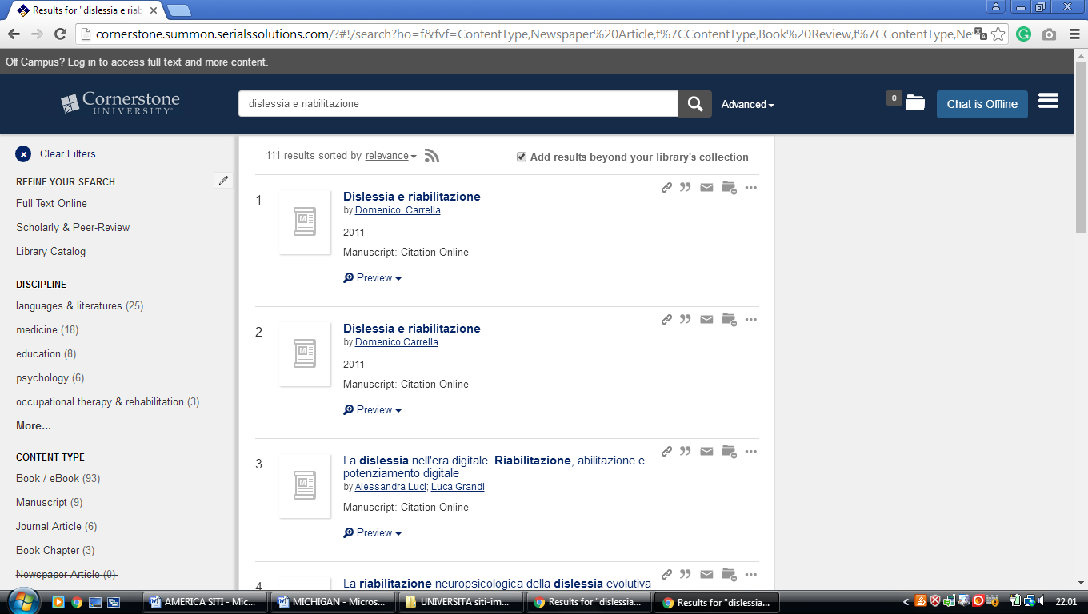

4 EASTERN MICHIGAN UNIVERSITY LIBRARY – (Ypsilanti , Michigan, Usa)
https://emich.summon.serialssolutions.com/search?s.q=dislessia+e+riabilitazione&utf8=%E2%9C%93&s.fvf%5B%5D=ContentType%2CNewspaper+Article%2Ct&spellcheck=true&keep_r=true#!/search?ho=f&fvf=ContentType,Newspaper%20Article,t&l=en&q=dislessia%20e%20riabilitazione

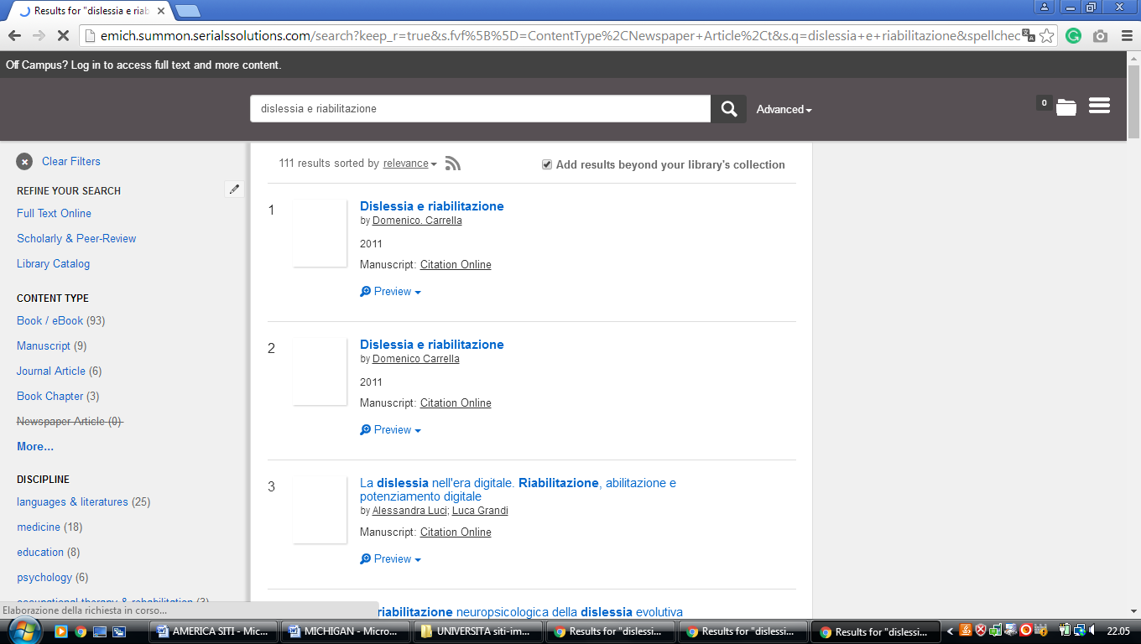

5 GRACE HAUENSTEIN LIBRARY – (Grand Rapids, Michigan, Usa)
https://aquinas.summon.serialssolutions.com/#!/search?ho=f&l=en&q=dislessia%20e%20riabilitazione

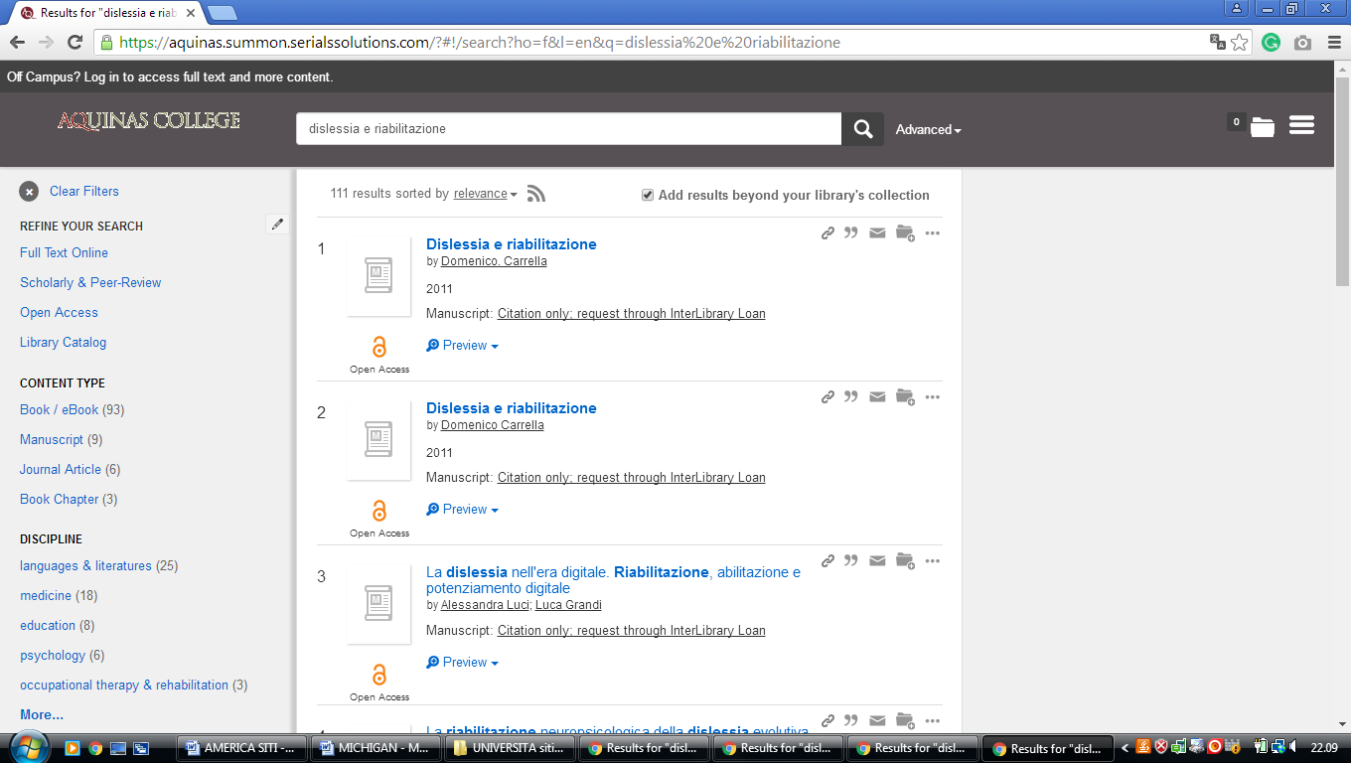

6 GRAND VALLEY STATE UNIVERSITY LIBRARIES - (Allendale, Michigan, Usa)
https://gvsu.summon.serialssolutions.com/search?spellcheck=true&s.q=dislessia+e+riabilitazione#!/search?ho=f&l=en&q=dislessia%20e%20riabilitazione

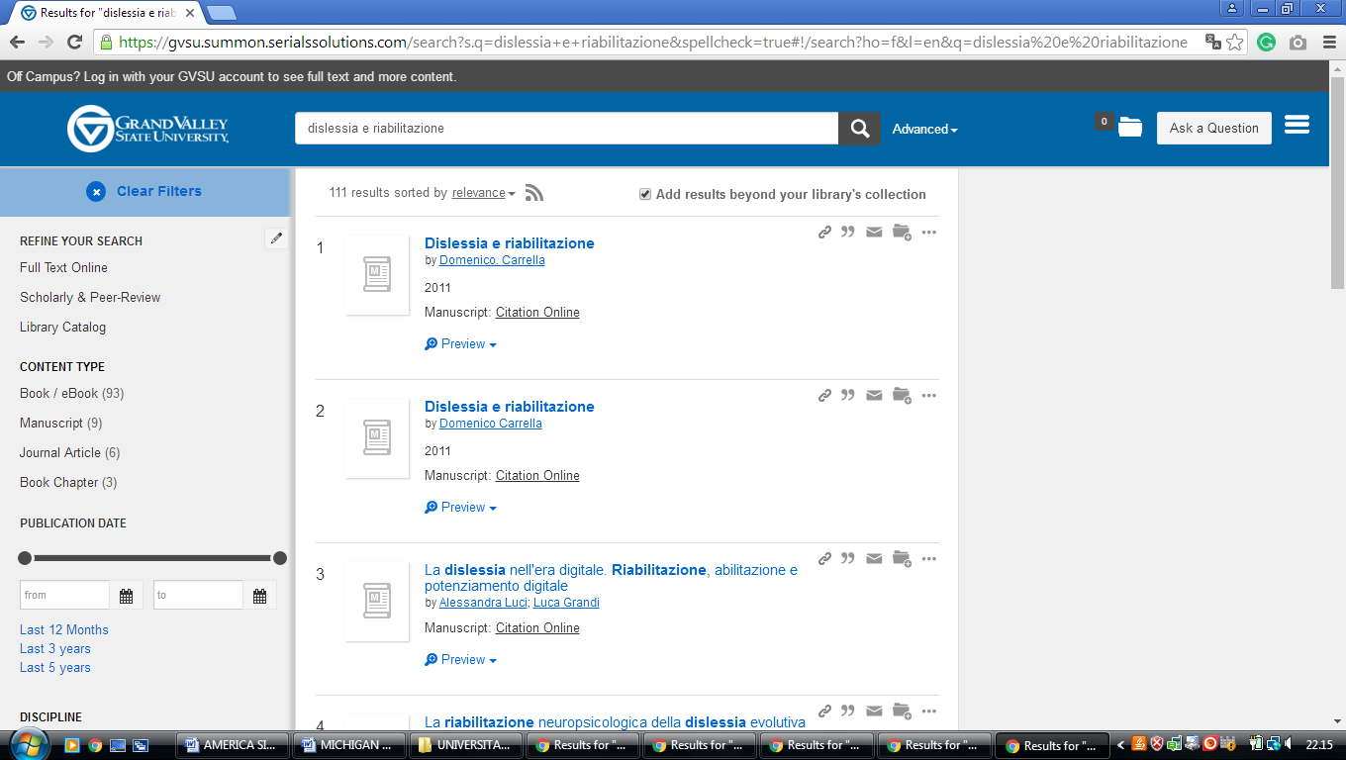

7 HFCC ESHLEMAN LIBRARY – (Dearborn, Michigan, Usa)
https://hfcc.summon.serialssolutions.com/#!/search?ho=f&l=en&q=dislessia%20e%20riabilitazione

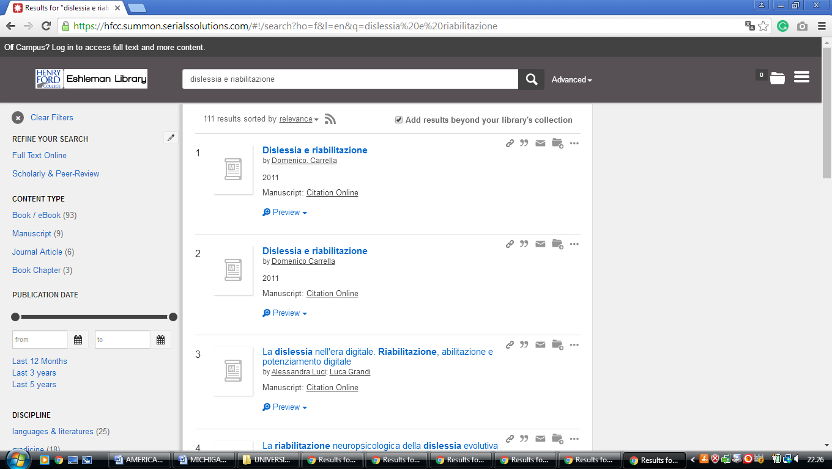

8 LAWRENCE TECH LIBRARY – (Southfield, Michigan, Usa)
https://ltu.on.worldcat.org/search?queryString=dislessia+e+riabilitazione

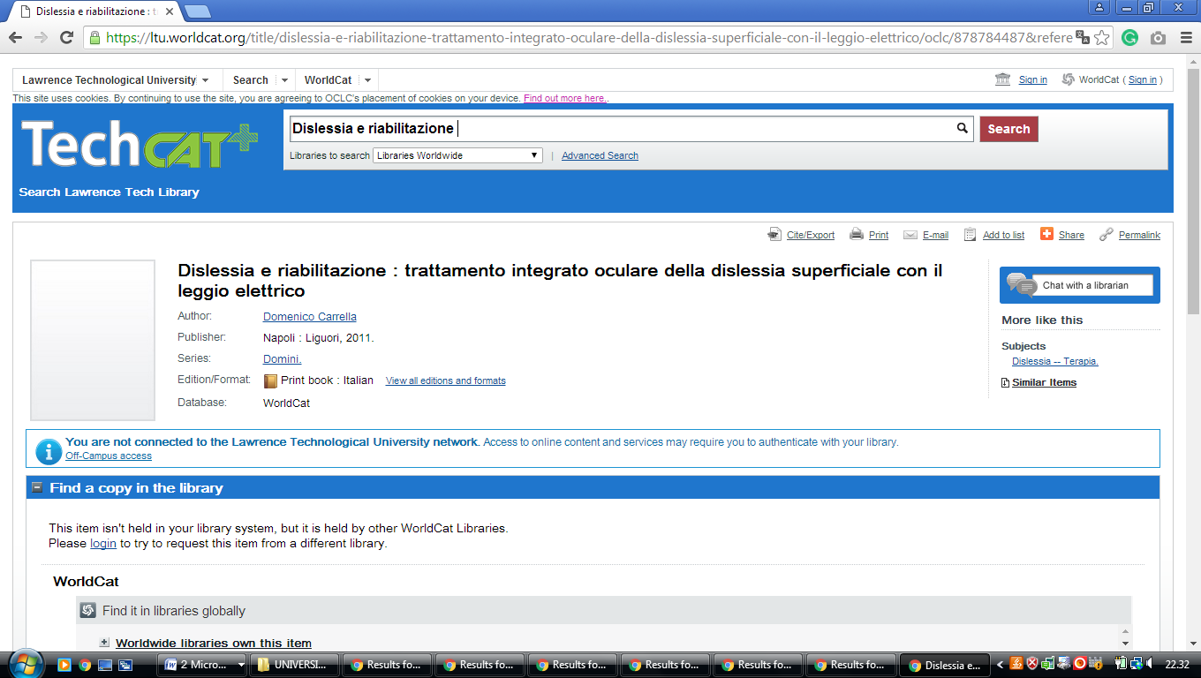

9 LYDIA M. OLSON LIBRARY - (Marquette, Michigan, Usa)
https://nmu.summon.serialssolutions.com/search?q=dislessia+e+riabilitazione#!/search?ho=f&l=en&q=dislessia%20e%20riabilitazione

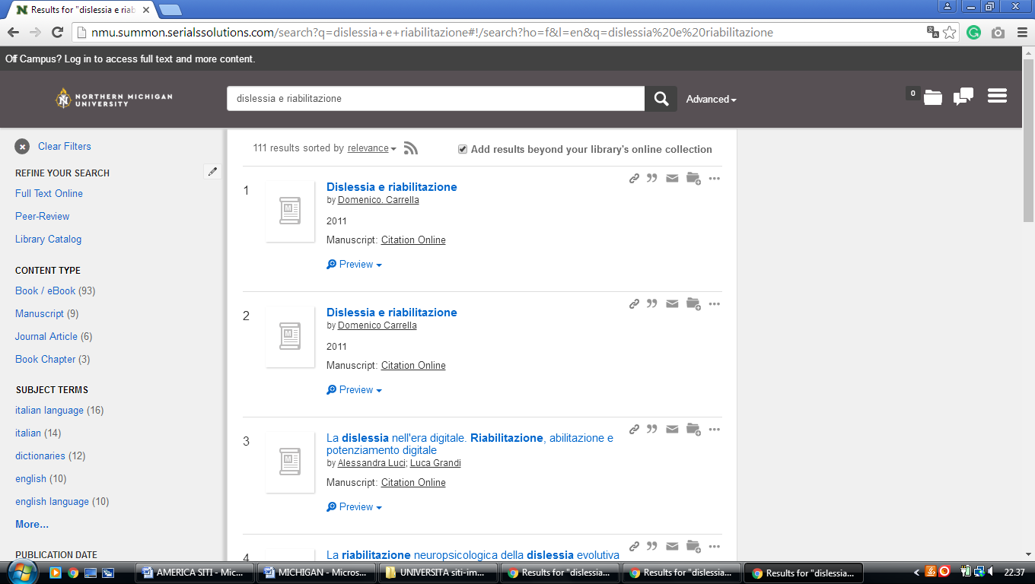

10 MICHIGAN STATE UNIVERSITY LIBRARIES – (East Lansing, Michigan, Usa)
http://msulibraries.summon.serialssolutions.com/advanced#!/search?ho=f&l=en&q=(dislessia%20e%20riabilitazione)

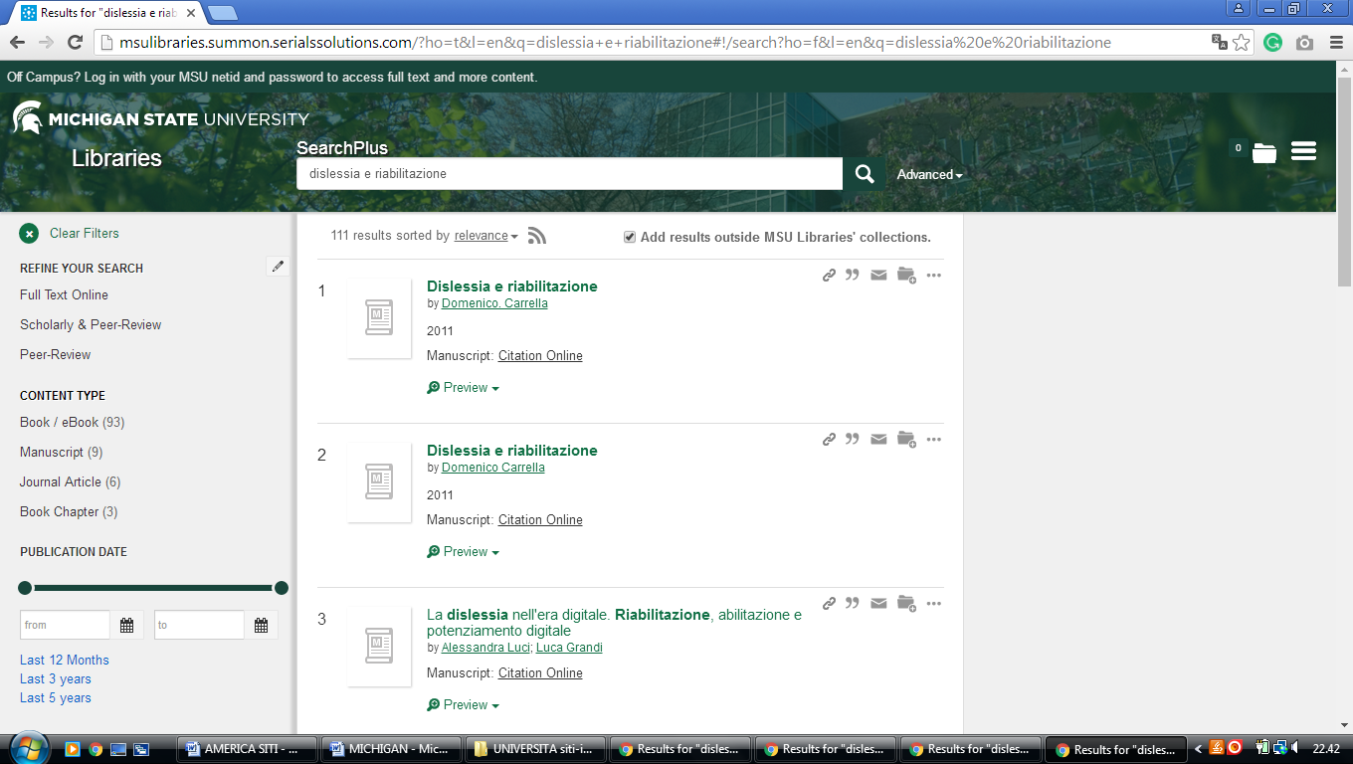

11 STOCKWELL-MUDD LIBRARY – (Albion, Michigan, Usa)
http://albion.summon.serialssolutions.com/?#!/search?ho=f&l=en&q=dislessia%20e%20riabilitazione

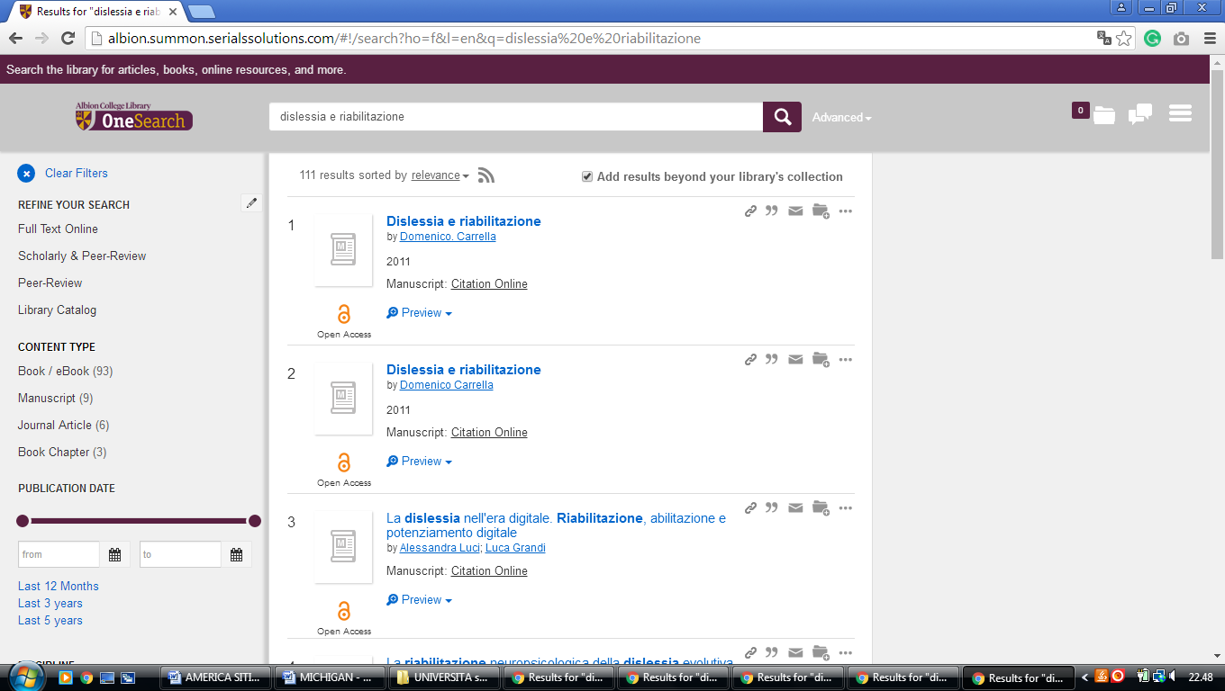

12 WESTERN MICHIGAN UNIVERSITY LIBRARIES – (Kalamazoo, Michigan, Usa)
https://primo-pmtna01.hosted.exlibrisgroup.com/primo-explore/search?vid=01WMU&search_scope=EVERYTHING&tab=default_tab&query=any,contains,dislessia%20e%20riabilitazione&offset=1&sortby=rank&lang=en_US&pcAvailability=true

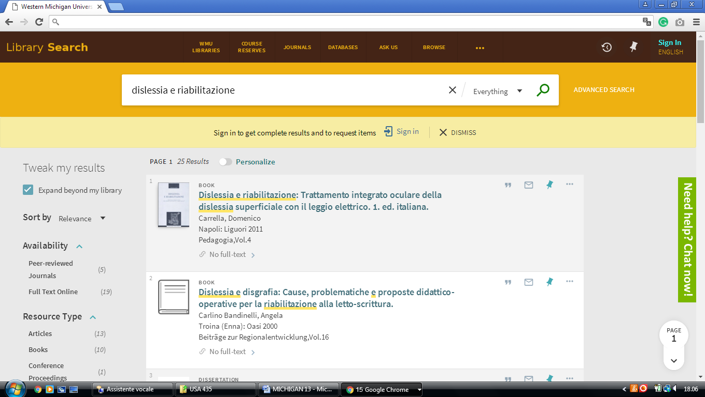

13 EASTERN MICHIGAN UNIVERSITYLIBRARY – (Ypsilanti, Michigan, Usa)
https://emich.summon.serialssolutions.com/search?s.q=dislessia+e+riabilitazione&utf8=%E2%9C%93&s.fvf%5B%5D=ContentType%2CNewspaper+Article%2Ct&spellcheck=true&keep_r=true#!/search?ho=f&fvf=ContentType,Newspaper%20Article,t&l=en&q=dislessia%20e%20riabilitazione

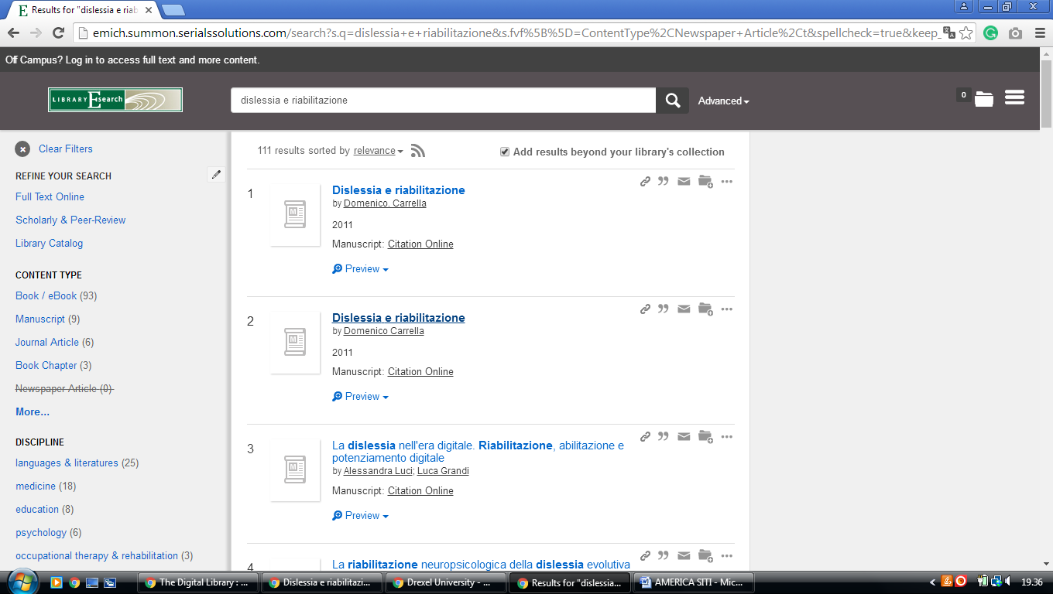

14 HOMEPAGE | U-M LIBRARY - UNIVERSITY OF MICHIGAN - (Ann Arbor, Michigan)
https://search.lib.umich.edu/articles?query=dislessia+e+riabilitazione&filter.holdings_only=false
