MINNESOTA = 14

1 LIBRARY · CONCORDIA COLLEGE – (Moorhead, Minnesota, Usa)
https://cord.on.worldcat.org/search?sortKey=LIBRARY&databaseList=&queryString=dislessia+e+riabilitazione&changedFacet=author&scope=&format=all&database=all&author=Carrella%2C+Domenico&year=all&yearFrom=&yearTo=&language=all&topic=all

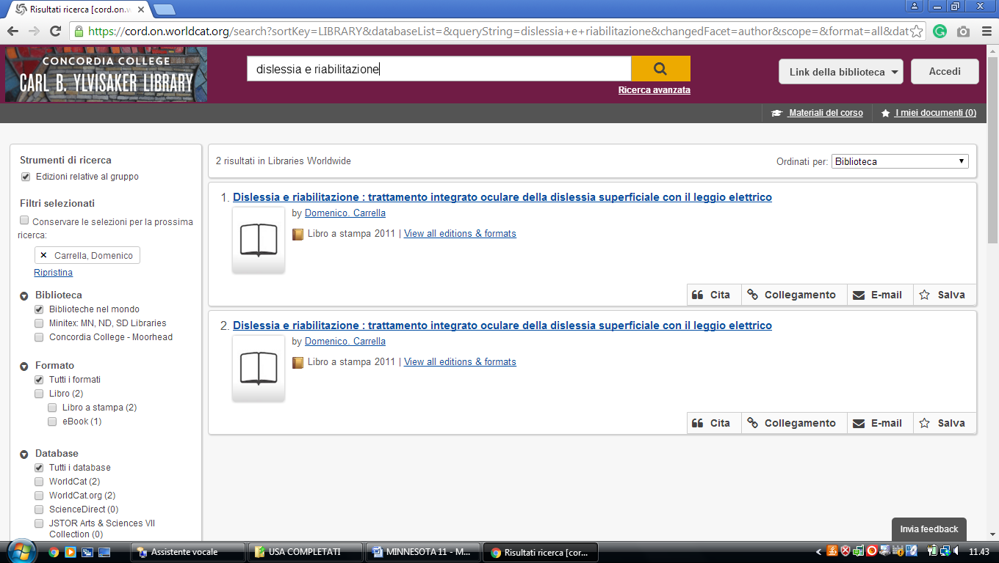

2 ST. CATHERINE UNIVERSITY LIBRARIES, MEDIA SERVICES, & ARCHIVES ... (st. Paul, Minnesota, Usa)
https://clicsearch.stkate.edu/primo-explore/search?query=any,contains,dislessia%20e%20riabilitazione&tab=default_tab&search_scope=stkate&vid=STKATE&mode=Basic&sortby=rank&pcAvailability=true

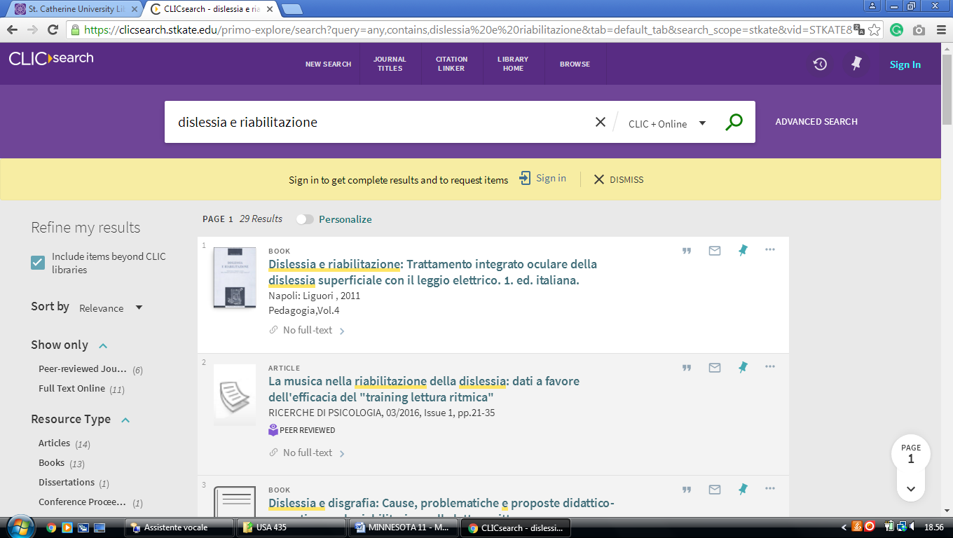

3 DEWITT WALLACE LIBRARY - MACALESTER COLLEGE - (St. Paul, Minnesota, Usa)
https://macalester.on.worldcat.org/search?sortKey=LIBRARY&databaseList=&queryString=dislessia+e+riabilitazione&changedFacet=author&scope=&format=all&database=all&author=Carrella%2C+Domenico&year=all&yearFrom=&yearTo=&language=all&topic=all
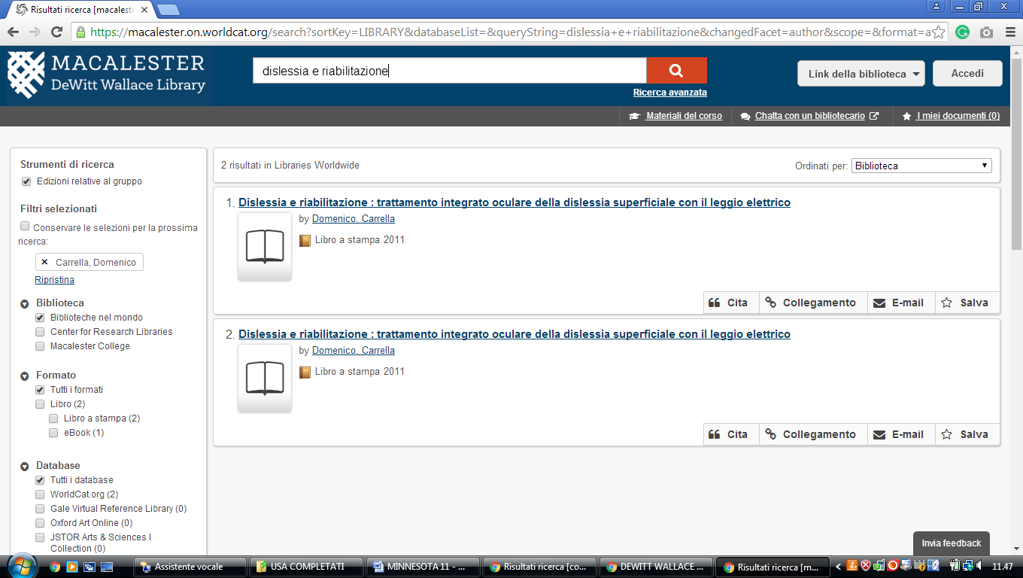

4 GOULD LIBRARY NORTHFIELD – (Minnesota, Usa)
https://carleton-primo.hosted.exlibrisgroup.com/primo-explore/search?vid=01BRC_CCO&tab=default_tab&search_scope=Everything&offset=0&query=any,contains,dislessia%20e%20riabilitazione&sortby=rank&pcAvailability=true

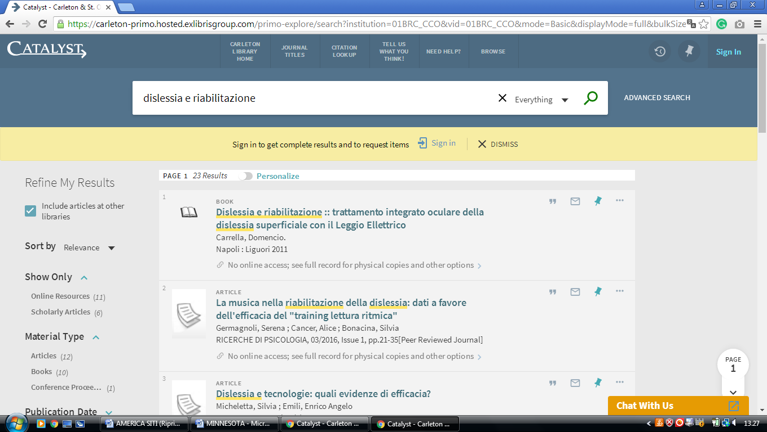

5 LINDELL LIBRARY - (Minneapolis, Minnesota, Usa)
https://augsburg.on.worldcat.org/search?sortKey=BEST_MATCH&databaseList=&queryString=dislessia+e+riabilitazione&changedFacet=scope&clusterResults=on&stickyFacetsChecked=on&scope=&scope=sz%3A37159
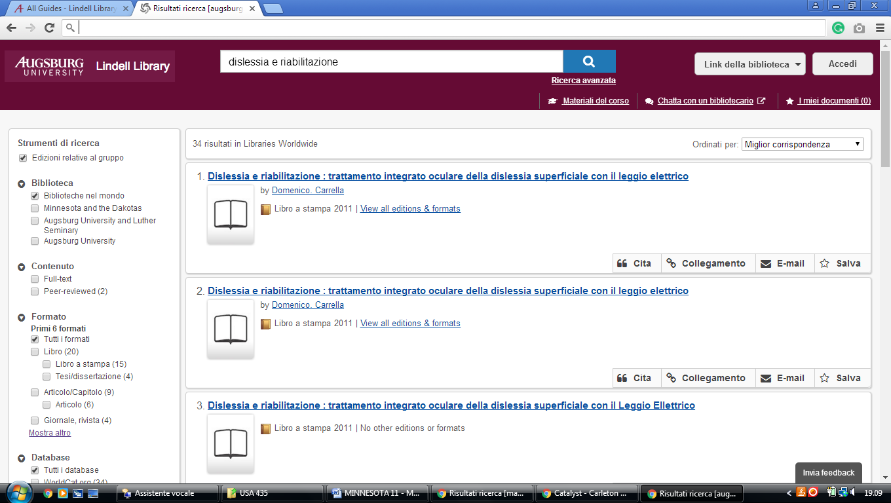

6 LIBRARY - LUTHER SEMINARY – (St. Paul, Minnesota, Usa)
https://luthersem.on.worldcat.org/search?sortKey=LIBRARY&databaseList=638&queryString=dislessia+e+riabilitazione&changedFacet=author&scope=&format=all&database=all&author=Carrella%2C+Domenico&year=all&yearFrom=&yearTo=&language=all&topic=all
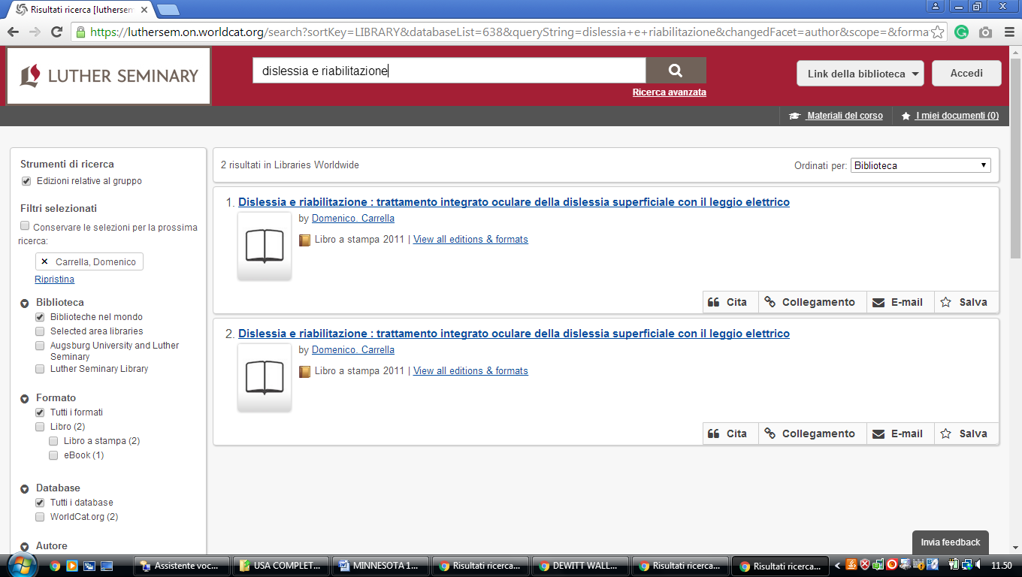

7 MNLINK
https://mnlink.on.worldcat.org/search?sortKey=BEST_MATCH&databaseList=&queryString=dislessia+e+riabilitazione&changedFacet=scope&scope=&format=all&database=all&author=all&year=all&yearFrom=&yearTo=&language=all
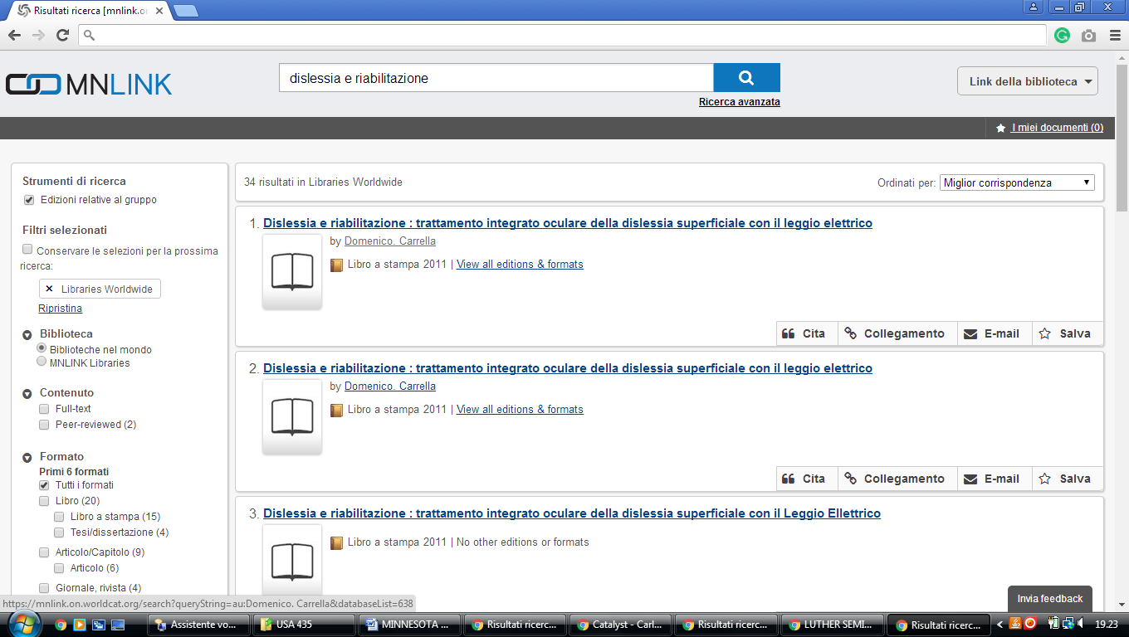

8 MINNESOTA STATE UNIVERSITY LIBRARY – (Mankato, Minnesota, Usa)
http://mnsu.summon.serialssolutions.com/?s.q=dislessia+e+riabilitazione#!/search?ho=f&l=en&q=dislessia%20e%20riabilitazione

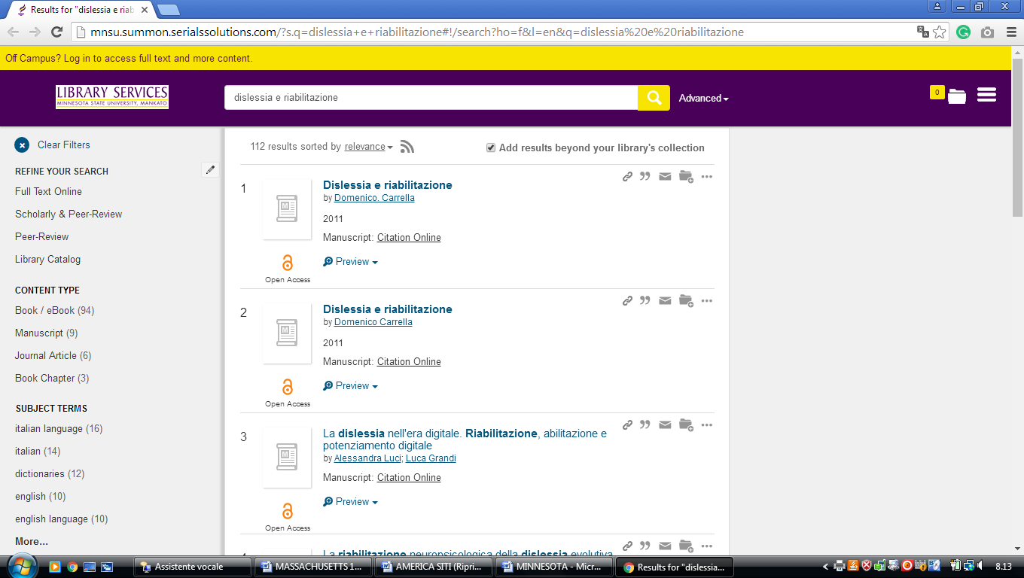

9 LIBRARY – MINNESOTA STATE UNIVERSITY, MANKATO – (Mankato, Minnesota, Usa)
https://minnesotastateuniversity-mankato.on.worldcat.org/search?databaseList=&queryString=dislessia+e+riabilitazione
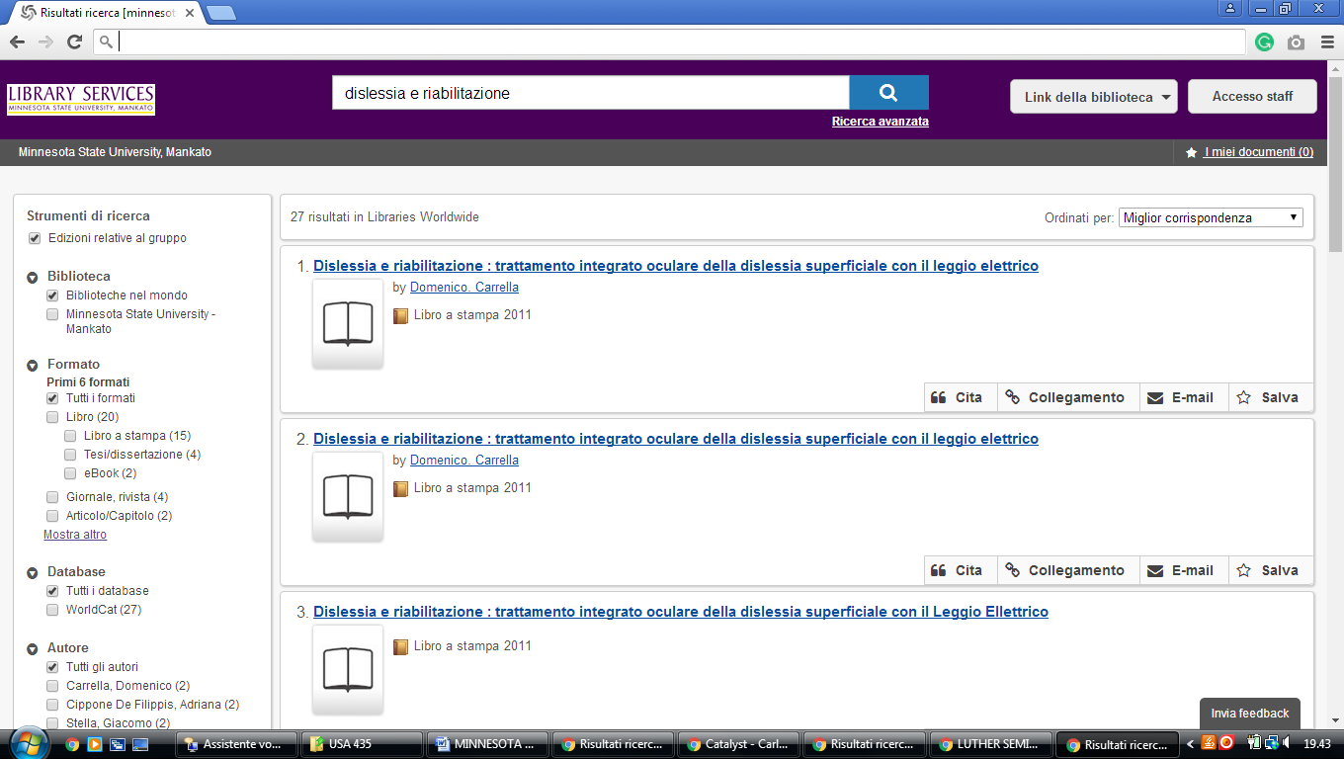

10 ST. OLAF COLLEGE LIBRARIES - (Northfield, Minnesota, Usa)
https://stolaf-primo.hosted.exlibrisgroup.com/primo-explore/search?vid=01BRC_SOC&tab=default_tab&search_scope=Everything&offset=0&query=any,contains,dislessia%20e%20riabilitazione&sortby=rank&pcAvailability=true
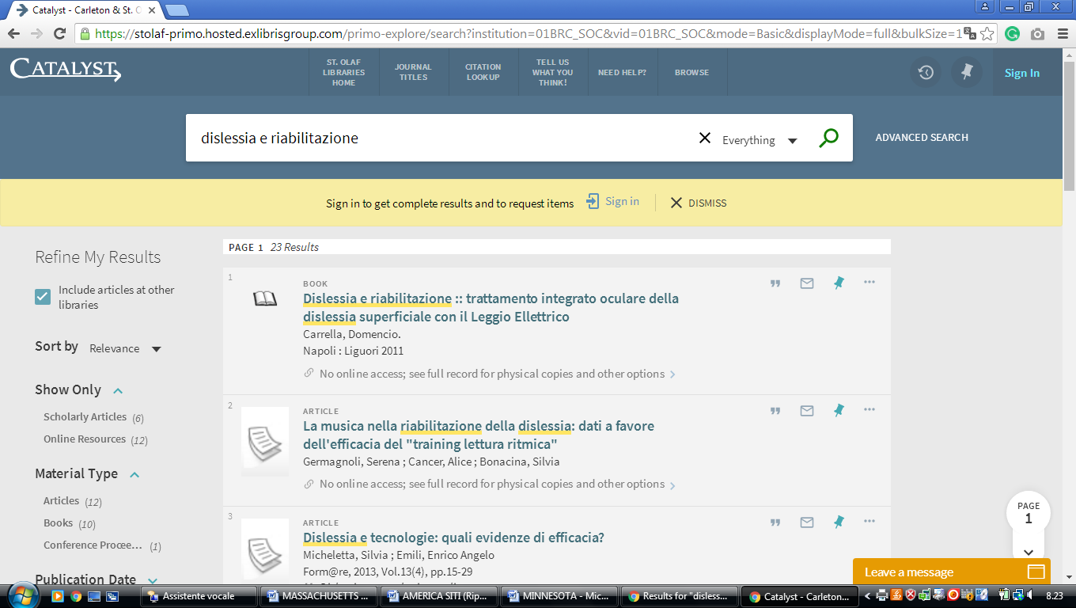

11 CROWN COLLEGE LIBRARY – ( st. Bonifacius, Minnesota, Usa)

https://crownlibrary.on.worldcat.org/external-search?queryString=dislessia+e+riabilitazione

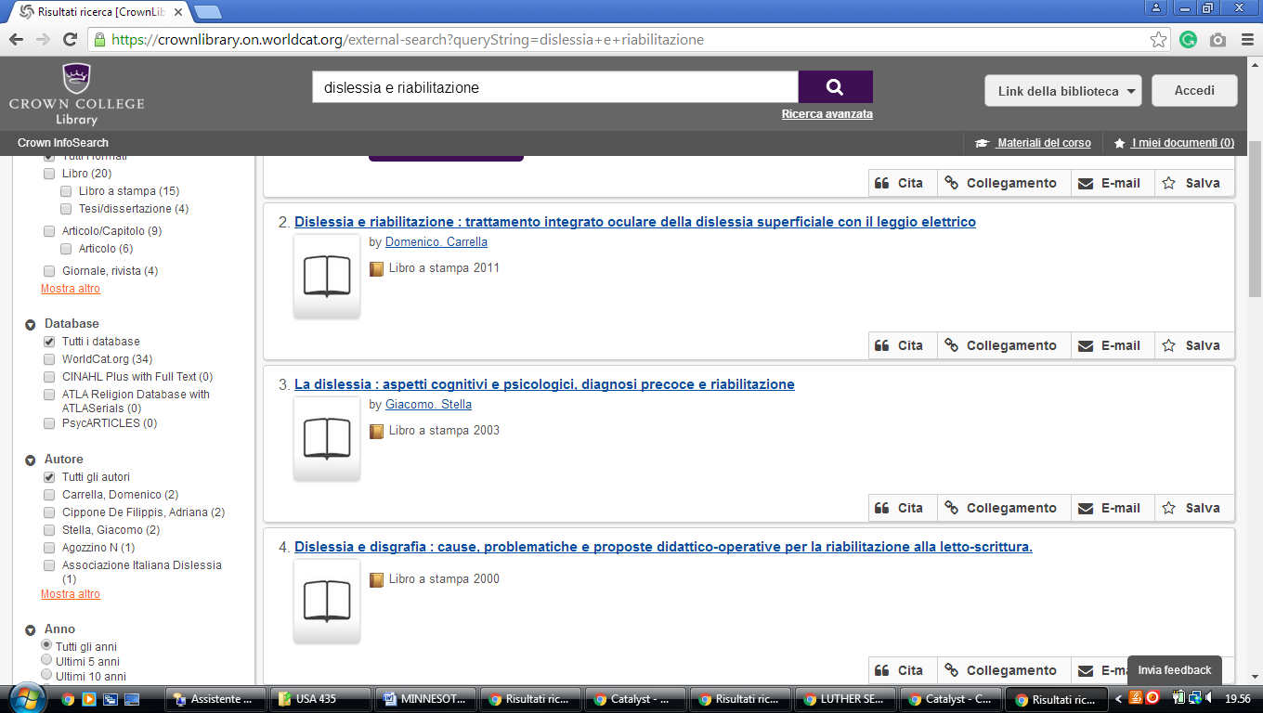

12 LIBRARIES – UNIVERSITY LIBRARIES – UNIVERSITY OF ST. THOMAS – MINNESOTA

12 CLICSEARCH - CLIC

https://clicsearch.bethel.edu/primo-explore/search?query=any,contains,dislessia%20e%20riabilitazione&tab=default_tab&search_scope=bethel&vid=BETHEL&offset=0&sortby=rank&pcAvailability=true

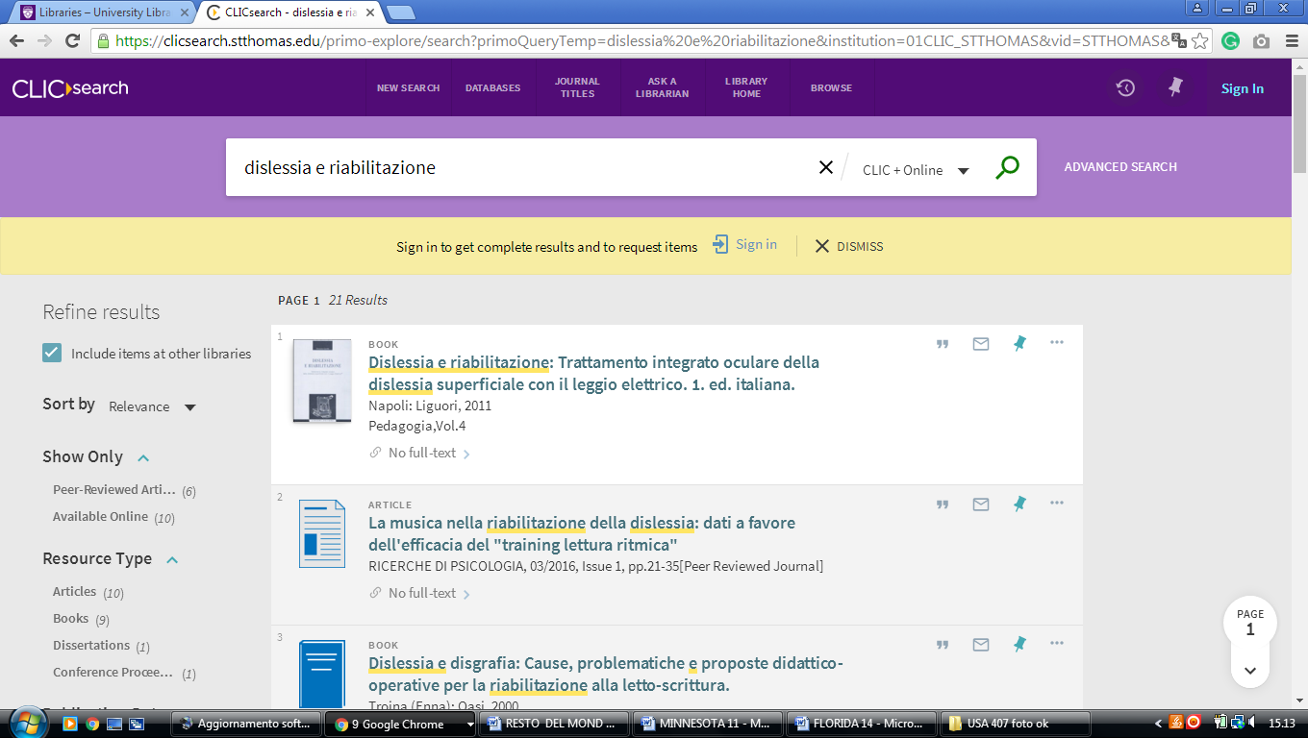

13 LIBRARY - GUSTAVUS ADOLPHUS COLLEGE - (St.Peter, Minnesota, Usa)
https://gustavusadolphuscollege.on.worldcat.org/search?sortKey=LIBRARY&databaseList=&queryString=kw%3Adislessia+e+riabilitazione&changedFacet=scope&clusterResults=on&scope=&scope=wz%3A1052
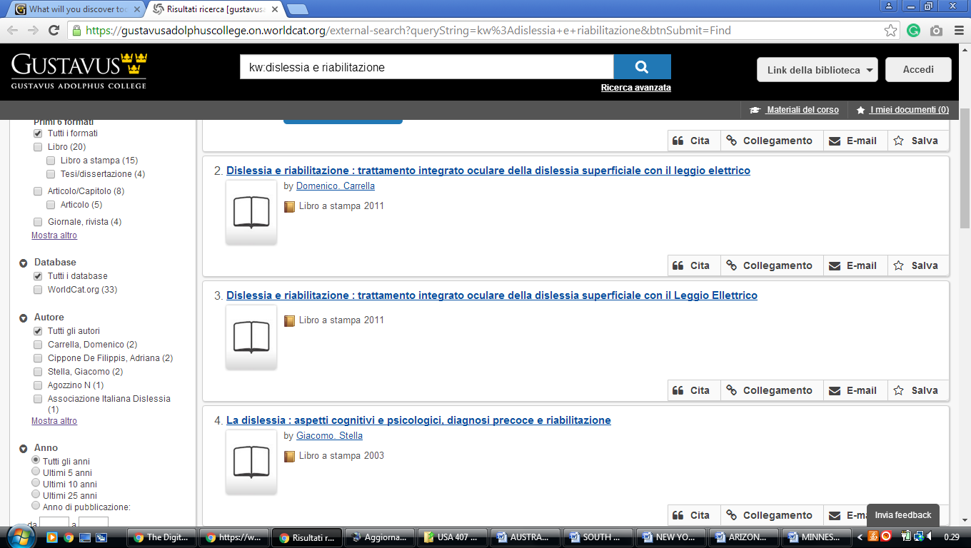

14 CLICSEARCH – UNIVERSITY LIBRARIES - UNIVERSITY OF ST. THOMAS -
(Minneapolis, Minnesota, Usa)
https://clicsearch.stthomas.edu/primo-explore/search?query=any,contains,dislessia%20e%20riabilitazione&tab=default_tab&search_scope=stthomas&vid=STTHOMAS&offset=0&sortby=rank&pcAvailability=true

