MISSUORI = 9

1 PICKLER MEMORIAL LIBRARY – (Kirksville, Missouri, Usa)
http://truman.summon.serialssolutions.com/search?s.q=dislessia+e+riabilitazione&s.fvf%5B%5D=ContentType%2CBook+Review%2Ct&spellcheck=true#!/search?ho=f&fvf=ContentType,Book%20Review,t&l=en&q=dislessia%20e%20riabilitazione

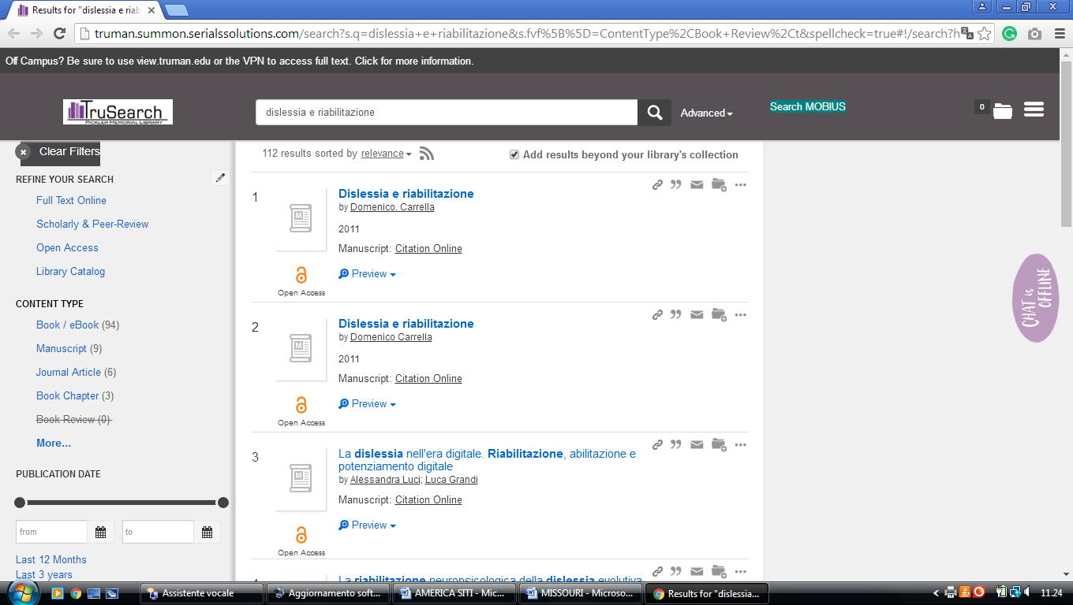

2 CURTIS LAWS WILSON LIBRARY – (Rolla, Missouri, USA)
http://mst.summon.serialssolutions.com/search?s.fvf%5B%5D=ContentType%2CNewspaper+Article%2Ct&keep_r=true&s.q=dislessia+e+riabilitazione#!/search?ho=f&fvf=ContentType,Newspaper%20Article,t&l=en&q=dislessia%20e%20riabilitazione

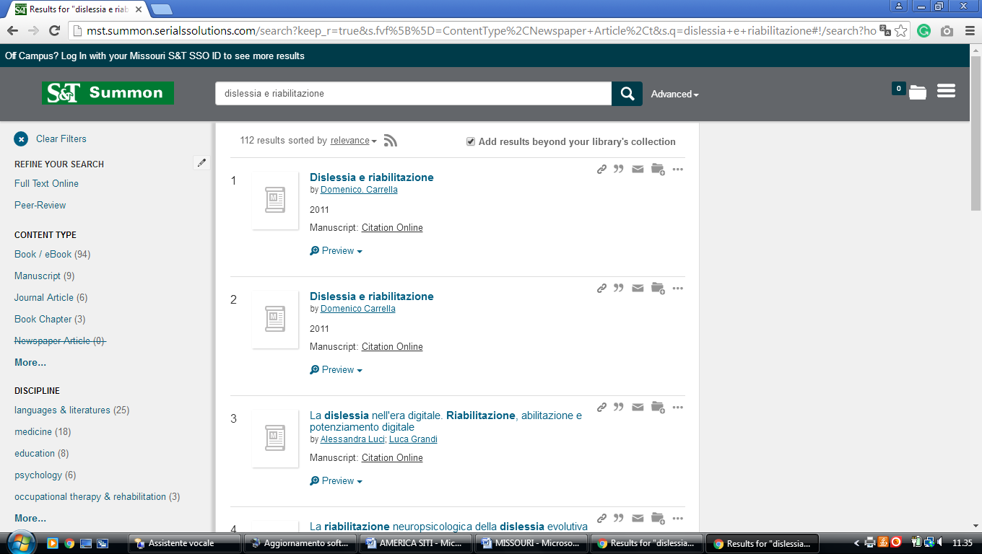

3 LINDENWOOD LIBRARY | LINDENWOOD UNIVERSITY - (St. Charles, Missouri, Usa)
http://lindenwood.summon.serialssolutions.com/?#!/search?ho=f&l=en&q=dislessia%20e%20riabilitazione

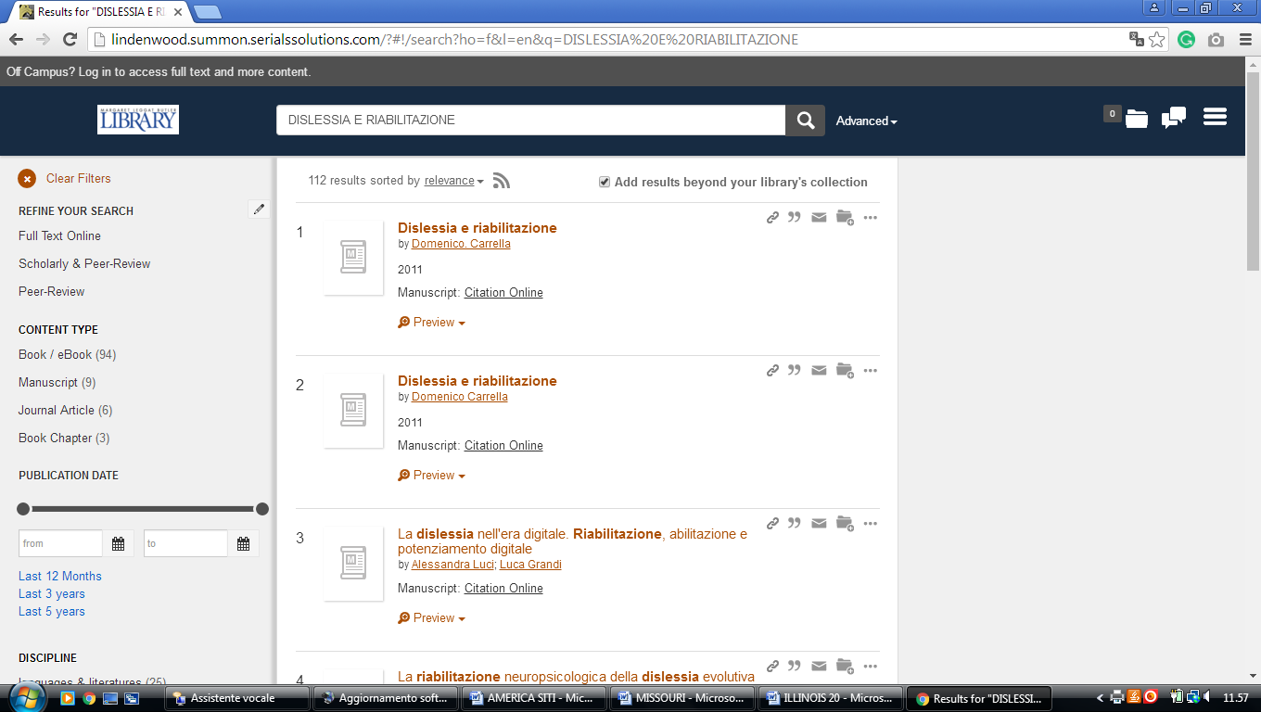

4 MIDWESTERN BAPTIST THEOLOGICAL SEMINARY LIBRARY - (KC, MISSUORI, Usa)
http://eds.a.ebscohost.com/eds/results?vid=3&sid=63b5e13c-8563-4d8e-8ffb-c002c1e31a28%40sessionmgr4009&bquery=(dislessia+AND+e+AND+riabilitazione)&bdata=JkF1dGhUeXBlPWlwLHVybCxjcGlkJmN1c3RpZD1zODM4NTA4MCZ0eXBlPTAmc2l0ZT1lZHMtbGl2ZQ%3d%3d

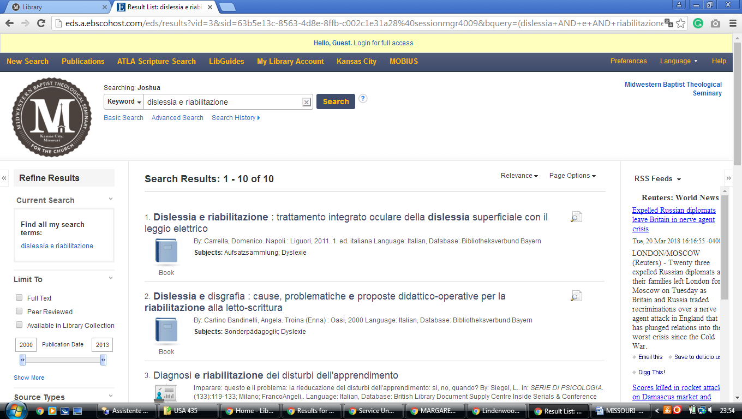

5 LIBRARY HOURS - JAMES C. KIRKPATRICK LIBRARY - UNIVERSITY OF CENTRAL ...(Warrensburg, Missouri, Usa)
http://ucmo.summon.serialssolutions.com/search?q=dislessia%20e%20riabilitazione&s.q=dislessia+e%20riabilitazione#!/search?ho=f&l=en&q=dislessia%20e%20riabilitazione
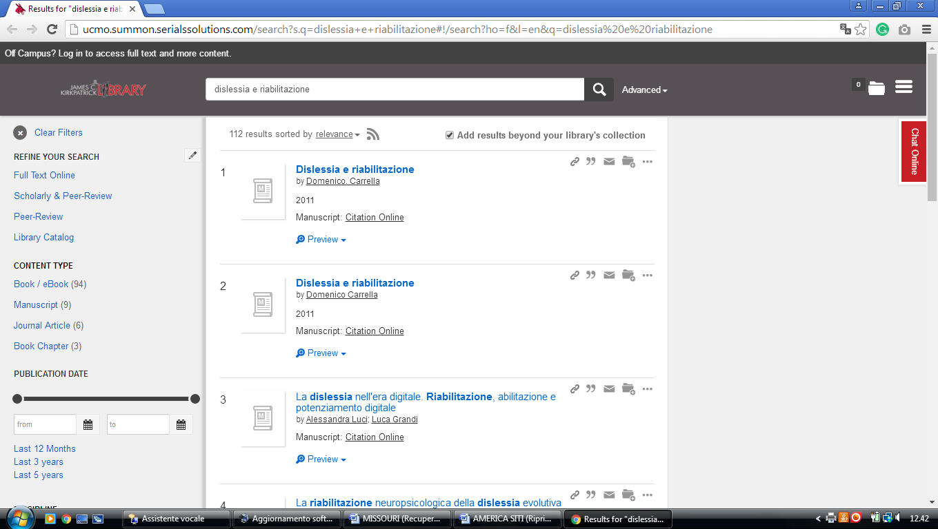

6 MILLER NICHOLS LIBRARY - UMKC LIBRARIES - UNIVERSITY OF MISSOURI ...- (Missouri, Usa)
https://umkc.summon.serialssolutions.com/?q=dislessia+e+riabilitazione&op=Submit&form_build_id=form-ACsBFfOMjmQnk52adMvsUkRfW1J8hZXOXkC8ABAAxB0&form_id=get_home_search_form#!/search?ho=f&l=it-IT&q=dislessia%20e%20riabilitazione&op=Submit&form_build_id=form-ACsBFfOMjmQnk52adMvsUkRfW1J8hZXOXkC8ABAAxB0&form_id=get_home_search_form
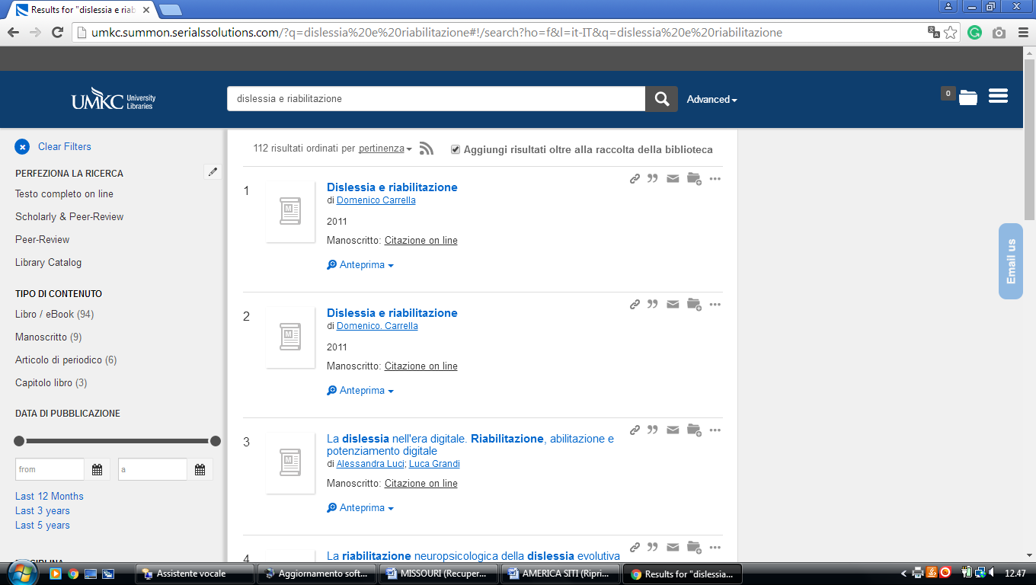

7 UNIVERSITY OF MISSOURI-KANSAS CITY LEON E. BLOCH LAW LIBRARY
https://umkc.summon.serialssolutions.com/?q=dislessia%20e%20riabilitazione&fvf=Discipline,law,f#!/search?ho=f&l=it-IT&q=dislessia%20e%20riabilitazione

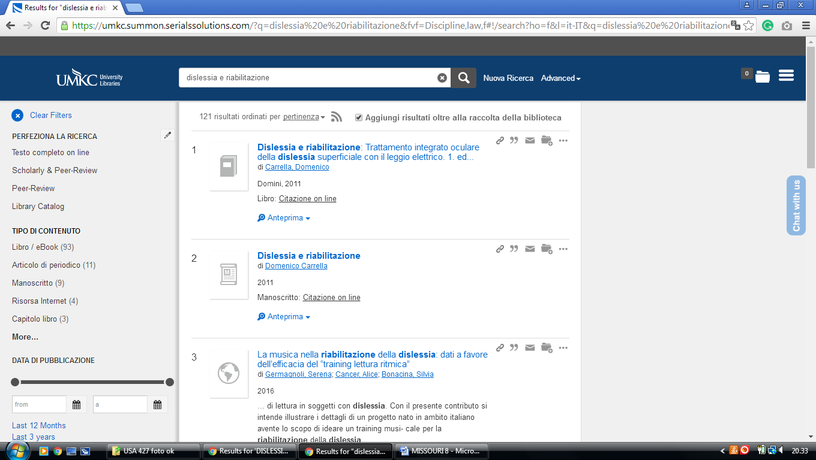

8 UNIVERSITY OF MISSOURI - ST. LOUIS, LIBRARY – (Missouri, Usa)
http://umsl.summon.serialssolutions.com/?q=dislessia+e+riabilitazione#!/search?ho=f&l=en&q=dislessia%20e%20riabilitazione
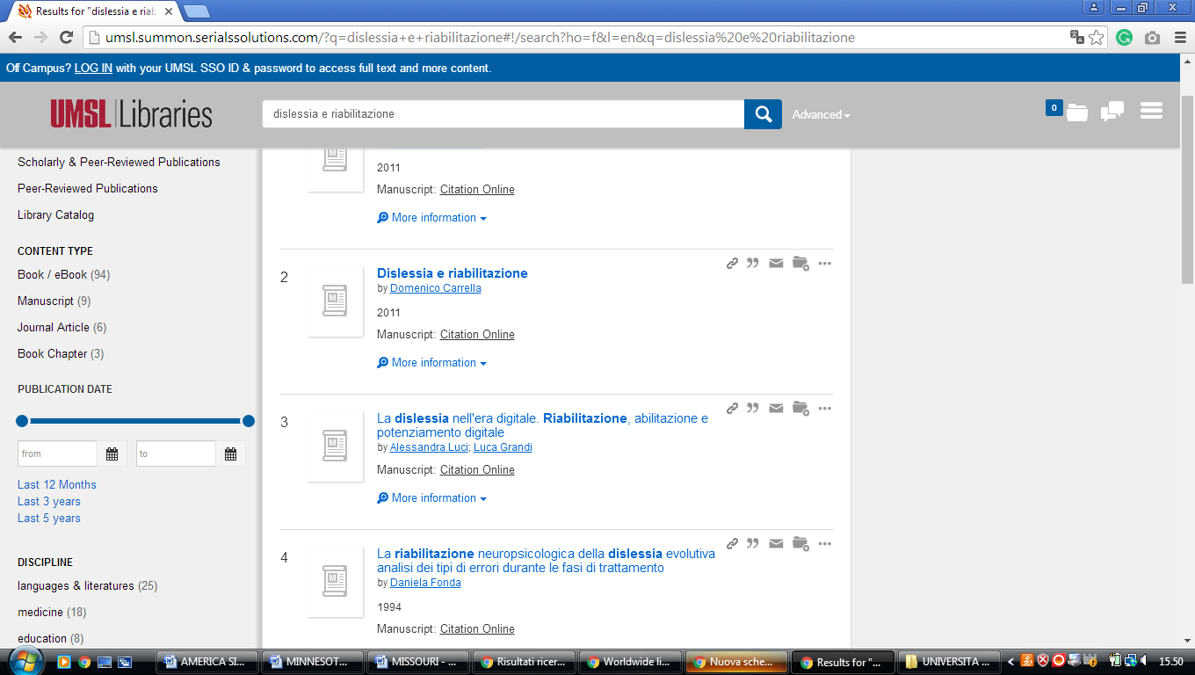

9 MILLER NICHOLS LIBRARY | UNIVERSITY LIBRARIES - (St. Kansas City, Mo, Usa)
https://umkc.summon.serialssolutions.com/?q=dislessia+e+riabilitazione&op=Submit&form_build_id=form-Bex82iE2i661sd24zLN5t0yQ764RDC-pmzn8BS3oFoQ&form_id=get_home_search_form#!/search?ho=f&l=it-IT&q=dislessia%20e%20riabilitazione&op=Submit&form_build_id=form-Bex82iE2i661sd24zLN5t0yQ764RDC-pmzn8BS3oFoQ&form_id=get_home_search_form

