MONTANA = 3

1 MONTANA STATE UNIVERSITY BILLINGS LIBRARY – (Billings, Montana, Usa)
https://msub-primo.hosted.exlibrisgroup.com/primo_library/libweb/action/search.do?ct=facet&pcAvailabiltyMode=true&pcAvailClicked=true&vid=01TRAILS_MSU_BILLINGS&fn=search&indx=1&dscnt=0&vl(freeText0)=dislessia%20e%20riabilitazione&dstmp=1521589849053

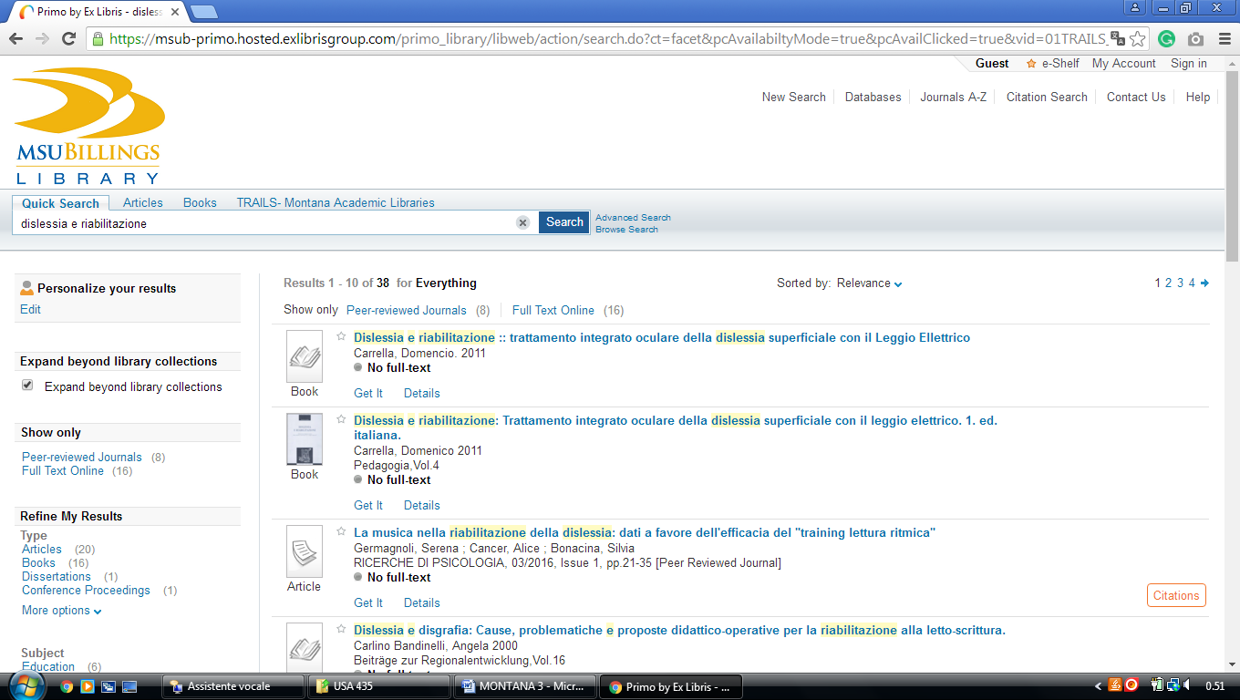

2 MONTANA TECH LIBRARY – (Butte, Montana, Usa)
https://mtech-primo.hosted.exlibrisgroup.com/primo-explore/search?institution=01TRAILS_UM_MTECH&vid=01TRAILS_UM_MTECH&tab=default_tab&search_scope=ALL-01TRAILS_UM_MTECH&query=any,contains,%20dislessia%20e%20riabilitazione&queryTemp=%20dislessia%20e%20riabilitazione&sortby=rank&lang=en_US&pcAvailability=true

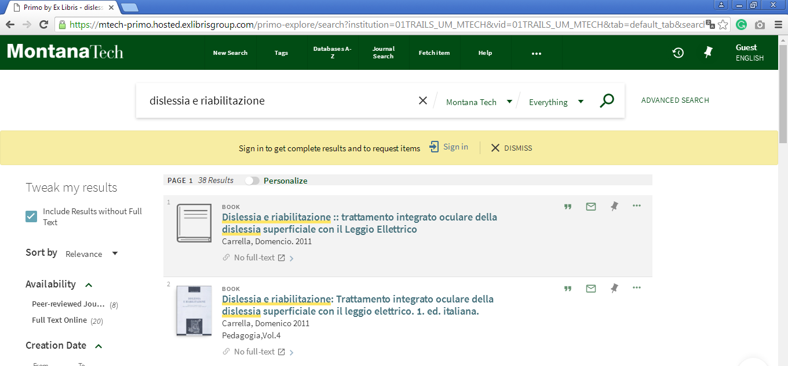

3 NORTHERN VANDE BOGART LIBRARY – (Havre, Montana, Usa)
https://msun-primo.hosted.exlibrisgroup.com/primo-explore/search?institution=01TRAILS_MSU_NORTH&vid=01TRAILS_MSU_NORTH&tab=default_tab&query=any,contains,%20dislessia%20e%20riabilitazione&queryTemp=%20dislessia%20e%20riabilitazione&sortby=rank&lang=en_US

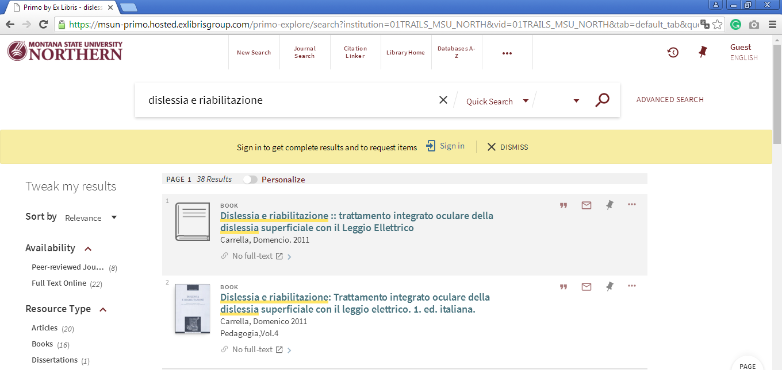

University Of Providence, Library | Great Falls,
https://omni-primo.hosted.exlibrisgroup.com/primo-explore/search?vid=01TRAILS_UGF&search_scope=EVERYTHING&tab=everything&query=any,contains,dislessia%20e%20riabilitazione&pcAvailability=true&lang=en_US
