NEBRASKA = 4

1 CONCORDIA UNIVERSITY NEBRASKA LIBRARY – (Seward, Nebraska, Usa)
https://cune.on.worldcat.org/search?sortKey=LIBRARY&databaseList=&queryString=dislessia+e+riabilitazione&changedFacet=scope&clusterResults=on&scope=&scope=wz%3A1022

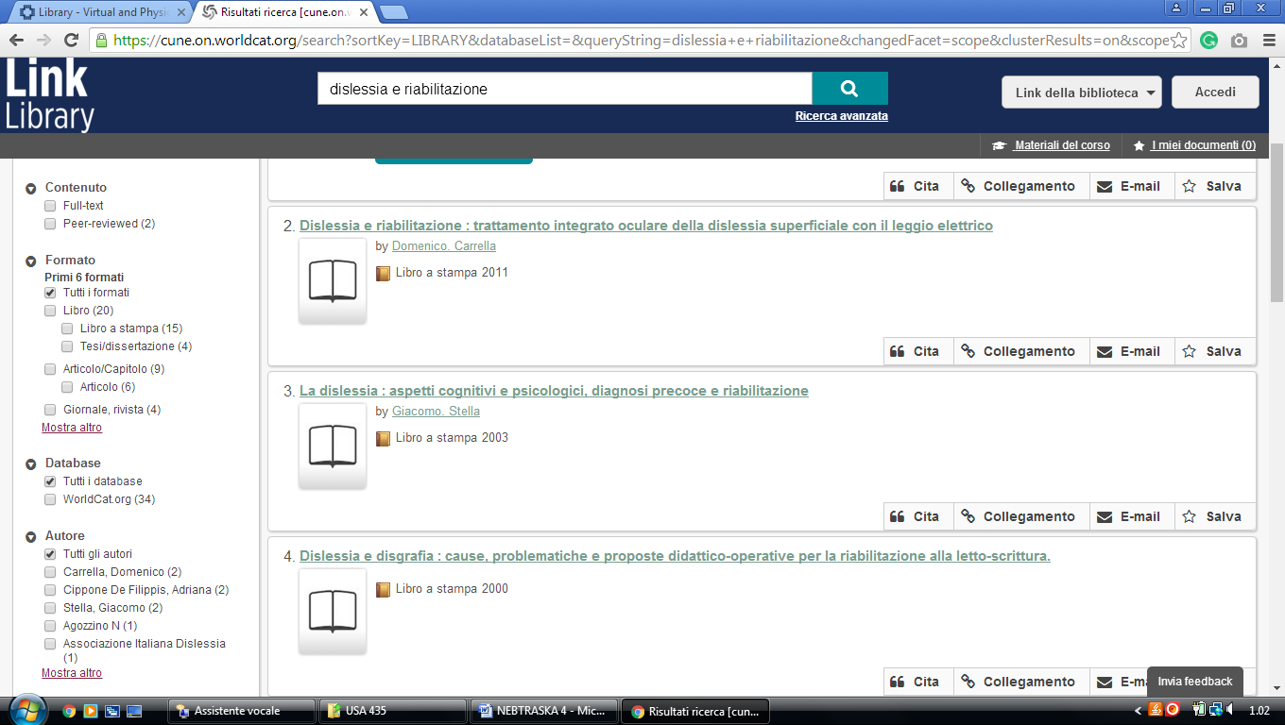

2 FREEMAN/LOZIER LIBRARY – (Bellevue, Nebraska, Usa)
http://eds.b.ebscohost.com/eds/results?vid=2&sid=fede2645-d9c1-4d97-9c09-e23d3af4fb56%40sessionmgr101&bquery=(dislessia+AND+e+AND+riabilitazione)&bdata=JnR5cGU9MCZzaXRlPWVkcy1saXZl
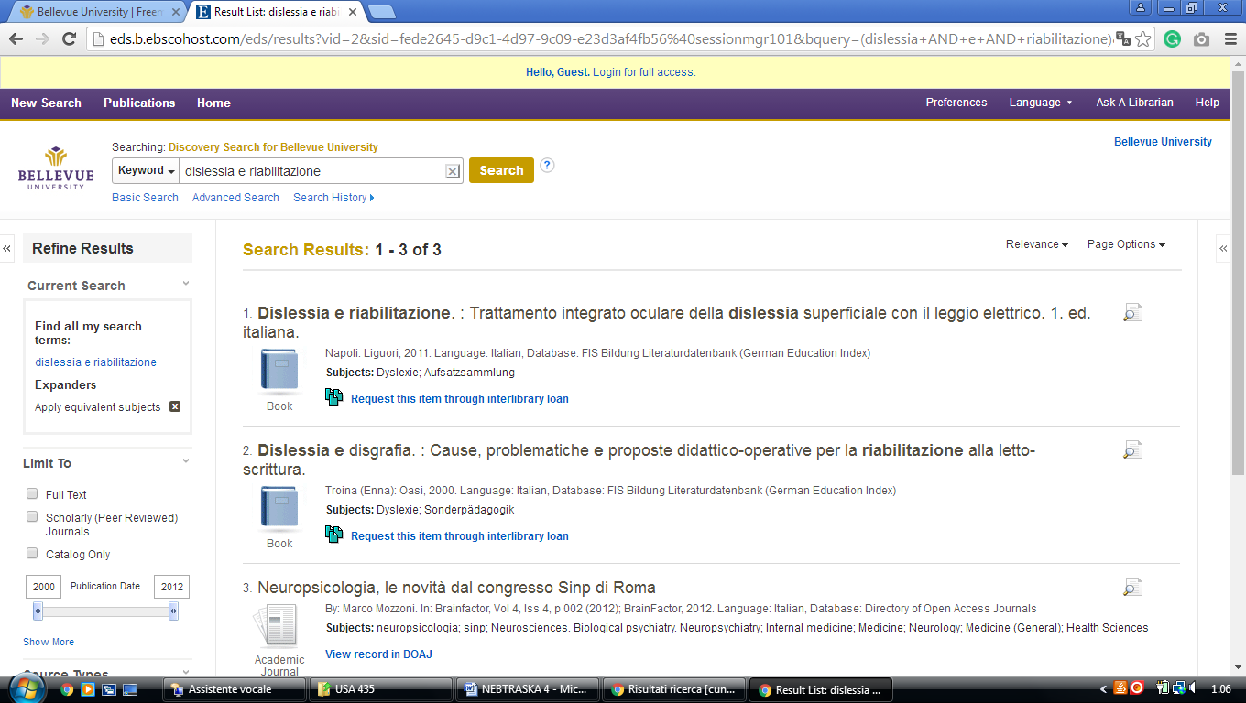

3 UNO CRISS LIBRARY – (Omaha, Nebraska, Usa)
https://unomaha.on.worldcat.org/search?sortKey=LIBRARY&databaseList=&queryString=dislessia+e+riabilitazione&changedFacet=scope&scope=&scope=wz%3A1908&format=all&database=all&author=all&year=all&yearFrom=&yearTo=

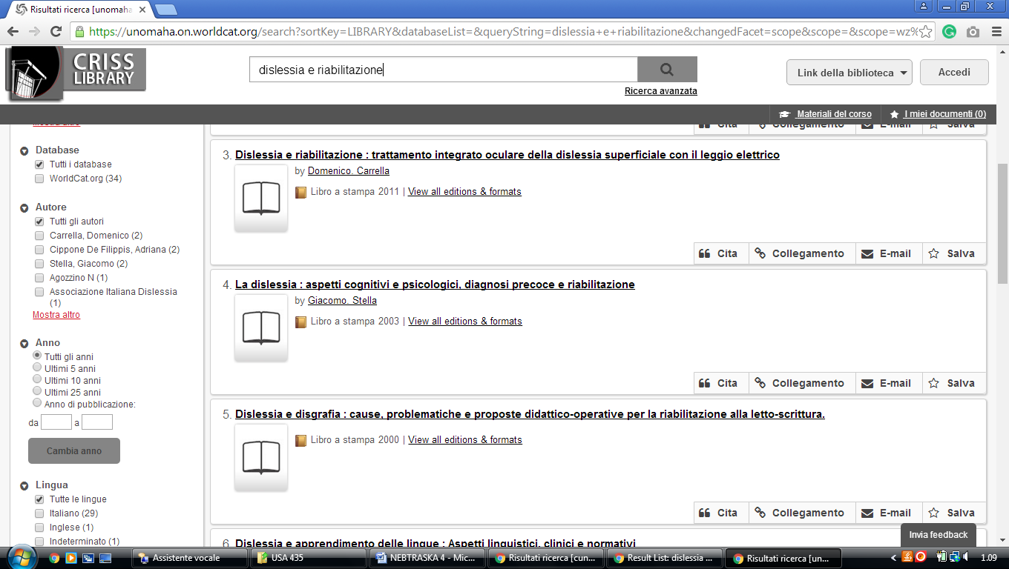

4 BELLEVUE UNIVERSITY, FREEMAN/LOZIER LIBRARY – (Bellevue, NE, Usa)
http://eds.b.ebscohost.com/eds/results?vid=5&sid=58dd56ac-9cdf-43c1-9100-02d3ff74aa22%40sessionmgr103&bquery=(dislessia+AND+e+AND+riabilitazione)&bdata=JnR5cGU9MCZzaXRlPWVkcy1saXZl

