NEVADA = 2

1 UNIVERSITY OF NEVADA - RENO LIBRARY – (Nevada, Usa)
https://unr.summon.serialssolutions.com/#!/search?ho=f&l=en&q=DISLESSIA%20E%20RIABILITAZIONE

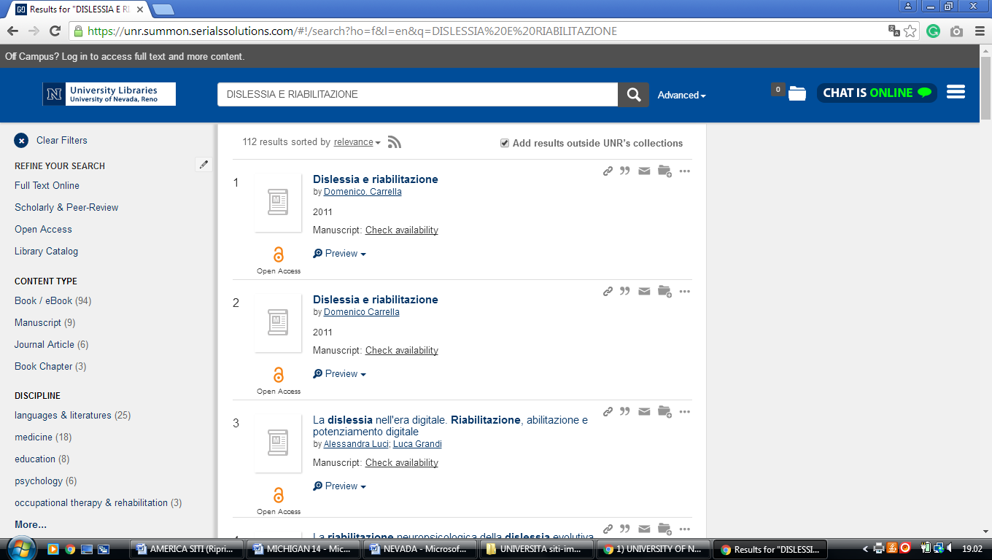

2 WNC LIBRARY & MEDIA SERVICES – (Carson City, Nevada, Usa)
http://wnc.summon.serialssolutions.com/?#!/search?ho=f&l=en&q=dislessia%20e%20riabilitazione

