NEW MEXICO = 3

1 UNM VALENCIA CAMPUS LIBRARY – (Tome, New Mexico, Usa)
https://vclibrary.on.worldcat.org/search?sortKey=LIBRARY&databaseList=&queryString=dislessia+e+riabilitazione&changedFacet=format&clusterResults=off&scope=&database=all&author=all&year=all&yearFrom=&yearTo=&language=all&topic=all

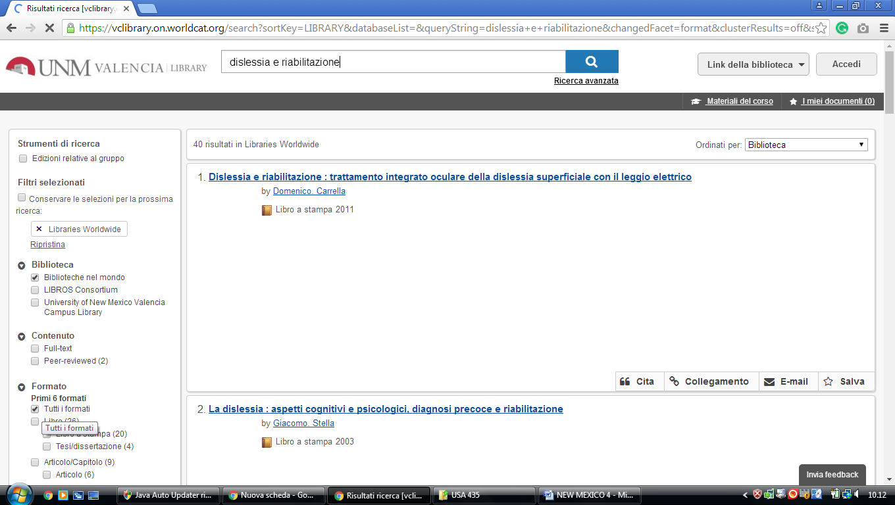

2 LIBRARY > INSTITUTE OF AMERICAN INDIAN ARTS (IAIA) – (Santa Fe, Usa)
https://iaialibrary.worldcat.org/search?q=dislessia+e+riabilitazione&qt=results_page&dblist=1708%2C1279%2C2259%2C2260%2C2262%2C2264%2C2267%2C1719%2C1728%2C638&scope=0&oldscope=2&fq=

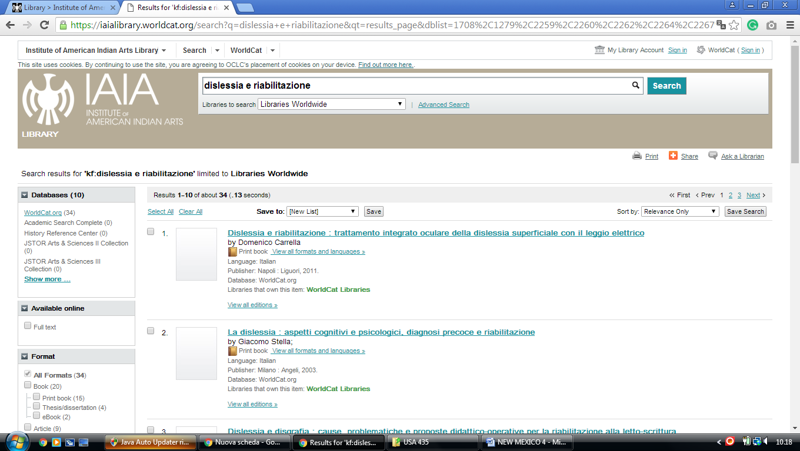

3 SKEEN LIBRARY – (Socorro, New Mexico, Usa)
https://nmt.on.worldcat.org/search?sortKey=LIBRARY&databaseList=&queryString=dislessia+e+riabilitazione&changedFacet=format&clusterResults=off&scope=&database=all&author=all&year=all&yearFrom=&yearTo=&language=all&topic=all

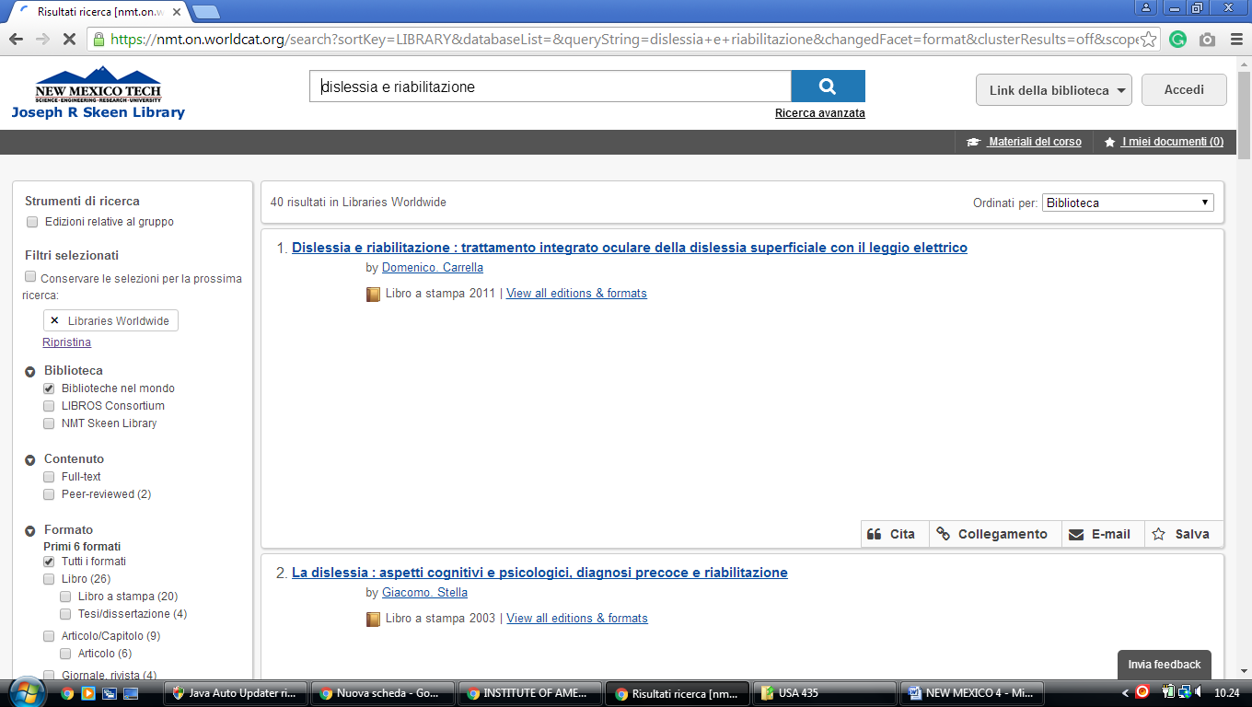

University of New Mexico library
https://unm.on.worldcat.org/search?queryString=kw:(DISLESSIA%20E%20RIABILITAZIONE)&databaseList=2264,2263,2262,1271,2261,2260,2281,143,2328,2007,2006,2237,2259,1697,3413,203,2268,2201,2267,1672,3036,3201,1708,638&page=1&queryType=search&origPageViewName=pages/advanced-search-page&scope=&stickyFacetsChecked=false&clusterResults=true
