NEW YORK = 25

1 SYRACUSE UNIVERSITY LIBRARY - (Syracuse, New York, Usa)
https://syracuse.summon.serialssolutions.com/search?q=dislessia+e+riabilitazione#!/search?ho=f&l=en&q=dislessia%20e%20riabilitazione
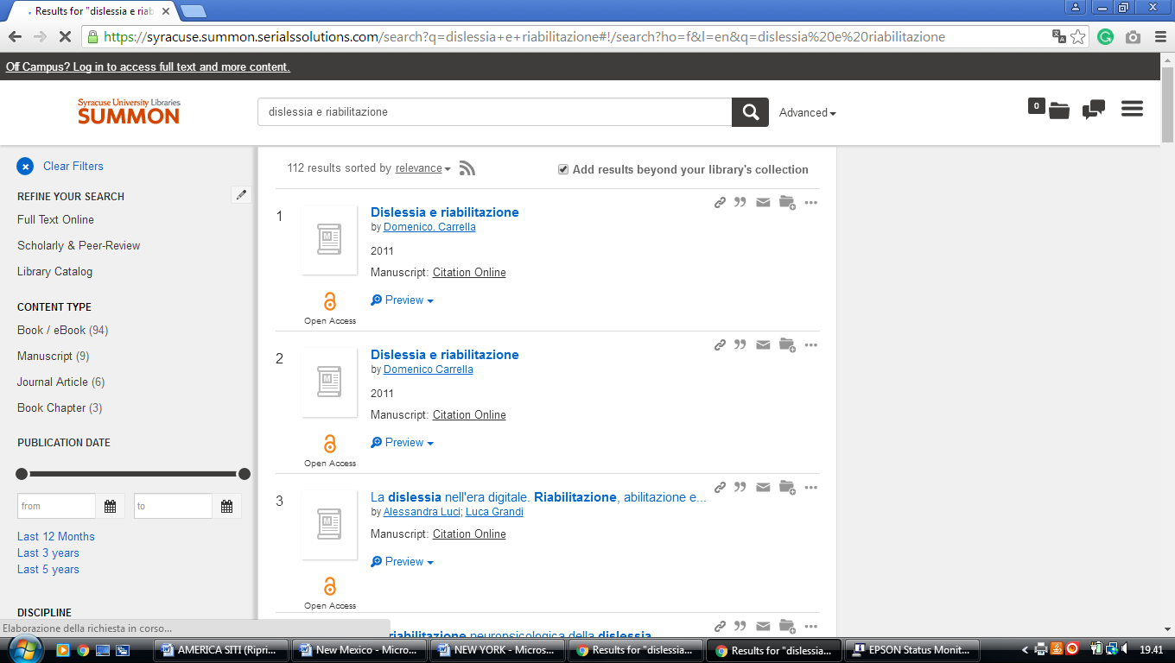

2 TOURO COLLEGE LIBRARIES - (New York City, New York, Usa)
http://touro.summon.serialssolutions.com/search?s.q=dislessia+e+riabilitazione#!/search?ho=f&l=en&q=dislessia%20e%20riabilitazione

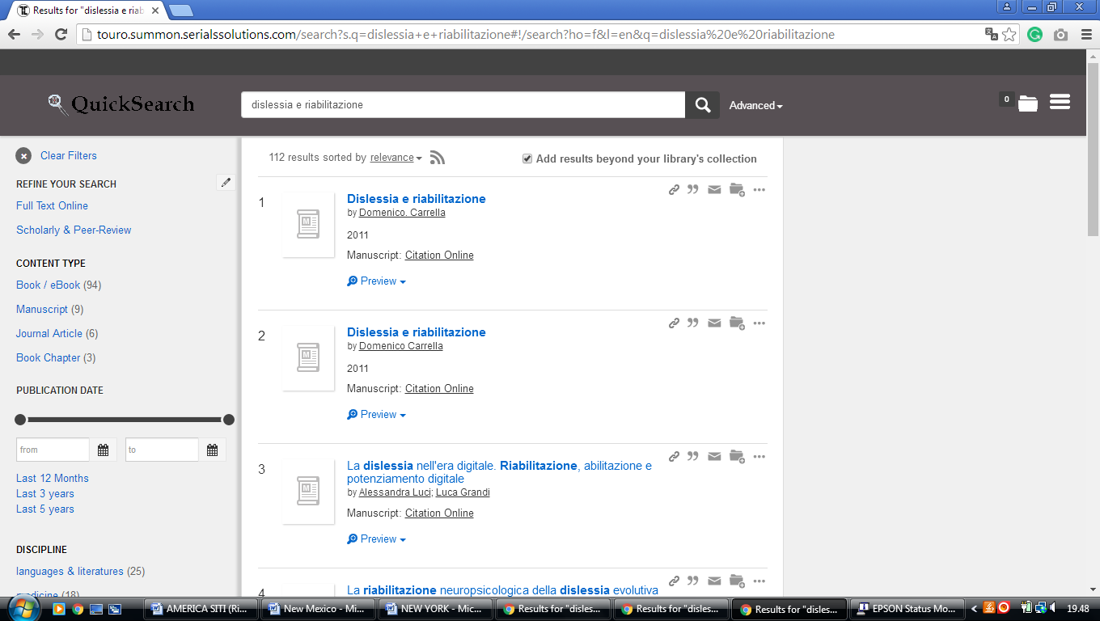

3 ADELPHI UNIVERSITY LIBRARIES – (Garden City, New York, Usa)
http://adelphi.summon.serialssolutions.com/?fvf=ContentType%2CBook+Review%2Ct&q=dislessia+e+riabilitazione#!/search?ho=f&fvf=ContentType,Book%20Review,t&l=en&q=dislessia%20e%20riabilitazione

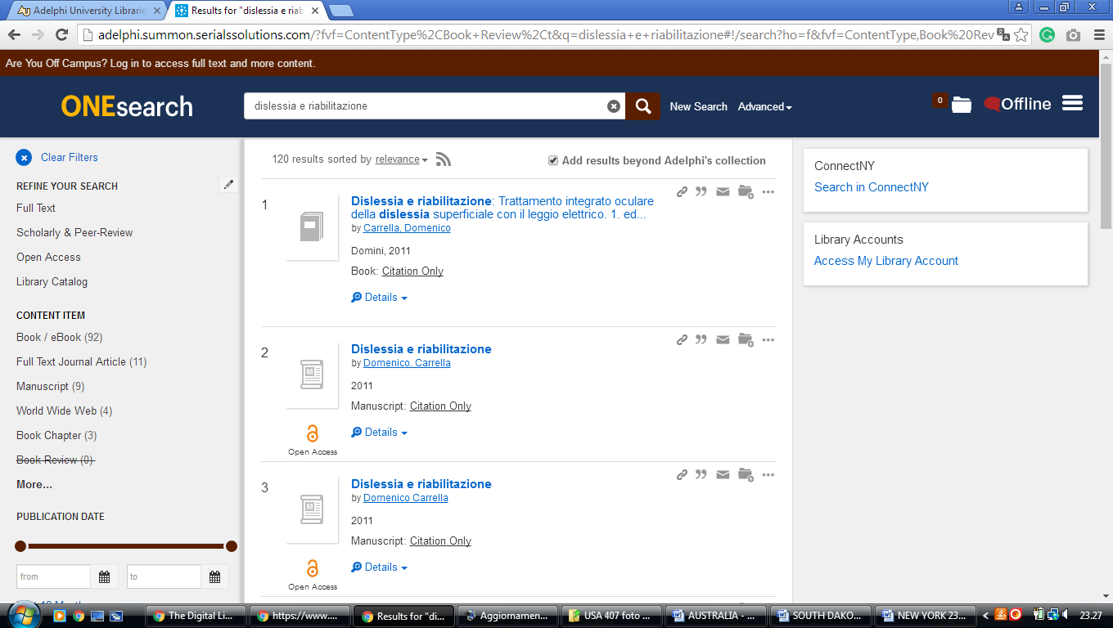

4 ANDREW L. BOUWHUIS LIBRARY – (Buffalo, New York, Usa)
http://canisius.summon.serialssolutions.com/?q=dislessia+e+riabilitazione#!/search?ho=f&l=en&q=dislessia%20e%20riabilitazione

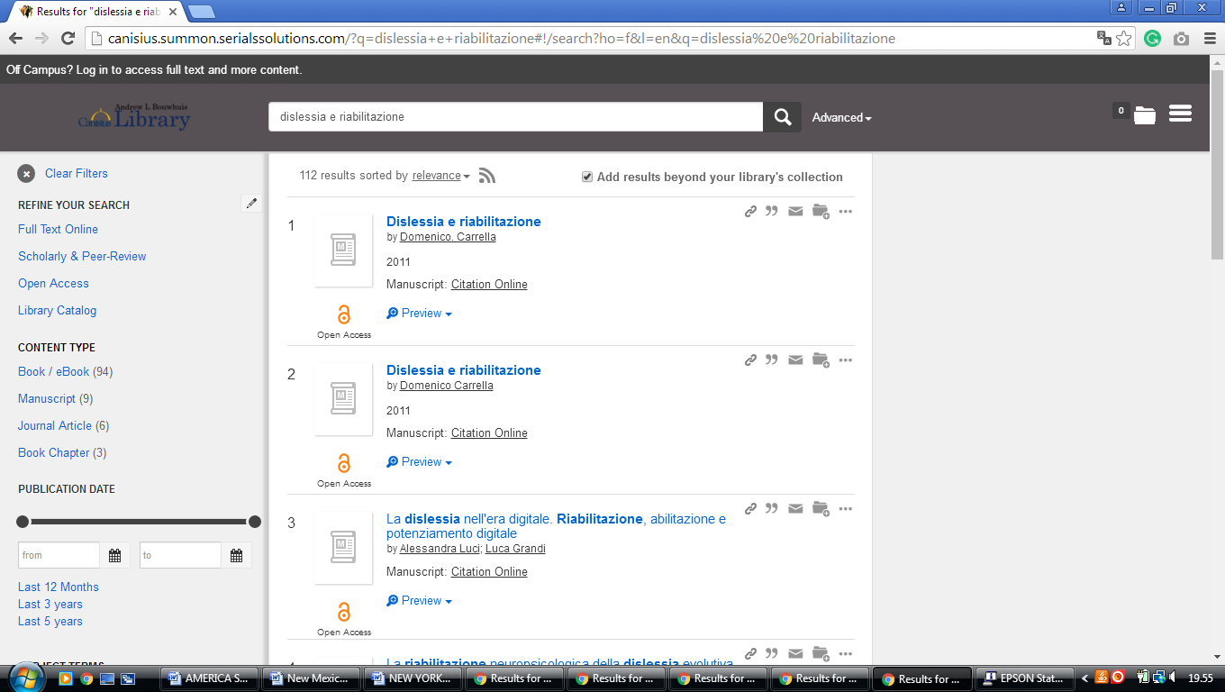

5 BROOME COMMUNITY COLLEGE LIBRARY - (Binghamton, New York, Usa)
https://search.idsproject.org/index.php?query_value%5B0%5D=%22dislessia+e+riabilitazione&query_value%5B1%5D=&query_value%5B2%5D=per&query_operator%5B2%5D=not&search_scope=worldcat&search_form=advanced&sort_keys=Relevance&oclc_symbol=YSY&view=ids&auto_search_orig=Keyword%2B%2528all%2529%2B%2526quot%253Bdislessia%2Be%2Briabilitazione%2BNOT%2BMaterial%2Btype%2B%2528all%2529%2Bper.%2B%255BMy%2Blibrary%255D&auto_search=true

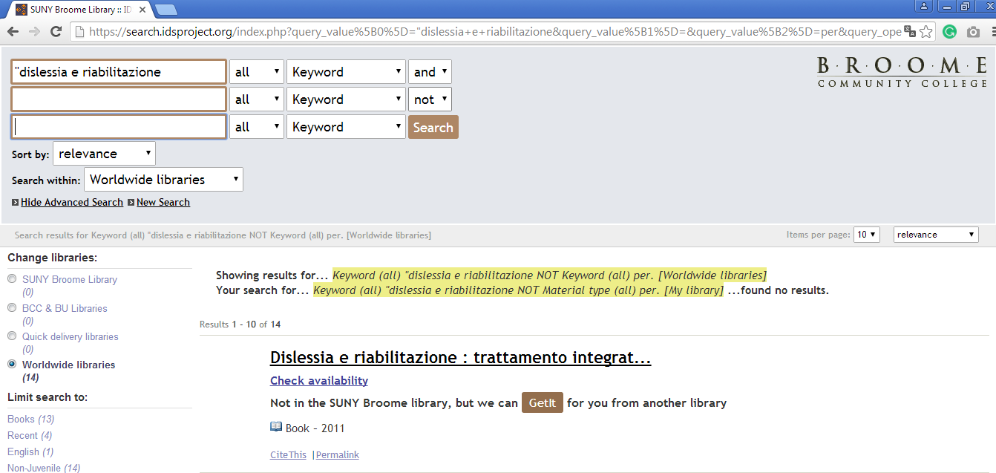

6 CORNELL UNIVERSITY LIBRARY – (Ithaca, New York, Usa)
http://cornell.worldcat.org/search?qt=wc_org_cornell&q=dislessia+e+riabilitazione&scope=0&oldscope=&wcsbtn2w=Search

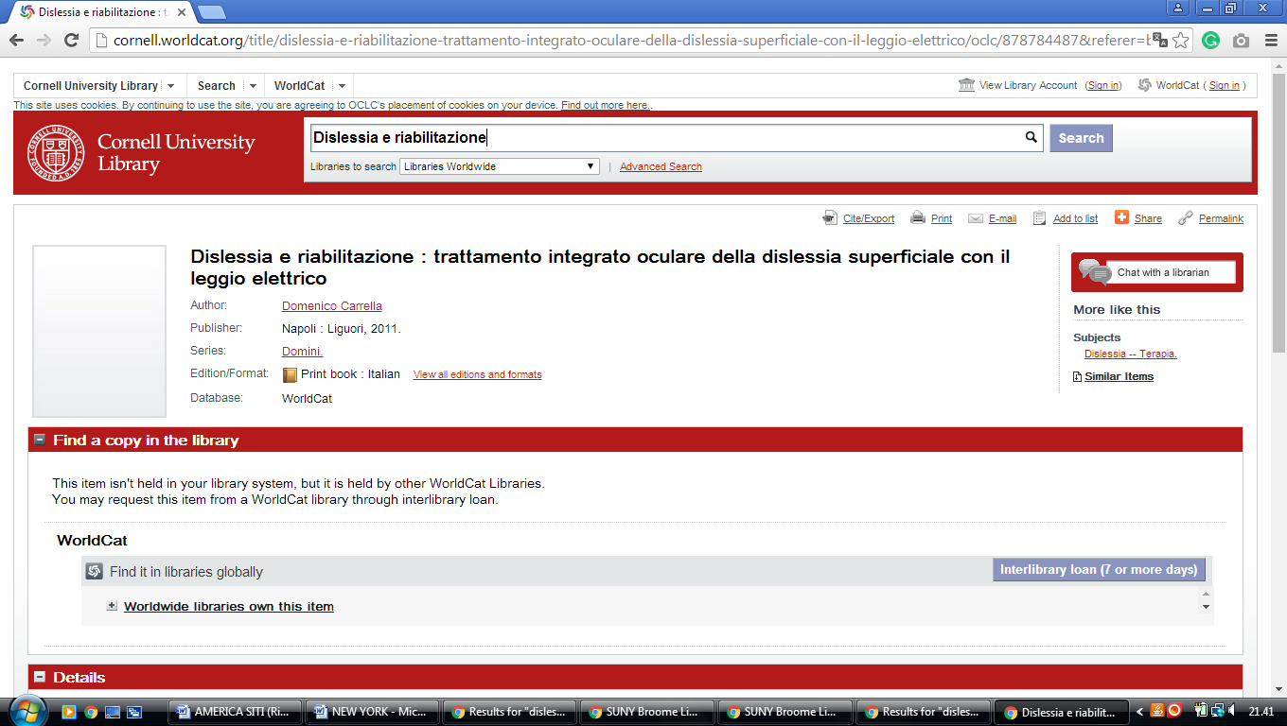

7 DANIEL A. REED LIBRARY – (Fredonia, New York, Usa)
http://fredonia.summon.serialssolutions.com/search?s.q=dislessia+e+riabilitazione#!/search?ho=f&l=en&q=dislessia%20e%20riabilitazione

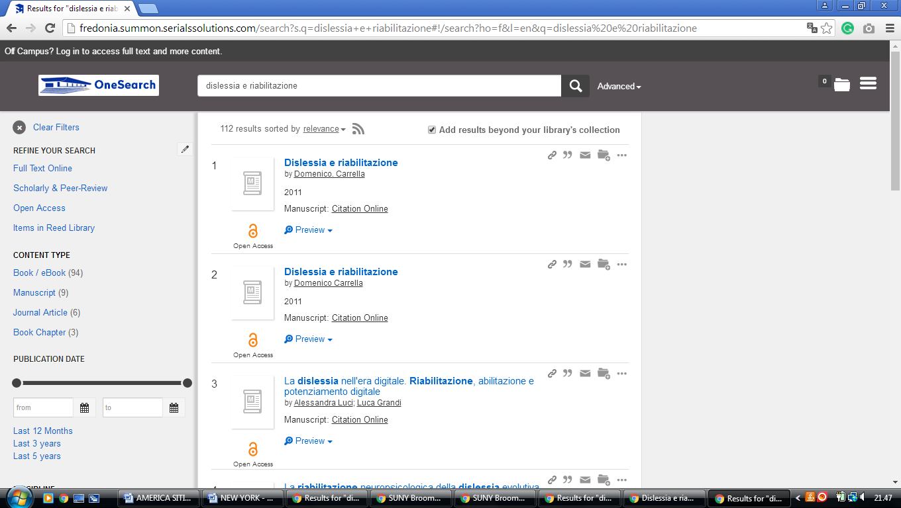

8 DRAKE MEMORIAL LIBRARY – (Brockport, New York, Usa)
https://brockport.summon.serialssolutions.com/?s.fvf=ContentType%2CNewspaper+Article%2Ct%7CContentType%2CBook+Review%2Ct%7CContentType%2CDissertation%2Ct&s.q=dislessia+e+riabilitazione#!/search?ho=f&fvf=ContentType,Newspaper%20Article,t%7CContentType,Book%20Review,t%7CContentType,Dissertation,t&l=en&q=dislessia%20e%20riabilitazione

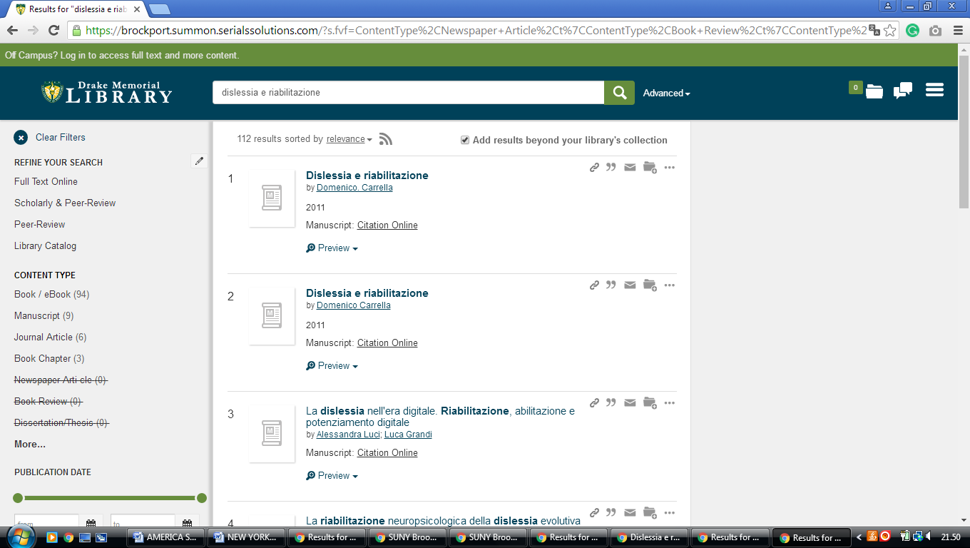

9 E. H. BUTLER LIBRARY – (Buffalo, New York, Usa)
https://buffalostate.summon.serialssolutions.com/search?s.q=dislessia+e+riabilitazione&spellcheck=true&keep_r=true#!/search?ho=f&l=en&q=dislessia%20e%20riabilitazione
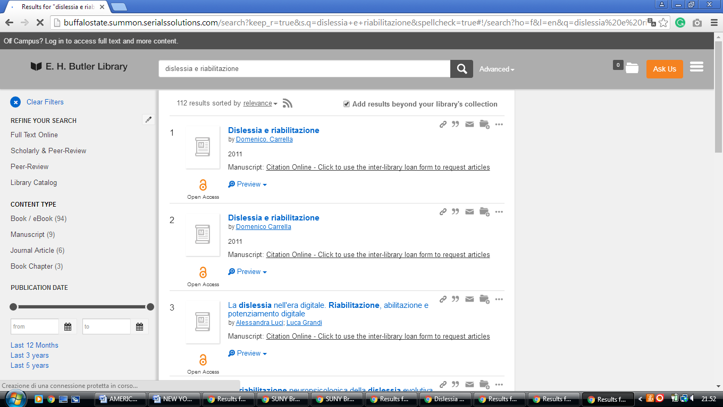

10 ERIE COMMUNITY COLLEGE LIBRARY – (Buffalo, New York, Usa)
http://ecc.summon.serialssolutions.com/search?utf8=%E2%9C%93&s.q=dislessia+e+riabilitazione#!/search?ho=f&l=en&q=dislessia%20e%20riabilitazione

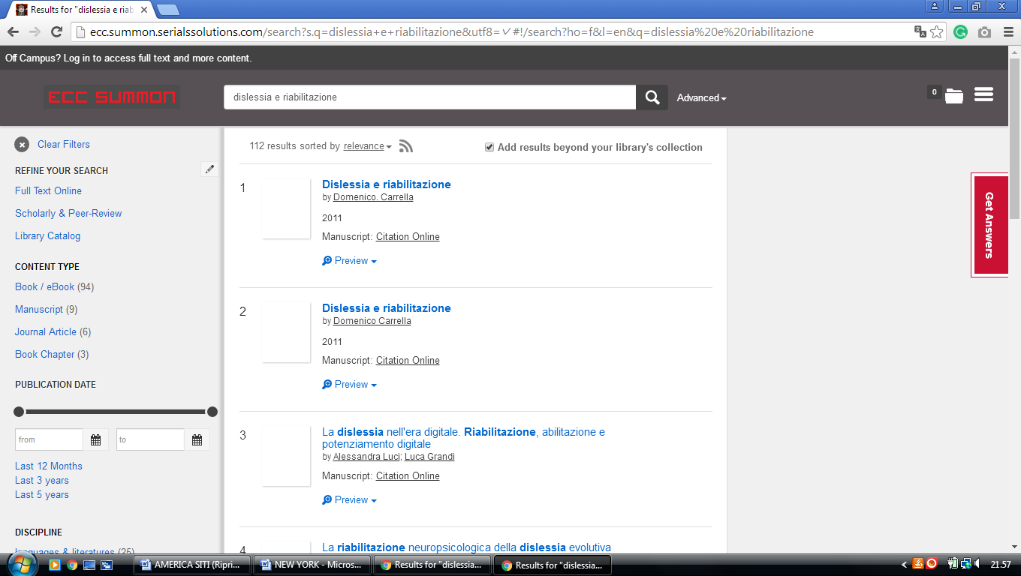

11 HAMILTON COLLEGE LIBRARY – (Clinton, New York, Usa)
https://hamilton.primo.exlibrisgroup.com/discovery/search?query=any,contains,dislessia%20e%20riabilitazione&tab=Everything&search_scope=MyInst_and_CI&vid=01HAMILTON_INST:01HAMILTON&lang=en&offset=0&sortby=rank&pcAvailability=true

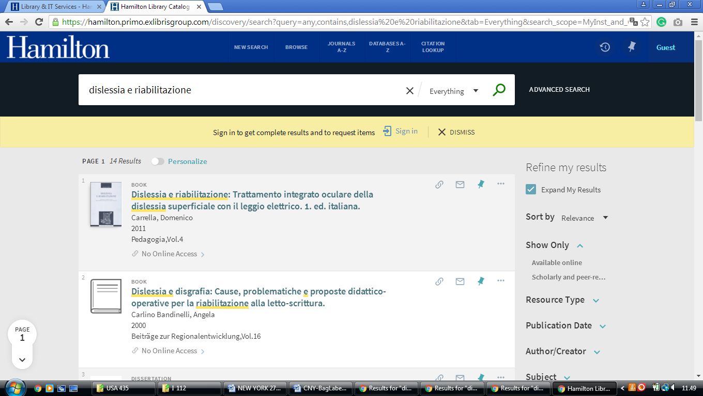

12 IONA COLLEGE LIBRARIES – (New Rochelle, New York, Usa)
https://iona.on.worldcat.org/search?sortKey=LIBRARY&databaseList=&queryString=dislessia+e+riabilitazione&changedFacet=format&clusterResults=off&scope=&database=all&author=all&year=all&yearFrom=&yearTo=&language=all&topic=all

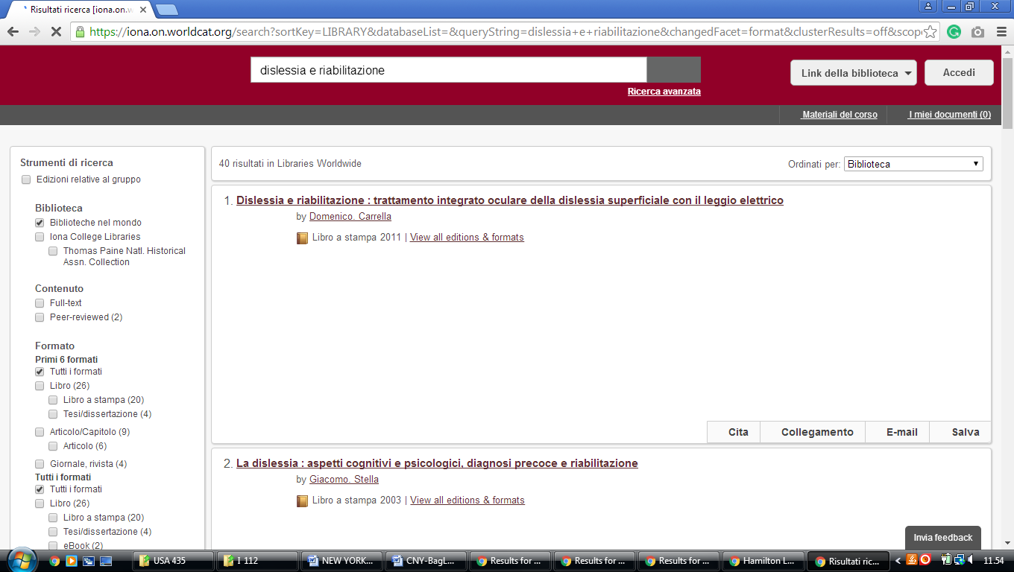

13 JAMES A. CANNAVINO LIBRARY – (Poughkeepsie, New York, Usa)
http://marist.summon.serialssolutions.com/?q=dislessia+e+riabilitazione#!/search?ho=f&l=en&q=dislessia%20e%20riabilitazione
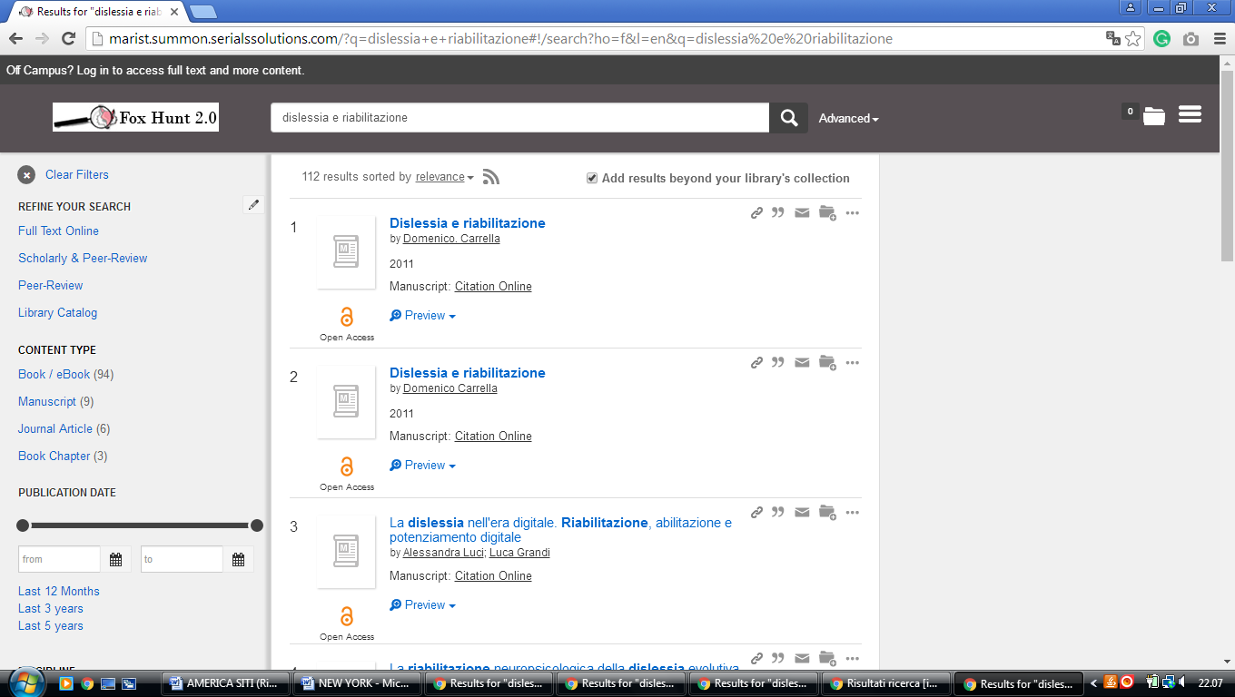

14 NIAGARA UNIVERSITY LIBRARY – (Niagara Falls, New York, Usa)
https://niagara.summon.serialssolutions.com/search?utf8=%E2%9C%93&s.q=dislessia+e+riabilitazione#!/search?ho=f&l=en&q=dislessia%20e%20riabilitazione

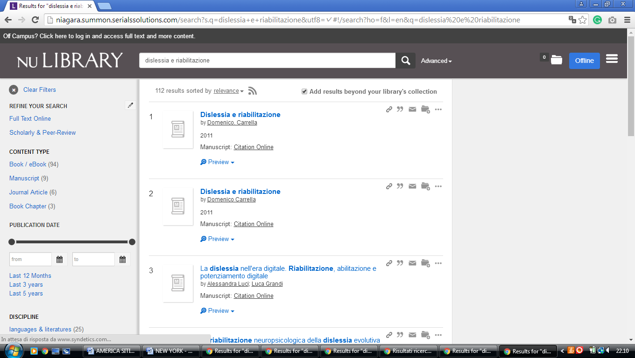

15 SAGE LIBRARIES – (Troy, New York, Usa)
https://sage.summon.serialssolutions.com/search?q=dislessia+e+riabilitazione#!/search?ho=f&l=en&q=dislessia%20e%20riabilitazione

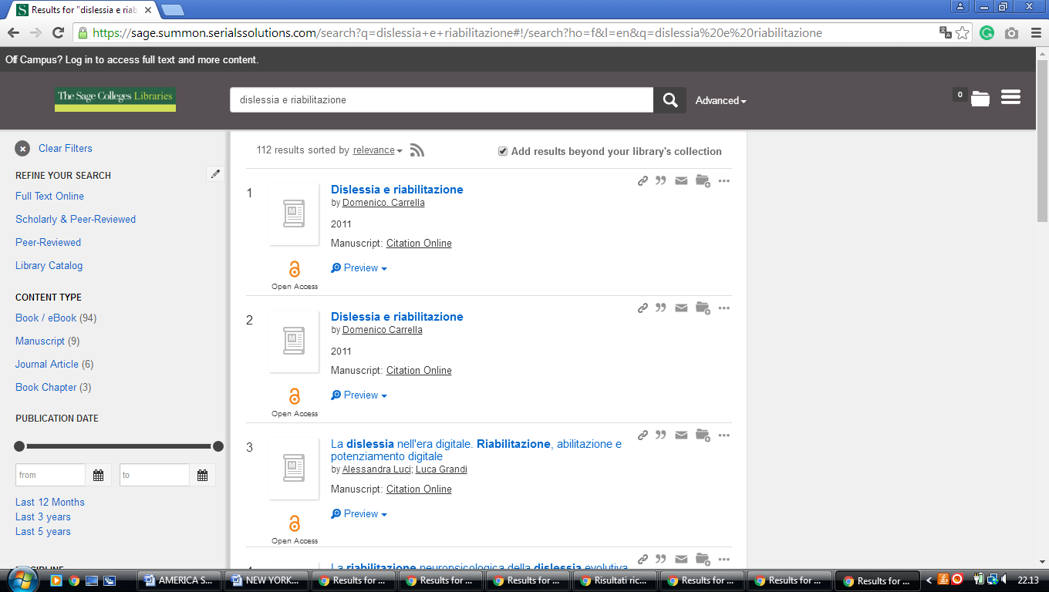

16 SCHAFFER LIBRARY - (Schenectady, New York, Usa)
https://union.summon.serialssolutions.com/?#!/search?ho=f&fvf=ContentType,Newspaper%20Article,t&l=en&q=dislessia%20e%20riabilitazione

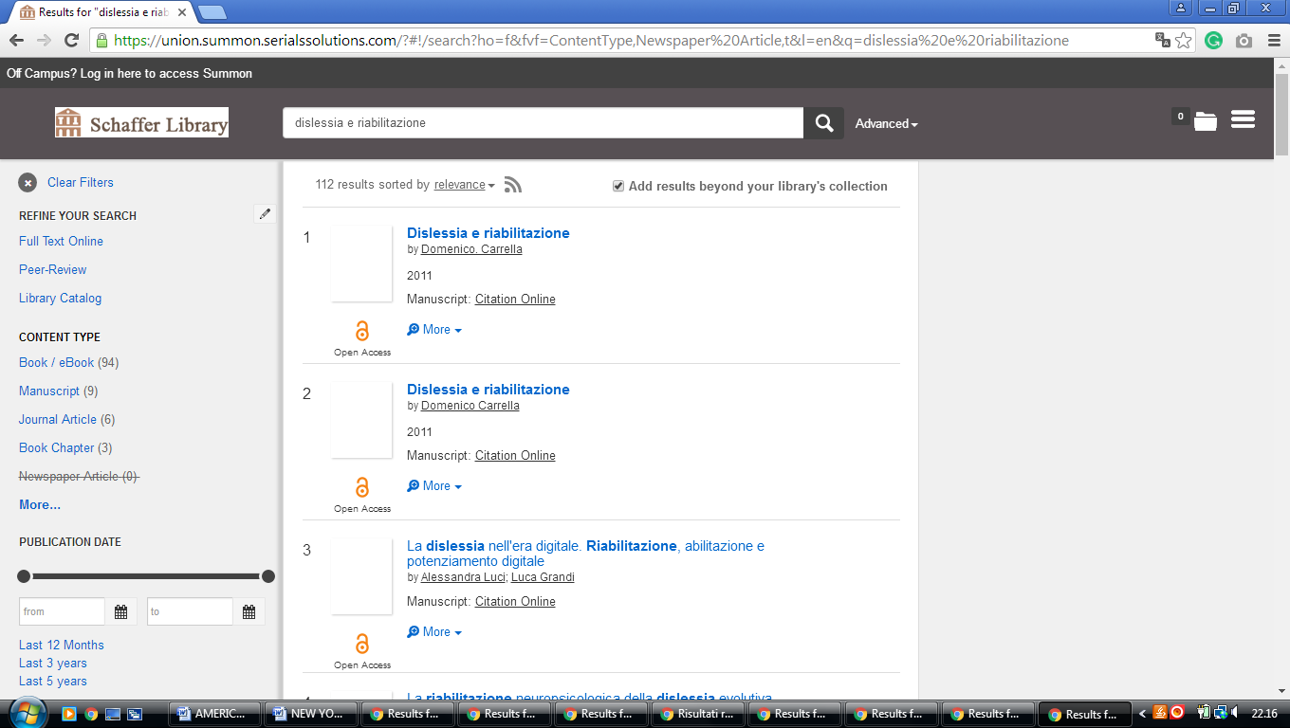

17 STONY BROOK UNIVERSITY LIBRARIES – (Stony Brook, New York, Usa)
http://eds.b.ebscohost.com/eds/results?vid=1&sid=cf0eb762-6fba-4d2e-96d3-78f289b72aa4%40sessionmgr103&bquery=(dislessia+AND+e+AND+riabilitazione)&bdata=JnR5cGU9MCZzaXRlPWVkcy1saXZlJnNjb3BlPXNpdGU%3d

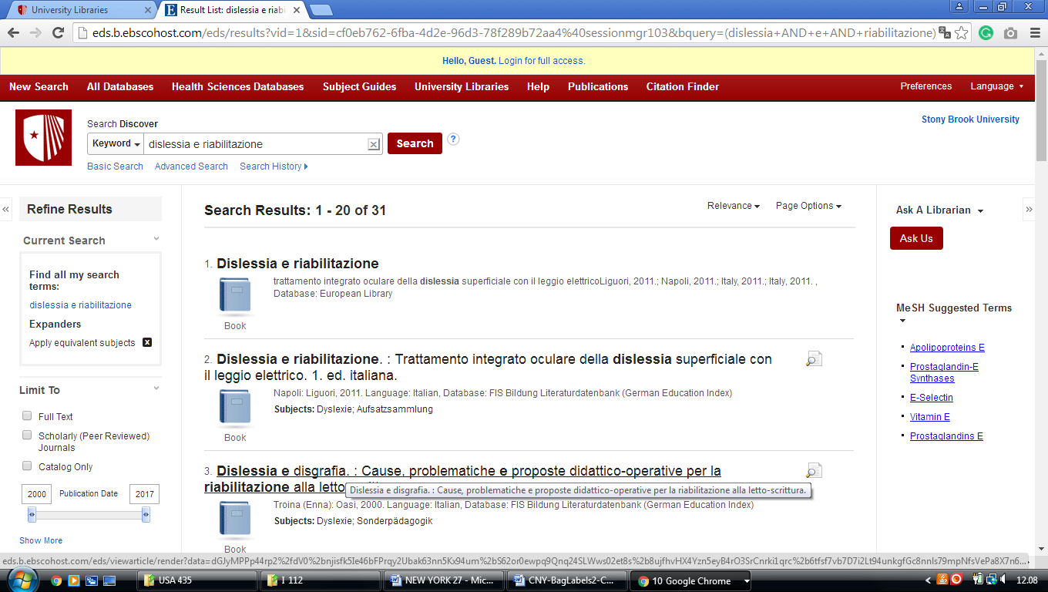

18 UNIVERSITY OF ROCHESTER LIBRARIES – (Rochester, New York, Usa)
http://rochester.summon.serialssolutions.com/search?s.q=dislessia+e+riabilitazione&submit=+&spellcheck=true&keep_r=true#!/search?ho=f&l=en&q=dislessia%20e%20riabilitazione

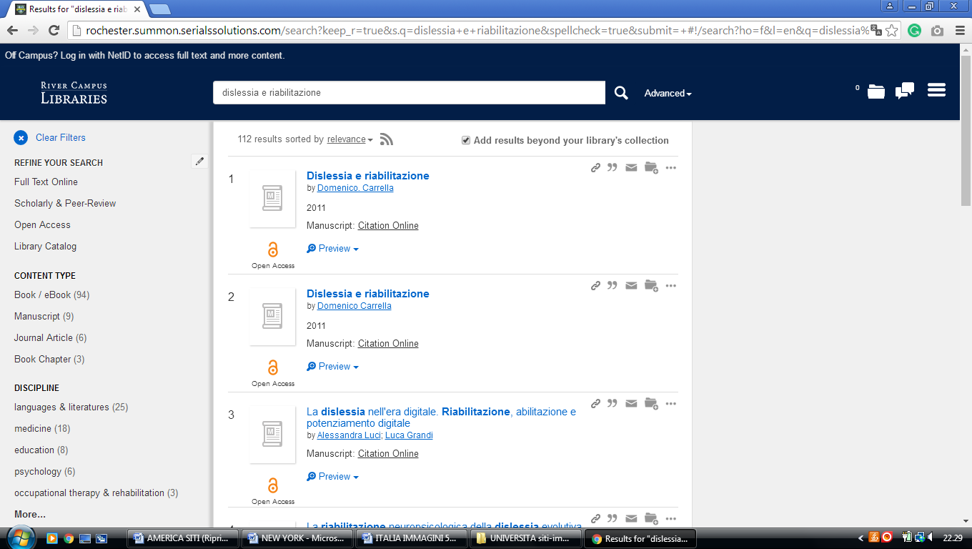

19 WARREN HUNTING SMITH LIBRARY – (Geneva, New York, Usa)
https://hws.summon.serialssolutions.com/?q=dislessia+e+riabilitazione#!/search?ho=f&l=en&q=dislessia%20e%20riabilitazione
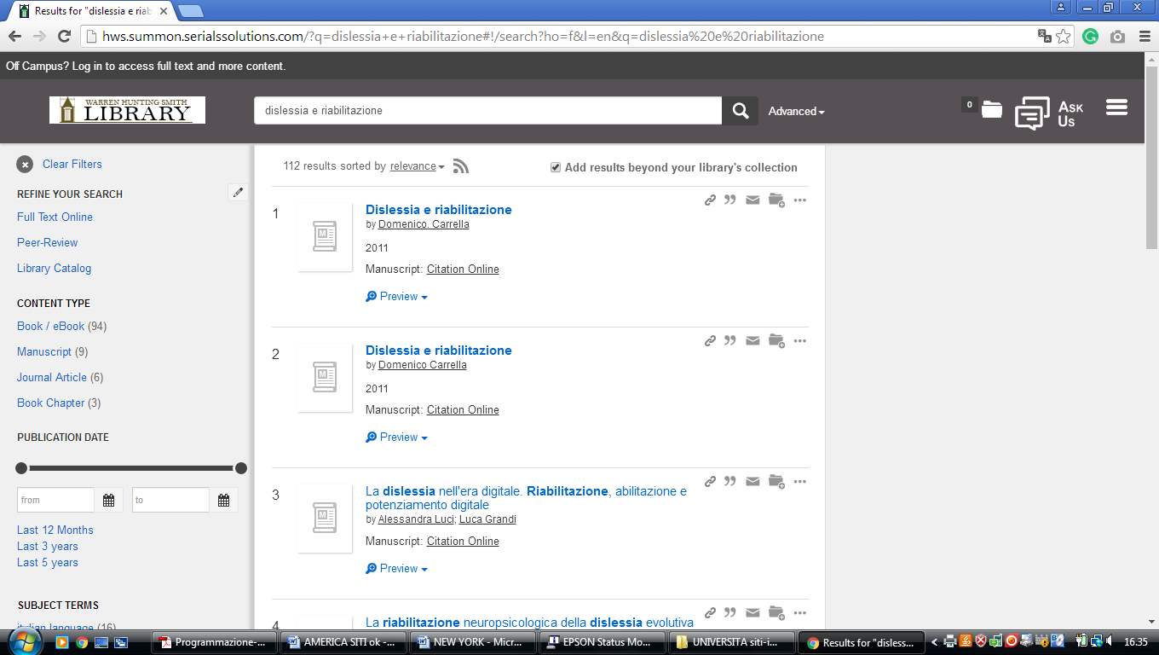

20 DRAKE MEMORIAL LIBRARY – (Brockport, New York, Usa)
https://brockport.summon.serialssolutions.com/?s.fvf=ContentType%2CNewspaper+Article%2Ct%7CContentType%2CBook+Review%2Ct%7CContentType%2CDissertation%2Ct&s.q=dislessia+e+riabilitazione#!/search?ho=f&fvf=ContentType,Newspaper%20Article,t%7CContentType,Book%20Review,t%7CContentType,Dissertation,t&l=en&q=dislessia%20e%20riabilitazione

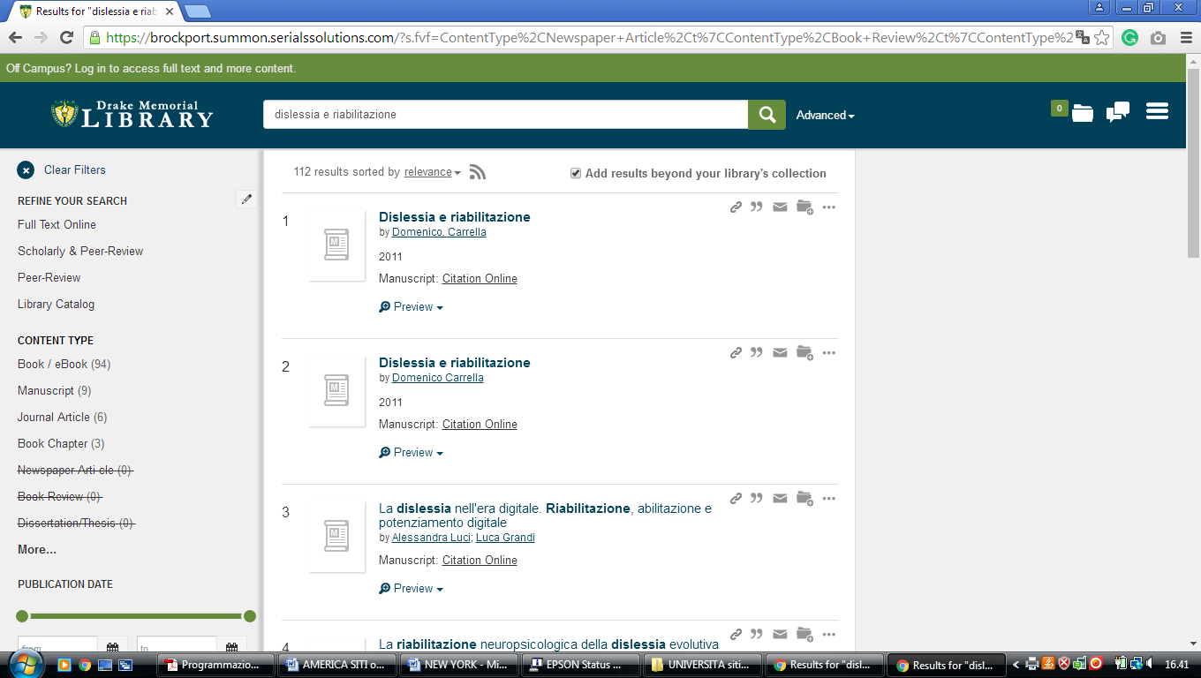

21 UNIVERSITY OF ROCHESTER LIBRARY – (Rochester, Ny, Usa)
http://rochester.summon.serialssolutions.com/search?s.q=dislessia+e+riabilitazione&submit=+&spellcheck=true&keep_r=true#!/search?ho=f&l=en&q=dislessia%20e%20riabilitazione

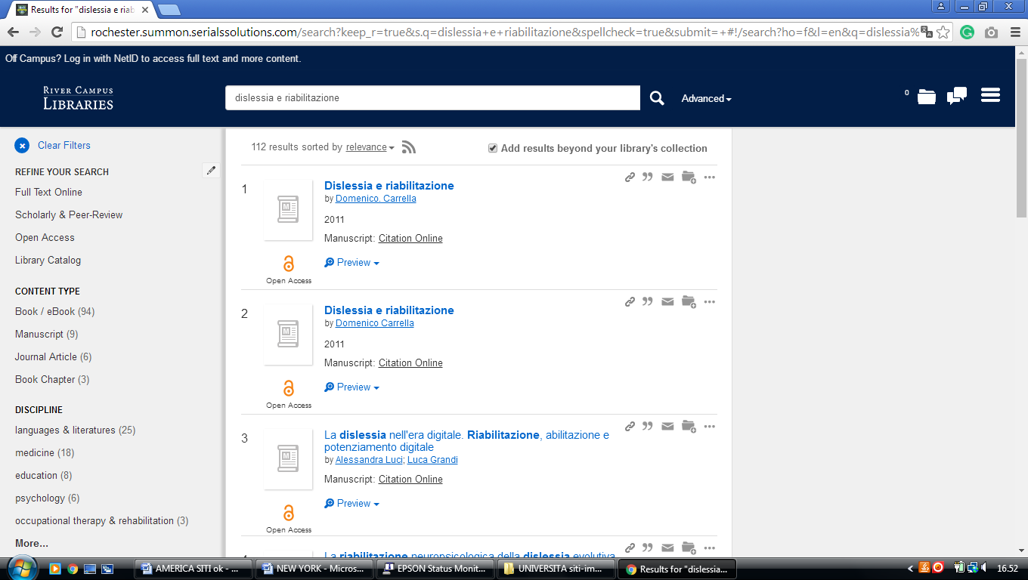

22 CLARKSON UNIVERSITY LIBRARY – (Potsdam, New York Usa)
https://clarksonuniversitylibrary.on.worldcat.org/search?queryString=dislessia%20e%20riabilitazione&databaseList=4058,2375,1461,3384,2271,3218,1953,1875,3313,1672,638,1736,1934,3879,2221,2264,2483,2263,2262,2261,2260,143,2237,2259,1542,2477,2476,3909,2277,3867,3967&page=1&queryType=search&stickyFacetsChecked=false

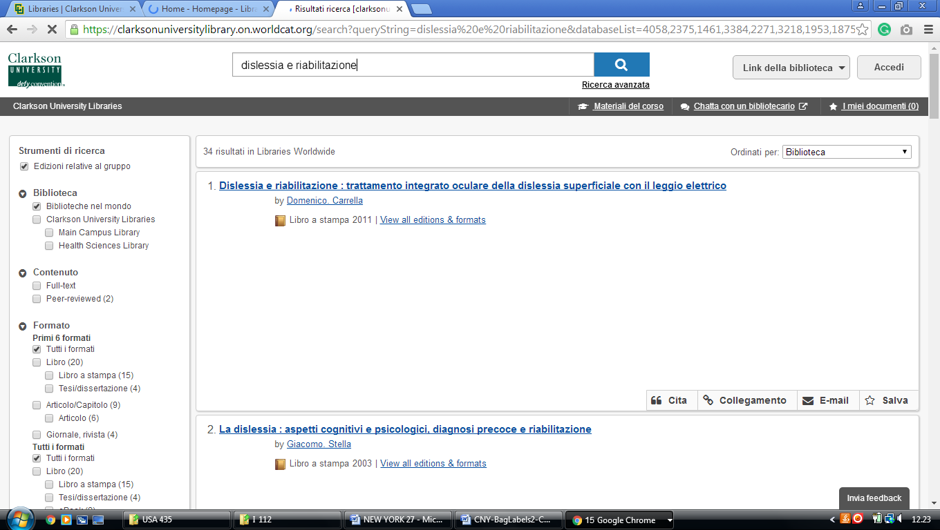

23 THE HAROLD KOHN VISION SCIENCE LIBRARY - SUNY COLLEGE OF OPTOMETRY - (New York)
http://eds.b.ebscohost.com/eds/resultsadvanced?vid=3&sid=39793f45-ba2c-4ea7-8cf2-7b608f7e77d3%40pdc-v-sessmgr01&bquery=(dislessia+AND+e+AND+riabilitazione)&bdata=JnR5cGU9MSZzaXRlPWVkcy1saXZl

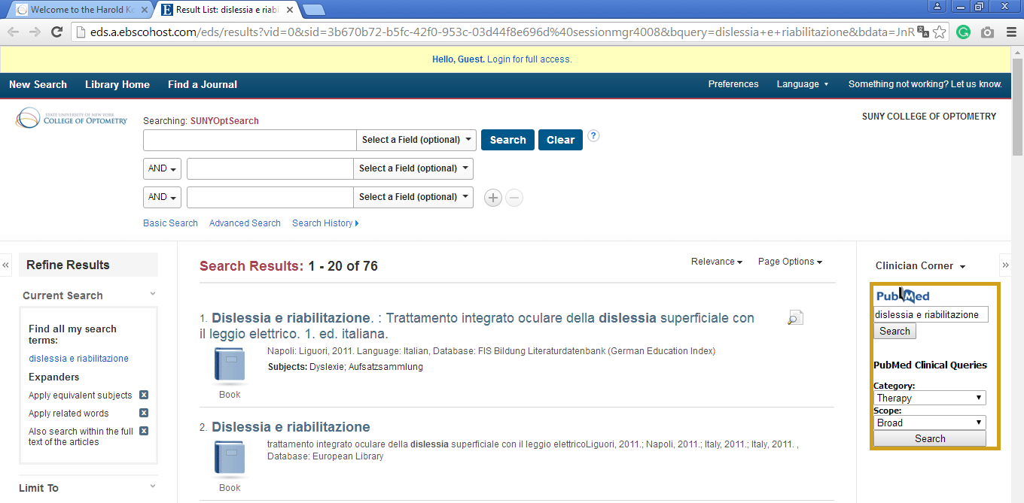

24 LIBRARIES | ST. JOHN'S UNIVERSITY - (New York, Usa)
https://stjohnsuniversitylibraries.on.worldcat.org/search?sortKey=BEST_MATCH&databaseList=&queryString=dislessia+e+riabilitazione&changedFacet=scope&clusterResults=on&scope=

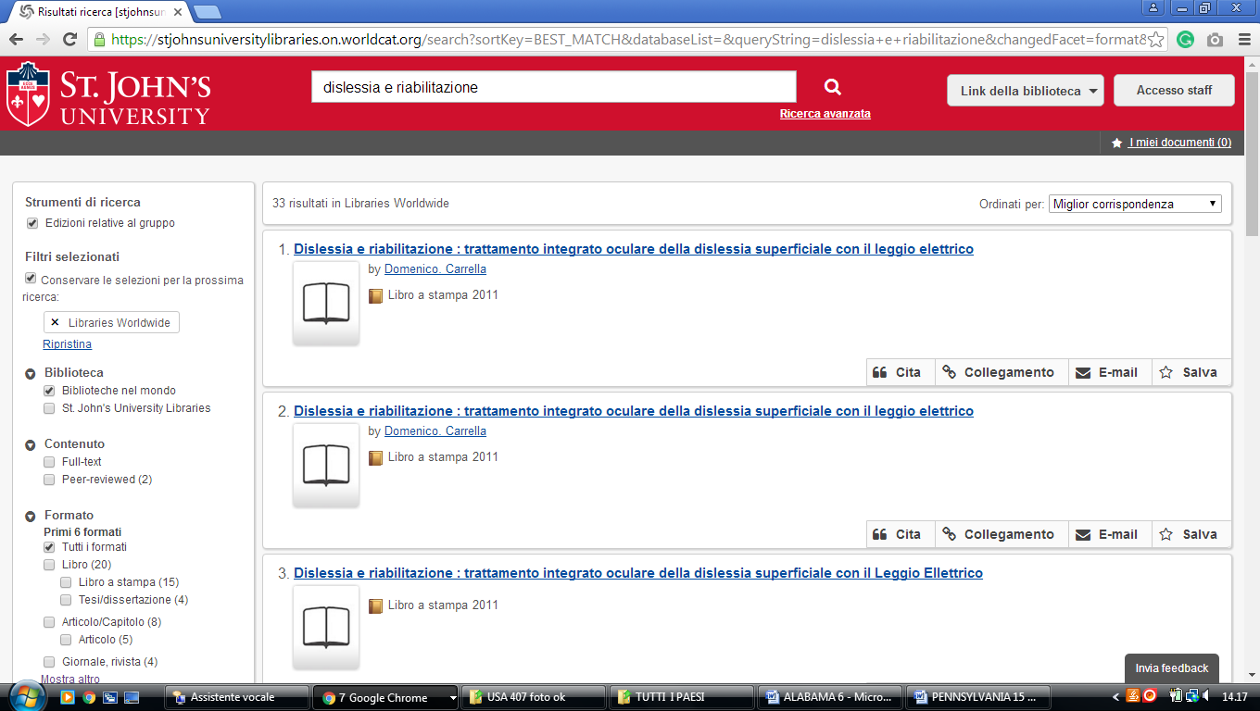

25 UNIVERSITY AT BUFFALO LIBRARIES – (New York, Usa)
https://buffalo.summon.serialssolutions.com/search?q=dislessia+e+riabilitazione&submit=%EE%A4%A4#!/search?ho=f&l=it-IT&q=dislessia%20e%20riabilitazione&submit=%EE%A4%A4

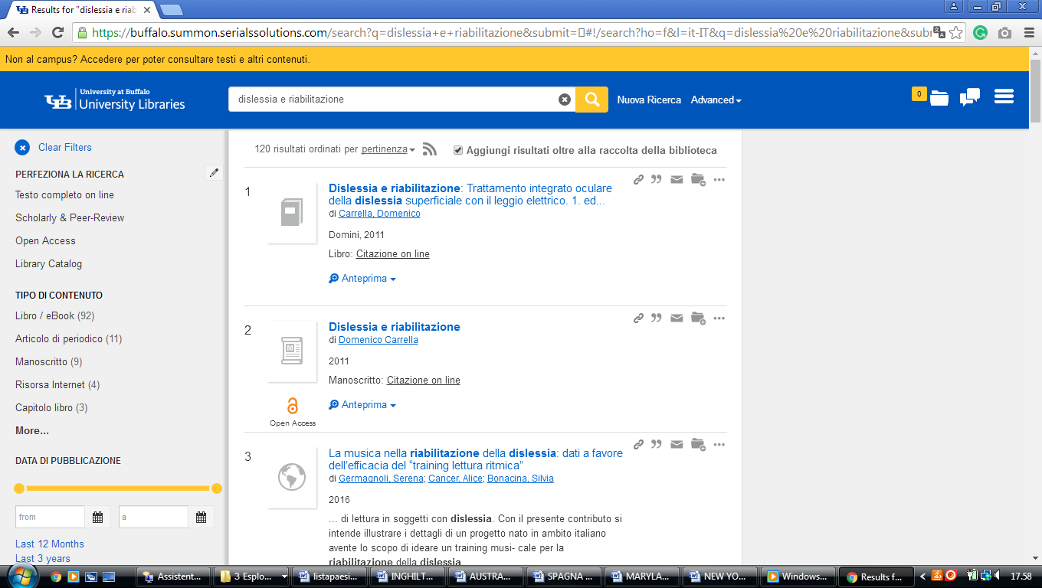

Anne Ross Library and Learning Resource Center, NEW YORK NY


Anne Ross Library

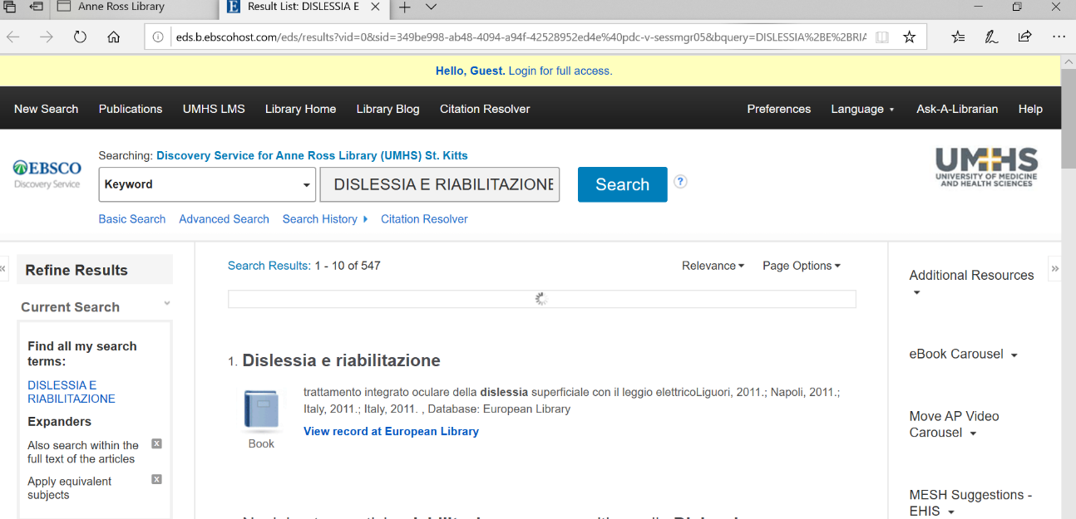

Stony Brook University Libraries
https://search.library.stonybrook.edu/discovery/search?vid=01SUNY_STB:01SUNY_STB&tab=Everything&qry=any&search_scope=MyInst_and_CI&mode=basic&displayMode=full&bulkSize=10&highlight=true&dum=true&query=any,contains,dislessia%20e%20riabilitazione&displayField=all&pcAvailabiltyMode=true&ebscohostsearchtext9=dislessia%20e%20riabilitazione&pcAvailability=true

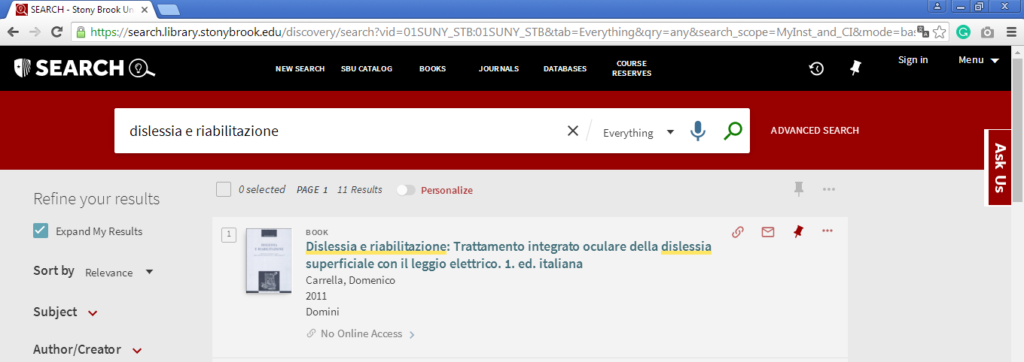

Clinton, Hamilton College, New York

Library & IT Services
https://hamilton.primo.exlibrisgroup.com/discovery/search?query=any,contains,dislessia%20e%20riabilitazione&tab=Everything&search_scope=MyInst_and_CI&vid=01HAMILTON_INST:01HAMILTON&lang=en&offset=0&pcAvailability=true
