NORTH CAROLINA = 13

1 CLEVELAND COMMUNITY COLLEGE, SHELBY, NC - (Rose Library – Shelby, North Carolina, Usa)
http://clevelandcc.summon.serialssolutions.com/?custid=s5071755&direct=true&scope=site&site=eds-live&profid=eds&groupid=main&authtype=ip%2Cguest&cli0=FT1&clv0=Y&bquery=dislessia+e+riabilitazione&cli1=RV#!/search?ho=f&l=en&custid=s5071755&direct=true&scope=site&site=eds-live&profid=eds&groupid=main&authtype=ip,guest&cli0=FT1&clv0=Y&bquery=dislessia%20e%20riabilitazione&cli1=RV&q=dislessia%20e%20riabilitazione

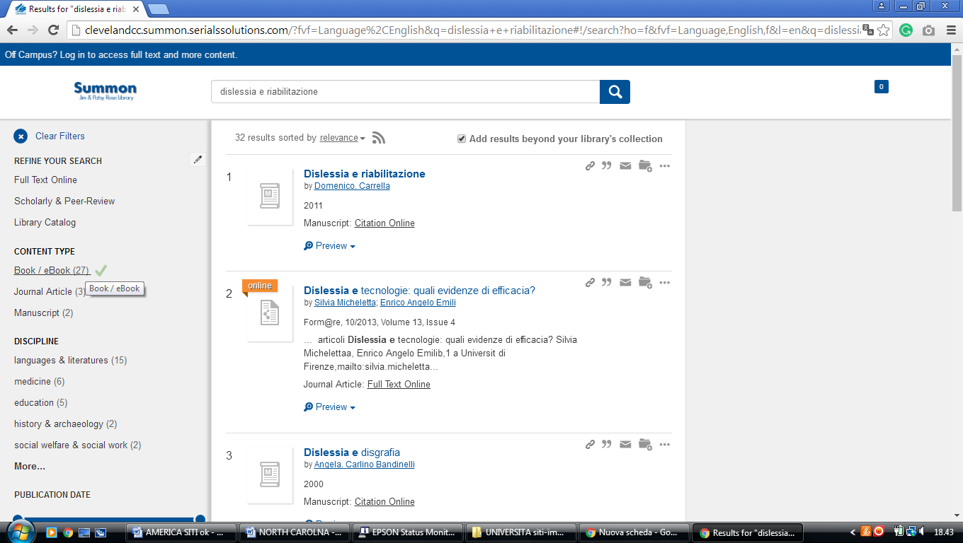

2 CARLYLE CAMPBELL LIBRARY – (Raleigh, North Carolina, Usa)
https://meredith.summon.serialssolutions.com/?fvf=ContentType%2CBook+Review%2Ct&q=dislessia+e+riabilitazione#!/search?ho=f&fvf=ContentType,Book%20Review,t&l=en&q=dislessia%20e%20riabilitazione

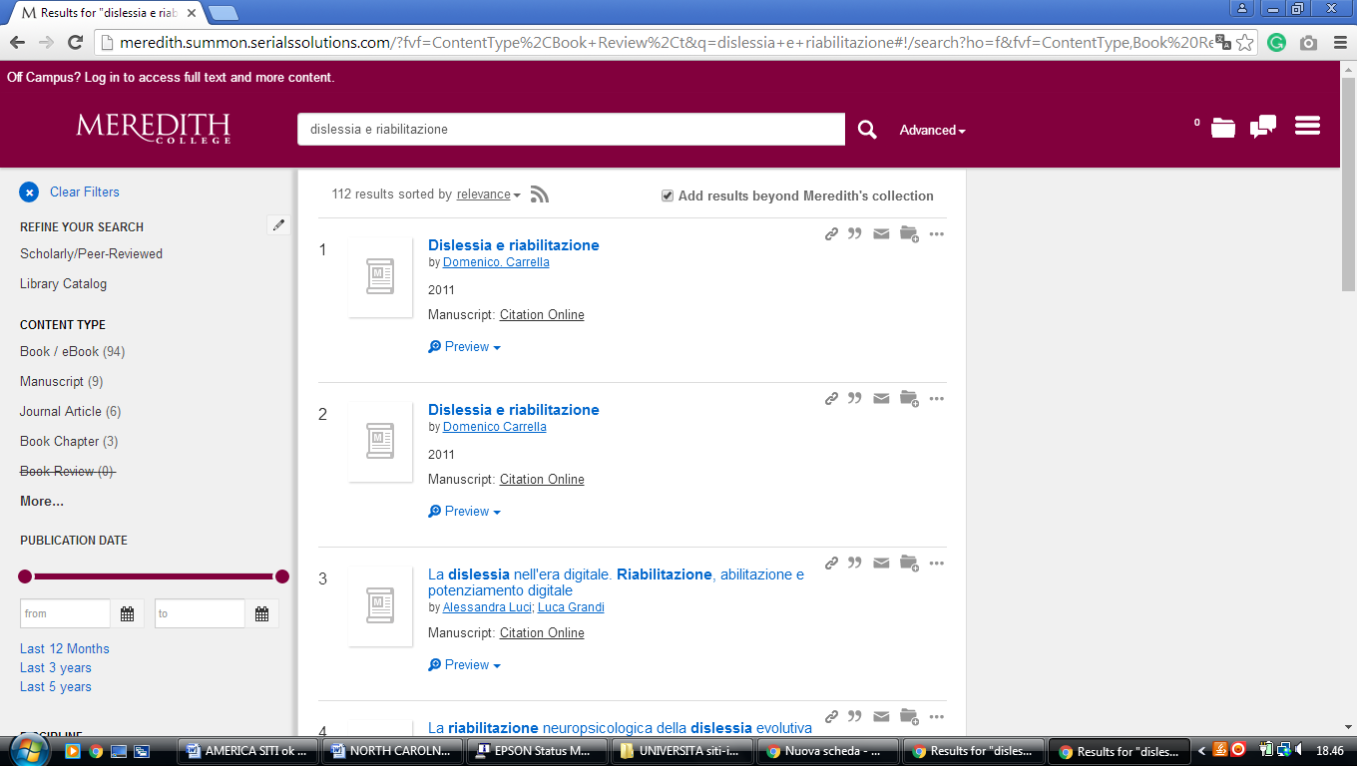

3 CATAWBA COLLEGE LIBRARY – (Salisbury, North Carolina, Usa)
https://catawba.worldcat.org/title/dislessia-e-riabilitazione-trattamento-integrato-oculare-della-dislessia-superficiale-con-il-leggio-elettrico/oclc/878784487&referer=brief_results

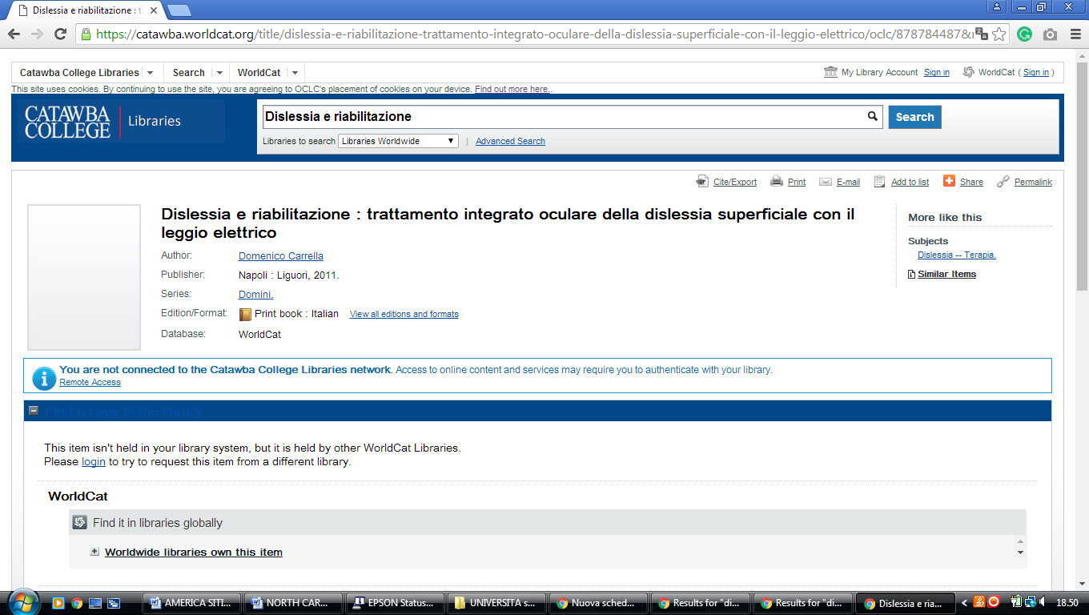

4 DAVIDSON COLLEGE LIBRARY – (Davidson, North Carolina, Usa)
https://davidson.on.worldcat.org/search?sortKey=LIBRARY&databaseList=&queryString=dislessia+e+riabilitazione&changedFacet=&clusterResults=off&scope=&format=&database=all&author=all&year=all&yearFrom=&yearTo=&language=all&topic=all

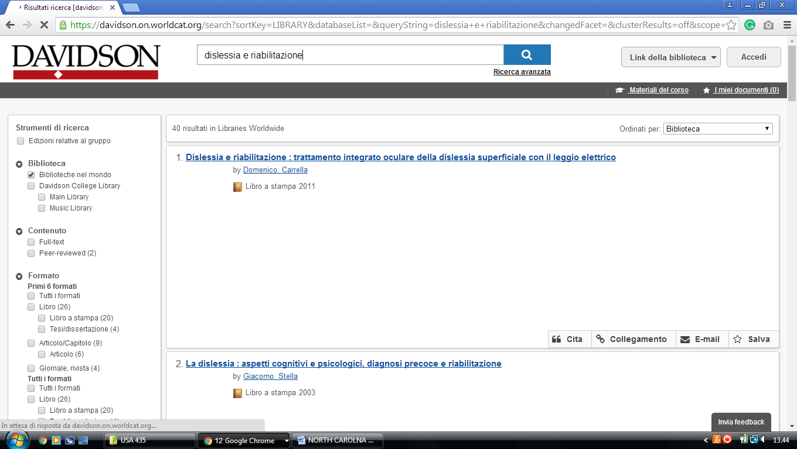

5 GUILFORD TECHNICAL COMMUNITY COLLEGE LIBRARY - (Jamestown, N.C., Usa)
https://gtcc.on.worldcat.org/search?sortKey=LIBRARY&databaseList=&queryString=dislessia+e+riabilitazione&changedFacet=&clusterResults=off&scope=&format=all&database=all&author=all&year=all&yearFrom=&yearTo=&language=all&topic=all

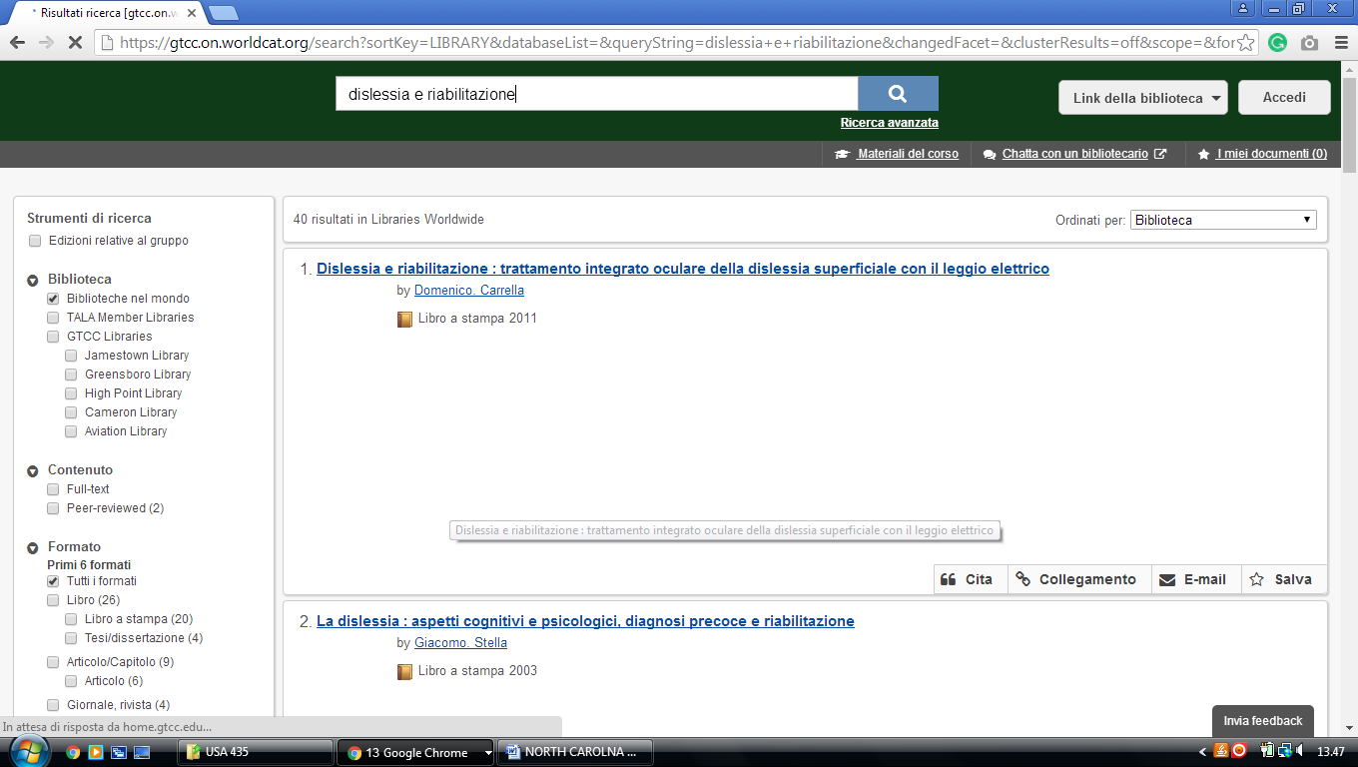

6 HIGH POINT UNIVERSITY LIBRARIES – (High Point, North Carolina, Usa)
https://hpulibraries.on.worldcat.org/search?sortKey=BEST_MATCH&databaseList=&queryString=dislessia+e+riabilitazione&changedFacet=scope&scope=&format=all&database=all&author=all&year=all&yearFrom=&yearTo=
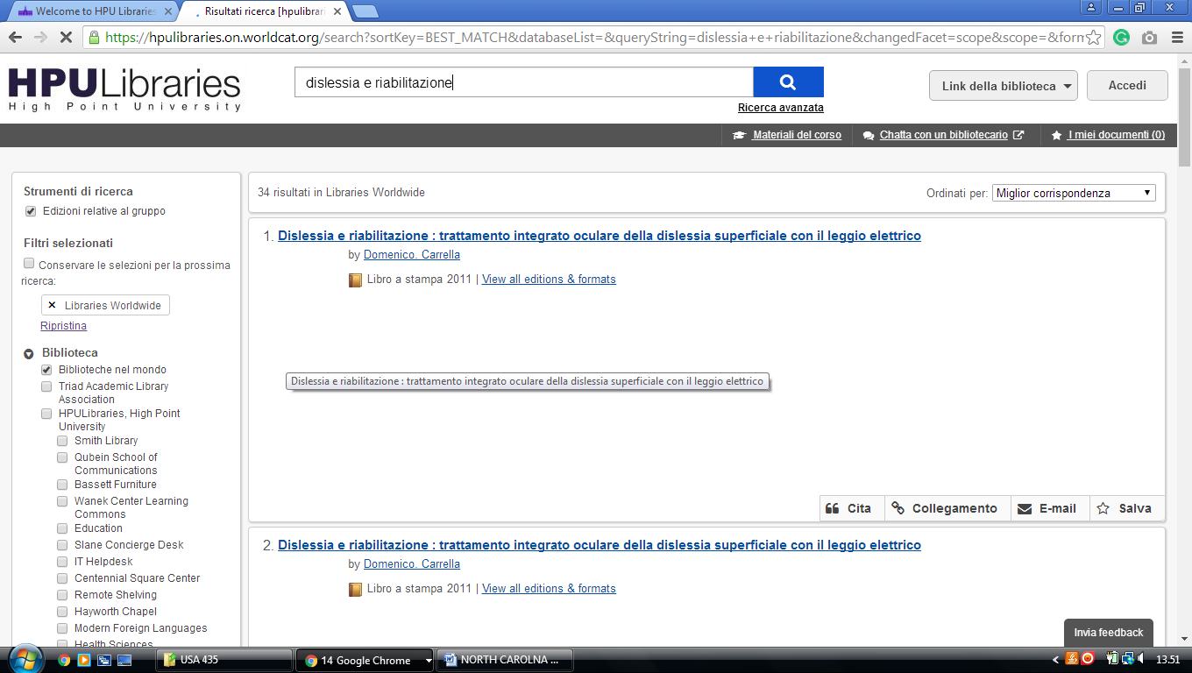

7 HOME | J. MURREY ATKINS LIBRARY | UNC CHARLOTTE – (Charlotte, North Carolina, Usa)
https://uncc.primo.exlibrisgroup.com/discovery/search?query=any,contains,dislessia%20e%20riabilitazione&vid=01UNCC_INST:01UNCC_INST&tab=Everything&search_scope=MyInst_and_CI&sortby=rank&pcAvailability=true

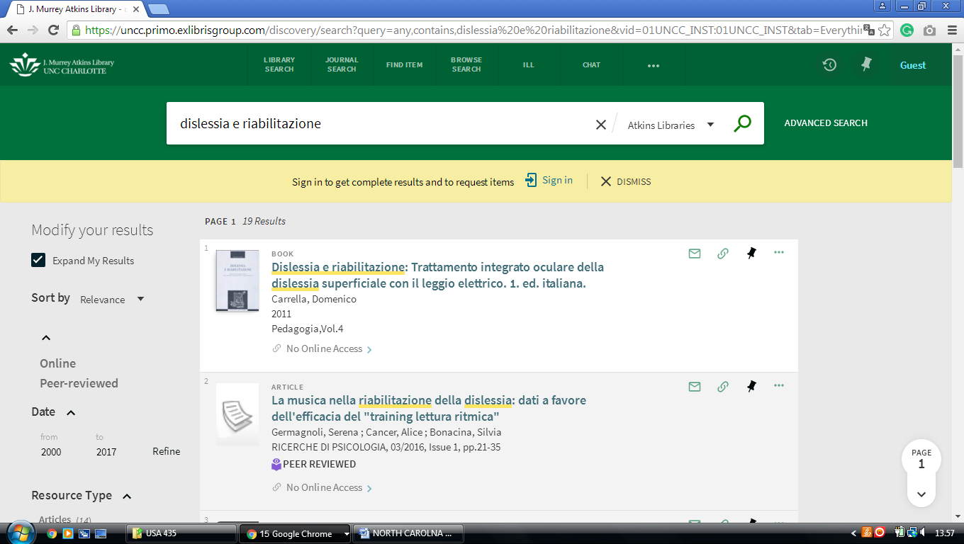

8 JOYNER LIBRARY – (Greenville, North Carolina,Usa)
https://eastcarolina.summon.serialssolutions.com/search?q=+++dislessia+e+riabilitazione++&submit=#!/search?ho=f&l=it-IT&q=%20%20%20dislessia%20e%20riabilitazione%20%20

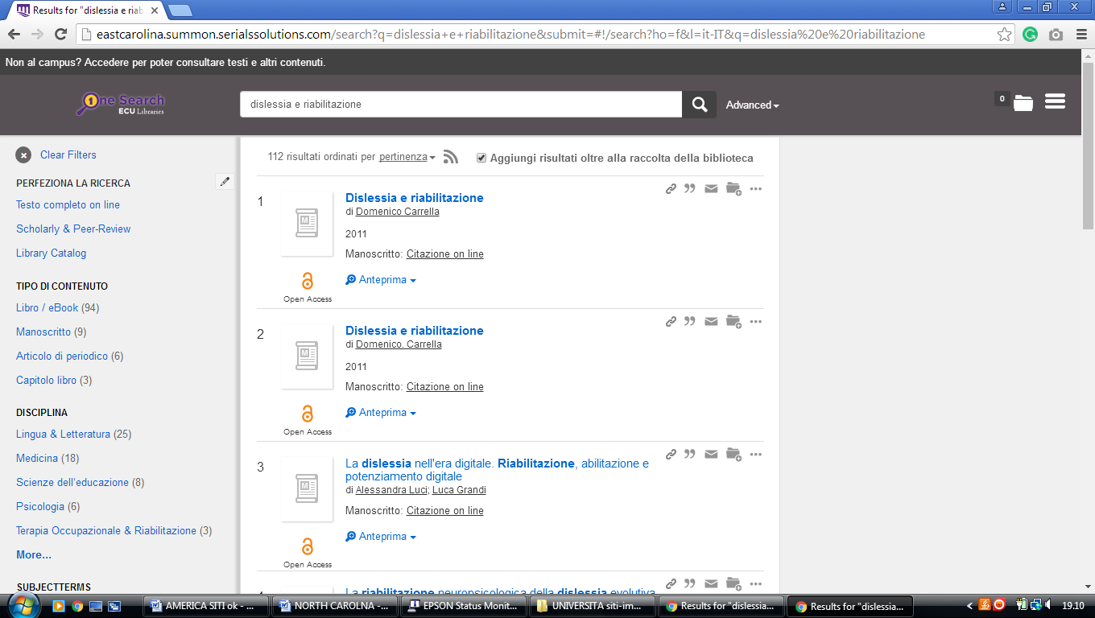

9 WAKE TECH LIBRARIES – (Raleigh, North Carolina, Usa)
http://waketech.summon.serialssolutions.com/?fvf=Language%2CEnglish&q=dislessia+e+riabilitazione#!/search?ho=f&fvf=Language,English,f&l=en&q=dislessia%20e%20riabilitazione

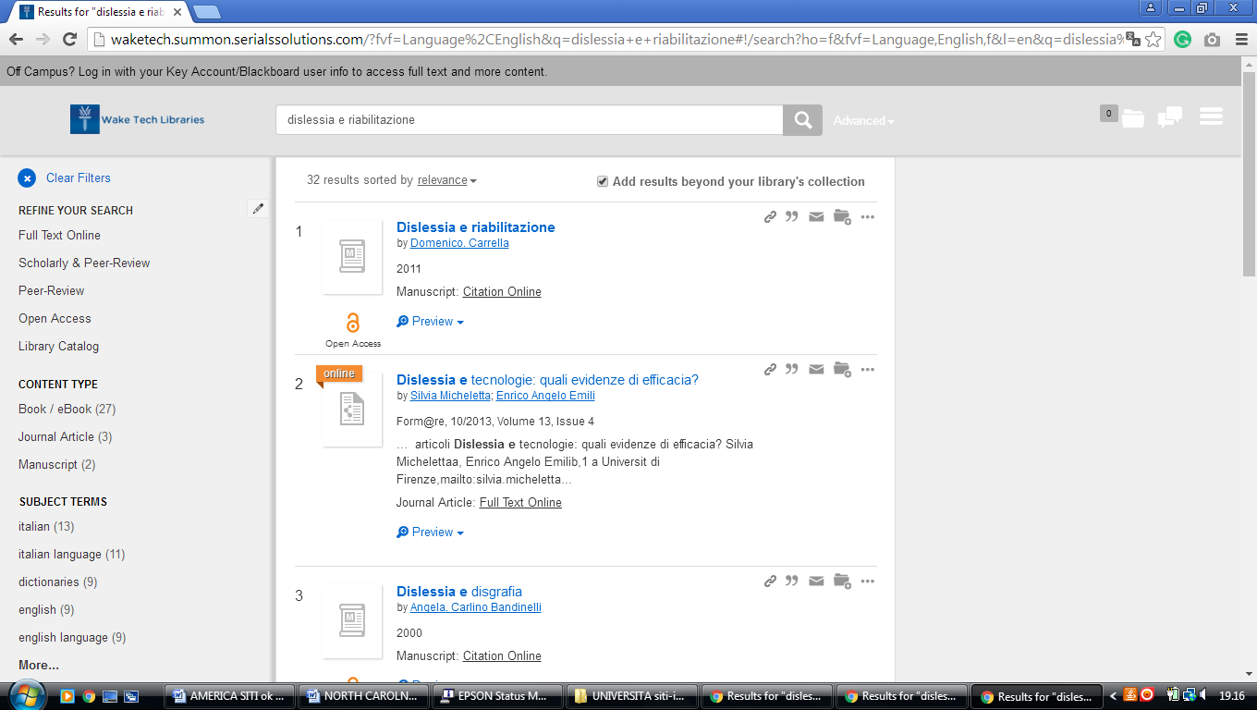

10 WALTER CLINTON JACKSON LIBRARY – (Greensboro, North Carolina, Usa)
http://uncg.worldcat.org/title/dislessia-e-riabilitazione-trattamento-integrato-oculare-della-dislessia-superficiale-con-il-leggio-elettrico/oclc/878784487&referer=brief_results

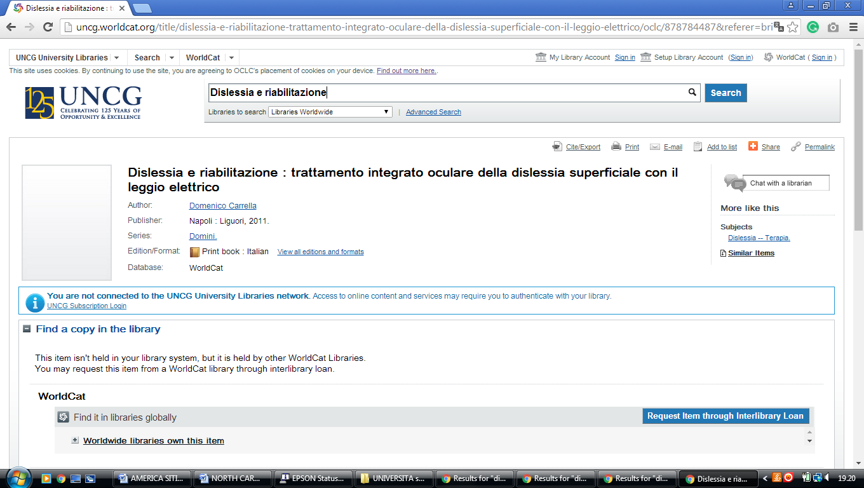

11 WARREN WILSON COLLEGE LIBRARY – (Asheville, North Carolina, Usa)
http://warrenwilson.summon.serialssolutions.com/#!/search?ho=f&l=en&q=dislessia%20e%20riabilitazione

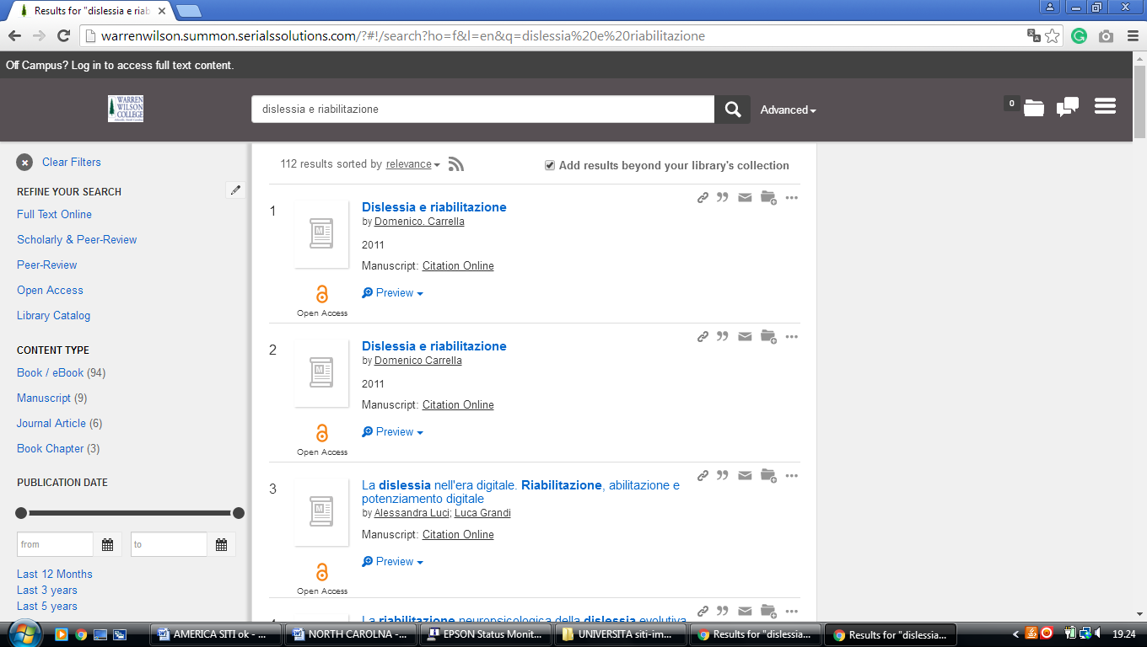

12 Z. SMITH REYNOLDS LIBRARY – (Winston-Salem, North Carolina, Usa)
https://wfu.summon.serialssolutions.com/#!/search?ho=f&fvf=ContentType,Newspaper%20Article,t%7CContentType,Book%20Review,t&l=en&q=dislessia%20e%20riabilitazione&_ga=2.53804008.1158008487.1521638958-1218349051.1521638958

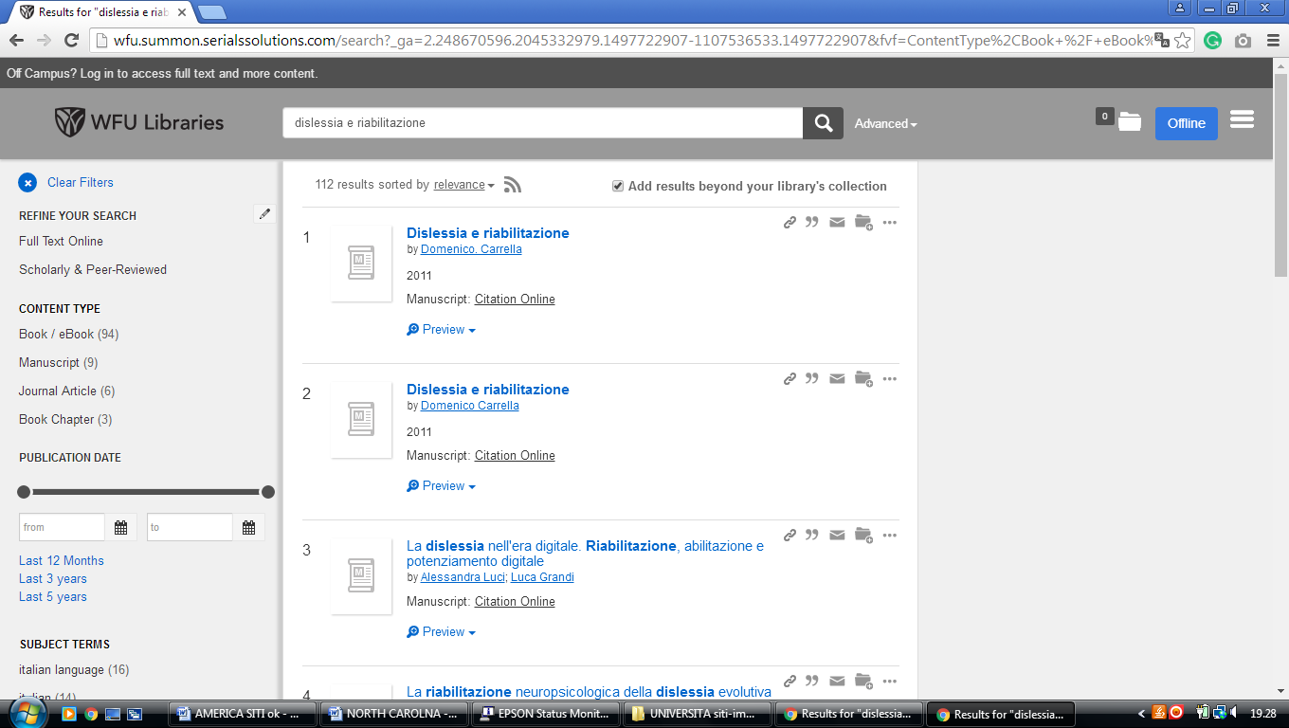

13 ELON UNIVERSITY, LIBRARY – (Elon, North Carolina, Usa)
https://elonuniversity.on.worldcat.org/search?queryString=dislessia+e+riabilitazione

