NEW JERSEY = 4

1 CAMPBELL LIBRARY – (Glassboro, New Jersey, Usa)
https://rowan.summon.serialssolutions.com/search?s.q=dislessia+e+riabilitazione#!/search?ho=f&l=en&q=dislessia%20e%20riabilitazione

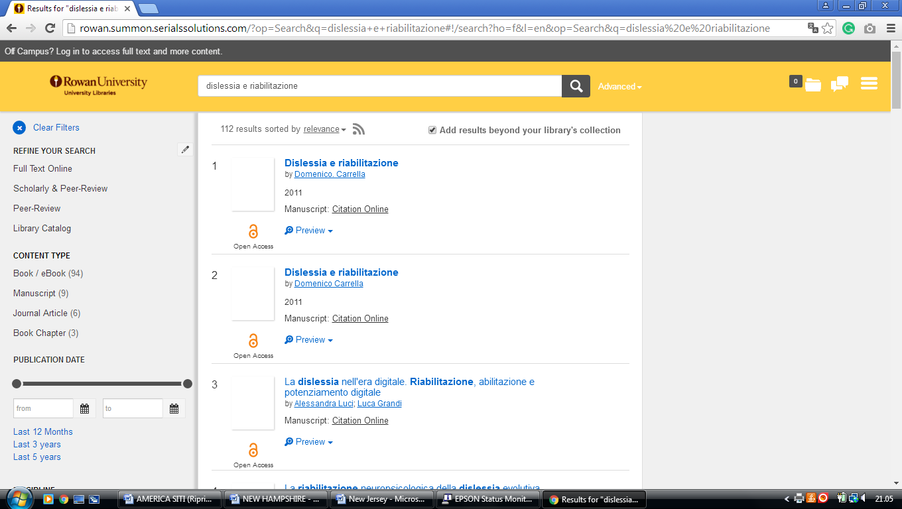

2 SAMUEL C. WILLIAMS LIBRARY - STEVENS INSTITUTE OF TECHNOLOGY

(Hoboken, New Jersey, Usa)

https://stevens.on.worldcat.org/external-search?queryString=dislessia%20e%20riabilitazione&databaseList=2375,2570,173,251,1931,233,1875,1697,3313,217,638,3879,1271,2261,2260,285,143,3404,245,2237,2259,2897,203,2278,1708,3867&page=1&queryType=search&stickyFacetsChecked=false

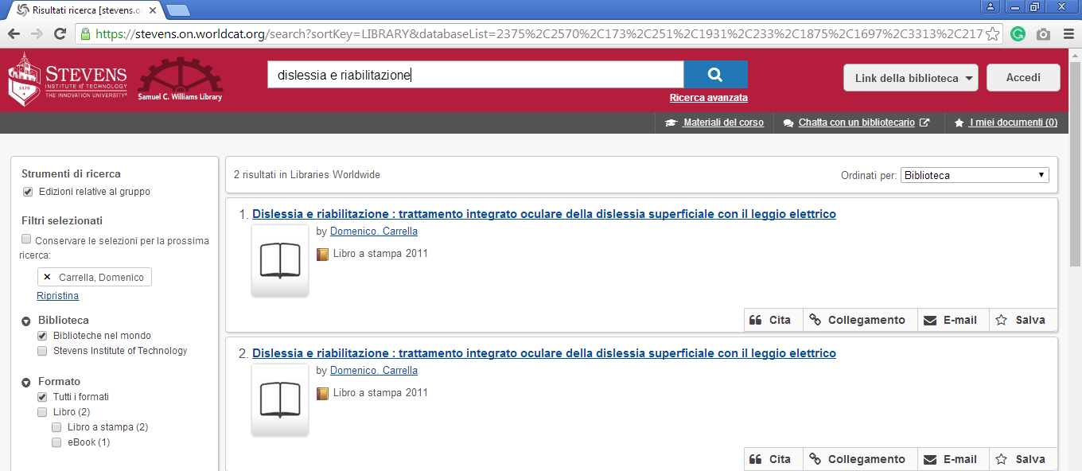

3 SETON HALL UNIVERSITY LIBRARY – (South Orange, New Jersey, Usa)
https://setonhall.on.worldcat.org/search?databaseList=283&queryString=dislessia+e+riabilitazione&clusterResults=false&scope=

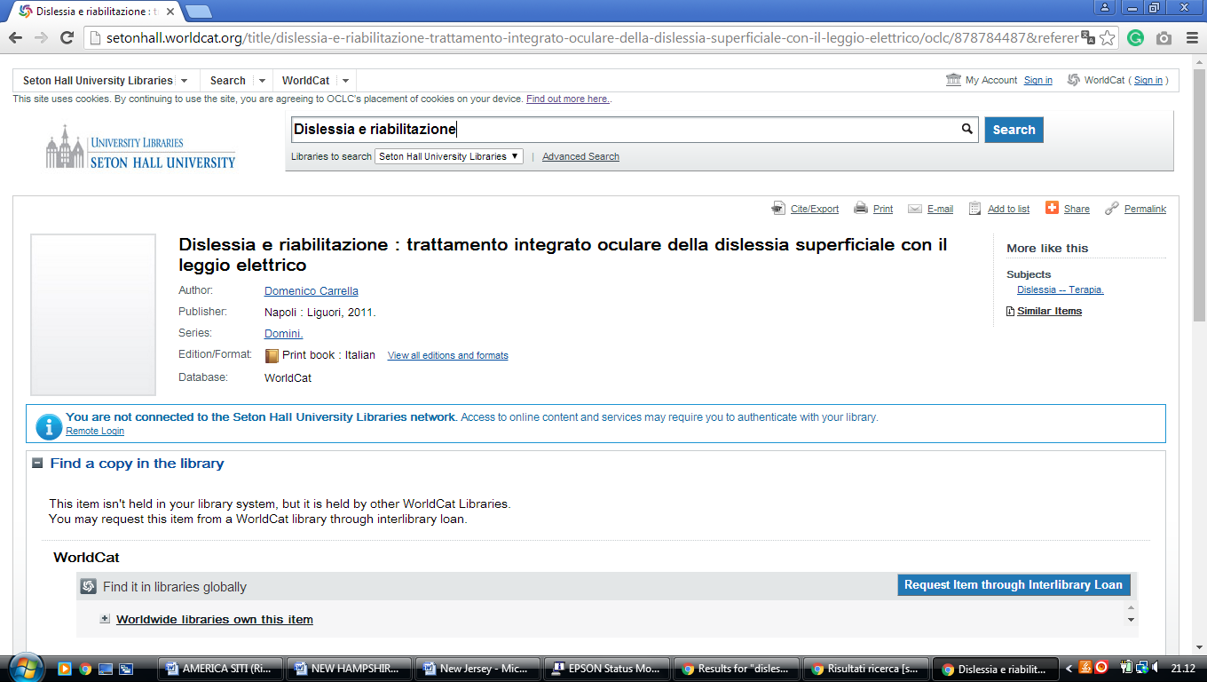

4 PRINCETON UNIVERSITY LIBRARY: HOME PAGE – (Princeton, New Jersey, Usa)
http://princeton.summon.serialssolutions.com/search?s.q=dislessia+e+riabilitazione&s.fvf=IsScholarly,true&keep_r=true&s.dym=t&s.ho=t#!/search?ho=f&l=en&q=dislessia%20e%20riabilitazione&dym=t

