OHIO = 9

1 UNIVERSITY OF CINCINNATI LIBRARIES – (Cincinnati, Ohio, Usa)
https://uc.summon.serialssolutions.com/search?q=dislessia+e+riabilitazione&x=18&y=13#!/search?ho=f&l=en&q=dislessia%20e%20riabilitazione&x=18&y=13
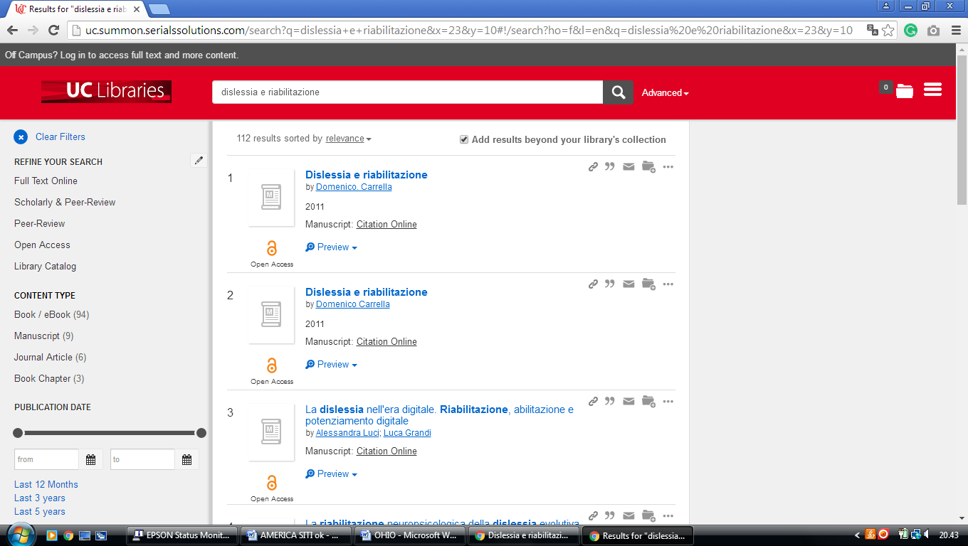

2 BOWLING GREEN STATE UNIVERSITY LIBRARY – (Ohio, Usa)
https://bgsu.summon.serialssolutions.com/search?s.q=dislessia+e+riabilitazione&spellcheck=true#!/search?ho=f&l=en&q=dislessia%20e%20riabilitazione

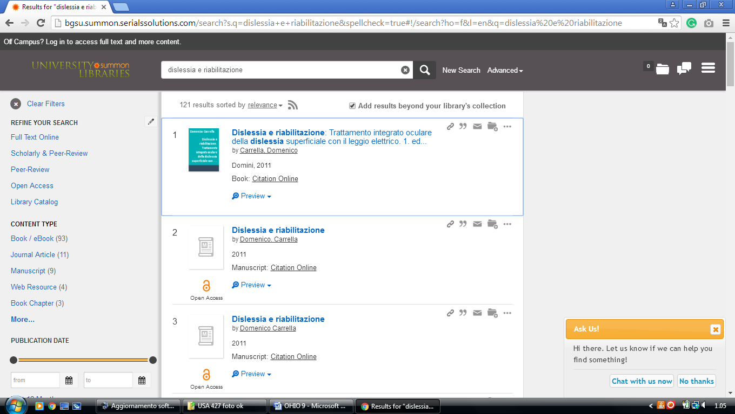

3 KELVIN SMITH LIBRARY – (Cleveland, Ohio, Usa)
http://case.summon.serialssolutions.com/search?s.q=dislessia+e+riabilitazione#!/search?ho=f&l=it-IT&q=dislessia%20e%20riabilitazione
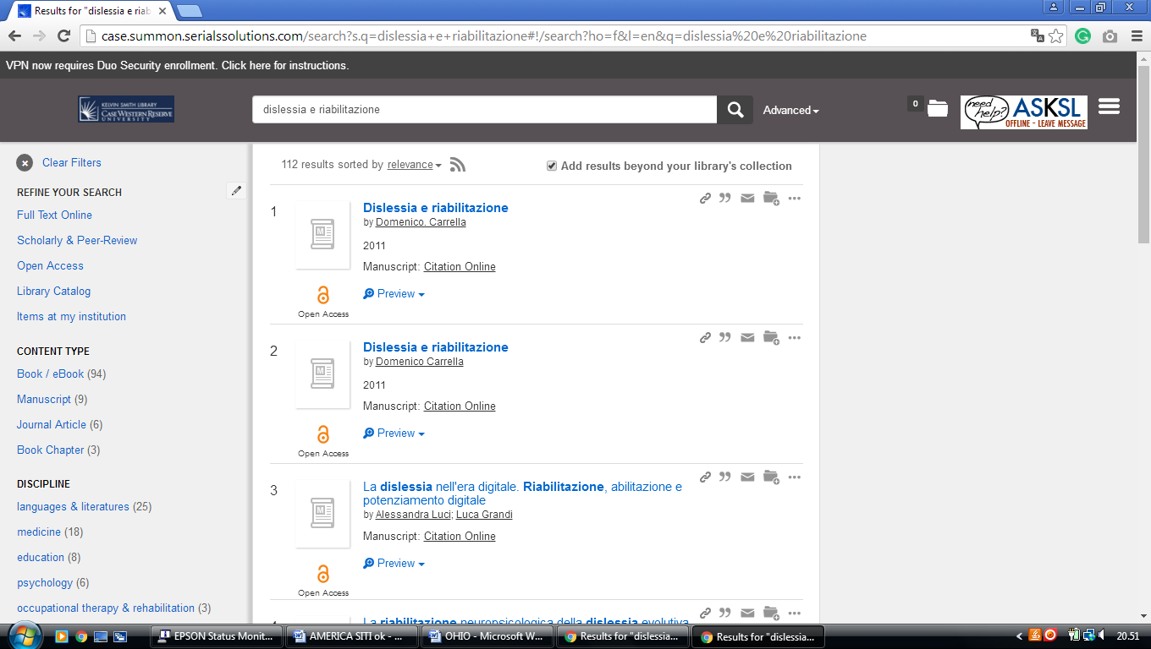

4 KENT STATE UNIVERSITY LIBRARY – (Kent, Ohio, Usa)
http://eds.a.ebscohost.com/eds/results?vid=0&sid=b9928991-70ca-4c01-a1ba-e4d0bbe780b0%40sessionmgr4010&bquery=dislessia+e+riabilitazione&bdata=JkF1dGhUeXBlPWlwJnR5cGU9MSZzaXRlPWVkcy1saXZlJnNjb3BlPXNpdGU%3d

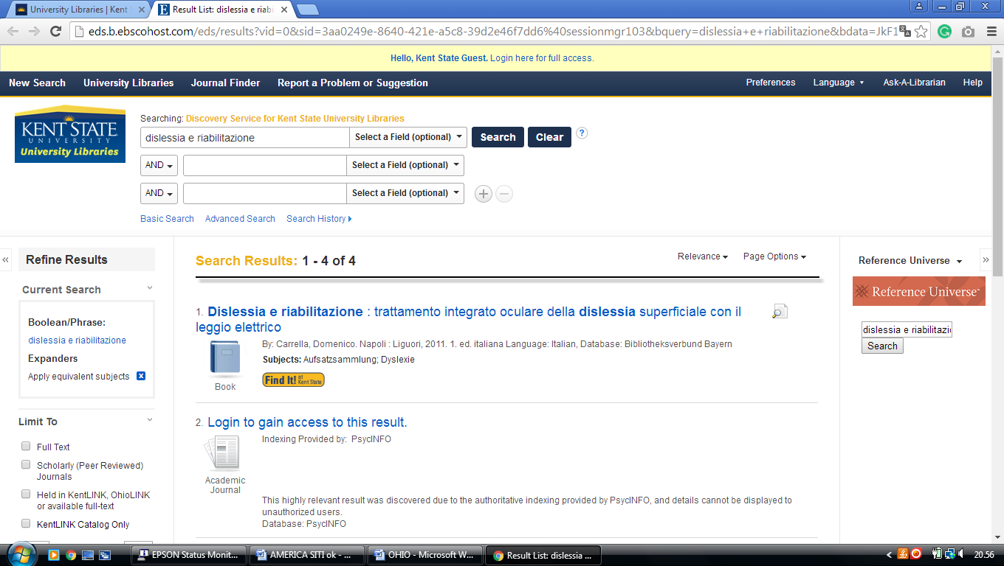

5 OBERLIN COLLEGE LIBRARY – (Oberlin, Ohio, Usa)
http://oberlin.summon.serialssolutions.com/search?s.q=dislessia+e+riabilitazione+#!/search?ho=f&l=en&q=dislessia%20e%20riabilitazione%20

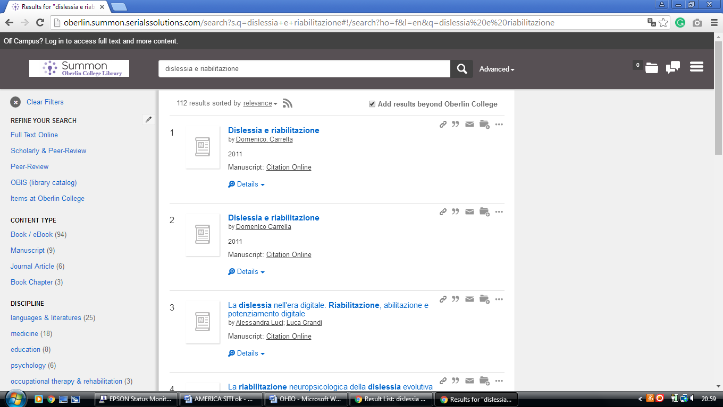

6 OHIO STATE UNIVERSITY LIBRARIES – (Columbus, Ohio, Usa)
http://osu.worldcat.org/search?q=kf%3Adislessia+e+riabilitazione&dblist=1461%2C1708%2C3909%2C1723%2C1725%2C239%2C638&se=%24d&sd=desc&fq=ap%3A%22carrella%2C+domenico%22&qt=facet_ap%3A

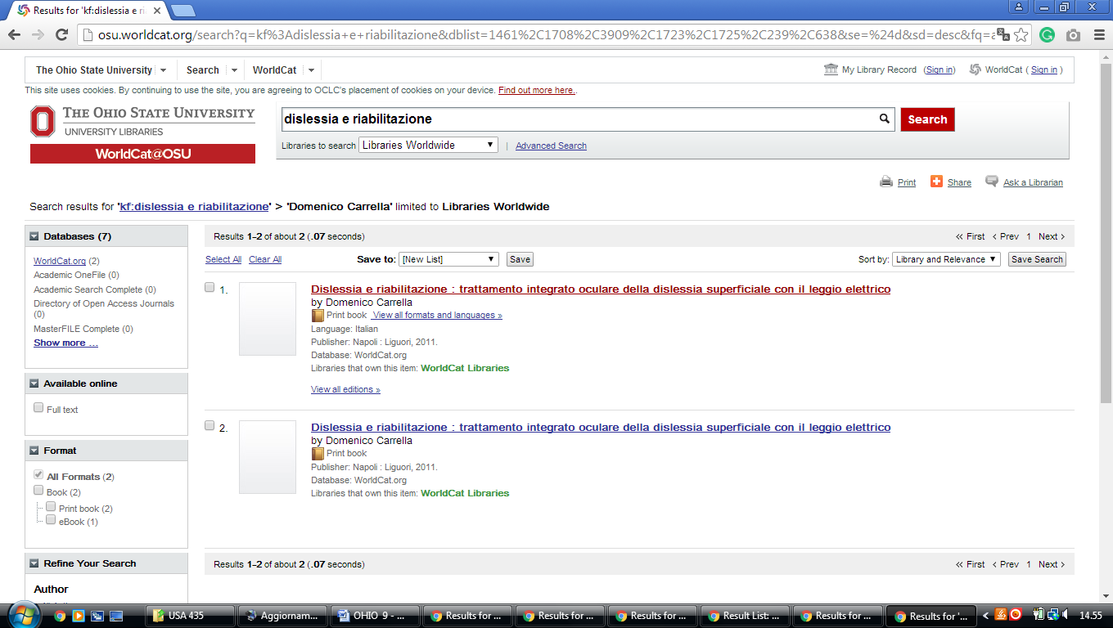

7 OHIO WESLEYAN UNIVERSITY LIBRARY – (Wesleyan, Ohio, Usa)
https://owu.summon.serialssolutions.com/search?ho=t&fvf=ContentType%2CNewspaper+Article%2Ct&fvf=ContentType%2CBook+Review%2Ct&q=dislessia+e+riabilitazione#!/search?ho=f&fvf=ContentType,Newspaper%20Article,t%7CContentType,Book%20Review,t&l=en&q=dislessia%20e%20riabilitazione
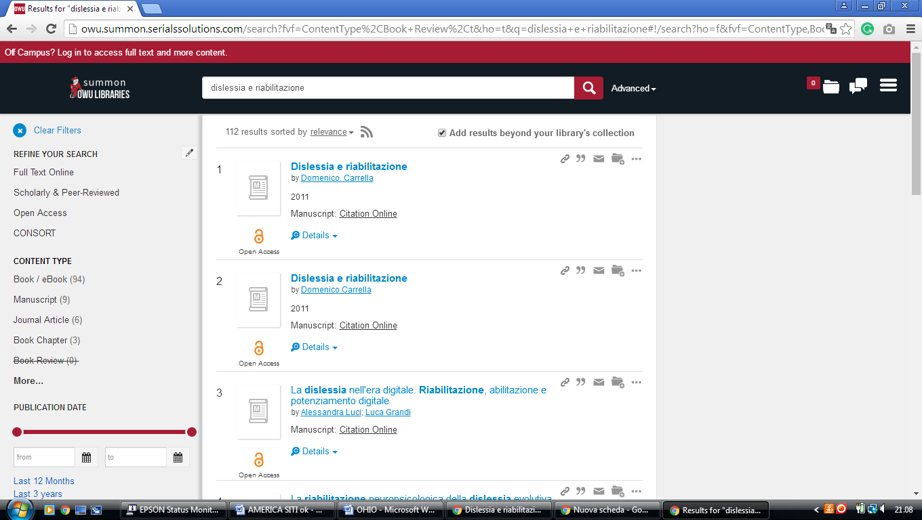

8 UC BLUE ASH COLLEGE LIBRARY – (Blue Ash, Ohio, Usa)
http://uc.summon.serialssolutions.com/search?q=dislessia+e+riabilitazione&search3.x=14&search3.y=19#!/search?ho=f&l=en&q=dislessia%20e%20riabilitazione&x=14&y=19
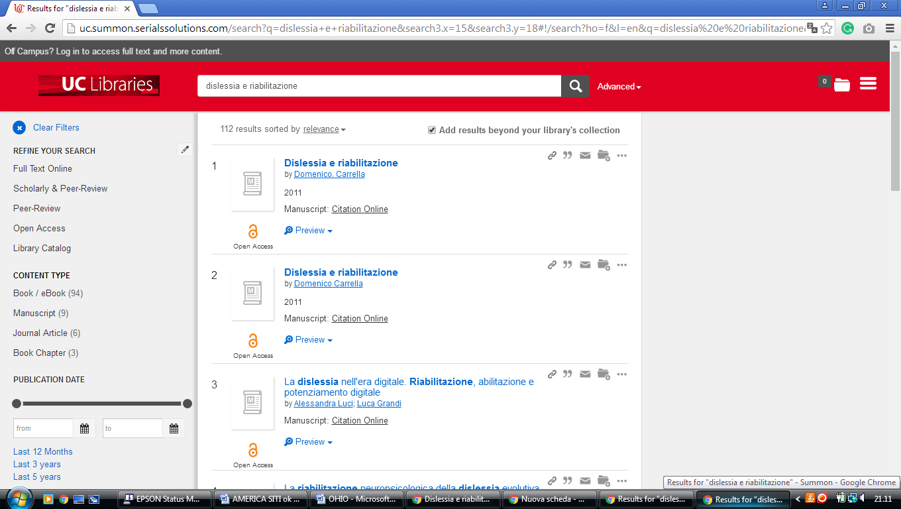

9 HEALTH SCIENCES LIBRARY MCMASTER UNIVERSITY – (Columbus, Ohio, Usa)
http://mcmasteruniversity.worldcat.org/search?q=dislessia+e+riabilitazione&dblist=638&se=%24d&sd=desc&fq=ap%3A%22carrella%2C+domenico%22&qt=facet_ap%3A

