OREGON = 5

1 BARBER LIBRARY - CENTRAL OREGON COMMUNITY COLLEGE – (Bend, Oregon, Usa)
https://centraloregoncc.on.worldcat.org/search?sortKey=LIBRARY&databaseList=638&queryString=dislessia+e+riabilitazione&changedFacet=author&clusterResults=off&scope=&format=all&database=all&author=Carrella%2C+Domenico&year=all&yearFrom=&yearTo=&language=all&topic=all
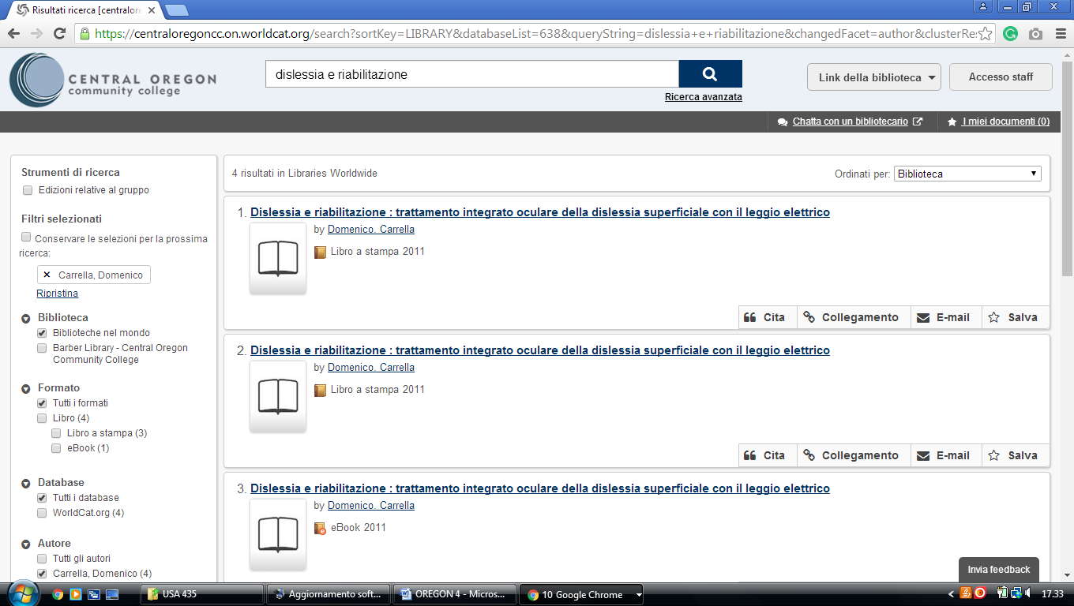

2 LINFIELD LIBRARIES | LINFIELD COLLEGE – (McMinnville, Oregon, Usa)
https://linfieldcollege.on.worldcat.org/search?sortKey=LIBRARY&databaseList=&queryString=dislessia+e+riabilitazione&changedFacet=author&scope=&format=all&database=all&author=Carrella%2C+Domenico&year=all&yearFrom=&yearTo=&language=all&topic=all

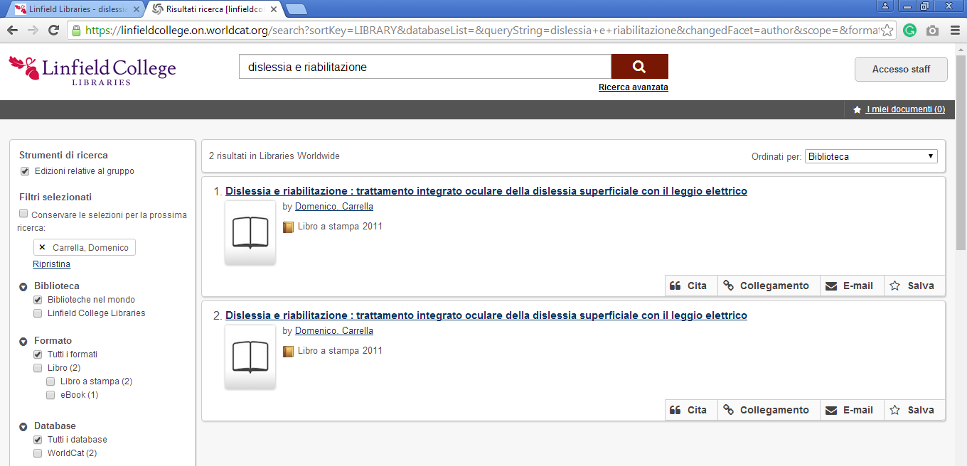

3 PIERCE LIBRARY, EASTERN OREGON UNIVERSITY – (La Grande, Oregon,
Usa)
https://easternoregon.on.worldcat.org/search?databaseList=&queryString=dislessia+e+riabilitazion

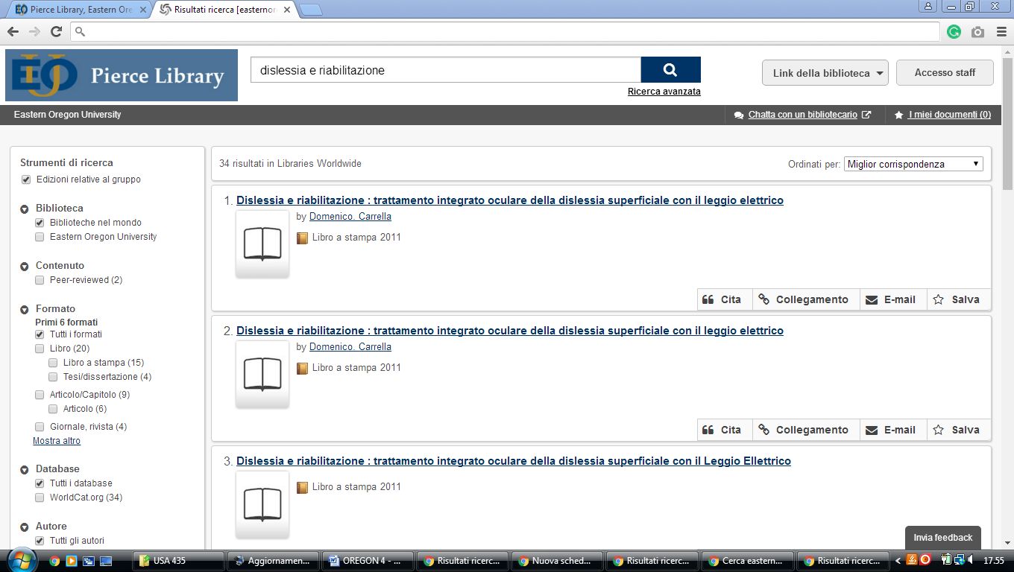

4 UNIVERSITY OF OREGON LIBRARIES – (Oregon, Usa)
https://uolibraries.on.worldcat.org/search?sortKey=LIBRARY&databaseList=283&queryString=kw%3A%28DISLESSIA+E+RIABILITAZIONE%29&changedFacet=author&scope=&format=all&database=all&author=Carrella%2C+Domenico&year=all&yearFrom=&yearTo=&language=all&topic=all

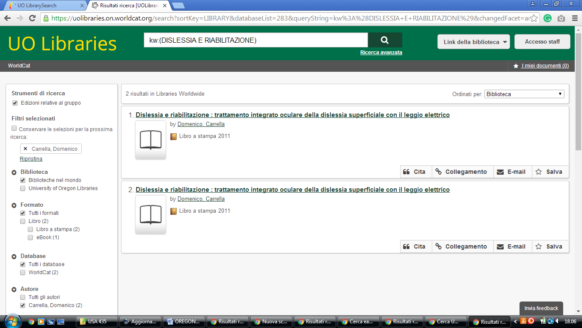

5 Hillsboro – Pacific University Libraries – (Oregon, Usa)
https://pacificu.on.worldcat.org/search?qt=worldcat_org_all&queryString=dislessia+e+riabilitazione
