PENNSYLVANIA = 16

1 QUICK START - LEHMAN - LIBRARY AT SHIPPENSBURG UNIVERSITY -
(Shippensburg, Pennsylvania, Usa)
http://shiplibrary.worldcat.org/search?q=dislessia+e+riabilitazione&dblist=638&se=%24d&sd=desc&fq=ap%3A%22carrella%2C+domenico%22&qt=facet_ap%3A
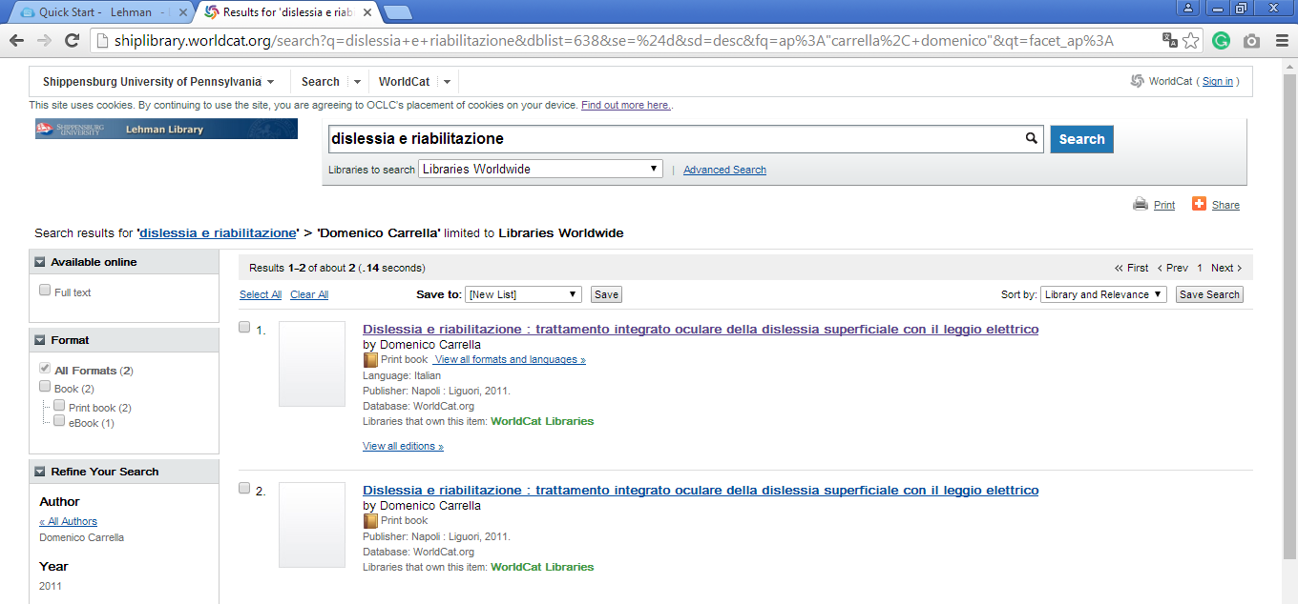

2 FALVEY MEMORIAL LIBRARY – (Villanova, Pennsylvania, Usa)
https://library.villanova.edu/Find/WorldcatRecord/745970355

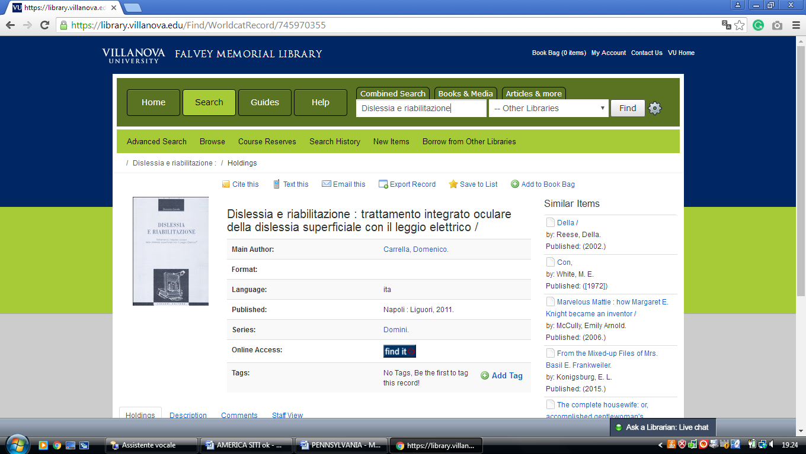

3 LA SALLE UNIVERSITY - CONNELLY LIBRARY – (Philadelphia, Penn., Usa)
http://lasalle.summon.serialssolutions.com/?q=dislessia+e+riabilitazione#!/search?ho=f&l=en&q=dislessia%20e%20riabilitazione

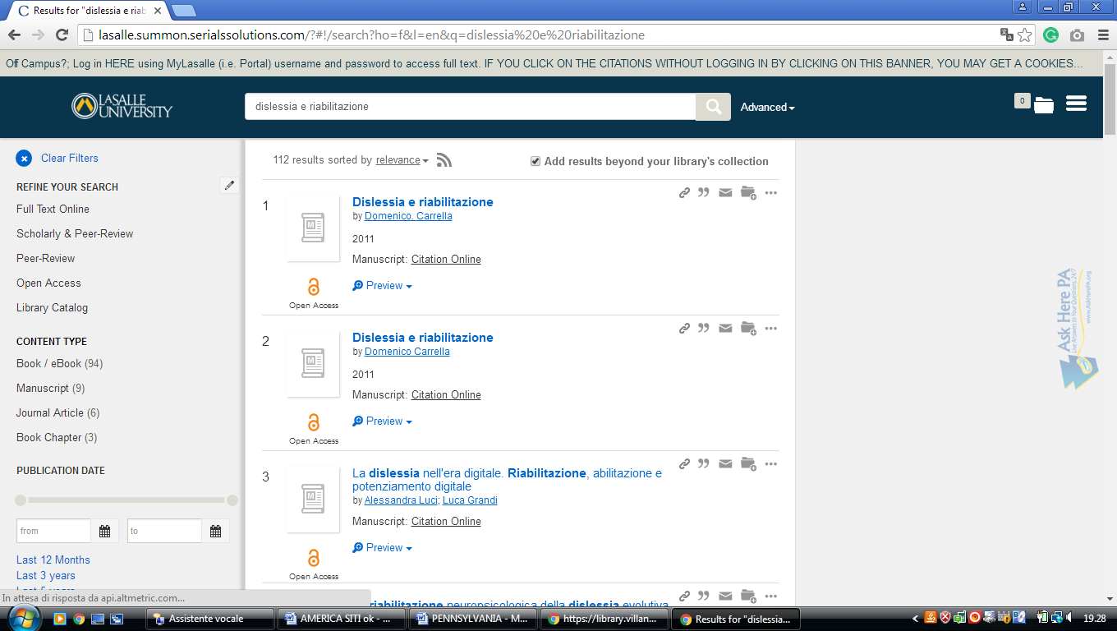

4 PENN LIBRARIES – (Philadelphia, Pennsylvania, Usa)
https://franklin.library.upenn.edu/bento?q=dislessia+e+riabilitazione&meta=t

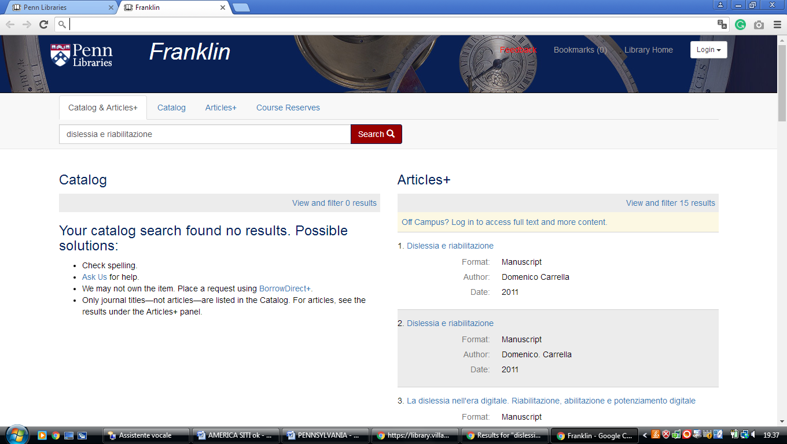

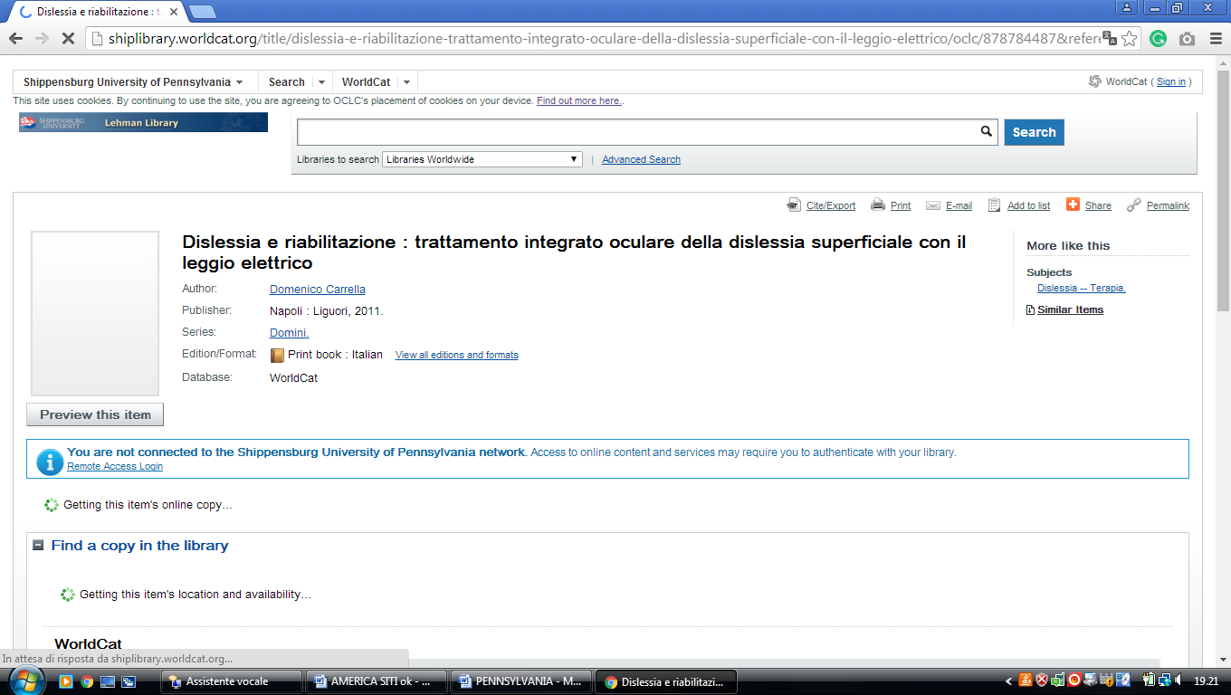
5 PENN STATE UNIVERSITY LIBRARIES – (State College, Penn., Usa)
https://psu.summon.serialssolutions.com/search/results?s.q=dislessia+e+riabilitazione#!/search?ho=f&l=en&q=dislessia%20e%20riabilitazione

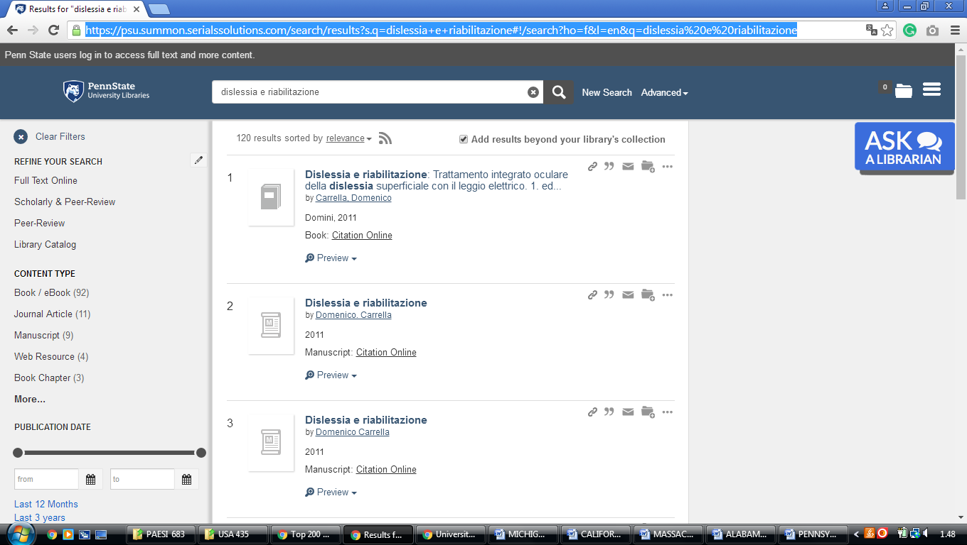

6 SAINT FRANCIS UNIVERSITY LIBRARY – (Loretto, Pennsylvania, Usa)
https://stfrancisuniversity.on.worldcat.org/search?sortKey=LIBRARY&databaseList=&queryString=dislessia+e+riabilitazione&changedFacet=author&scope=&format=all&database=all&author=Carrella%2C+Domenico&year=all&yearFrom=&yearTo=&language=all&topic=all

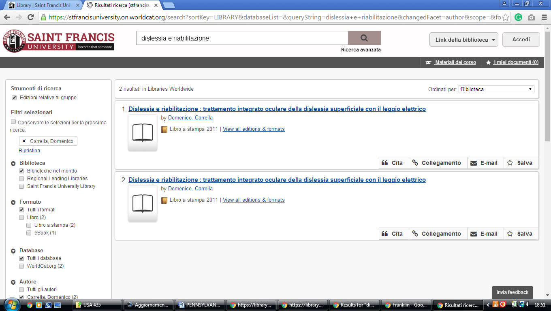

7 SCHMIDT LIBRARY – (York, Pennsylvania, Usa)
https://stfrancisuniversity.on.worldcat.org/search?sortKey=LIBRARY&databaseList=&queryString=dislessia+e+riabilitazione&changedFacet=author&scope=&format=all&database=all&author=Carrella%2C+Domenico&year=all&yearFrom=&yearTo=&language=all&topic=all

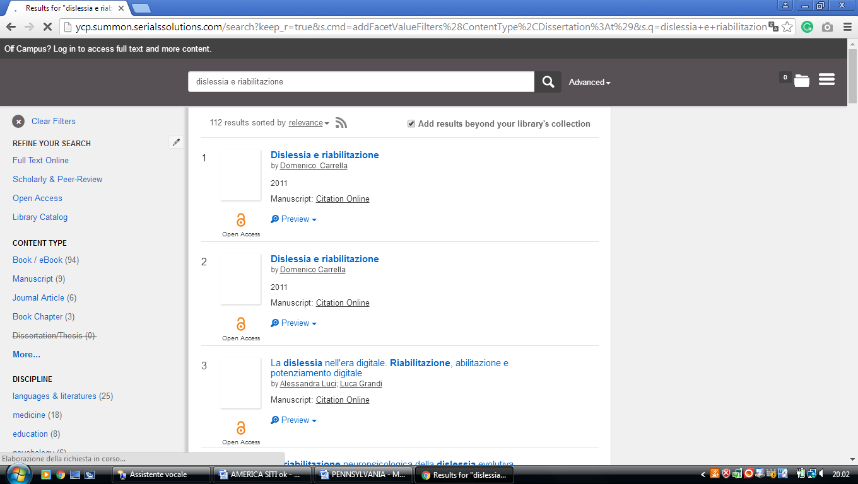

8 TEMPLE UNIVERSITY LIBRARIES – (Philadelphia, Pennsylvania, Usa)
https://temple-primo.hosted.exlibrisgroup.com/primo-explore/search?query=any,contains,&query=dislessia%20e%20riabilitazione&query=&vid=TULI&tab=default_tab&search_scope=default_scope&sortby=rank&pcAvailabilityMode=true&mode=Basic&displayMode=full&bulkSize=10&highlight=true&dum=true&displayField=all&pcAvailabiltyMode=true&pcAvailability=true

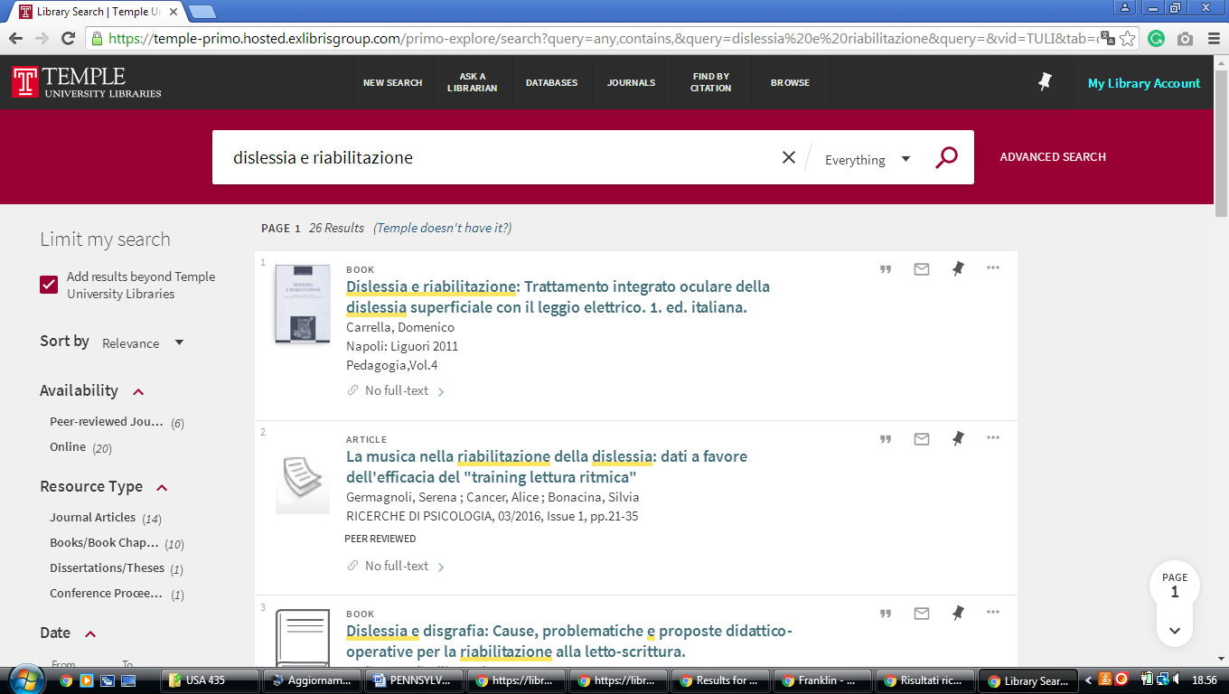

9 LIBRARY | EASTERN UNIVERSITY - (Wayne, Pennsylvania, Usa)
https://eastern.summon.serialssolutions.com/?q=dislessia%20riabilitazione#!/search?ho=f&l=en&q=dislessia%20riabilitazione

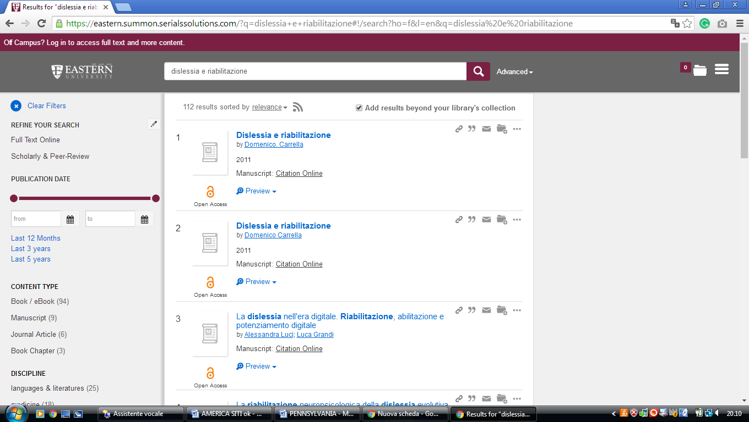

10 WASHINGTON AND JEFFERSON COLLEGE LIBRARY – (WA., Penn., Usa)
http://washjeff.summon.serialssolutions.com/search/results?q=dislessia+e+riabilitazione&submit=Unleash+Summon%21#!/search?ho=f&l=en&q=dislessia%20e%20riabilitazione&submit=Unleash%20Summon!

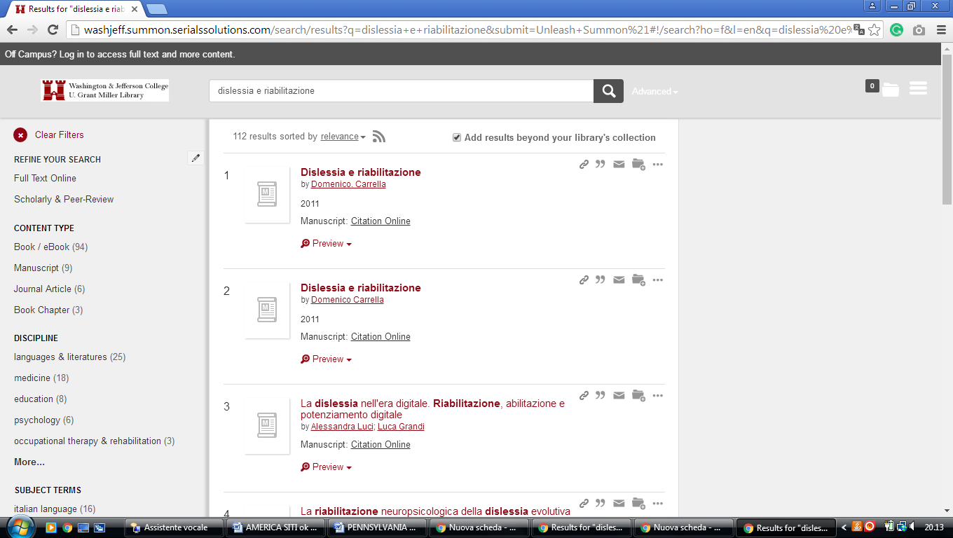

11 WESTMINSTER COLLEGE LIBRARY – (New Wilmington, Pennsylvania, Usa)
https://westminster.on.worldcat.org/search?sortKey=LIBRARY&databaseList=&queryString=dislessia+e+riabilitazione&changedFacet=author&scope=&format=all&database=all&author=Carrella%2C+Domenico&year=all&yearFrom=&yearTo=&language=all&topic=all

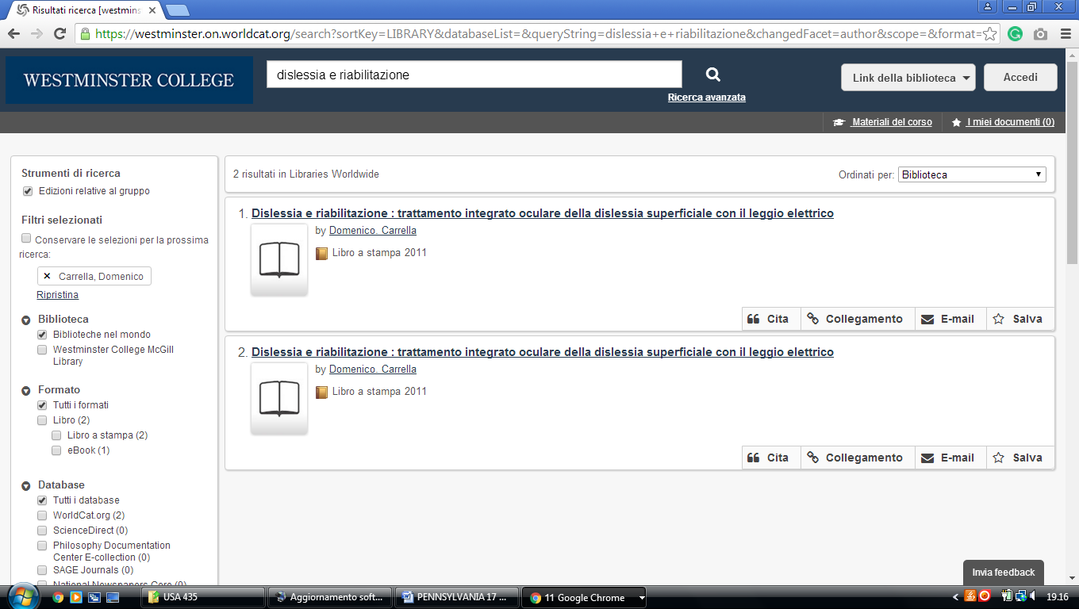

12 DIGITIZED COLLECTIONS « LIBRARY AND INFORMATION ... - ALLEGHENY COLLEGE LIBRARY - (Meadville, Pennsylvania, Usa)
https://allegheny.summon.serialssolutions.com/#!/search?ho=f&l=en&q=dislessia%20e%20riabilitazione

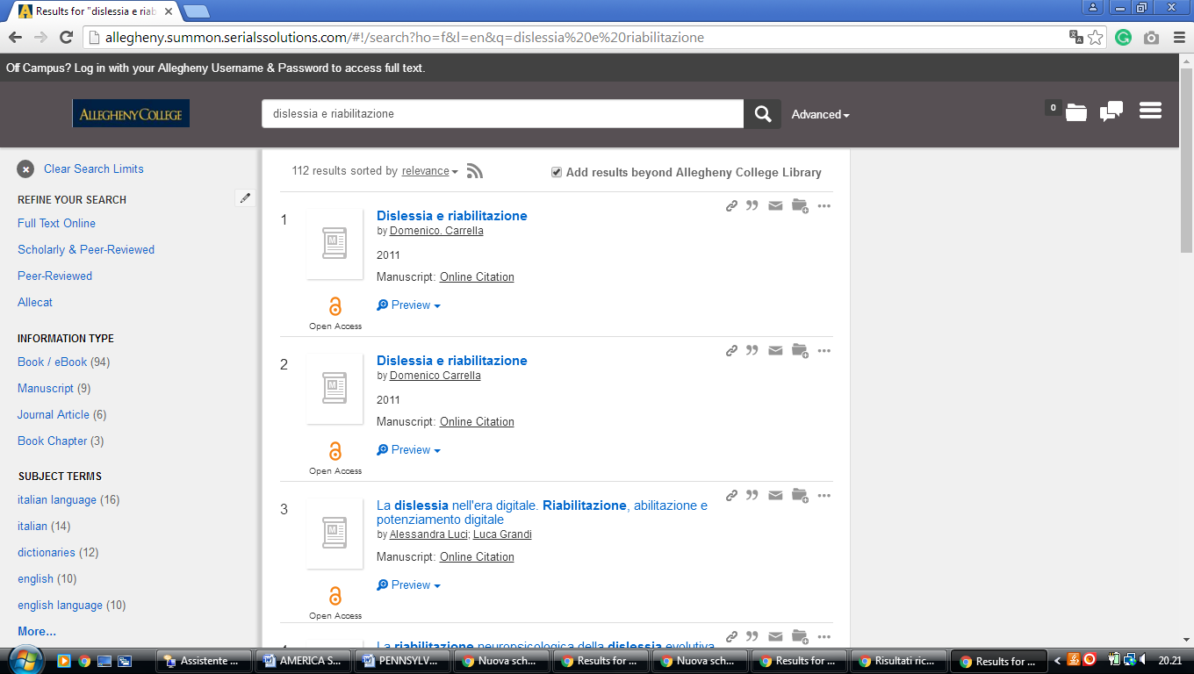

13 BLOOMSBURG UNIVERSITY OF PENN. LIBRARY – (Harvey A. Penn. Usa)
http://eds.a.ebscohost.com/eds/resultsadvanced?vid=7&sid=4b9f0aca-d28b-4eb9-8c66-daa180efade3%40sessionmgr4007&bquery=(dislessia+AND+e+AND+riabilitazione)&bdata=JnR5cGU9MSZzaXRlPWVkcy1saXZlJnNjb3BlPXNpdGU%3d

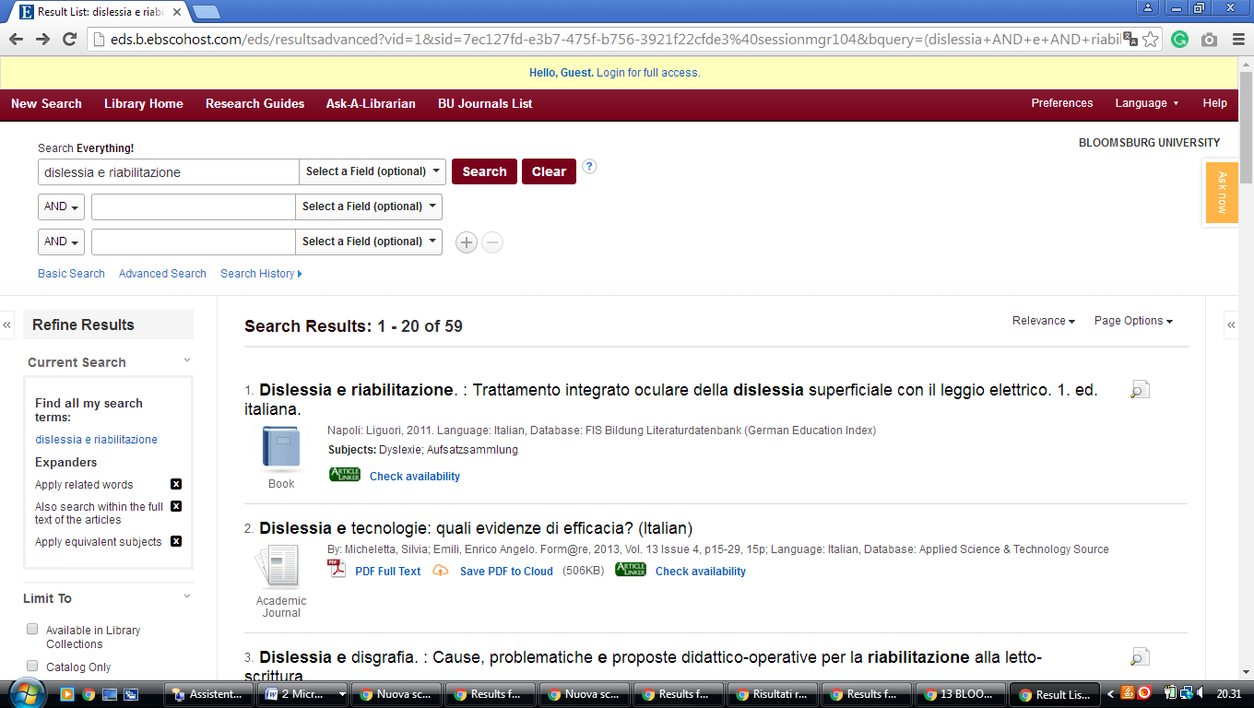

14 BUCKNELL UNIVERSITY, BERTRAND LIBRARY – (Lewisburg, PA, Usa)
https://bucknell.on.worldcat.org/search?sortKey=LIBRARY&databaseList=&queryString=dislessia+e+riabilitazione&changedFacet=author&scope=&format=all&database=all&author=Carrella%2C+Domenico&year=all&yearFrom=&yearTo=&language=all&topic=all

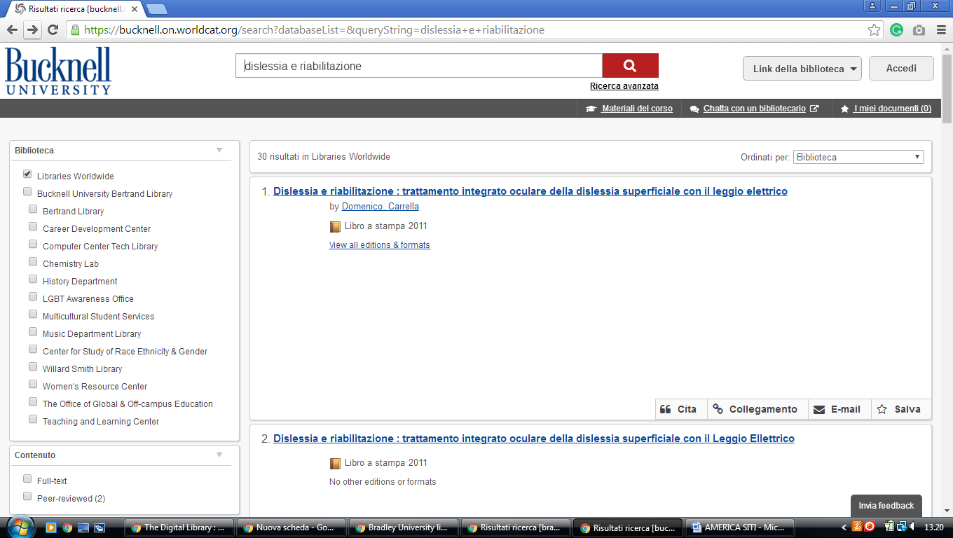

15 LIBRARY | HOLY FAMILY UNIVERSITY

https://holyfamily.on.worldcat.org/search?sortKey=LIBRARY_PLUS_RELEVANCE&databaseList=&queryString=dislessia+e+riabilitazione&changedFacet=author&stickyFacetsChecked=on&scope=&subformat=Book%3A%3Abook_printbook&subformat=Book%3A%3Abook_thsis&subformat=Book%3A%3Abook_digital&subformat=Book%3A%3Abook_mic&subformat=Book%3A%3Abook_largeprint&subformat=Book%3A%3Abook_braille&subformat=Book%3A%3Abook_continuing&database=all&author=Carrella%2C+Domenico&year=all&yearFrom=&yearTo=&language=all&topic=all

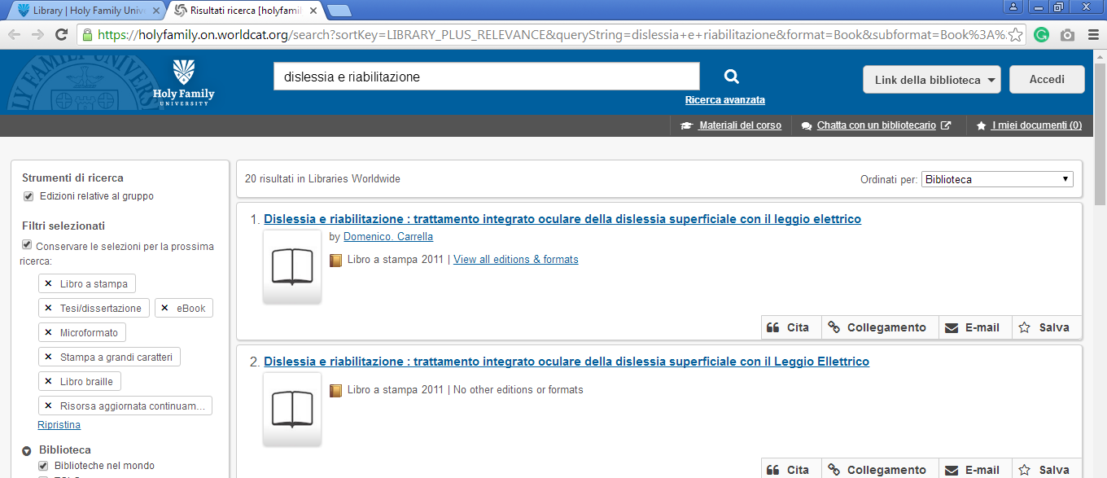

16 NORTH HALL LIBRARY - MANSFIELD UNIVERSITY - (Pennsylvania, Usa)
http://mansfieldpa.worldcat.org/search?q=dislessia+e+riabilitazione&dblist=638&se=%24d&sd=desc&fq=ap%3A%22carrella%2C+domenico%22&qt=facet_ap%3A
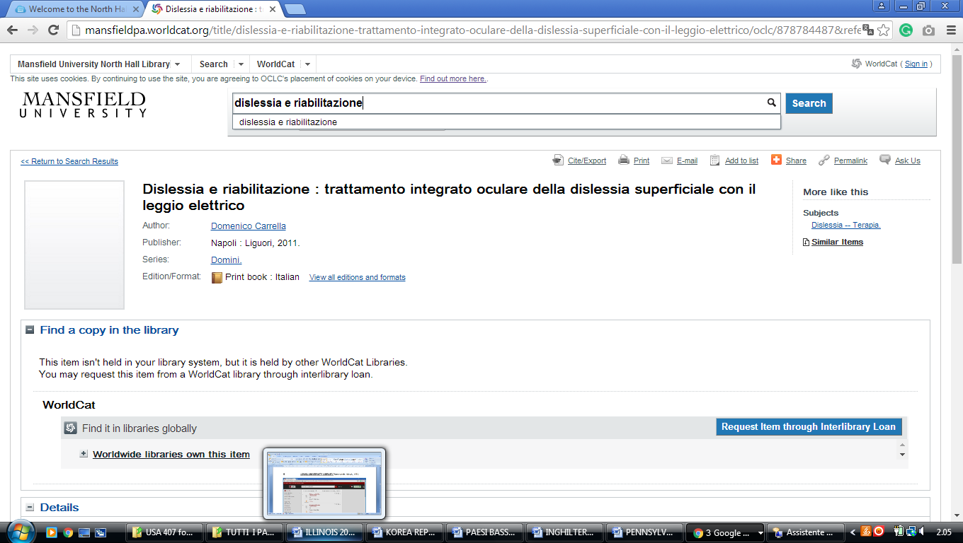

Drexel University Library
https://drexel.summon.serialssolutions.com/#!/search?ho=f&l=en&q=dislessia%20e%20riabilitazione

