RHODE ISLAND = 7

1 RHODE ISLAND COLLEGE LIBRARY (RI) – (Providence, Rhode Island, Usa) https://ric.on.worldcat.org/search?sortKey=LIBRARY&databaseList=&queryString=dislessia+e+riabilitazione&changedFacet=author&scope=&format=all&database=all&author=Carrella%2C+Domenico&year=all&yearFrom=&yearTo=&language=all&topic=all
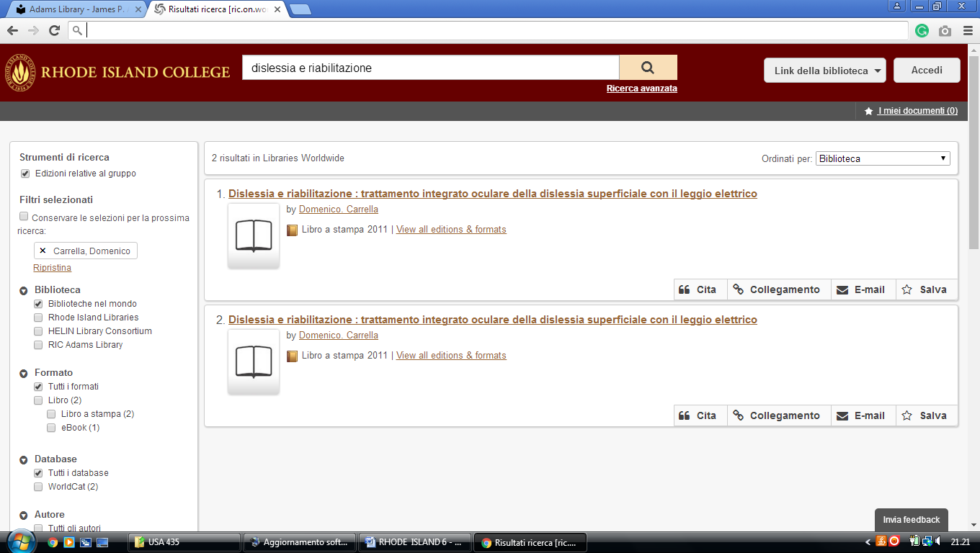

2 COMMUNITY COLLEGE OF RHODE ISLAND LIBRARY – (Warwick, R.I., Usa)
https://ccri.on.worldcat.org/search?sortKey=BEST_MATCH&databaseList=283&queryString=dislessia+e+riabilitazione&changedFacet=scope&clusterResults=off&stickyFacetsChecked=on&scope=

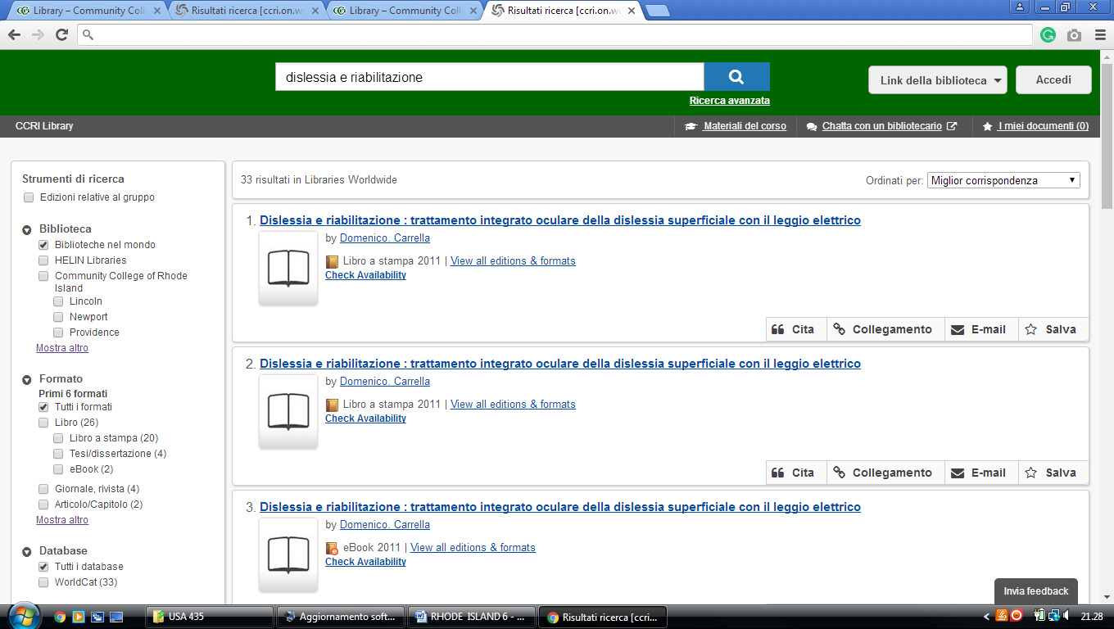

3 DOUGLAS AND JUDITH KRUPP LIBRARY – (Smithfield, R. I., Usa)
https://bryant.on.worldcat.org/search?sortKey=BEST_MATCH&databaseList=&queryString=kw%3A%2Cdislessia+e+riabilitazione&changedFacet=author&scope=&format=all&database=all&author=Carrella%2C+Domenico&year=all&yearFrom=&yearTo=&language=all&topic=all
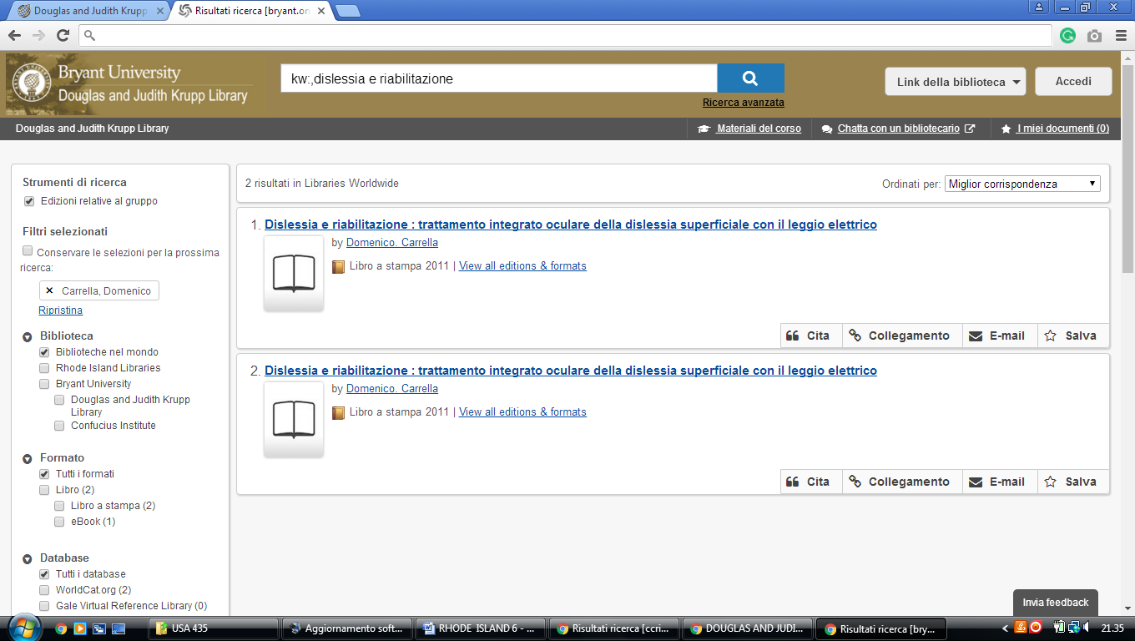

4 MCKILLOP LIBRARY LOGO MCKILLOP LIBRARY – (Newport, R.I., Usa)
https://salve.on.worldcat.org/search?sortKey=LIBRARY&databaseList=&queryString=dislessia+e+riabilitazione&changedFacet=author&scope=&format=all&database=all&author=Carrella%2C+Domenico&year=all&yearFrom=&yearTo=&language=all&topic=all
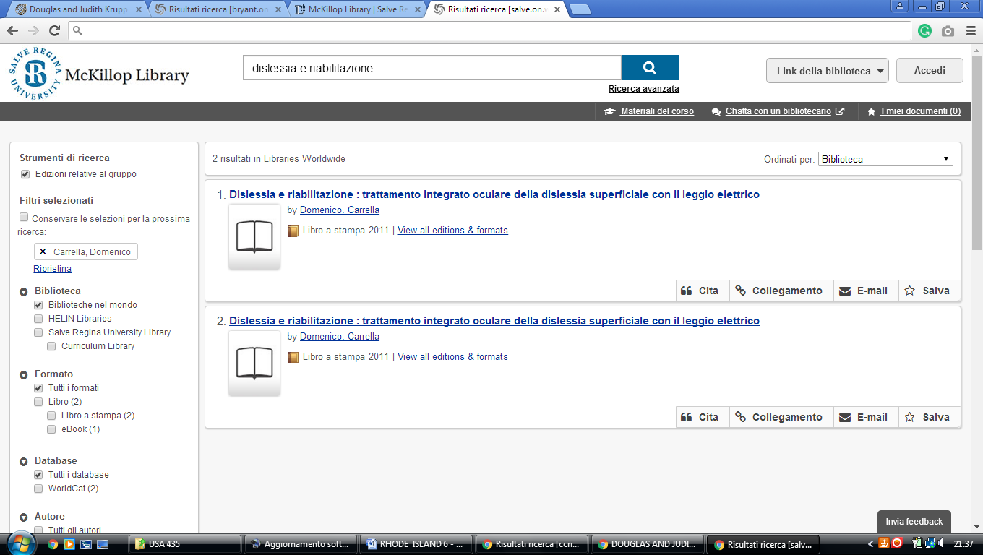

5 PHILLIPS MEMORIAL LIBRARY – (Providence, Rhode Island, Usa)
https://providencecollege.on.worldcat.org/search?sortKey=LIBRARY&databaseList=283%2C1708%2C638&queryString=dislessia+e+riabilitazione&changedFacet=author&clusterResults=off&scope=&format=all&database=all&author=Carrella%2C+Domenico&year=all&yearFrom=&yearTo=&language=all&topic=all
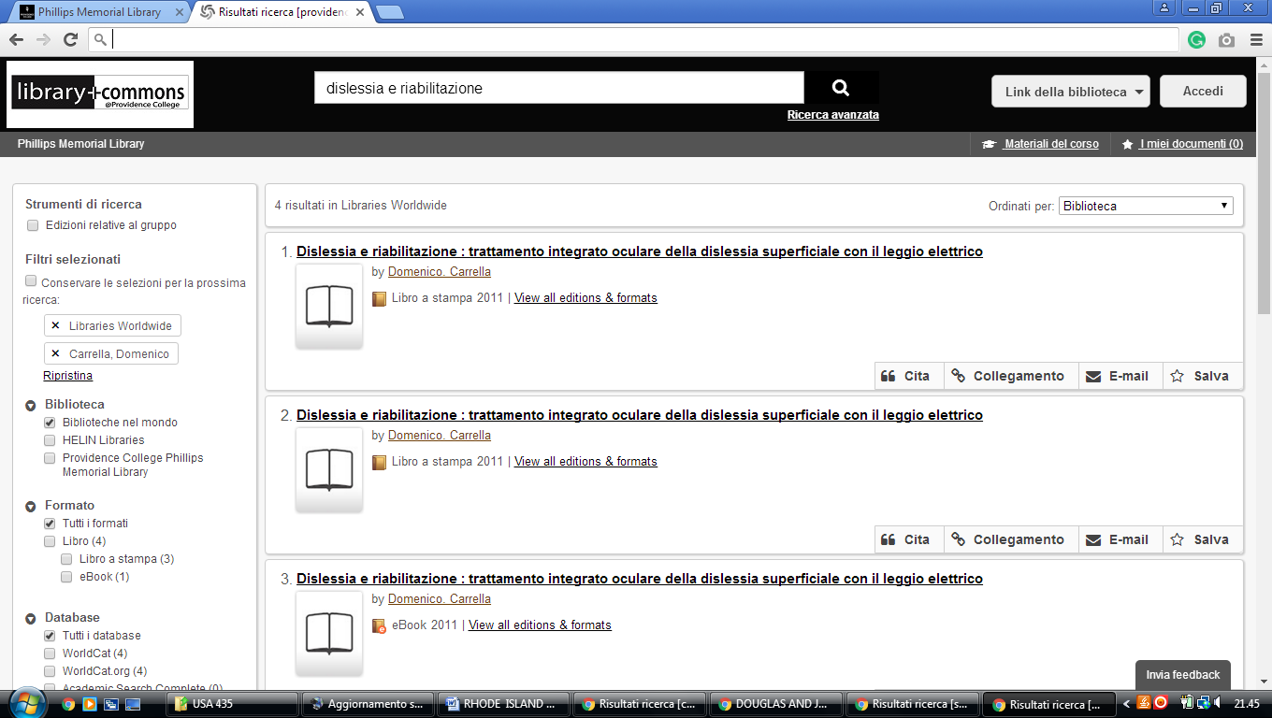

6 LIBRARIES | ROGER WILLIAMS UNIVERSITY - (Bristol, Rhode Island, Usa)
https://rwulibrary.on.worldcat.org/search?sortKey=BEST_MATCH&databaseList=&queryString=dislessia+e+riabilitazione&changedFacet=author&scope=&format=all&database=all&author=Carrella%2C+Domenico&year=all&yearFrom=&yearTo=&language=all&topic=all
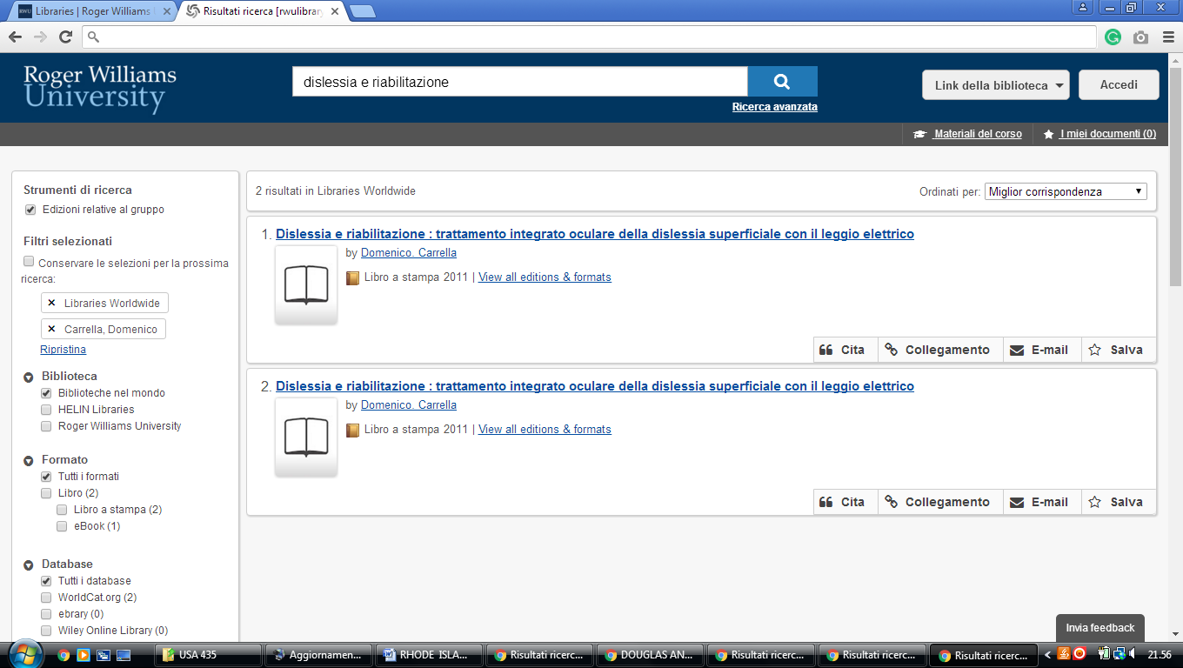

New Providence university John Hay Library

https://omni-primo.hosted.exlibrisgroup.com/primo-explore/search?query=any,contains,dislessia%20e%20riabilitazione&tab=articles&search_scope=PRIMO_CENTRAL&vid=01TRAILS_UGF&lang=en_US&offset=0&pcAvailability=true

