SOUTH CAROLINA 3

1 LIBRARY, MULTIMEDIA CENTER AND ARCHIVES | BENEDICT COLLEGE -
(Columbia, South Carolina, Usa)
http://eds.b.ebscohost.com/eds/resultsadvanced?vid=4&sid=a787204a-56a6-4e89-8e8d-1c0e4025f0a6%40sessionmgr101&bquery=(dislessia+AND+e+AND+riabilitazione)&bdata=JnR5cGU9MSZzaXRlPWVkcy1saXZlJnNjb3BlPXNpdGU%3d

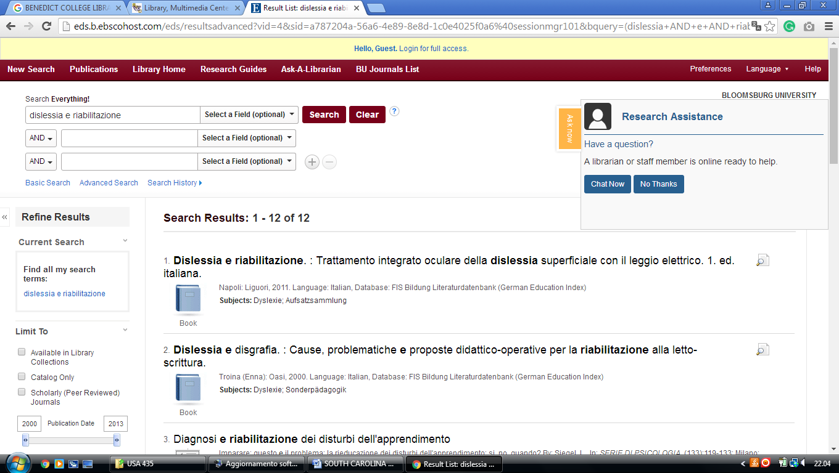

2 DANIEL LIBRARY – (Charleston, South Carolina, Usa)

http://eds.a.ebscohost.com/eds/resultsadvanced?vid=2&sid=f3877440-4112-49cd-a28f-cbf0f8699707%40sessionmgr4009&bquery=(dislessia+AND+e+AND+riabilitazione)&bdata=JnR5cGU9MSZzaXRlPWVkcy1saXZl
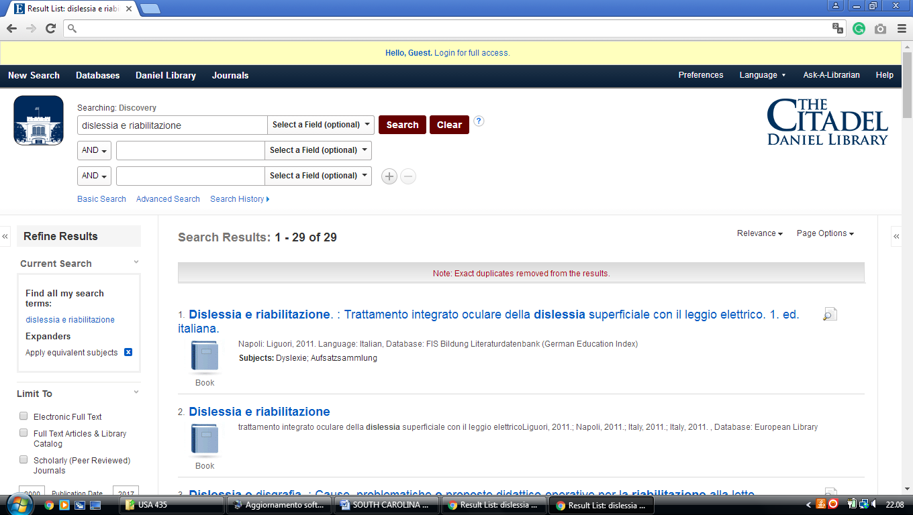

3 MEDICAL UNIVERSITY OF SOUTH CAROLINA LIBRARY- (Charleston, Usa)
https://musc.on.worldcat.org/search?sortKey=BEST_MATCH&databaseList=&queryString=dislessia+e+riabilitazione&changedFacet=author&clusterResults=on&scope=&format=all&database=all&author=Carrella%2C+Domenico&year=all&yearFrom=&yearTo=&language=all&topic=all

