SOUTH DAKOTA = 4

1 AUGUSTANA UNIVERSITY, MIKKELSEN LIBRARY – (South Dakota, Usa)
https://augustana.on.worldcat.org/search?sortKey=LIBRARY&databaseList=&queryString=dislessia+e+riabilitazione&changedFacet=author&scope=&format=all&database=all&author=Carrella%2C+Domenico&year=all&yearFrom=&yearTo=&language=all&topic=all
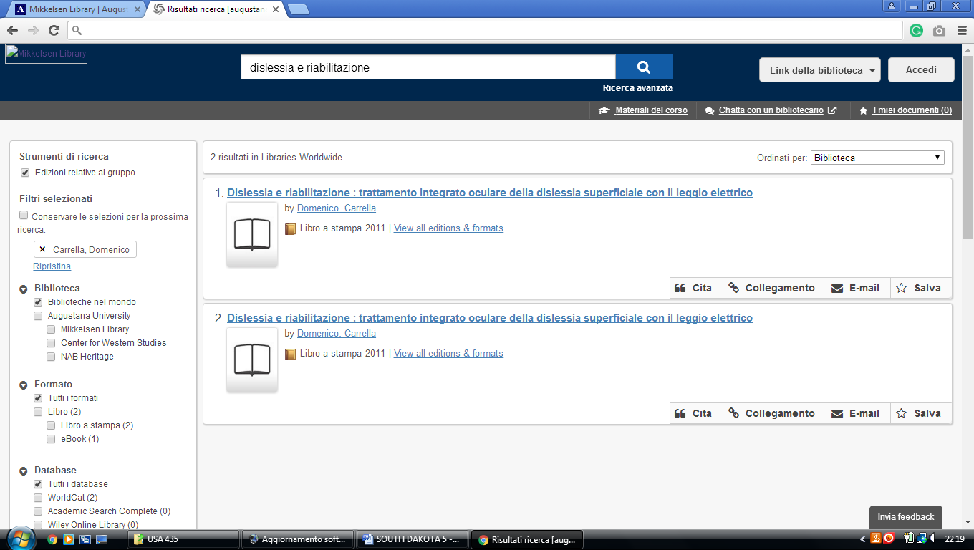

2 DEVEREAUX LIBRARY – (Rapid City, South Dakota, Usa)
https://southdakotaschoolofminesandtechnology.on.worldcat.org/search?sortKey=LIBRARY&databaseList=&queryString=+dislessia+e+riabilitazione&changedFacet=author&scope=&format=all&database=all&author=Carrella%2C+Domenico&year=all&yearFrom=&yearTo=&language=all&topic=all
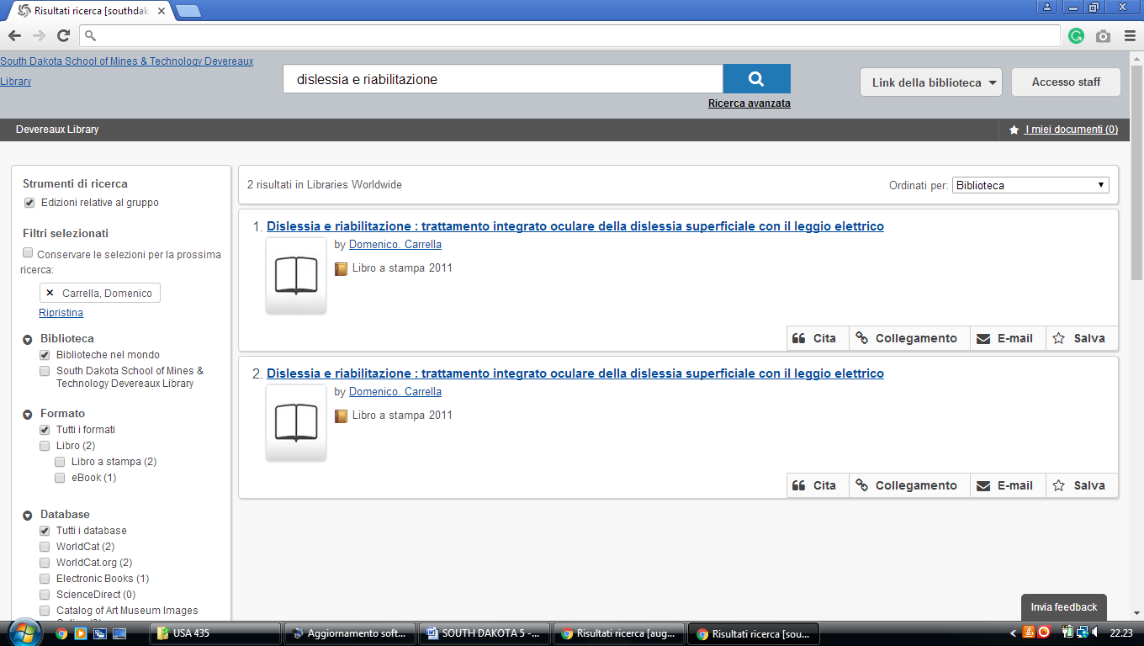

3 UNIVERSITY OF SOUTH DAKOTA LIBRARY – (Vermillion, South Dakota, Usa)
http://usd.worldcat.org/search?q=kw%3Adislessia+e+riabilitazione&dblist=638&se=%24d&sd=desc&fq=ap%3A%22carrella%2C+domenico%22&qt=facet_ap%3A

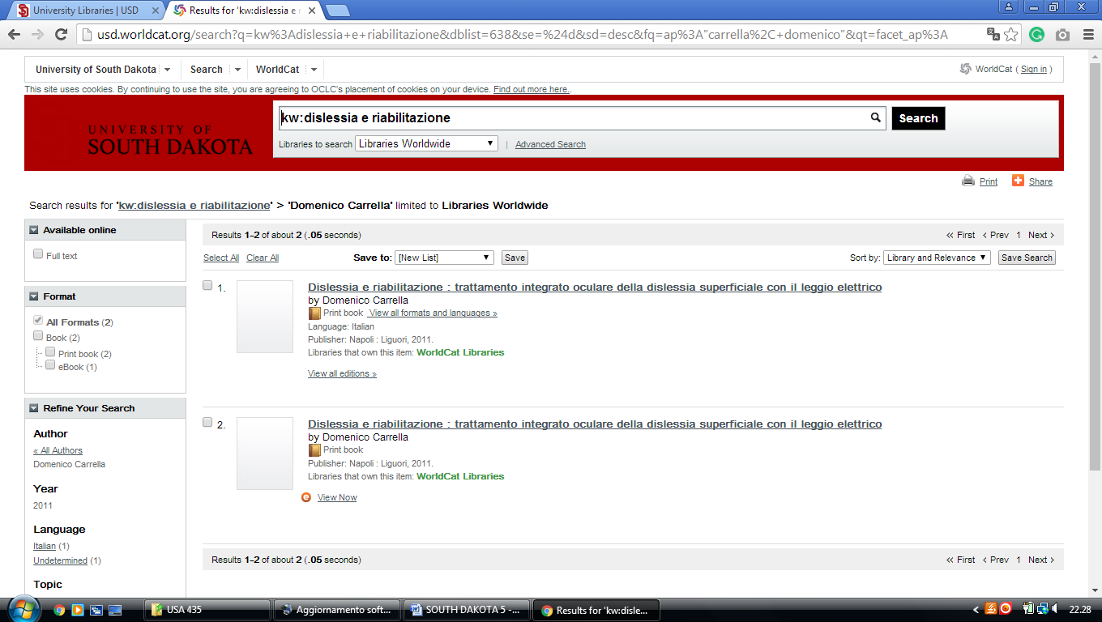

4 BEULAH WILLIAMS LIBRARY – (Aberdeen, South Dakota, Usa)
http://usd.worldcat.org/search?q=kw%3Adislessia+e+riabilitazione&dblist=638&se=%24d&sd=desc&fq=ap%3A%22carrella%2C+domenico%22&qt=facet_ap%3A

