TEXAS = 17

1 TEXAS MEDICAL CENTER LIBRARY – (Houston, Texas, Usa)
http://tmclibrary.summon.serialssolutions.com/search?s.q=dislessia+e+riabilitazione#!/search?ho=f&l=it-IT&q=dislessia%20e%20riabilitazione

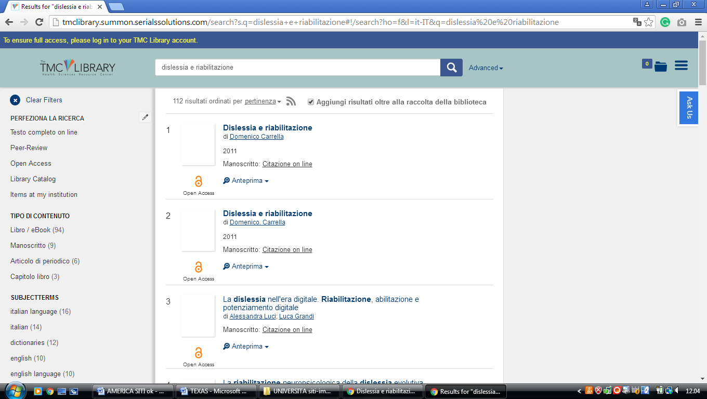

2 A. FRANK SMITH JR. LIBRARY CENTER – (Georgetown, Texas, Usa)
https://southwestern.worldcat.org/search?q=kf%3Adislessia+e+riabilitazione&dblist=638&se=%24d&sd=desc&fq=ap%3A%22carrella%2C+domenico%22&qt=facet_ap%3A

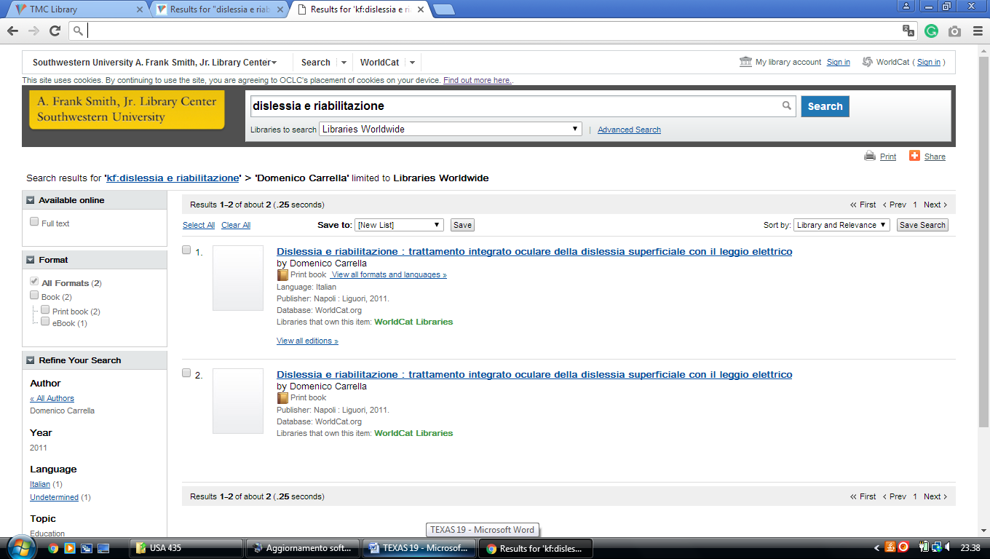

3 BAYLOR UNIVERSITY LIBRARIES – (Waco,Texas, Usa)
https://baylor.summon.serialssolutions.com/?#!/search?ho=f&fvf=ContentType,Newspaper%20Article,t&l=en&q=dislessia%20e%20riabilitazione

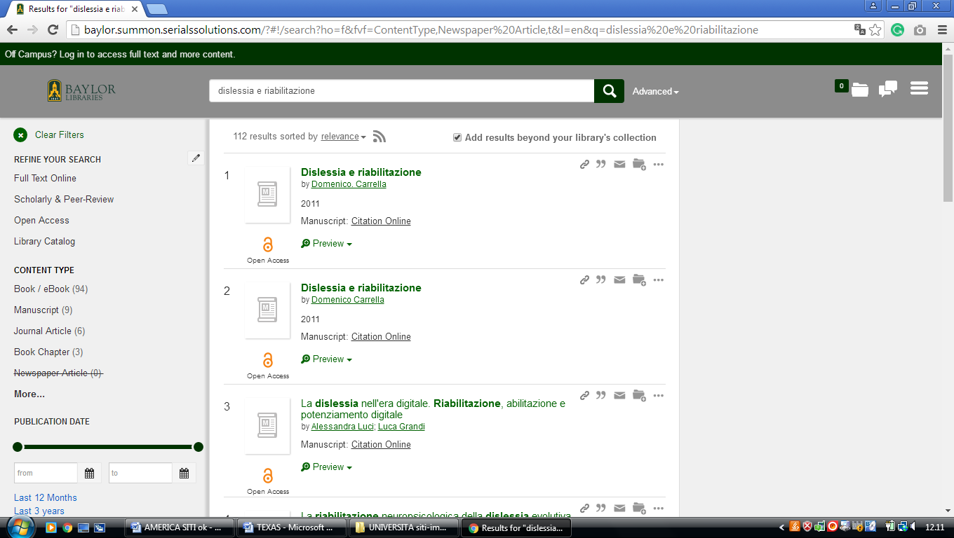

4 DOHERTY LIBRARY – (Houston, Texas, Usa)
https://universityofstthomas.on.worldcat.org/search?sortKey=LIBRARY&databaseList=&queryString=dislessia+e+riabilitazione&changedFacet=author&clusterResults=off&scope=&format=all&database=all&author=Carrella%2C+Domenico&year=all&yearFrom=&yearTo=&language=all&topic=all

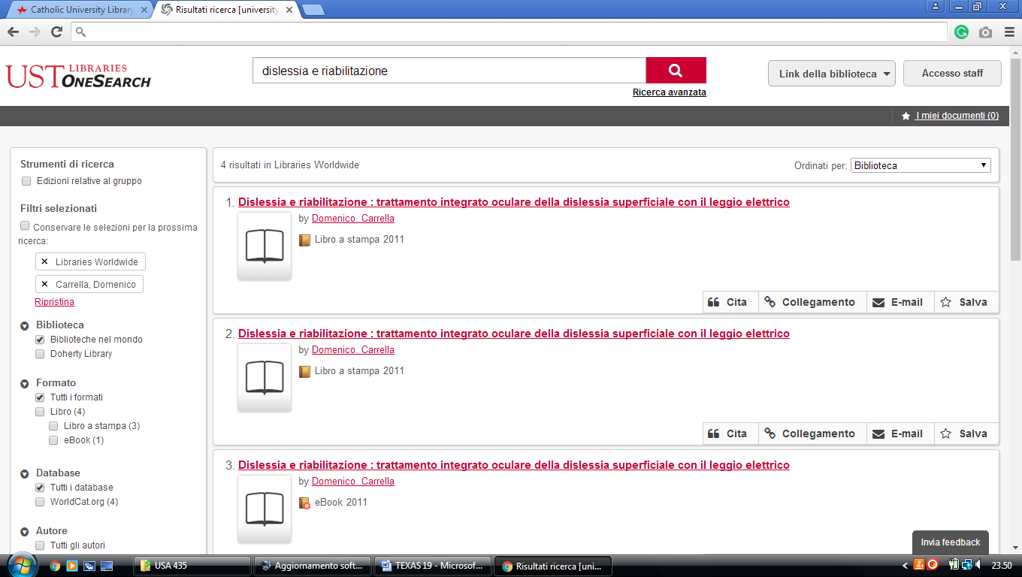

5 DUNAGAN LIBRARY – (Odessa, Texas, Usa)
http://utpb.summon.serialssolutions.com/?s.q=dislessia+e+riabilitazione&keep_r=true#!/search?ho=f&l=en&q=dislessia%20e%20riabilitazione
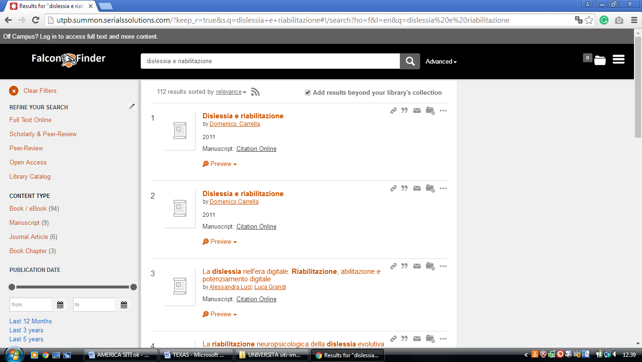

6 KILLAM LIBRARY – (Laredo, Texas, Usa)
https://tamiu.on.worldcat.org/search?sortKey=LIBRARY&databaseList=2572%2C2264%2C2274%2C2263%2C2262%2C1271%2C2261%2C2260%2C2281%2C2328%2C1931%2C1875%2C2623%2C2237%2C2259%2C1697%2C2267%2C3201%2C2277%2C239%2C1708%2C638%2C1738%2C1847&queryString=dislessia+e+riabilitazione&changedFacet=author&scope=&format=all&database=all&author=Carrella%2C+Domenico&year=all&yearFrom=&yearTo=&language=all&topic=all

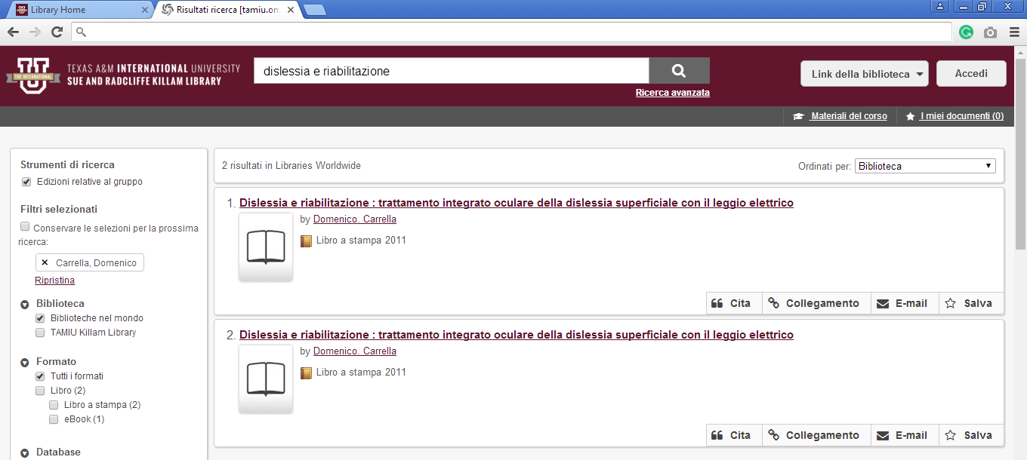

7 MOODY MEDICAL LIBRARY – (Galveston, Texas, Usa)
https://utmblibrary.summon.serialssolutions.com/?q=dislessia+e+riabilitazione&myinst=UT+Medical+Branch+Library&fvf=ContentType%2CBook+Review%2Ct&fvf=ContentType%2CNewspaper+Article%2Ct&fvf=Language%2CEnglish&keep_r=true#!/search?ho=f&fvf=ContentType,Book%20Review,t%7CContentType,Newspaper%20Article,t%7CLanguage,English,f&l=en&q=dislessia%20e%20riabilitazione

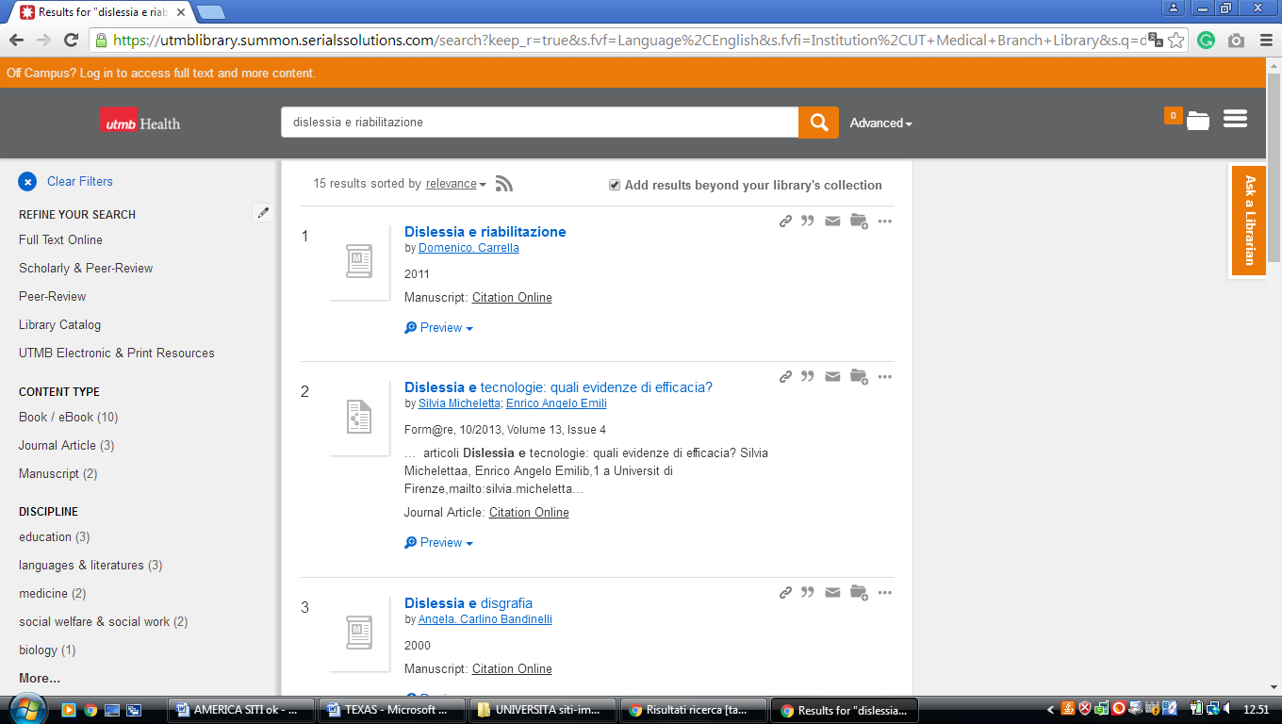

8 PALO ALTO COLLEGE LIBRARY – (San Antonio , Texas, Usa)
https://paclibrary.on.worldcat.org/search?sortKey=LIBRARY&databaseList=&queryString=dislessia+e+riabilitazione&changedFacet=author&clusterResults=off&scope=&format=all&database=all&author=Carrella%2C+Domenico&year=all&yearFrom=&yearTo=&language=all&topic=all

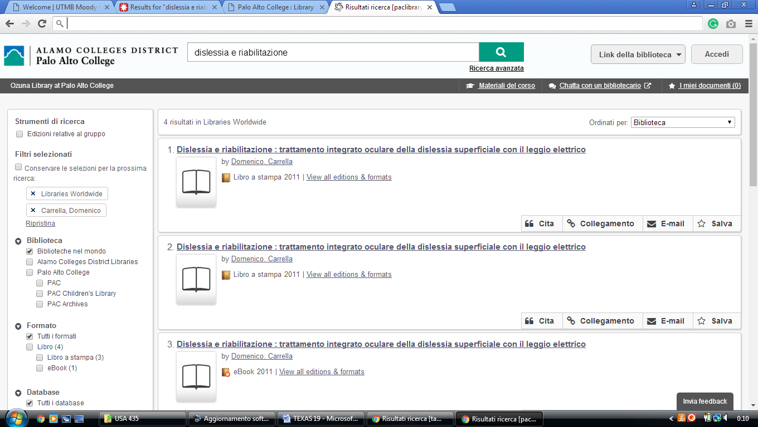

9 RANDOLPH C. WATSON LIBRARY - (Kilgore, Texas, Usa)
https://kilgore.on.worldcat.org/search?sortKey=LIBRARY&databaseList=&queryString=dislessia+e+riabilitazione&changedFacet=author&scope=&format=all&database=all&author=Carrella%2C+Domenico&year=all&yearFrom=&yearTo=&language=all&topic=all
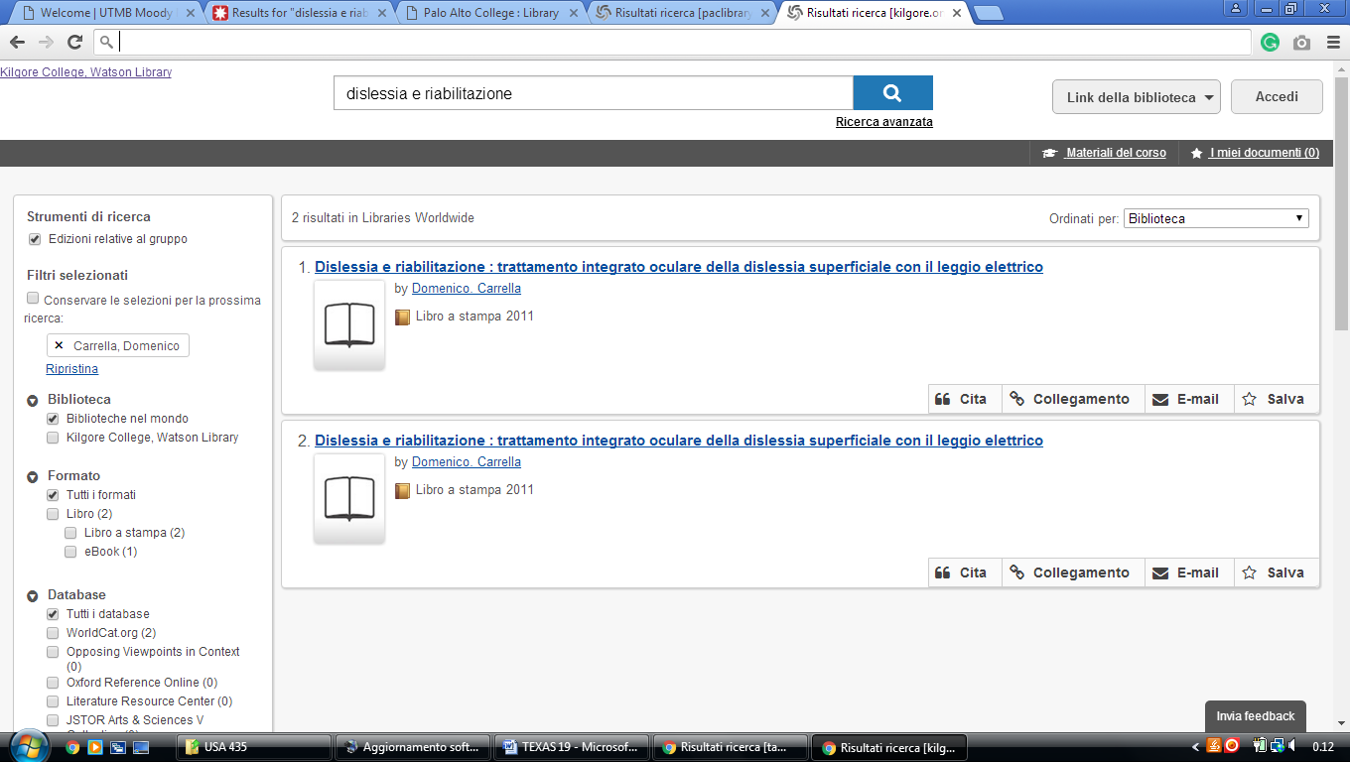

10 ST. MARY'S UNIVERSITY LOUIS J. BLUME LIBRARY – (San Antonio Texas, Usa)
http://eds.b.ebscohost.com/eds/resultsadvanced?vid=5&sid=e9414ffd-c71c-4676-a1a8-8fc1f72cb03a%40sessionmgr101&bquery=(dislessia+AND+e+AND+riabilitazione)&bdata=JnR5cGU9MSZzaXRlPWVkcy1saXZlJnNjb3BlPXNpdGU%3d

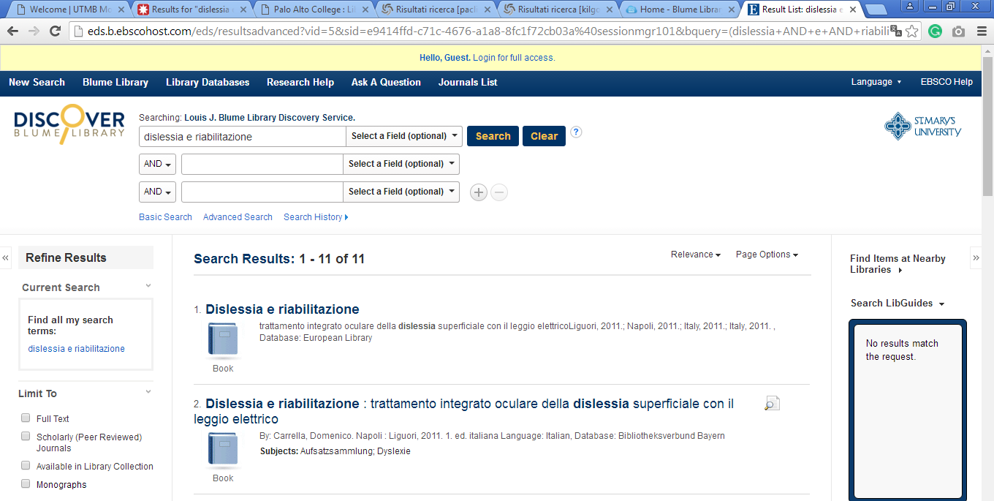

11 UNIVERSITY OF TEXAS ARLINGTON LIBRARY - (Arlington, Texas, Usa)
http://uta.summon.serialssolutions.com/search?q=dislessia+e+riabilitazione#!/search?ho=f&l=en&q=dislessia%20e%20riabilitazione

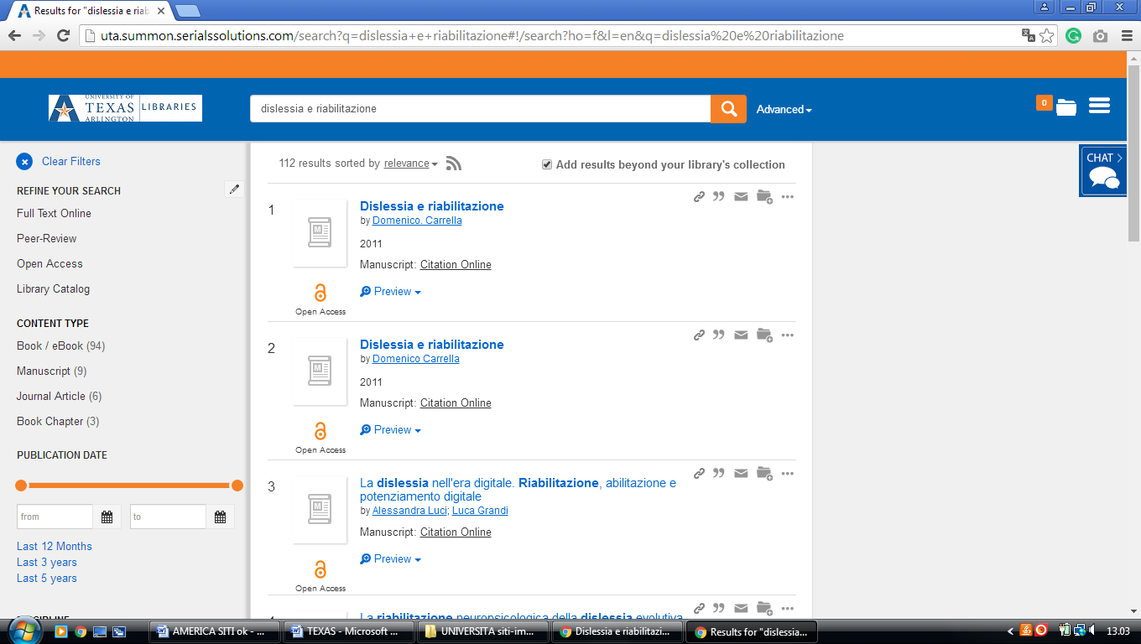

12 UNIVERSITY OF TEXAS AT SAN ANTONIO LIBRARY – (San Antonio Texas, Usa)
https://utsa.summon.serialssolutions.com/?s.q=dislessia+e+riabilitazione&q=&s.fvf%5B%5D=ContentType%2CNewspaper+Article%2Ct&s.fvf%5B%5D=ContentType%2CBook+Review%2Ct#!/search?ho=f&fvf=ContentType,Newspaper%20Article,t%7CContentType,Book%20Review,t&l=en&q=dislessia%20e%20riabilitazione

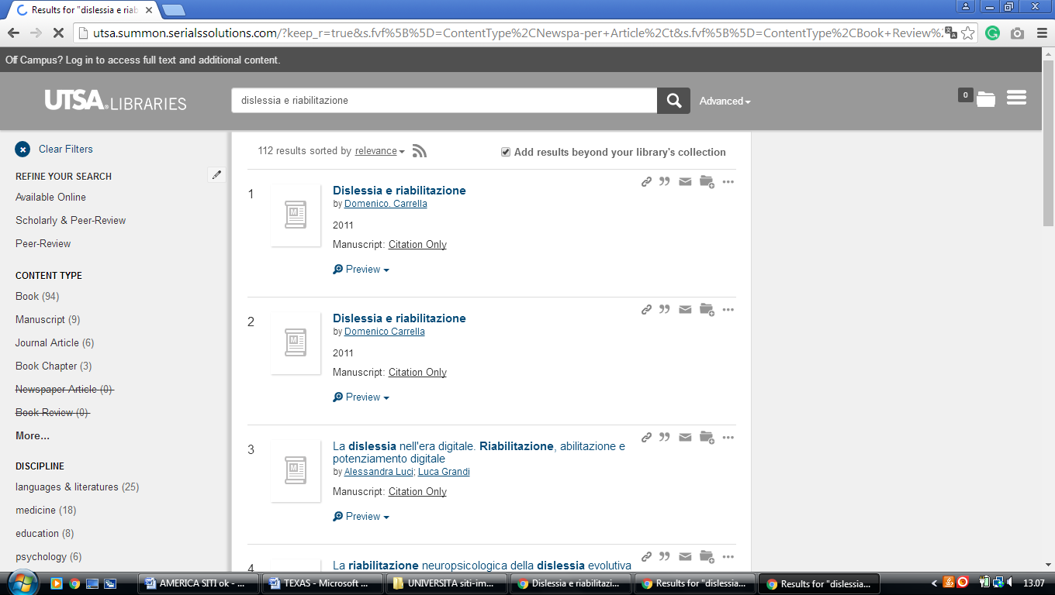

13 UNIVERSITY OF TEXAS LIBRARIES – (Austin, Texas, Usa)
https://utexas.summon.serialssolutions.com/search?s.q=dislessia+e+riabilitazione#!/search?ho=f&l=en&q=dislessia%20e%20riabilitazione
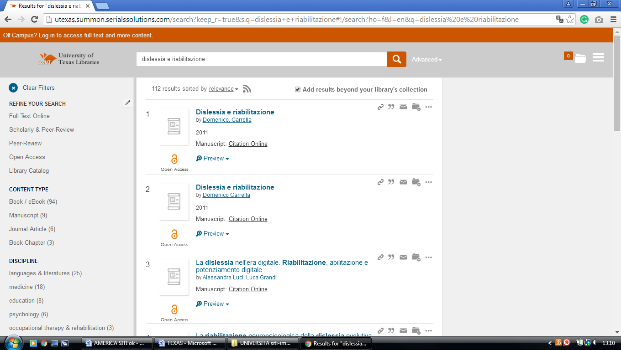

14 WELCOME TO UTSA LIBRARIES | UTSA LIBRARIES – (Circle, San Antonio, TX, Usa)
https://tamiu.on.worldcat.org/search?sortKey=LIBRARY&databaseList=2572%2C2264%2C2274%2C2263%2C2262%2C1271%2C2261%2C2260%2C2281%2C2328%2C1931%2C1875%2C2623%2C2237%2C2259%2C1697%2C2267%2C3201%2C2277%2C239%2C1708%2C638%2C1738%2C1847&queryString=dislessia+e+riabilitazione&changedFacet=author&scope=&format=all&database=all&author=Carrella%2C+Domenico&year=all&yearFrom=&yearTo=&language=all&topic=all

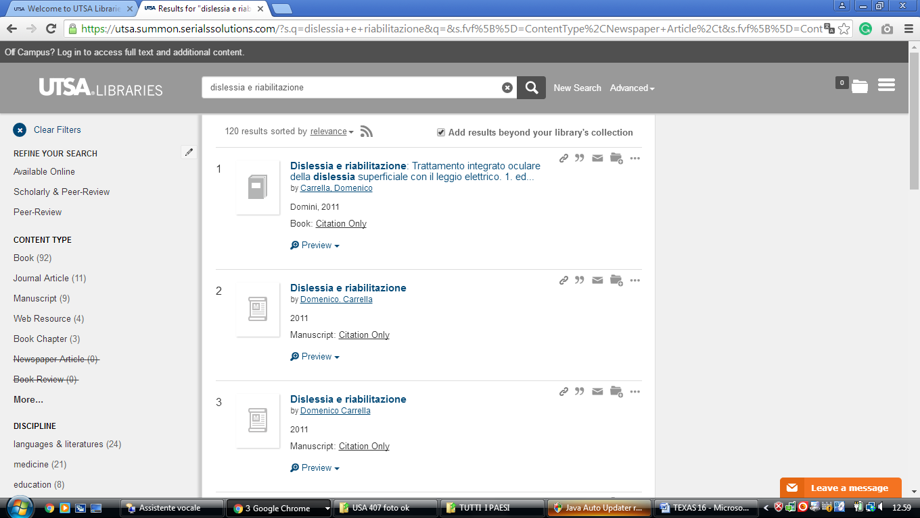

15 UNIVERSITY OF TEXAS LIBRARIES | THE UNIVERSITY OF TEXAS AT AUSTIN – (Usa)
https://utexas.summon.serialssolutions.com/search?s.q=dislessia+e+riabilitazione#!/search?ho=f&l=en&q=dislessia%20e%20riabilitazione

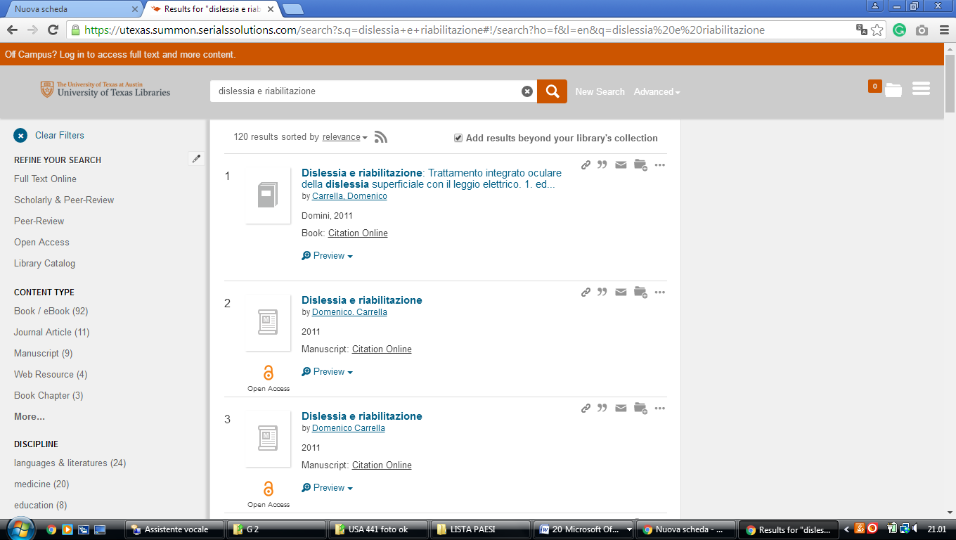

16 UTA LIBRARIES - THE UNIVERSITY OF TEXAS AT ARLINGTON - (Usa)
http://uta.summon.serialssolutions.com/search?q=dislessia+e+riabilitazione#!/search?ho=f&l=en&q=dislessia%20e%20riabilitazione

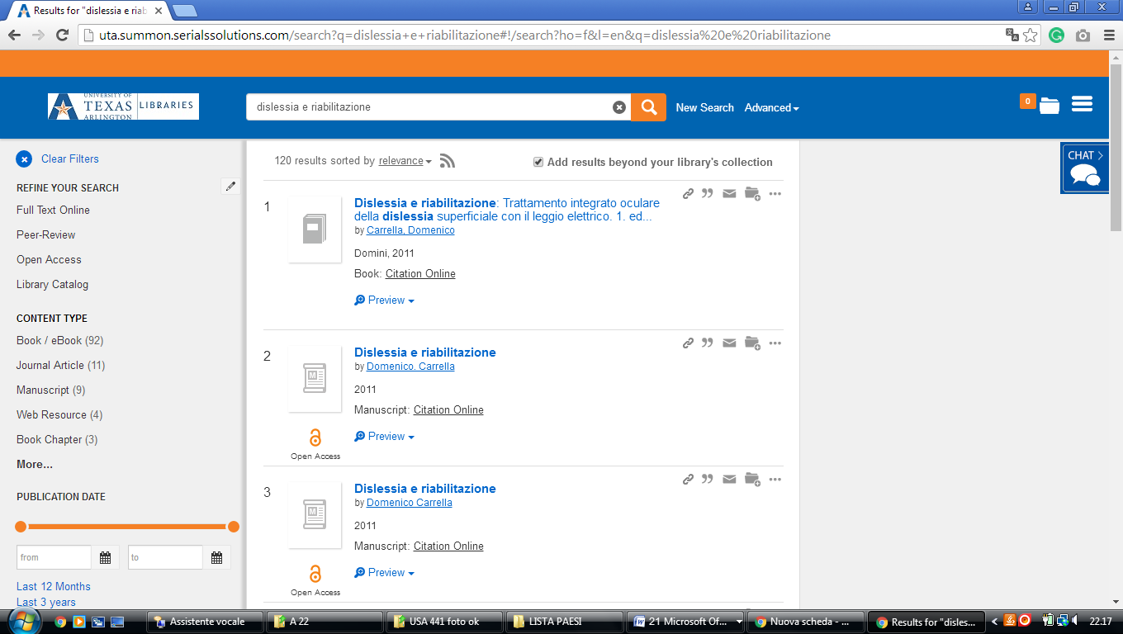

17 ACE - ACADEMIC CENTER FOR ENRICHMENT - (Texas- Usa) https://seu.on.worldcat.org/search?sortKey=LIBRARY&databaseList=&queryString=dislessia+e+riabilitazione&changedFacet=format&clusterResults=off&scope=&format=all&database=all&author=all&year=all&yearFrom=&yearTo=&language=all&topic=all
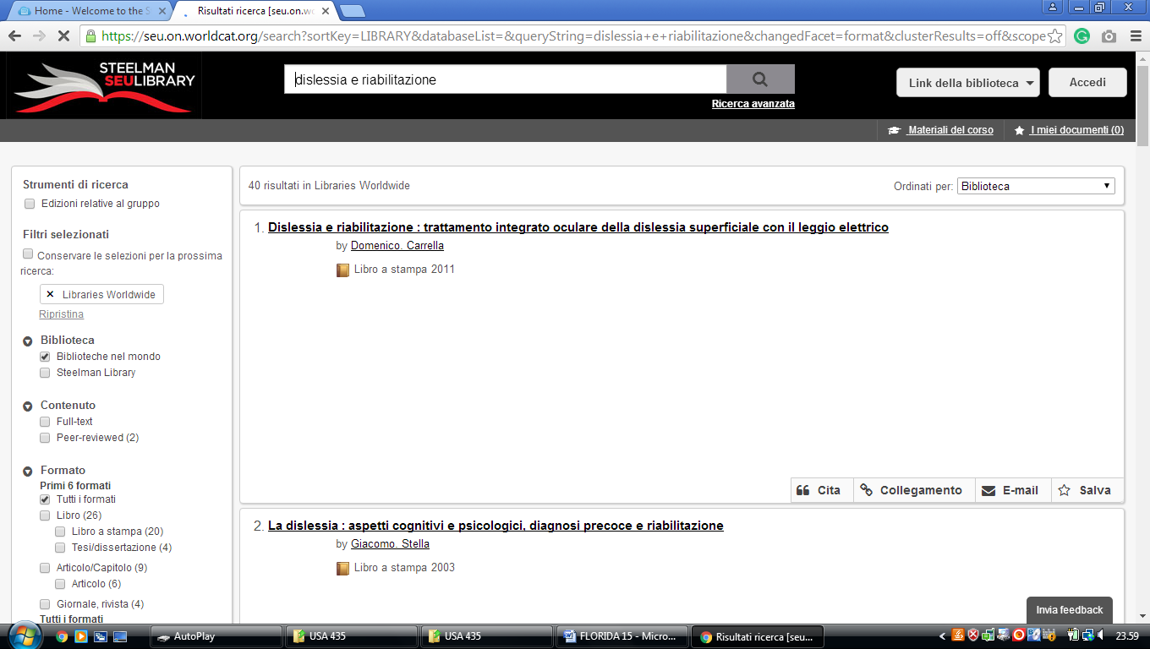

10 FLORIDA STATE UNIVERSITY LIBRARIES Tallahassee, Florida, USA

