UTHA = 2

1 STEWART LIBRARY - WEBER STATE UNIVERSITY - (Ogden, Utah, Usa)
https://weber.summon.serialssolutions.com/#!/search?ho=f&l=en&q=dislessia%20e%20riabilitazione

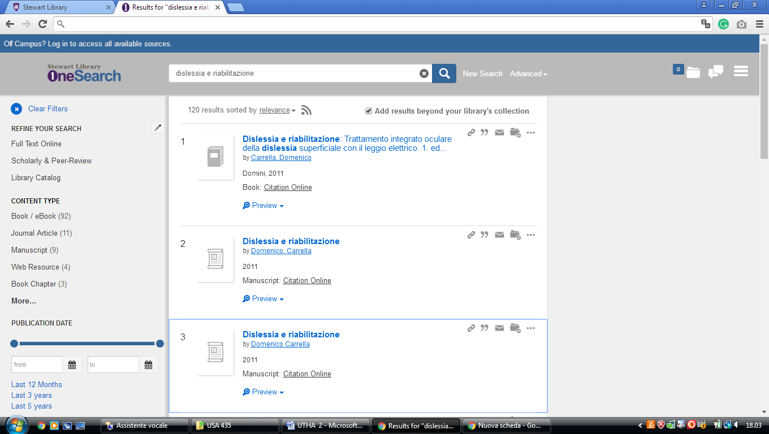

2 HAROLD B. LEE LIBRARY – (Provo, Utah, Usa)
https://search.lib.byu.edu/byu/search?type%5B%5D=book&type%5B%5D=ebook&q=dislessia+e+riabilitazione&expand=true

