VIRGINIA 11

1 ALEXANDER MACK LIBRARY - (Bridgewater, Virginia, Usa)
https://bridgewatercollege.on.worldcat.org/search?sortKey=BEST_MATCH&databaseList=&queryString=dislessia+e+riabilitazione&changedFacet=scope&clusterResults=on&scope=&scope=wz%3A947

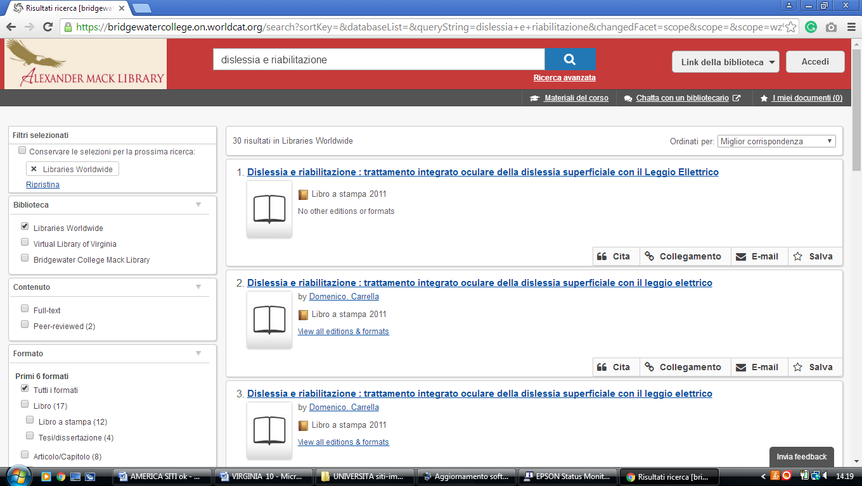

2 AVERETT UNIVERSITY LIBRARY – (Danville, Virginia, Usa)
http://averett.on.worldcat.org/search?sortKey=RECENCY&databaseList=&queryString=dislessia+e+riabilitazione&changedFacet=scope&clusterResults=on&scope=&scope=wz%3A6679

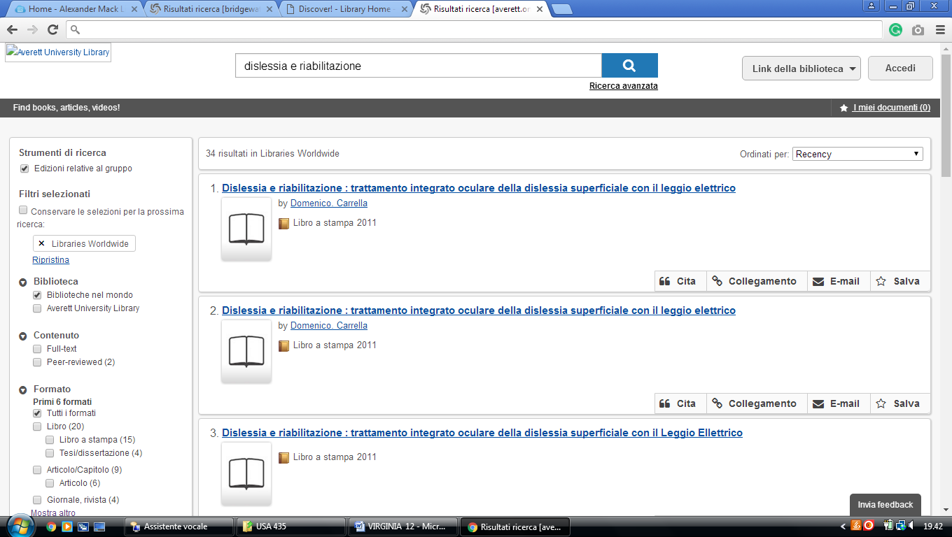

3 BOATWRIGHT MEMORIAL LIBRARY – (Richmond, Virginia, Usa)
https://richmond.summon.serialssolutions.com/search?s.q=#!/search?ho=f&l=it-IT&q=dislessia%20e%20riabilitazione

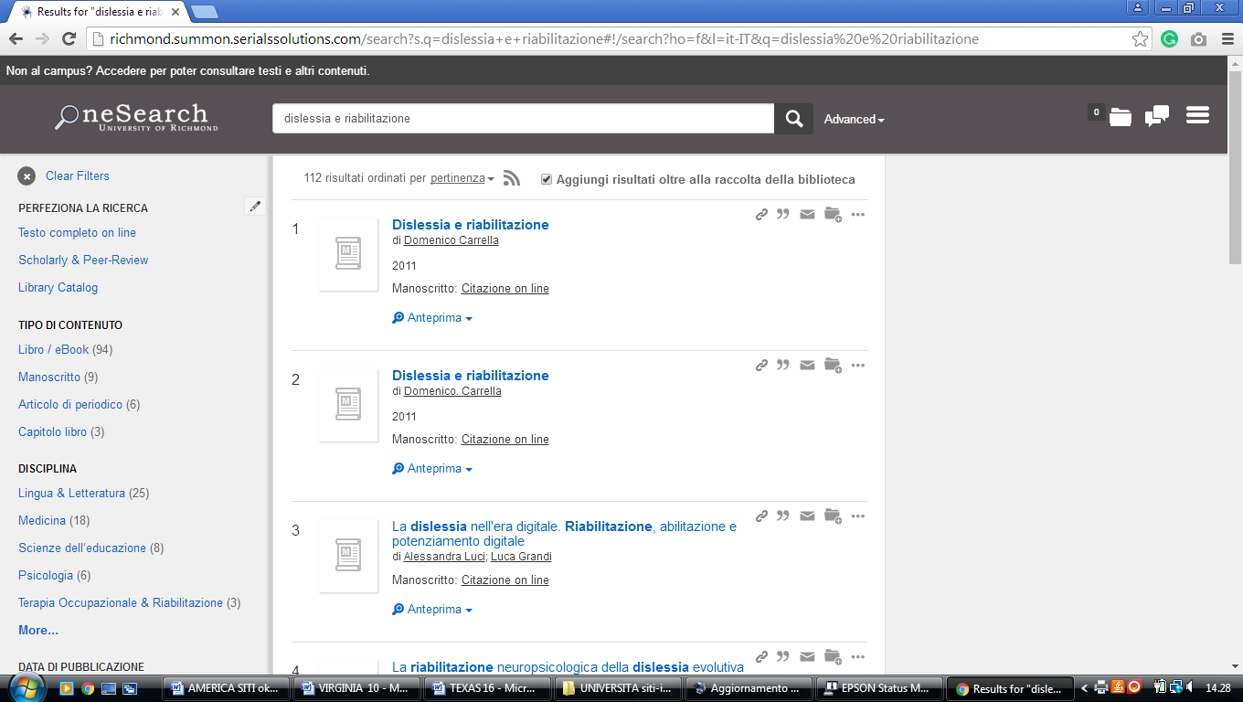

4 EARL GREGG SWEM LIBRARY – (Williamsburg, Virginia, Usa)
https://wm-primo.hosted.exlibrisgroup.com/primo_library/libweb/action/search.do?ct=facet&pcAvailabiltyMode=true&pcAvailClicked=true&vid=01COWM_WM&mode=Basic&tab=pci&fn=search&indx=1&dscnt=0&vl(freeText0)=dislessia%20e%20riabilitazione&dstmp=1521744849909

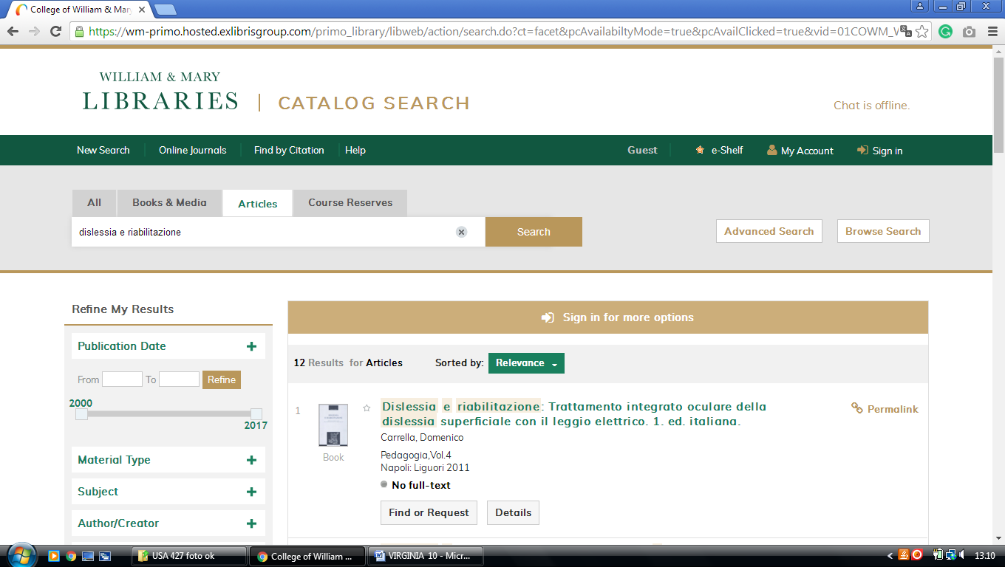

5 GREENWOOD LIBRARY – (Farmville, Virginia, Usa)
https://longwooduniversity.on.worldcat.org/search?sortKey=LIBRARY&databaseList=&queryString=dislessia+e+riabilitazione&changedFacet=author&clusterResults=on&scope=&format=&database=all&author=Carrella%2C+Domenico&year=all&yearFrom=&yearTo=&language=all&topic=all

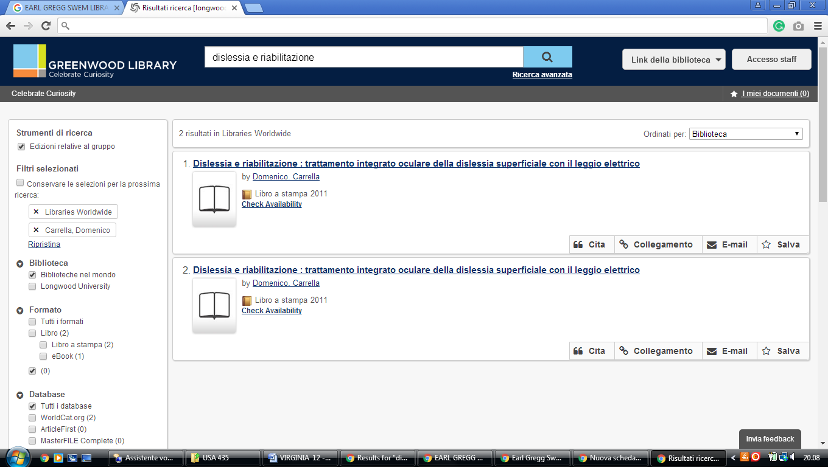

6 HARVEY LIBRARY – (Hampton, Virginia, Usa)
http://hamptonu.summon.serialssolutions.com/search?s.q=#!/search?ho=f&l=en&q=dislessia%20e%20riabilitazione

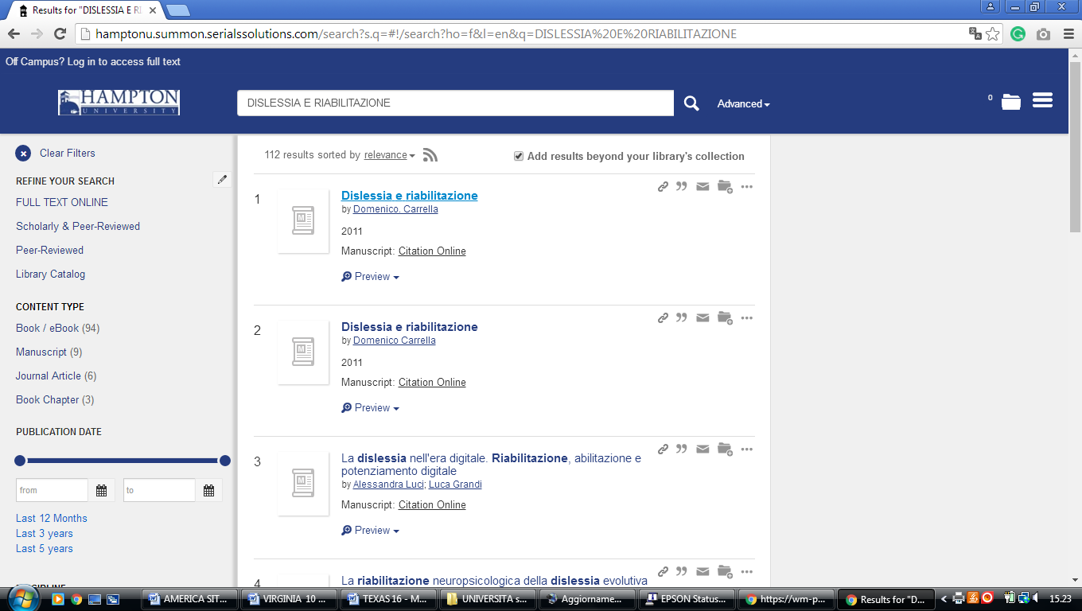

7 HENRY CLAY HOFHEIMER II LIBRARY – ( Norfolk, Virginia, Usa)
https://vwu.on.worldcat.org/search?sortKey=LIBRARY&databaseList=&queryString=dislessia+e+riabilitazione&changedFacet=author&scope=&format=all&database=all&author=Carrella%2C+Domenico&year=all&yearFrom=&yearTo=&language=all&topic=all

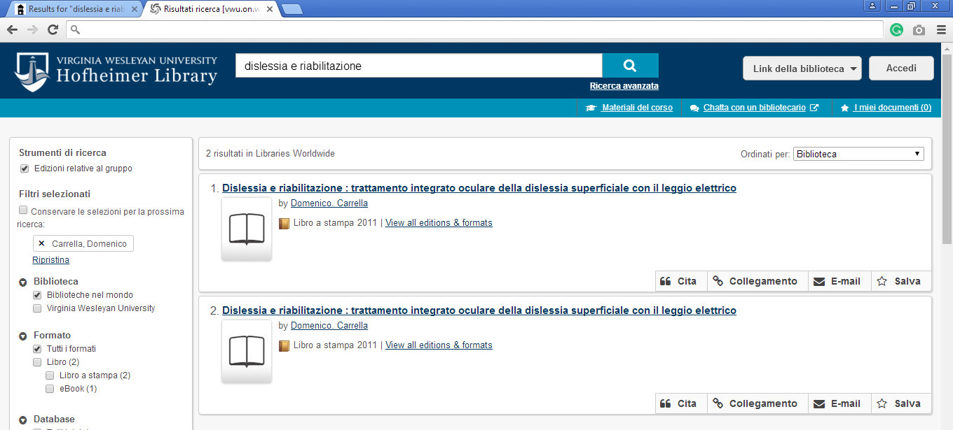

8 UNIVERSITY LIBRARIES | VIRGINIA TECH - (Virginia, Usa)
https://vt.summon.serialssolutions.com/#!/search?ho=f&l=en&q=(dislessia%20e%20riabilitazione)

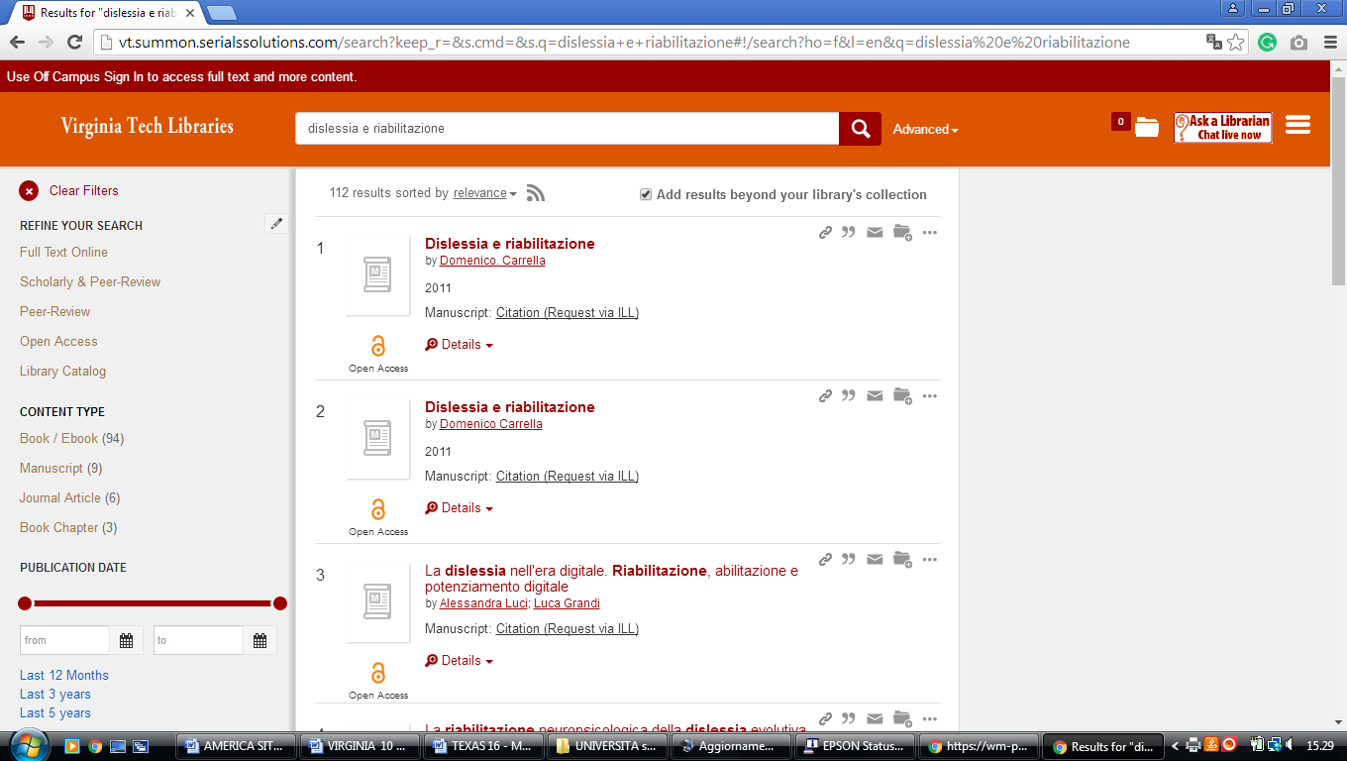

9 WYNDHAM ROBERTSON LIBRARY – (Roanoke, Virginia, Usa)
https://hollins-primo.hosted.exlibrisgroup.com/primo-explore/search?institution=01HOLLINS&vid=01HOLLINS&mode=Basic&displayMode=full&bulkSize=10&highlight=true&dum=true&query=any,contains,%20dislessia%20e%20riabilitazione&query=&displayField=all&search_scope=default_scope&queryTemp=%20dislessia%20e%20riabilitazione&sortby=rank&lang=en_US&pcAvailability=true

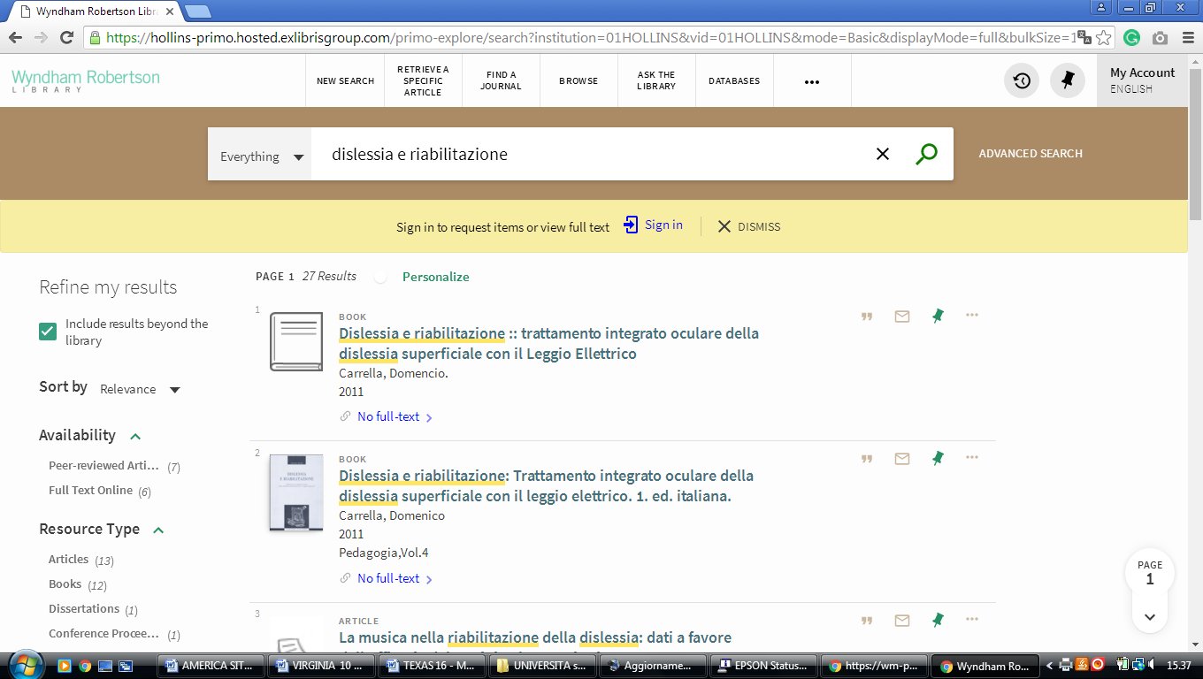

10 OATWRIGHT MEMORIAL LIBRARY - UNIVERSITY OF RICHMOND – (Virginia, Usa)
https://richmond.summon.serialssolutions.com/search?s.q=dislessia+e+riabilitazione#!/search?ho=f&l=it-IT&q=dislessia%20e%20riabilitazione

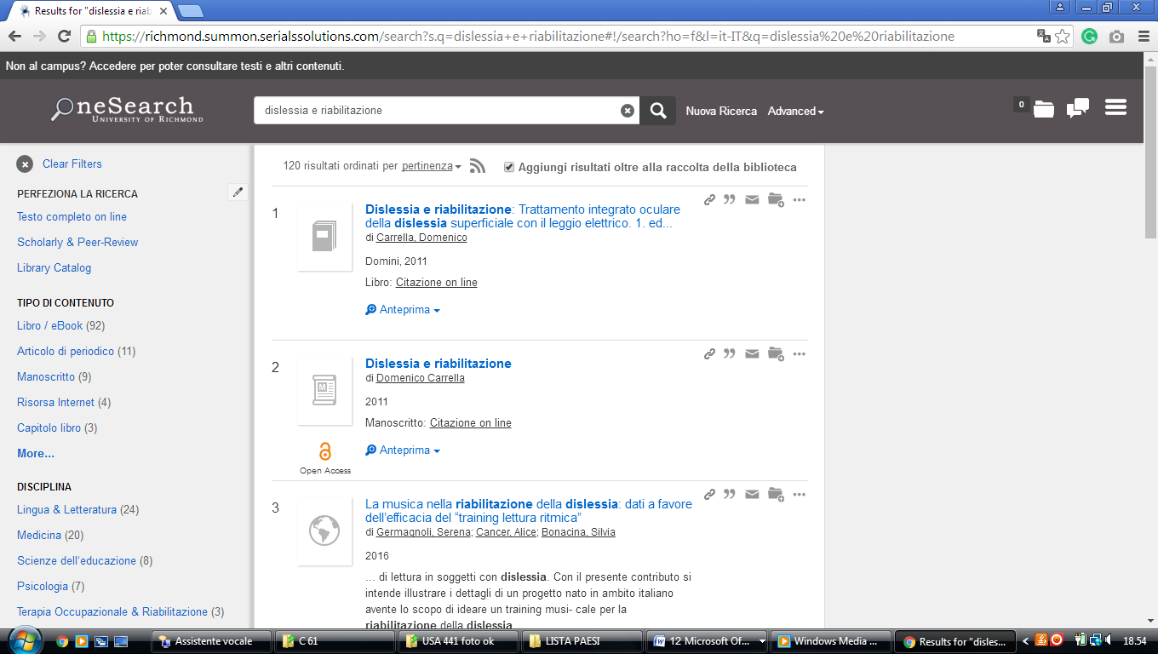

11 WILLIAM & MARY LIBRARIES | - (Virginia, Usa)
https://wm-primo.hosted.exlibrisgroup.com/primo_library/libweb/action/search.do?ct=facet&pcAvailabiltyMode=true&pcAvailClicked=true&pcAvailabiltyMode=false&query=any%2Ccontains%2Cdislessia%20e%20riabilitazione&fn=search&vl(516891084UI0)=any&indx=1&search_scope=EVERYTHING&dscnt=0&scp.scps=scope%3A(CWF_Print_WM)%2Cscope%3A(LAW)%2Cscope%3A(WM_Print_WM)%2Cscope%3A(01COWM_WM)%2Cscope%3A(01COWM_WM_CR)%2Cscope%3A(WM_Alma_WM)%2Cscope%3A(COWM_WM_E)%2Cprimo_central_multiple_fe&displayMode=full&mode=Basic&vid=01COWM_WM&institution=01COWM_WM&bulkSize=50&ct=search&highlight=true&tab=default_tab&displayField=all&vl(freeText0)=dislessia%20e%20riabilitazione&dum=true&dstmp=1520775572856&fromDL

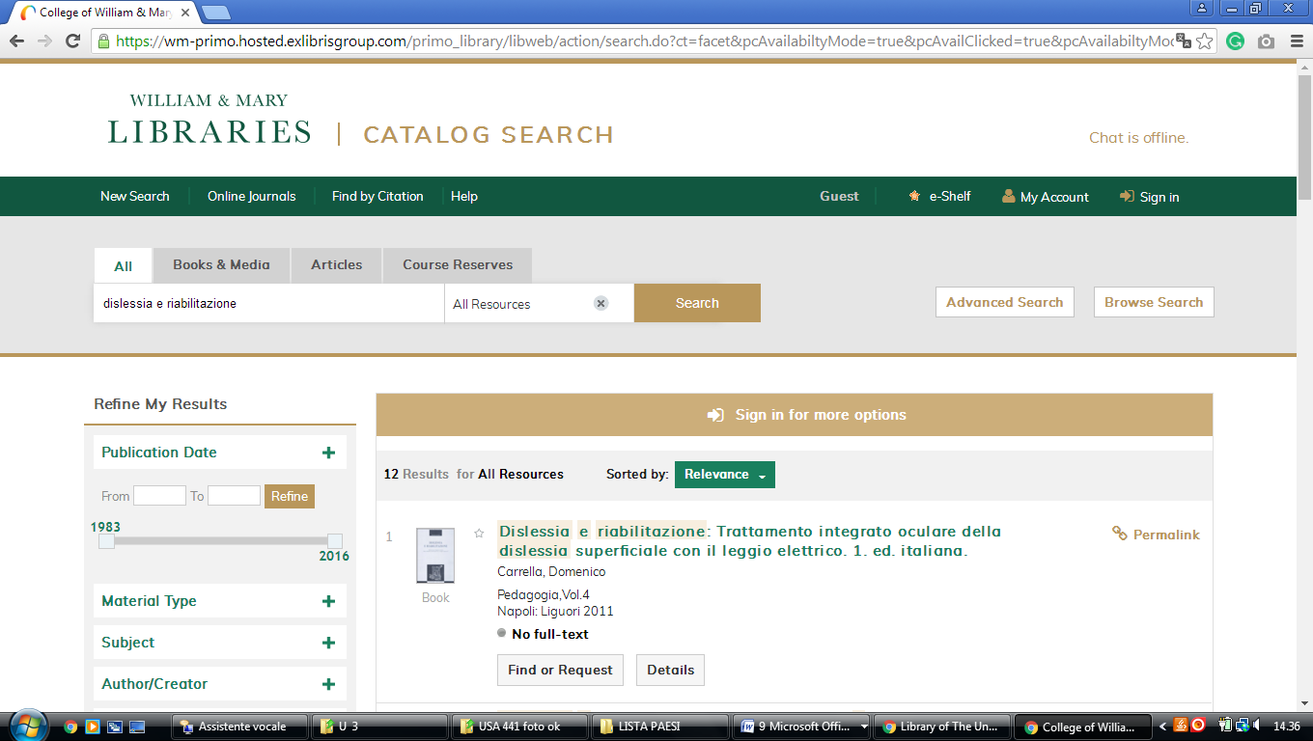

Jerry Falwell Library - Liberty University

http://liberty.summon.serialssolutions.com/#!/search?ho=f&l=en&q=(dislessia%20e%20riabilitazione)

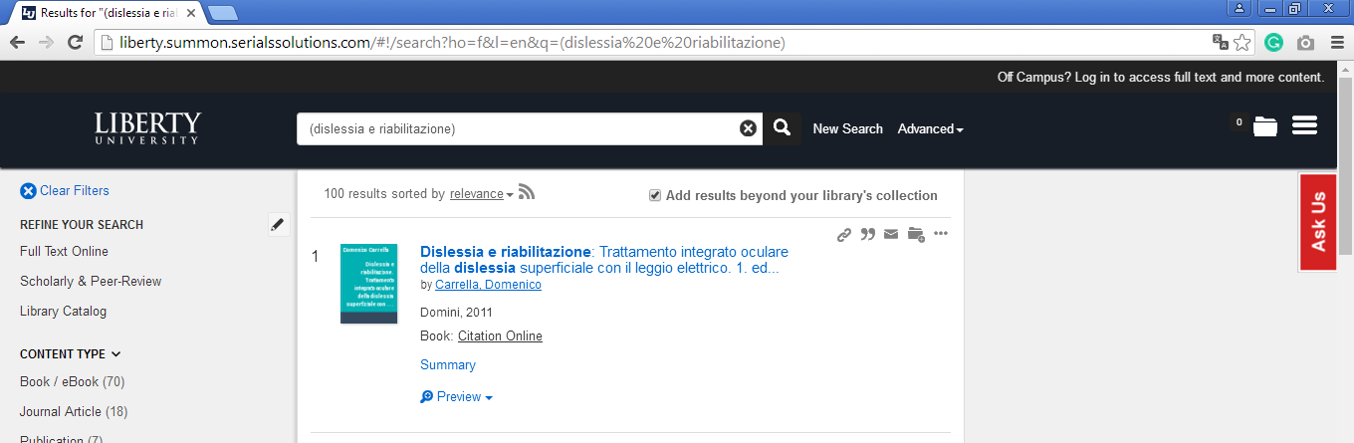

WEST VIRGINIA UNIVERSITY (WV)

Libraries at West Virginia University (WV)
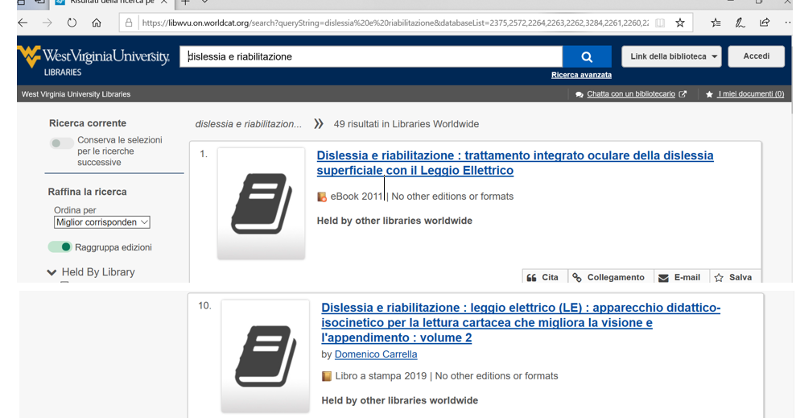
https://libwvu.on.worldcat.org/discovery

