WISCONSIN = 21

1 BELOIT COLLEGE LIBRARY – (Beloit, Wisconsin, Usa)
https://beloit.on.worldcat.org/search?sortKey=LIBRARY&databaseList=&queryString=dislessia+e+riabilitazione&changedFacet=author&scope=&format=all&database=all&author=Carrella%2C+Domenico&year=all&yearFrom=&yearTo=&language=all&topic=all
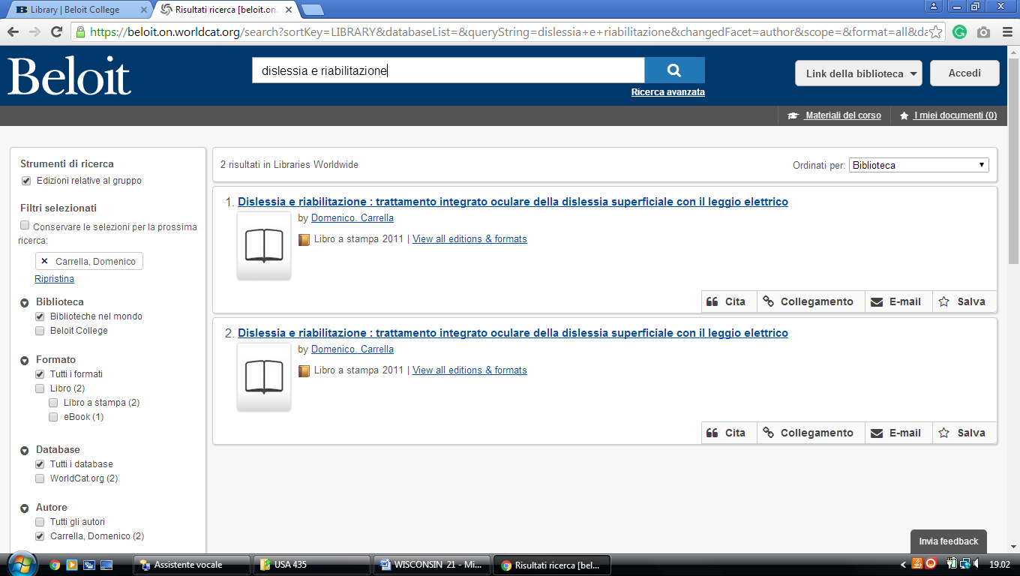

2 CARROLL COLLEGE LIBRARY - (Waukesha, Wisconsin, Usa)
https://carroll-primo.hosted.exlibrisgroup.com/primo-explore/search?vid=01TRAILS_CARROLL&query=any,contains,dislessia%20e%20riabilitazione&tab=everything&search_scope=EVERYTHING&facet=rtype,exclude,newspaper_articles&facet=rtype,exclude,reviews&sortby=rank&lang=en_US&pcAvailability=true
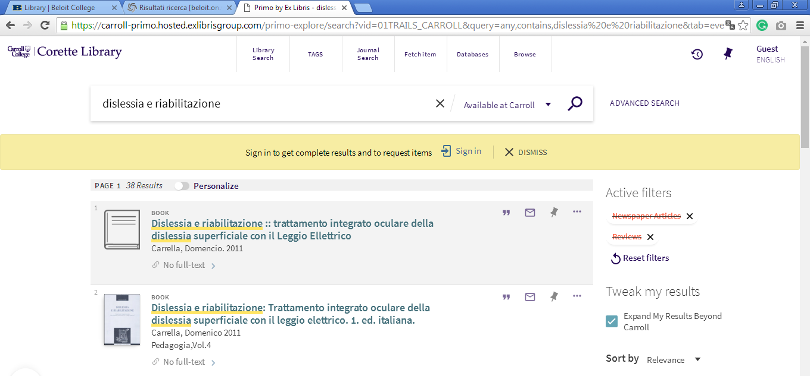

3 CHALMER DAVEE UNIVERSITY LIBRARY - (River Falls, Wisconsin, Usa)
https://uw-primo.hosted.exlibrisgroup.com/primo-explore/search?institution=RF&vid=RF&search_scope=Everything&mode=Basic&displayMode=full&bulkSize=10&highlight=true&dum=true&query=any,contains,dislessia%20e%20riabilitazione&displayField=all&pcAvailabiltyMode=true&sortby=rank&lang=en_US

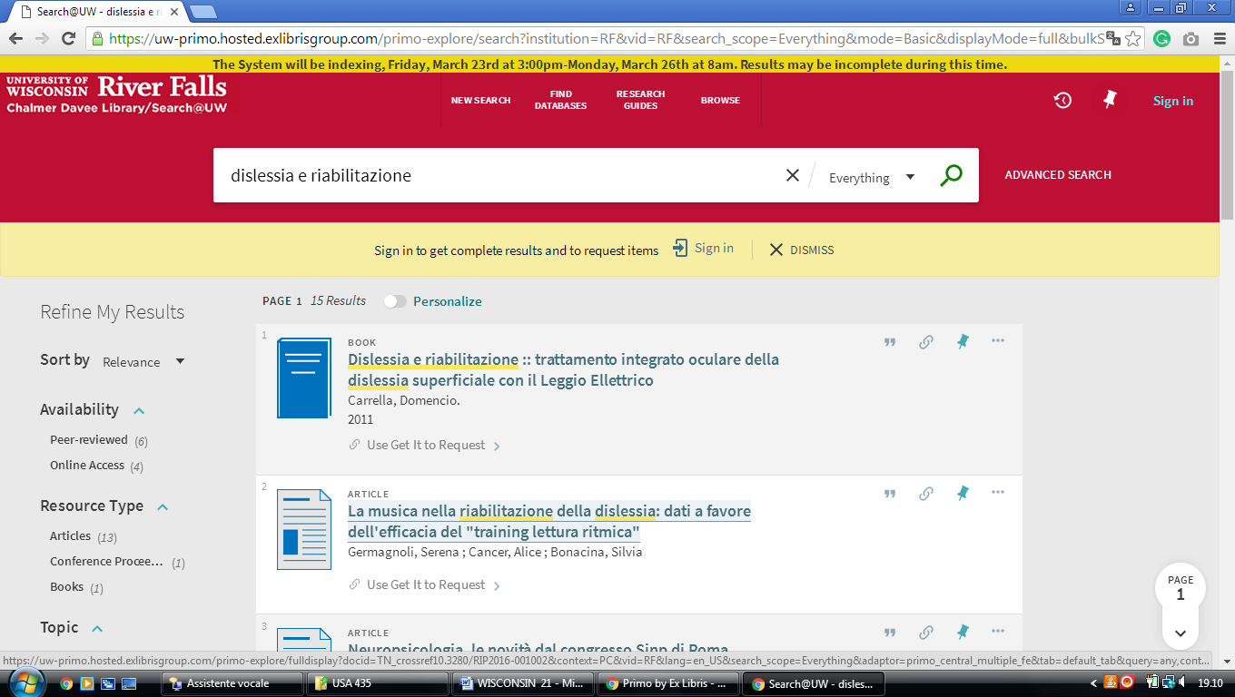

4 MCINTYRE LIBRARY - (University Wisconsin, Usa)
https://uwi-primoalma-prod.hosted.exlibrisgroup.com/primo-explore/search?query=any,contains,dislessia%20e%20riabilitazione&tab=default_tab&sortby=rank&vid=EC&lang=en_US&search_scope=Everything
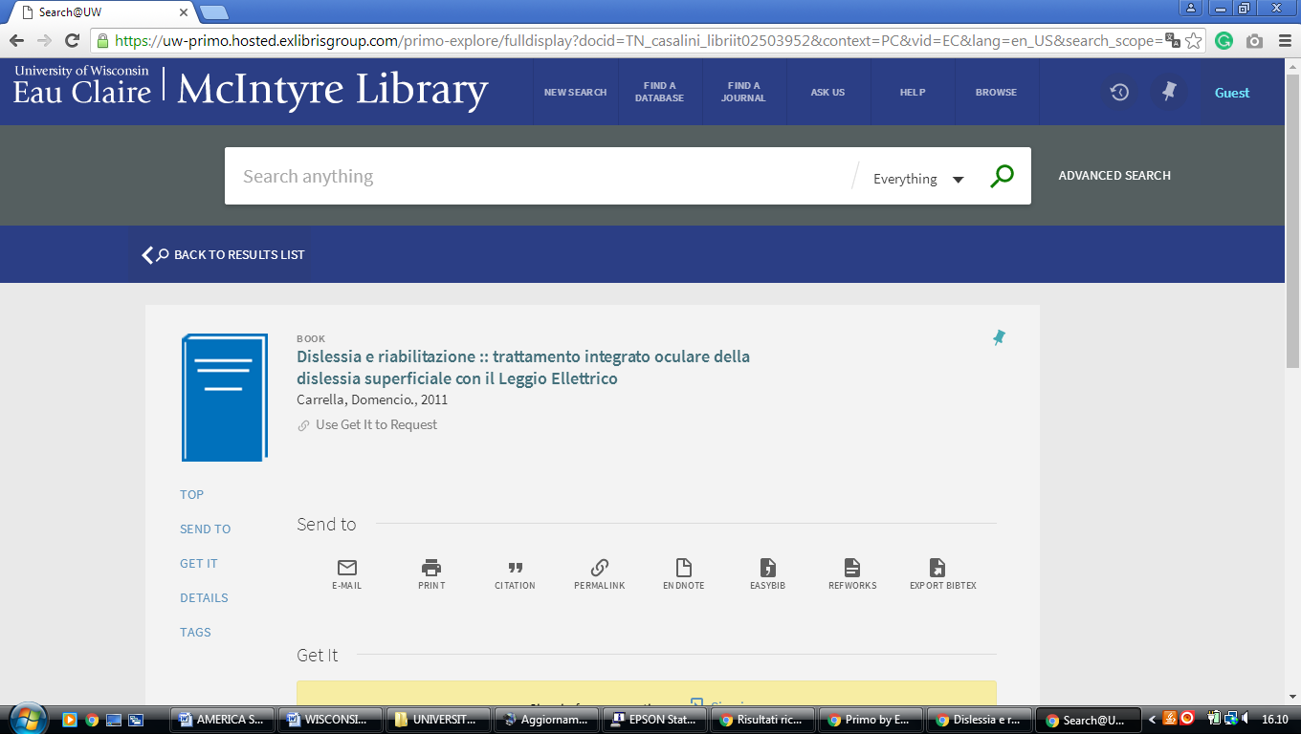

5 POLK LIBRARY – (Oshkosh, Wisconsin, Usa)
https://uw-primo.hosted.exlibrisgroup.com/primo-explore/search?search_scope=OSH_ALL&institution=OSH&vid=OSH&query=any,contains,DISLESSIA%20E%20RIABILITAZIONE&sortby=rank&lang=en_US

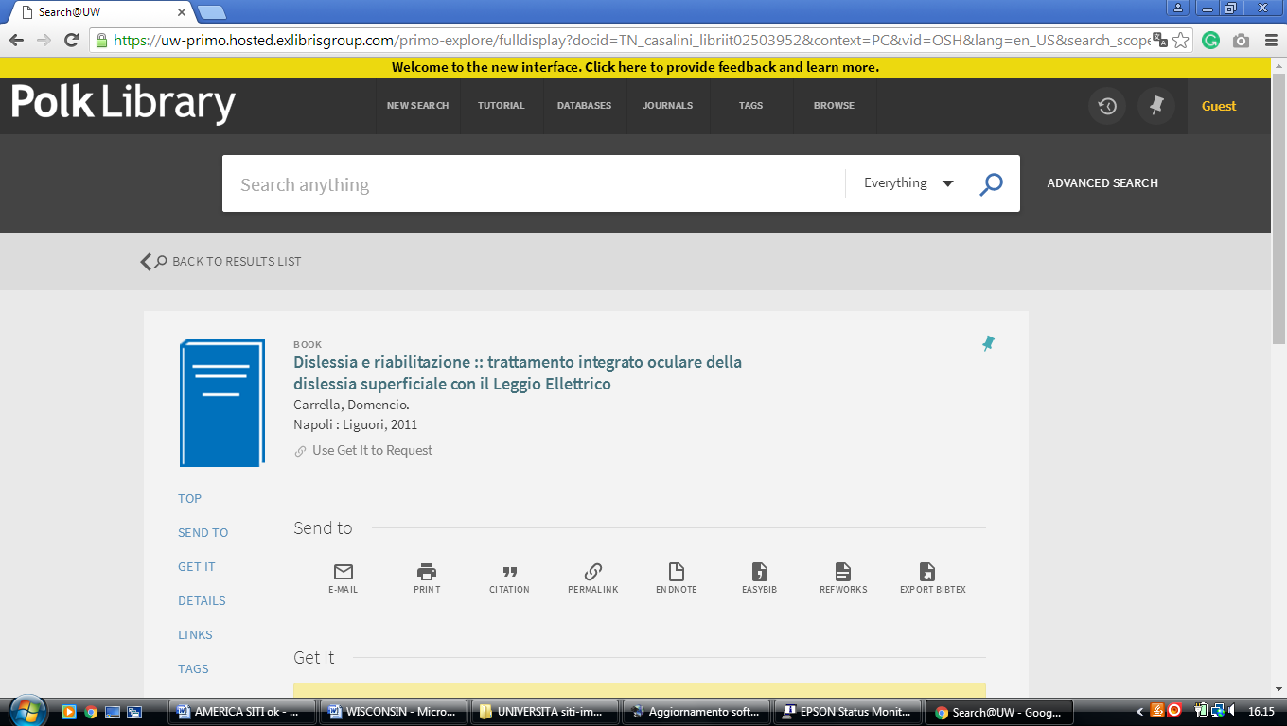

6 STEVENS POINT UNIVERSITY LIBRARY – (Stevens Point, Wisconsin, Usa)
https://uwi-primoalma-prod.hosted.exlibrisgroup.com/primo-explore/search?query=any,contains,dislessia%20e%20riabilitazione&tab=default_tab&search_scope=SP_ALL&vid=SP&lang=en_US&offset=0&sortby=rank&pcAvailability=true

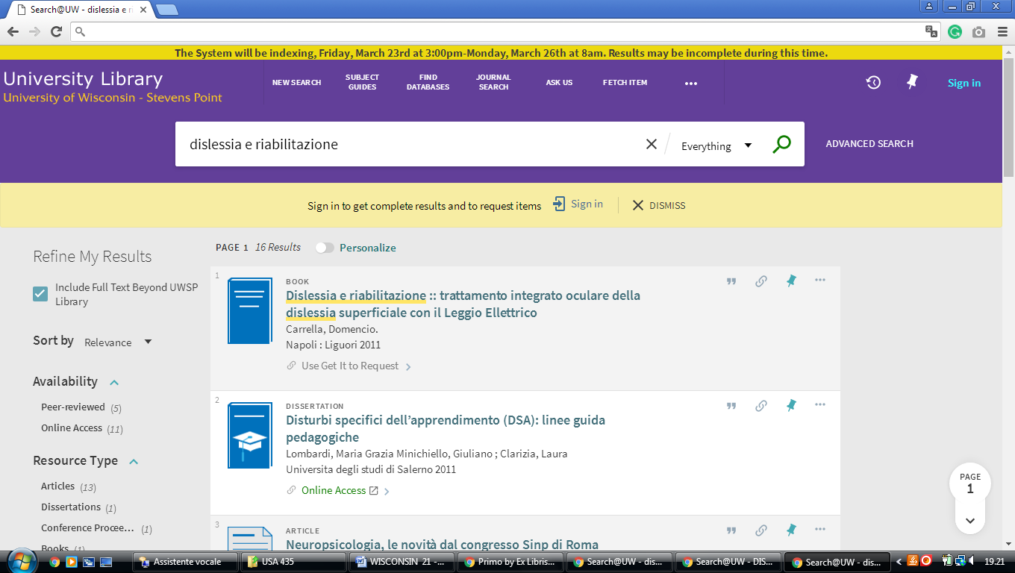

7 HTTPS://UWBSC.ON.WORLDCAT.ORG - (University of Wisconsin - Baraboo/Sauk County, Usa)
https://uwbsc.on.worldcat.org/search?sortKey=LIBRARY&databaseList=&queryString=dislessia+e+riabilitazione&changedFacet=author&scope=&format=all&database=all&author=Carrella%2C+Domenico&year=all&yearFrom=&yearTo=&language=all&topic=all

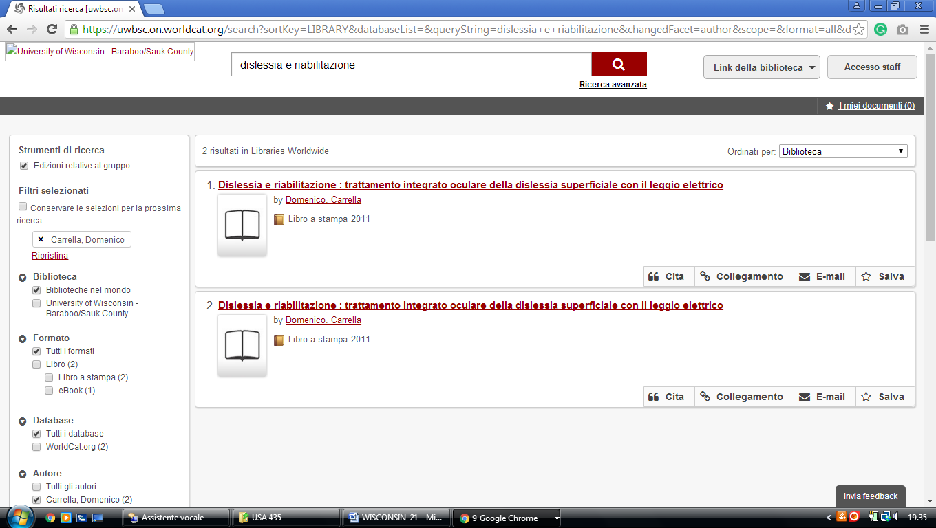

8 HTTP://UNIVERSITYOFWISCONSIN-BARRONCOUNTY.ON.WORLDCAT.ORG
(University of Wisconsin - Uw-Barron County Library, Usa)
https://universityofwisconsin-barroncounty.on.worldcat.org/search?sortKey=LIBRARY&databaseList=&queryString=dislessia+e+riabilitazione&changedFacet=author&scope=&format=all&database=all&author=Carrella%2C+Domenico&year=all&yearFrom=&yearTo=&language=all&topic=all

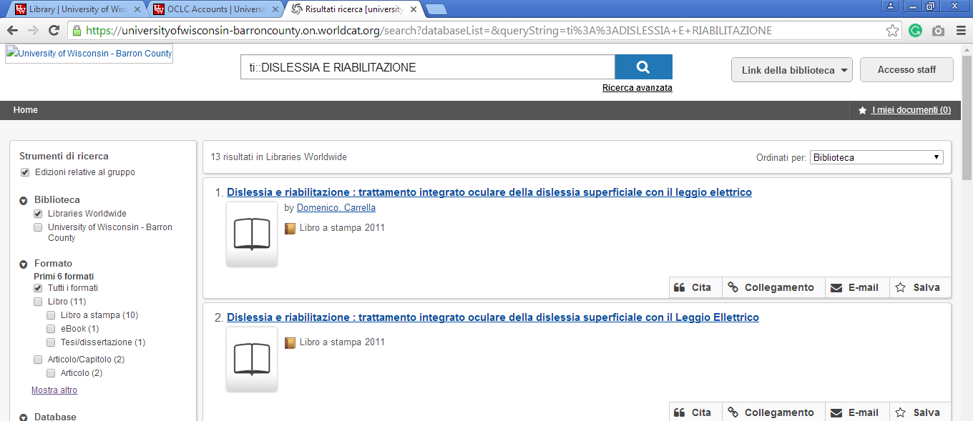

9 HTTP://UNIVERSITYOFWISCONSIN-FONDDULAC.ON.WORLDCAT.ORG (University of Wisconsin - Fond Du Lac Library, Usa)
https://universityofwisconsin-fonddulac.on.worldcat.org/search?sortKey=LIBRARY&databaseList=&queryString=dislessia+e+riabilitazione&changedFacet=author&scope=&format=all&database=all&author=Carrella%2C+Domenico&year=all&yearFrom=&yearTo=&language=all&topic=all

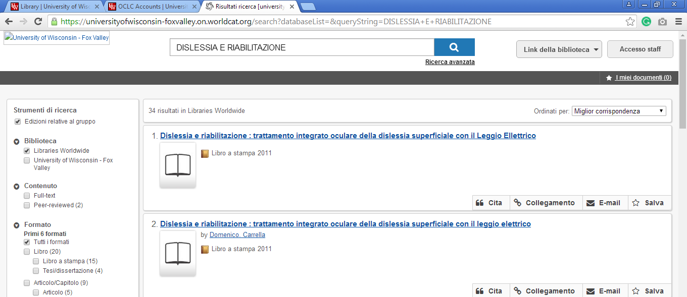

10 HTTPS://UNIVERSITYOFWISCONSIN FOXVALLEY.ON.WORLDCAT.ORG. (University of Wisconsin - Fox Valley Library,Usa)
https://universityofwisconsin-foxvalley.on.worldcat.org/search?databaseList=&queryString=dislessia+e+riabilitazione

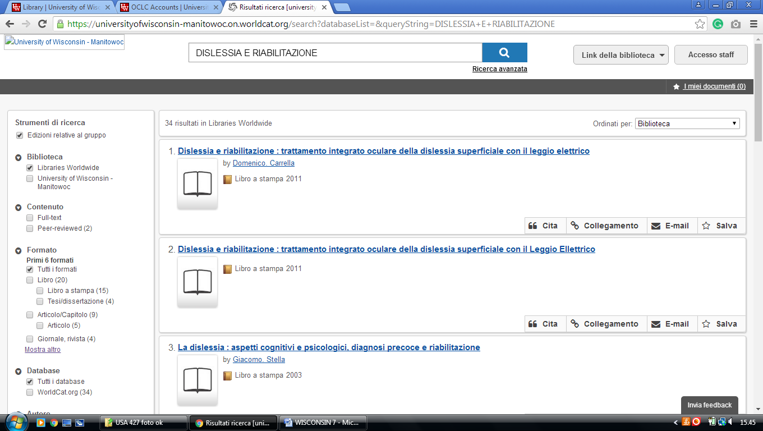

11 HTTP://UNIVERSITYOFWISCONSIN MANITOWOC.ON.WORLDCAT.ORG,
(Uw-Manitowoc Library, Wisconsin, Usa)
https://universityofwisconsin-manitowoc.on.worldcat.org/search?sortKey=LIBRARY&databaseList=&queryString=dislessia+e+riabilitazione&changedFacet=author&scope=&format=all&database=all&author=Carrella%2C+Domenico&year=all&yearFrom=&yearTo=&language=all&topic=all
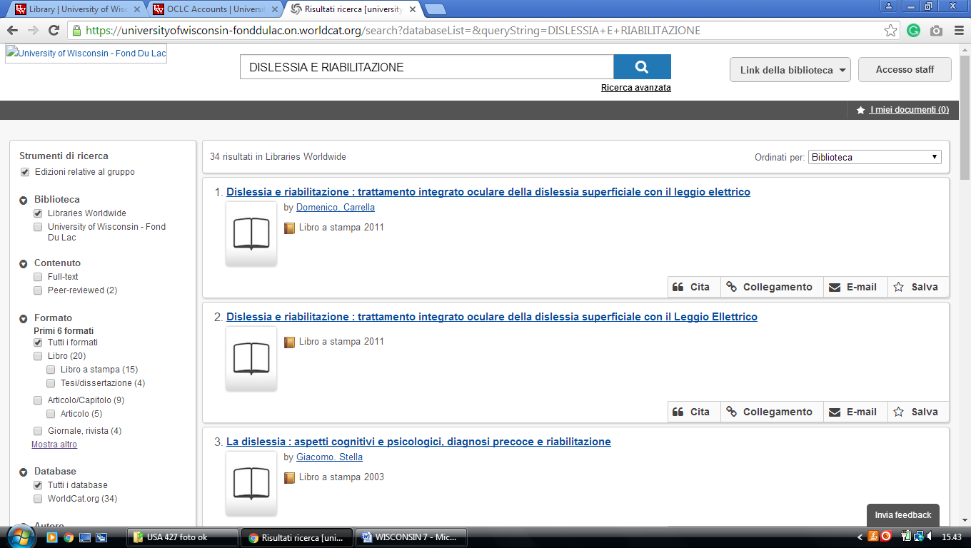

12 HTTP://UNIVERSITYOFWISCONSIN-MARINETTE.ON.WORLDCAT.ORG. (Uw-Marinette Library, Wisconsin, Usa)
https://universityofwisconsin-marinette.on.worldcat.org/search?databaseList=&queryString=dislessia+e+riabilitazione

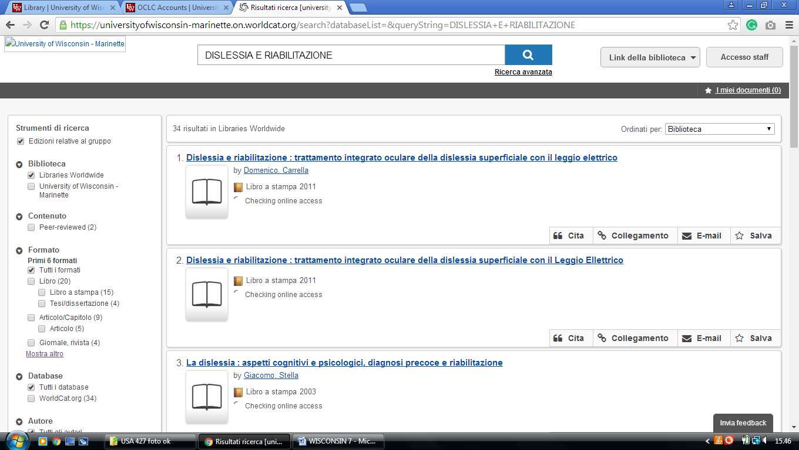

UW-Marathon County: http://universityofwisconsin-marathoncounty.on.worldcat.org

13 HTTP://UNIVERSITYOFWISCONSIN. MARATHONCOUNTY ON.WORLDCAT.ORG. (Uw-Marathon Countylibrary, Wisconsin, Usa)
https://universityofwisconsin-marathoncounty.on.worldcat.org/search?sortKey=LIBRARY&databaseList=&queryString=dislessia+e+riabilitazione&changedFacet=author&scope=&format=all&database=all&author=Carrella%2C+Domenico&year=all&yearFrom=&yearTo=&language=all&topic=all

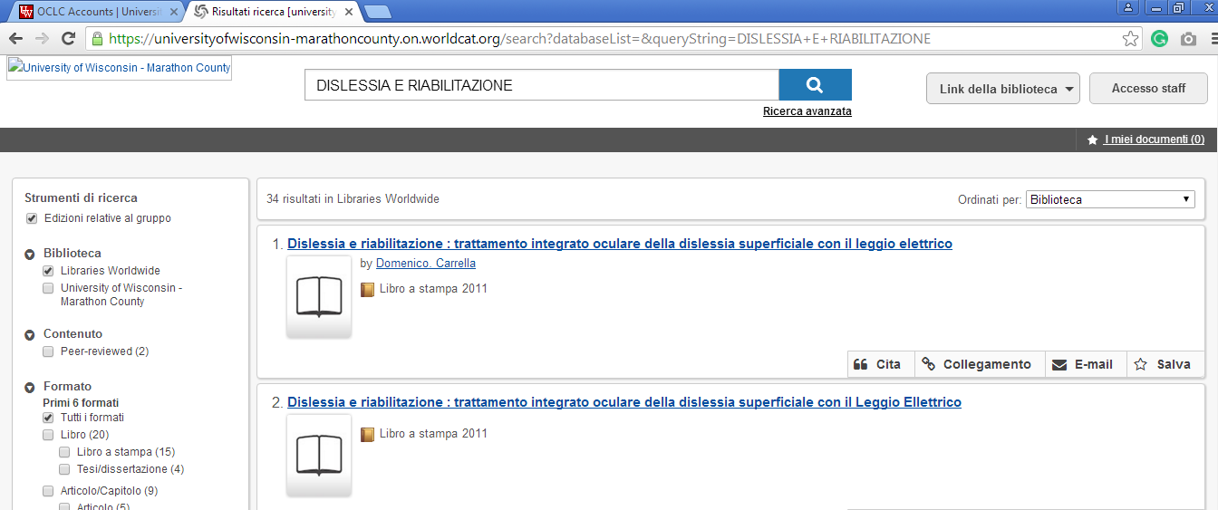

14 HTTP://UNIVERSITYOFWISCONSIN73804.ON.WORLDCAT.ORG – (Uw-Marshfield/Wood County Library, Wisconsin, Usa)
https://universityofwisconsin-marathoncounty.on.worldcat.org/search?databaseList=&queryString=dislessia+e+riabilitazione

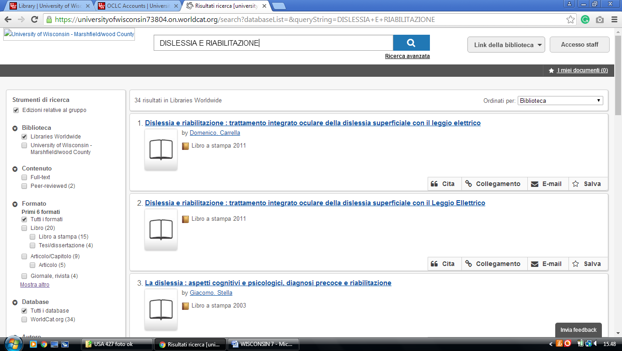

UW-Richland: http://universityofwisconsin-richland.on.worldcat.org

UW-Rock County: http://universityofwisconsin-rockcounty.on.worldcat.org

15 HTTP://UNIVERSITYOFWISCONSIN-RICHLAND.ON.WORLDCAT.ORG, - (Uw-Richland Library, Wisconsin, Usa)
https://universityofwisconsin-richland.on.worldcat.org/search?databaseList=&queryString=dislessia+e+riabilitazione

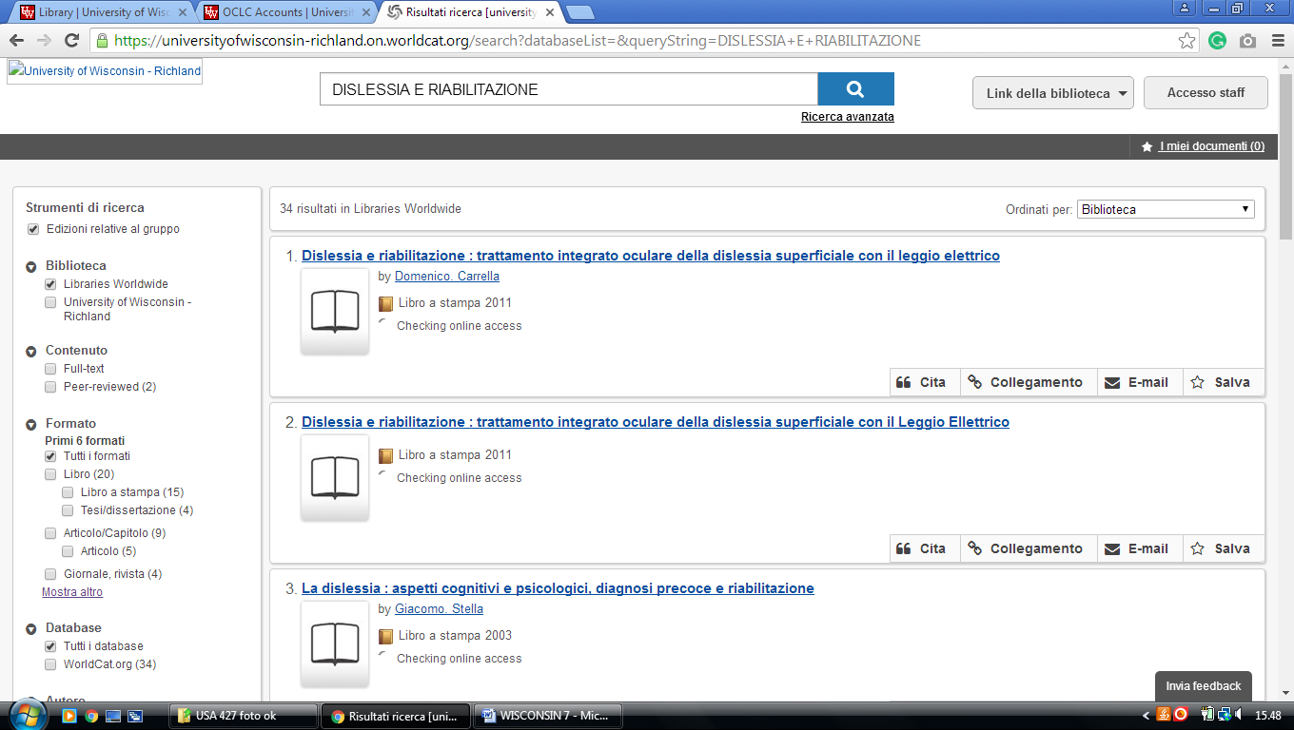

16 HTTPS://UNIVERSITYOFWISCONSIN-ROCKCOUNTY.ON.
WORLDCAT.ORG/discovery - (Uw-Rock County Library, Wisconsin, Usa)
https://universityofwisconsin-rockcounty.on.worldcat.org/search?databaseList=&queryString=dislessia+e+riabilitazione

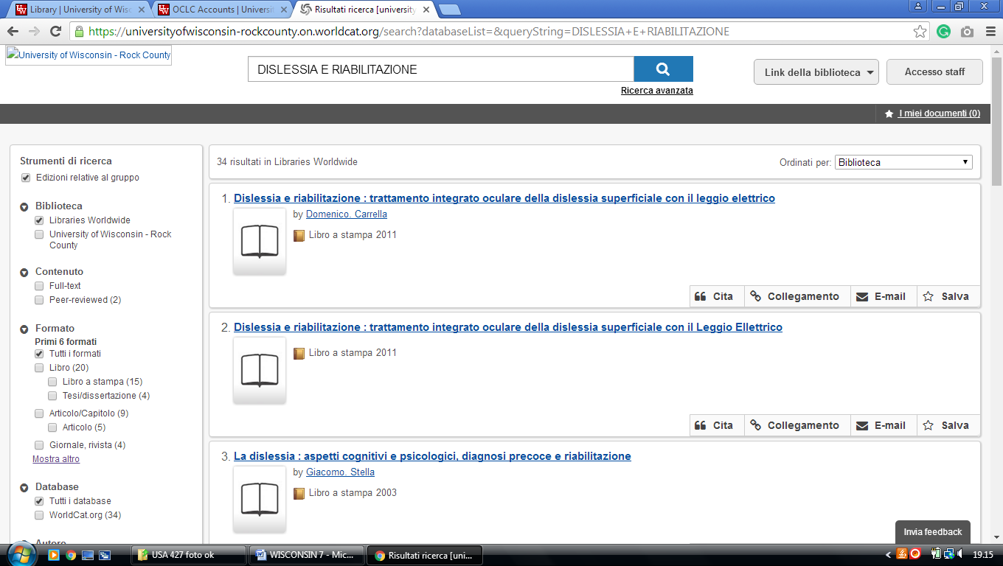

17 HTTPS://UNIVERSITYOFWISCONSIN-SHEBOYGAN.ON.
WORLDCAT.ORG/discovery- (Uw-Sheboygan, Wisconsin, Usa)
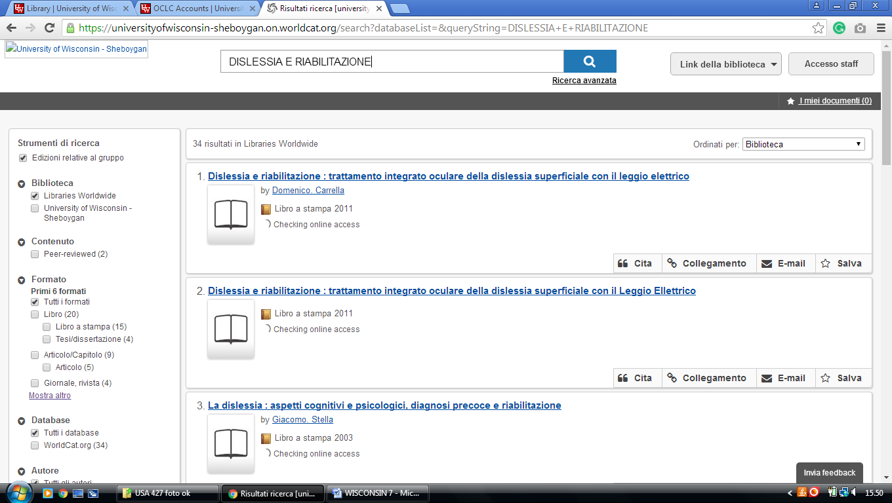
https://universityofwisconsin-sheboygan.on.worldcat.org/search?sortKey=LIBRARY&databaseList=&queryString=dislessia+e+riabilitazione&changedFacet=author&scope=&format=all&database=all&author=Carrella%2C+Domenico&year=all&yearFrom=&yearTo=&language=all&topic=all

18 HTTP://UNIVERSITYOFWISCONSIN73808.ON.WORLDCAT.ORG
(Uw-Washington County Library, Wisconsin, Usa)
https://universityofwisconsin73808.on.worldcat.org/search?databaseList=&queryString=dislessia+e+riabilitazione

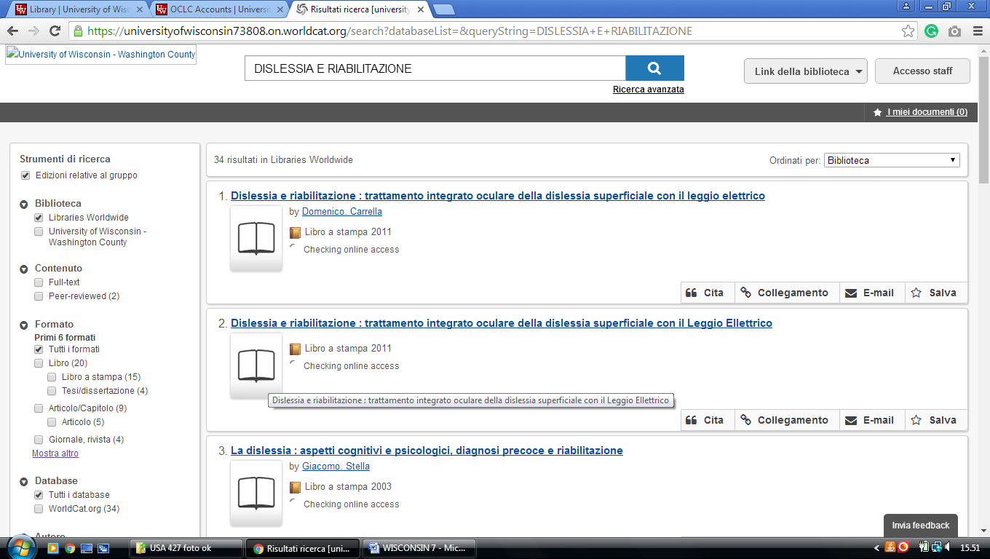

UW-Waukesha: http://universityofwisconsin-waukesha.on.worldcat.org

19 HTTP://UNIVERSITYOFWISCONSIN-WAUKESHA.ON.WORLDCAT.ORG (Uw-Waukesha Library, Wisconsin, Usa)
https://universityofwisconsin-waukesha.on.worldcat.org/search?databaseList=&queryString=dislessia+e+riabilitazione

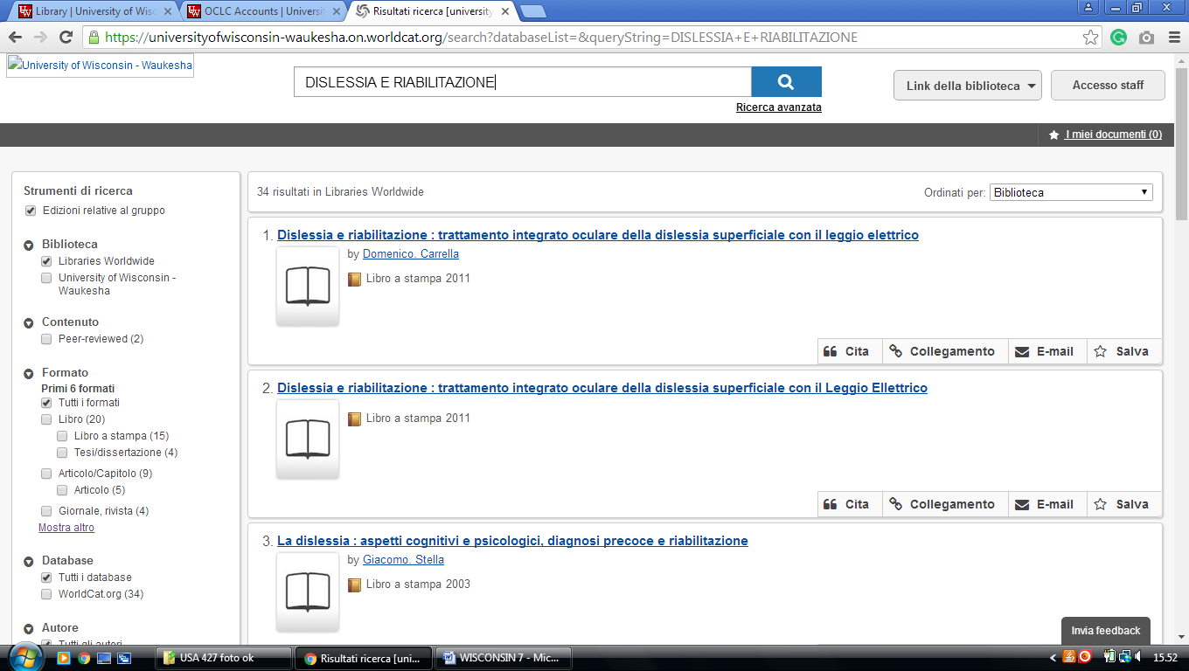

20 HTTPS://MCW.ON.WORLDCAT.ORG/ - (Medical College of Wisconsin, Usa)

https://mcw.on.worldcat.org/search?sortKey=LIBRARY&databaseList=&queryString=dislessia+e+riabilitazione&changedFacet=author&scope=&format=all&data

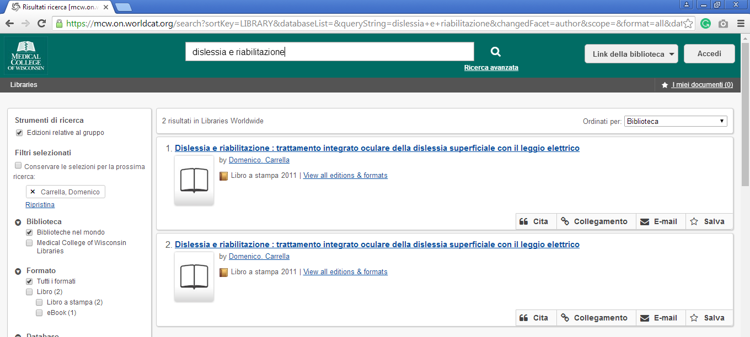

21 HTTP://UWBSC.ON.WORLDCAT.ORG - (UW-Baraboo/Sau County, Wisconsin, Usa)
https://uwbsc.on.worldcat.org/search?databaseList=&queryString=dislessia+e+riabilitazione

