WYOMING = 2

1 HINCKLEY LIBRARY – (Powell, Wyoming, Usa)
http://nwc.summon.serialssolutions.com/advanced#!/search?ho=f&l=en&q=(dislessia%20e%20riabilitazione)

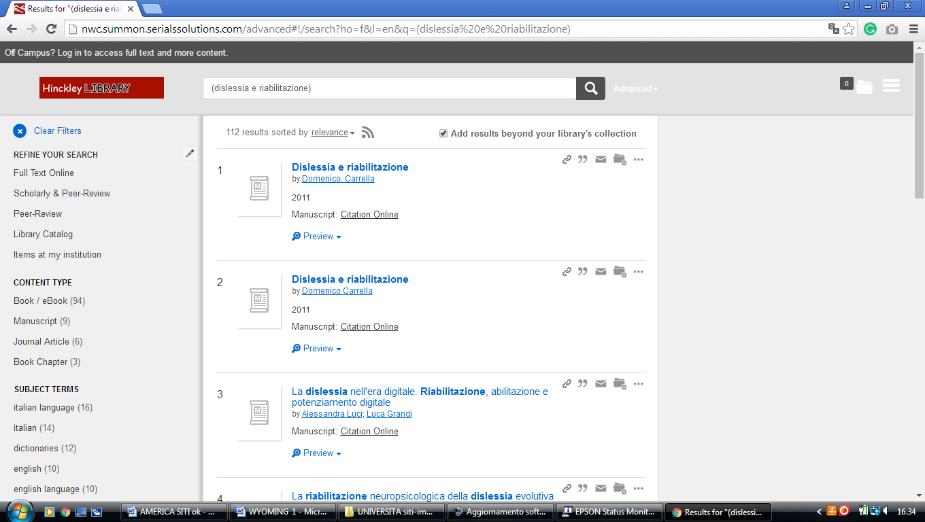

2 LIBRARIES RESEARCH LAUNCHPAD @ UNIVERSITY OF WYOMING

(E. University Ave. Laramie WY, Usa)
http://uwyo.summon.serialssolutions.com/search?fvf=ContentType%2CJournal+Article&fvf=ContentType%2CNewspaper+Article&fvf=ContentType%2CMagazine+Article&spellcheck=true&q=dislessia+e+riabilitazione#!/search?ho=f&l=en&q=dislessia%20e%20riabilitazione

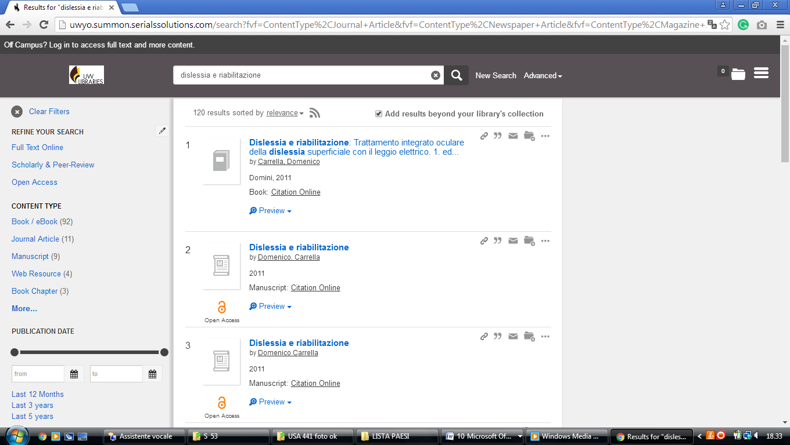

University of Wyoming Libraries AMERICA

uwyo.summon.serialssolutions.com/search?fvf=ContentType%2CJournal+Article&fvf=ContentType%2CNewspaper+Article&fvf=ContentType%2CMagazine+Article&spellcheck=true&q=dislessia+e+riabilitazione#!/search?ho=f&l=en&q=dislessia%20e%20riabilitazione

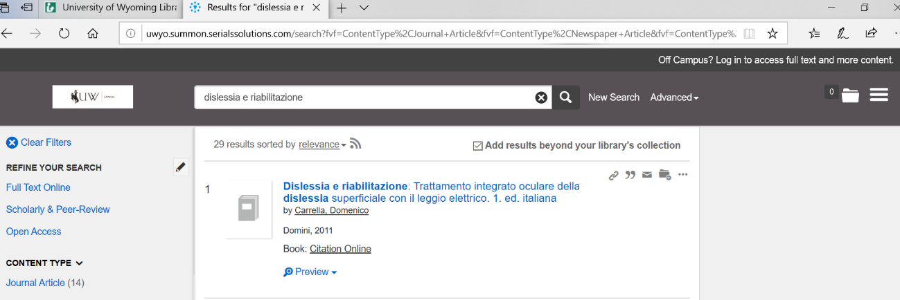

Casper College Library
Casper , Wyoming, United States
